**Undergraduate Final Year Project Proposal**

**[Job Seeker Through Database Integration]**

**[Solomon San Thawng Lal]**

**[IS - 2]**

**[B.Sc. Hons (Computing Information System]**

**[001121802]**

Table of Contents

2. Introduction 2

3. Planning 2

4. Aims 2

5. Objectives 3

6. Legal, Social, Ethical and Professional Issues and Considerations 5

7. References 6

8. Bibliography 7

9. Appendix 9

# 2. Introduction

**2.1 Background**

This system is about Job Seeker through database integration. The reason I write about this is because there are no much Job opportunities in Myanmar. People can't find jobs what they deserve and person with talent will miss the chance to upgrade his talent. There are many jobs available but if they are going to count on man work, they might not easily find it. So, in order to help them, I decide to build this website. So that they can surf jobs from our sites and get the jobs. Moreover, not only for employees but also for employers who need to recruit employees for the company. They can just post jobs through our websites so that it will save time and money. From using the website, they can view the employee resume that are posted in the site. In that way, they can hire they want to and even email who are registered on the site if they pay for it. One exception for using the site is employers can create their own account but he must pay the price per job before it.

# 3. Planning

**3.1 Research**

With the use of DSDM approach, I use the timeboxes to make the plan. According to the Moscow, I prioritize the timeboxes what should be done first, so that I won't lose track of time. You can see the details of my planning using the Gantt Chart below the appendix.

The task will utilize Agile DSDM Atern to permit adaptability during the venture. MoSCoW need Timeboxing, Techniques, for example, model will be utilized to get the venture on schedule and produce just the prerequisites for business the executives. There are no particular necessities in the task, so there will be adjustments to the adjustments in the undertaking stages. Consistence with the Atern DSDM rules will profit the application in an opportune way, without influencing the nature of the application. Then to build the site, php language will be used. I will use it since it is easy for the server-side language. It can generate dynamic site, run on various platforms and support wide range if database. So, because of that reason, it will be a lot easier to connect with MySQL. It is ideal for my project, use standard SQL and the most important reason is, it is created, circulated, and bolstered by Oracle Corporation.

# 4. Aims

If the website is succeeded, there will be lots of company who will be cooperate with us. They will recruit employees and advertise their company. Then, we can earn money from them. Moreover, people can find jobs even from different states and wait for the reply. This will save them from traveling if they aren't accepted.

# 5. Objectives

**5.1.1 Time box for business**

Firstly, before starting the project, I will surf the method that I have to use in the project and business flow of the job system. Then at the same time, I will look for the similar system and the idea for the prototype. In the case there will be risk management so that I will have to careful with that as well as Legal, Social, Ethical and Professional issues. The time duration will be 1 week and a day. So, I will work 6 hours per day.

**Deliverable Keys:** Class Diagram, Considerations for legal, social, ethical and professional, Over View of the system, recommendations for the similar system

**5.1.2 Time box for Technique**

This stage will be done for researching how to build the database system. After it, I will start coding with the use of php programming. The time duration will be 4 days. So, I will work 6 hours per day.

**Deliverables:** Class Diagram, Considerations for legal, social, ethical and professional, Over View of the system, recommendations for the similar system

(Keith, 1985), (Schools, 1994), (School, 1994), (education, 1996)

**5.2 Analysis**

In this stage, by using the Moscow, I will prioritize the tasks. From analyzing the similar the system, I will choose which system is the best and reference that system. I will overview of the ER Diagram, Activity Diagram, Screen Design, Use-case and Class Diagram. While building the system, I will follow the rules of Jakob Nielsen heuristics. Project technique and requirement of the system will follow up to follow the blank. The time duration will be 2 weeks. So, I will work 5 hours per day.

**Deliverables:** Time Box, Functional and Non-Functional Requirement, Gant Chart, ER Diagram, Activity Diagram, Activity Diagram, Use-case and Class Diagram, Screen Design

**5.3 Time Box: Manage Employer**

In this time box, I will prioritize the manage employer which is the most important in my system. In this stage, I will plan how to manage the employer. The system will not be run without the post of jobs by the employer. First of all, I will draw ER, Class, use-case and activity diagram. Then I will produce screen design and data dictionary. After that, I will design functional protype then operational prototype. Iteration will be done to get the better design. If it will go well, I will start coding and start the test scripting. Functional testing and user ability testing will be done to fully run. The time duration will be 1 month and 3 days. So, I will work 6 hours per day.

**Deliverables Keys:** Use-Case, Class Diagram, Activity Diagram, Screen Design, Database Design, Functional Prototype, Functional Testing, Test script, Operational Prototype, Usability Testing, Iteration, Deployment Diagram, Data Dictionary

(Tsang, 2002), (Tsang, 2002), (Tsang, 2002), (Tsang, 2002)

**5.4 Time Box: Manage Employee**

In this time box, I will prioritize the manage employee which is the second important in my system. In this stage, I will plan how to manage the employee. Without employee, there will no jobs will be applied. First of all, I will draw ER, Class, use-case and activity diagram. Then I will produce screen design and data dictionary. After that, I will design functional protype then operational prototype. Iteration will be done to get the better design. If it will go well, I will start coding and start the test scripting. Functional testing and user ability testing will be done to fully run. The time duration will be 1 month and 3 days. So, I will work 6 hours per day.

**Deliverables Keys:** Use-Case, Class Diagram, Activity Diagram, Screen Design, Database Design, Functional Prototype, Functional Testing, Test script, Operational Prototype, Usability Testing, Iteration, Deployment Diagram, Data Dictionary

**5.5 Time Box: Manage Job Applied**

In this time box, I will prioritize the manage job applied which is the third important in my system. In this stage, I will plan how to manage the job applied. The job applied will benefit both the employers and the employee. The job will be applied by the employee and the employers will decide on it. First of all, I will draw ER, Class, use-case and activity diagram. Then I will produce screen design and data dictionary. After that, I will design functional protype then operational prototype. Iteration will be done to get the better design. If it will go well, I will start coding and start the test scripting. Functional testing and user ability testing will be done to fully run. The time duration will be 1 month and 3 days. So, I will work 6 hours per day.

**Deliverables Keys:** Use-Case, Class Diagram, Activity Diagram, Screen Design, Database Design, Functional Prototype, Functional Testing, Test script, Operational Prototype, Usability Testing, Iteration, Deployment Diagram, Data Dictionary

**5.6 Evaluation**

This time box will prioritize the tasks before uploading the system. I will report the evaluation that will be done and overview the impact effects. That means outcome of measurable results and benefits. Then, I will choose the evaluation method the solve the problem. The time duration will be 2 weeks and a day. So, I will work 6 hours per day.

**Deliverables:** Further development of the system, tangible or intangible, the final report

(Janssen, 1999)

# 6. Legal, Social, Ethical and Professional Issues and Considerations

In Myanmar, there are no specific rules for computerized system. It has no impact of rules from other country to my company. So, I give reference the laws I wrote in assignment to the UK. **DPA** means Information assurance and the human right protection are connected in a general sense. A thorough way to deal with information assurance depends on the twin objectives as a key right, and securing the scope of rights. This complete way to deal with information insurance should shape some portion of a much more extensive national digital security procedure. Conflict **Circumstances means** at the venture level, when tasks include enormous quantities of individuals and a few outside merchants, there are adequate open doors for partners to give inappropriate inclination to specific groups or companies. So, it has to ensure that all gatherings associated with a venture comprehend the organization's gauges and the meaning of an irreconcilable situation is obvious to everybody. **Employee's Conflict** means in the association, there are consistently worker who doesn't do their put their full productivity at work and decreasing waste all through the association. Some are unskillful yet to direction to work them that they can't deal with it. This may influence the business that are given by the clients. **Responsibilities** means Responsibilities inside the PMI people group include looking after confidentiality, conforming to laws and guidelines, and acting in manners that are reliable with policies and procedures. Professionals should settle on decisions and maintain moves that make responsibility for.

(Catambay, 2006), ((BCS), n.d.),

(Units, 1939), (Kellman, n.d.), (Dixon, 2002)

# 7. References

(BCS), B. C. S., n.d. *BCS Codes of Conduct and Practice.* [Online]   
Available at: https://www.cs.uct.ac.za/mit_notes/ethics/htmls/ch04s04.html  
[Accessed 17 2 2020].

Catambay, A., 2006. *www.clarizen.com.* [Online]   
Available at: https://www.clarizen.com/ethical-issues-project-management-deal/  
[Accessed 15 2 2020].

Dixon, A., 2002. *study.* [Online]   
Available at: https://study.com/academy/lesson/pmi-code-of-ethics-professional-conduct.html  
[Accessed 16 2 2020].

education, N., 1996. *Research.* Yangon: Nc.

Janssen, C., 1999. *Investopedia.* [Online]   
Available at: https://www.investopedia.com/ask/answers/012815/what-difference-between-tangible-and-intangible-assets.asp  
[Accessed 19 2 2020].

Keith, 1985. *agilekrc.* [Online]   
Available at: https://agilekrc.com/resource/168/what-dsdm-and-8-principles  
[Accessed 16 2 2020].

Kellman, D., n.d. *HR Exchange.* [Online]   
Available at: https://www.hrexchangenetwork.com/employment-law/articles/avoid-these-6-recruiting-related-legal-issues  
[Accessed 26 2 2020].

Schools, w., 1994. *w3 Schools.* [Online]   
Available at: https://www.w3schools.com/php/php_intro.asp  
[Accessed 17 2 2020].

School, w., 1994. *w3 Scgool.* [Online]   
Available at: https://www.w3schools.com/php/php_mysql_intro.asp  
[Accessed 17 2 2020].

Tsang, C., 2002. *Visual Paradigm.* [Online]   
Available at: https://www.visual-paradigm.com/guide/uml-unified-modeling-language/what-is-class-diagram/  
[Accessed 18 2 2020].

Tsang, C., 2002. *Visual Paradigm.* [Online]   
Available at: https://www.visual-paradigm.com/guide/uml-unified-modeling-language/what-is-use-case-diagram/  
[Accessed 18 2 2020].

Tsang, C., 2002. *Visual Paradigm.* [Online]   
Available at: https://www.visual-paradigm.com/guide/uml-unified-modeling-language/what-is-activity-diagram/  
[Accessed 18 2 2020].

Tsang, C., 2002. *Visual Paradigm.* [Online]   
Available at: https://www.visual-paradigm.com/guide/data-modeling/what-is-entity-relationship-diagram/  
[Accessed 19 2 2020].

Units, C. E., 1939. *Employers Council.* [Online]   
Available at: https://www.employerscouncil.org/legal-issues-for-human-resources-professionals  
[Accessed 16 2 2020].

# 8. Bibliography

(BCS), B. C. S., n.d. *BCS Codes of Conduct and Practice.* [Online]   
Available at: https://www.cs.uct.ac.za/mit_notes/ethics/htmls/ch04s04.html  
[Accessed 17 2 2020].

Catambay, A., 2006. *www.clarizen.com.* [Online]   
Available at: https://www.clarizen.com/ethical-issues-project-management-deal/  
[Accessed 15 2 2020].

Dixon, A., 2002. *study.* [Online]   
Available at: https://study.com/academy/lesson/pmi-code-of-ethics-professional-conduct.html  
[Accessed 16 2 2020].

education, N., 1996. *Research.* Yangon: Nc.

Janssen, C., 1999. *Investopedia.* [Online]   
Available at: https://www.investopedia.com/ask/answers/012815/what-difference-between-tangible-and-intangible-assets.asp  
[Accessed 19 2 2020].

Keith, 1985. *agilekrc.* [Online]   
Available at: https://agilekrc.com/resource/168/what-dsdm-and-8-principles  
[Accessed 16 2 2020].

Kellman, D., n.d. *HR Exchange.* [Online]   
Available at: https://www.hrexchangenetwork.com/employment-law/articles/avoid-these-6-recruiting-related-legal-issues  
[Accessed 26 2 2020].

Schools, w., 1994. *w3 Schools.* [Online]   
Available at: https://www.w3schools.com/php/php_intro.asp  
[Accessed 17 2 2020].

School, w., 1994. *w3 Scgool.* [Online]   
Available at: https://www.w3schools.com/php/php_mysql_intro.asp  
[Accessed 17 2 2020].

Tsang, C., 2002. *Visual Paradigm.* [Online]   
Available at: https://www.visual-paradigm.com/guide/uml-unified-modeling-language/what-is-class-diagram/  
[Accessed 18 2 2020].

Tsang, C., 2002. *Visual Paradigm.* [Online]   
Available at: https://www.visual-paradigm.com/guide/uml-unified-modeling-language/what-is-use-case-diagram/  
[Accessed 18 2 2020].

Tsang, C., 2002. *Visual Paradigm.* [Online]   
Available at: https://www.visual-paradigm.com/guide/uml-unified-modeling-language/what-is-activity-diagram/  
[Accessed 18 2 2020].

Tsang, C., 2002. *Visual Paradigm.* [Online]   
Available at: https://www.visual-paradigm.com/guide/data-modeling/what-is-entity-relationship-diagram/  
[Accessed 19 2 2020].

Units, C. E., 1939. *Employers Council.* [Online]   
Available at: https://www.employerscouncil.org/legal-issues-for-human-resources-professionals  
[Accessed 16 2 2020].

# 9. Appendix

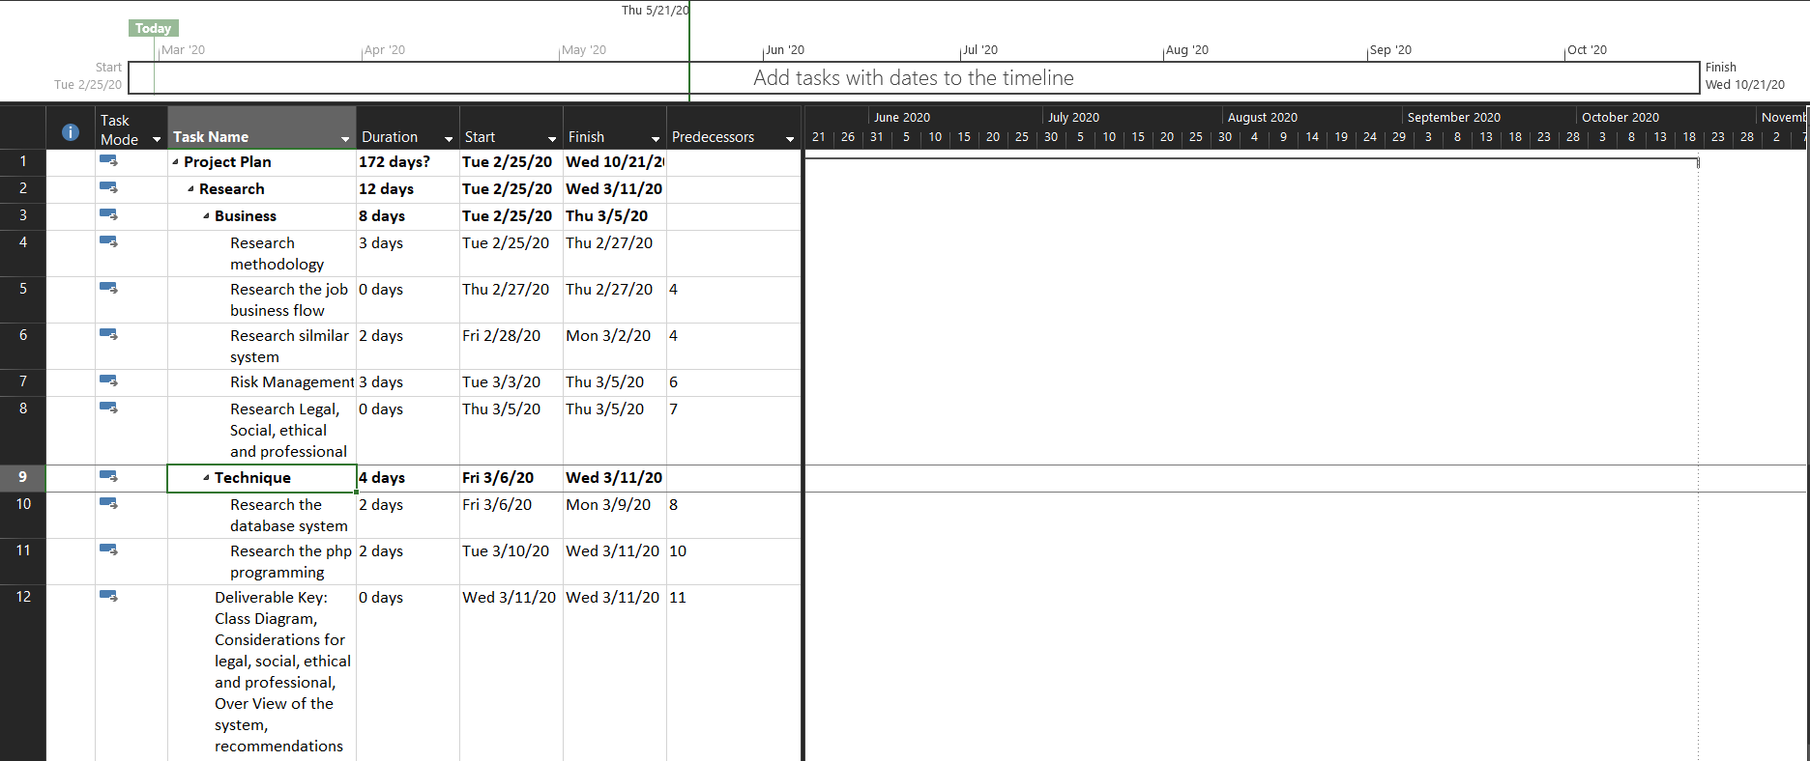

Fig (1.1)

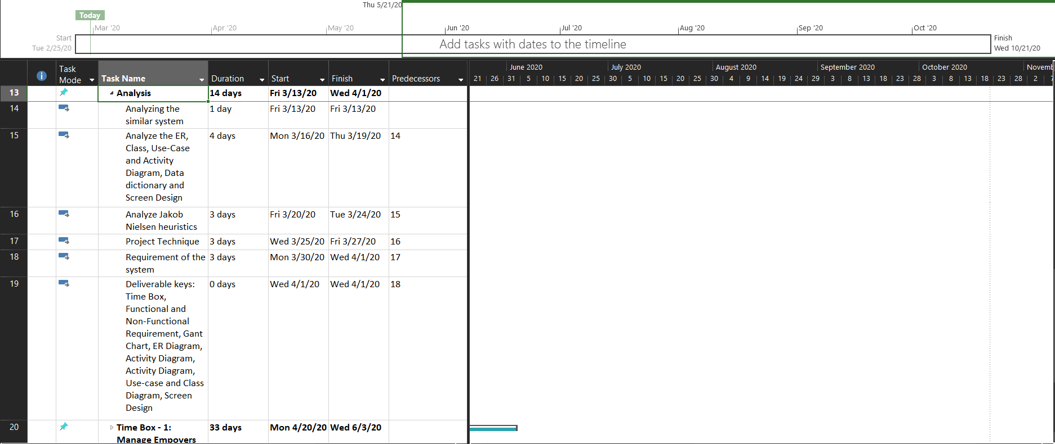

Fig (1.2)

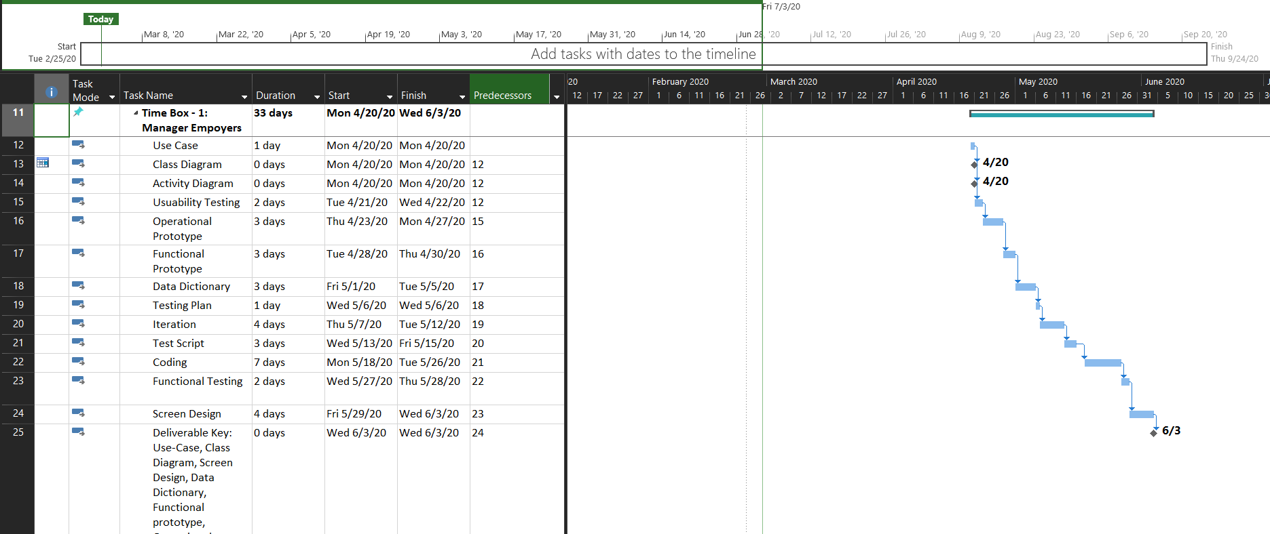

Fig (1.3)

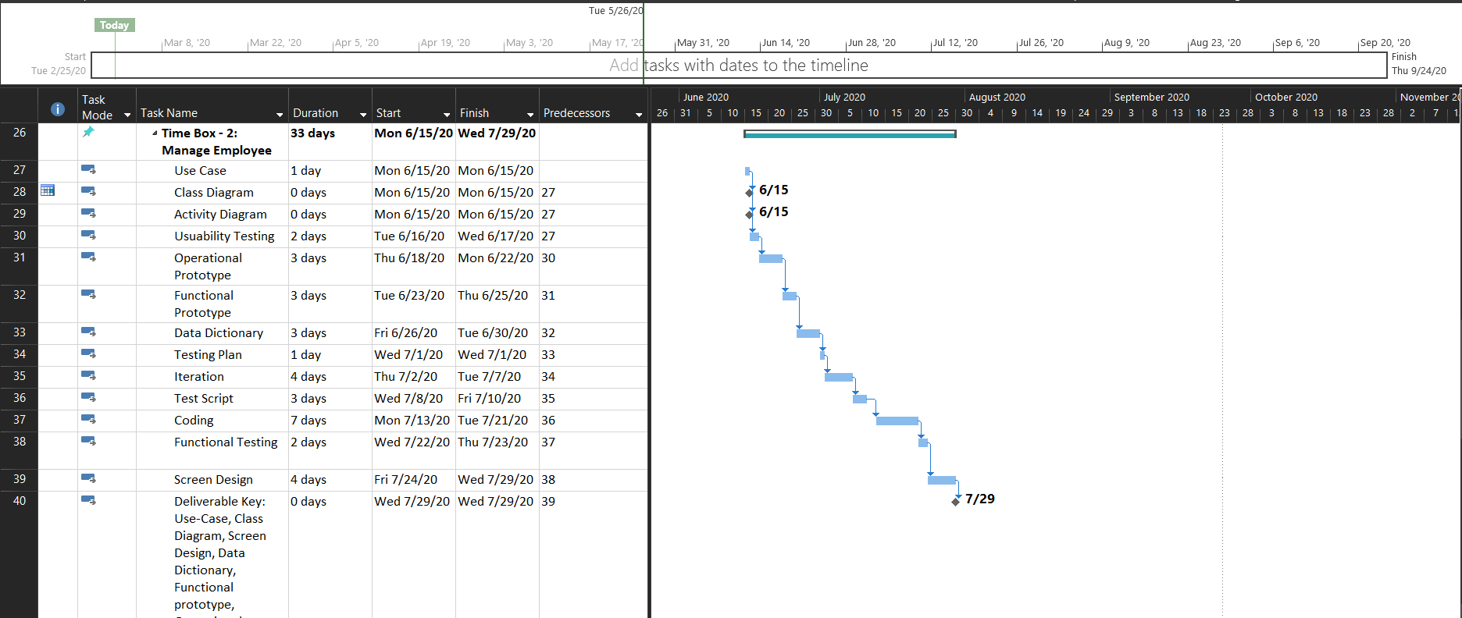

Fig (1.4)

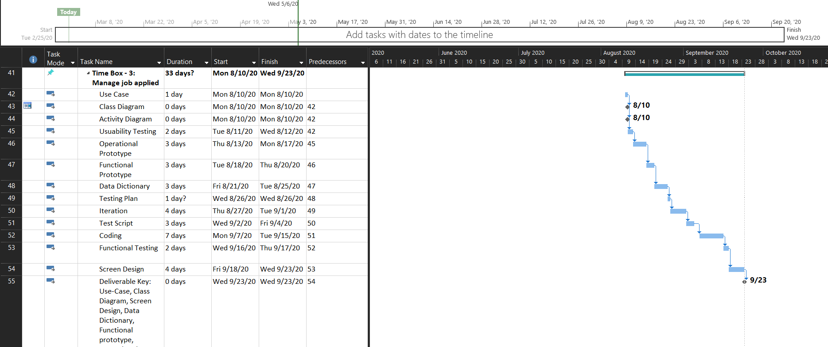

Fig (1.5)

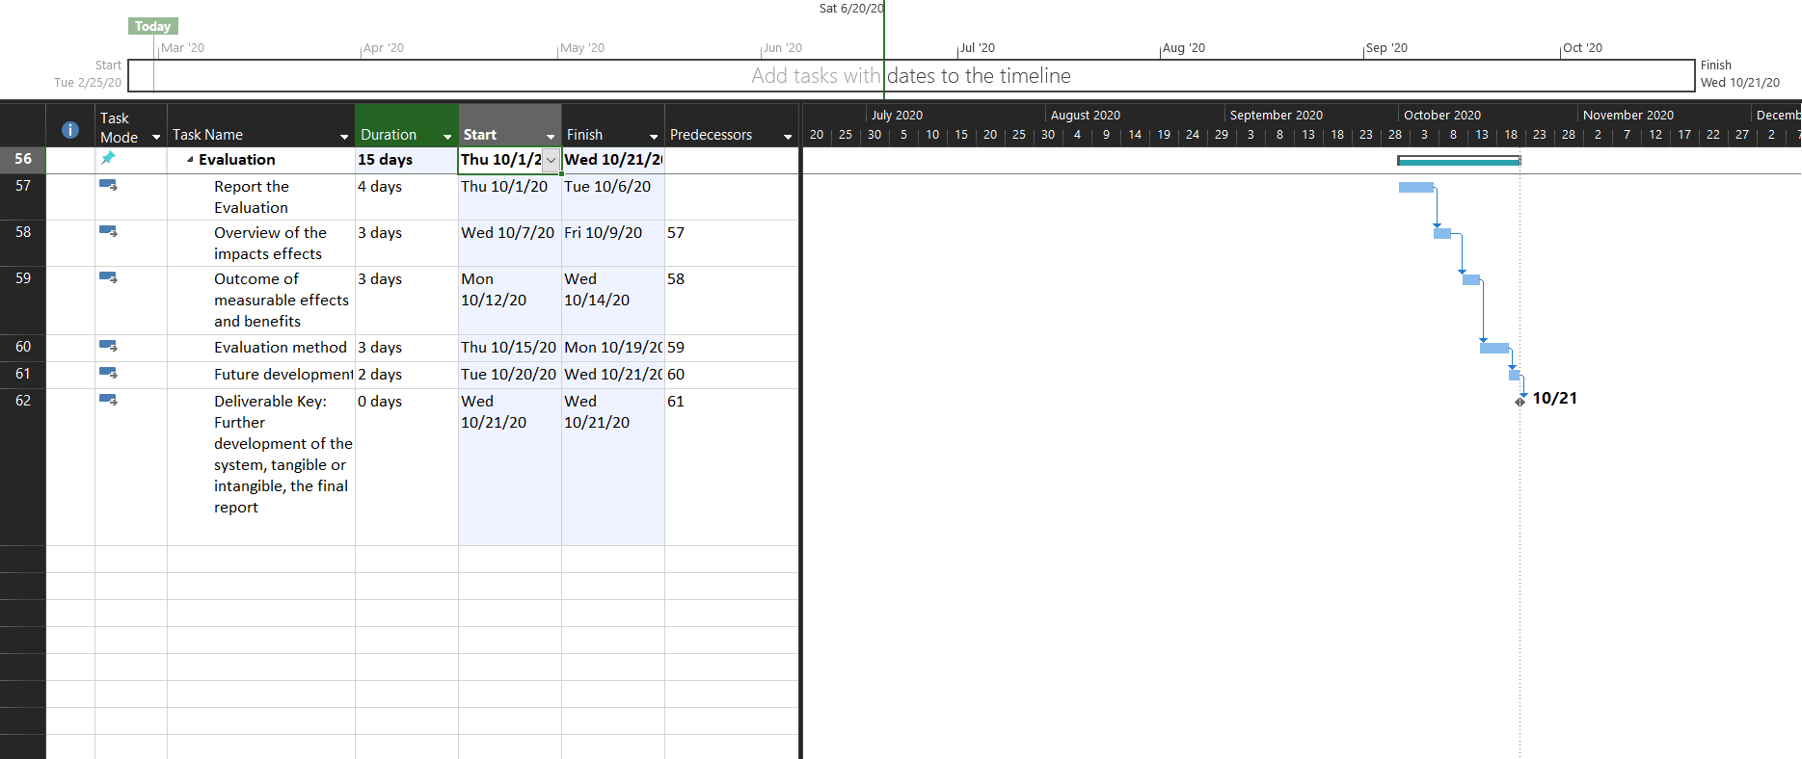

Fig (1.6)