# Team Profile

## Jay Hunter

Jay’s three tests were *Myers-Briggs*, *Learning Type*, and a *Career Aptitude* test which categorised him as ENFP, a Visual Learner, and the following careers: Remote Sensing Technician, Timing Device Assembler and Adjuster, Computer-Controlled Machine Tool Operator. Using this information, Jay can communicate effectively with the group and work on any task given without dissent. Being a visual learner, he may be able to provide useful graphics or styling ideas for the group.

## 

## Adam Wilkinson

The “Myer-Briggs” style test has me listed as a virtuoso tagged as wanting to explore and always seeking improvement. The categorised sections have me consistent down the middle in all parts. The learning style quiz shows that I am a visual learner. The suitable job test lists a variety of jobs with a common theme of production and jobs that would require problem solving. These attributes mean that when put into a team environment I am always wanting to learn and develop from the knowledge and experience of my group. When they show me a better way of achieving an outcome it will better my work which will result in a better contribution to the group.

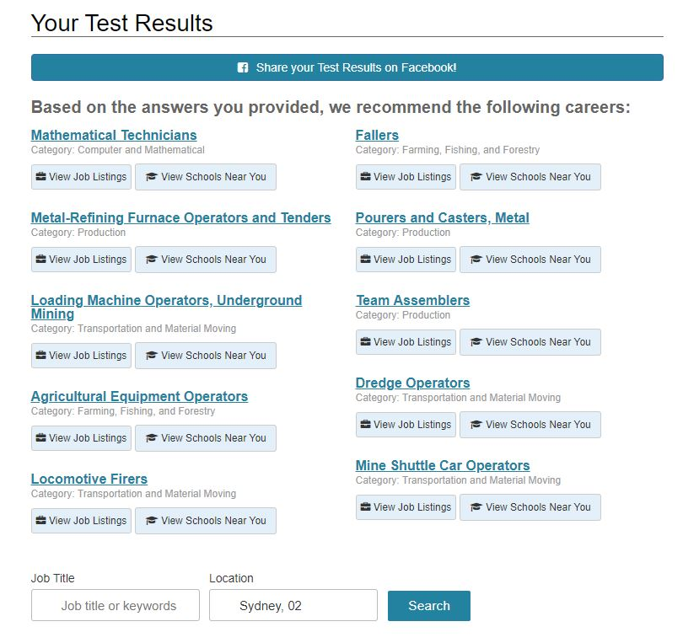 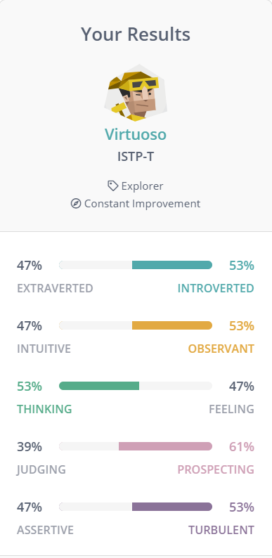

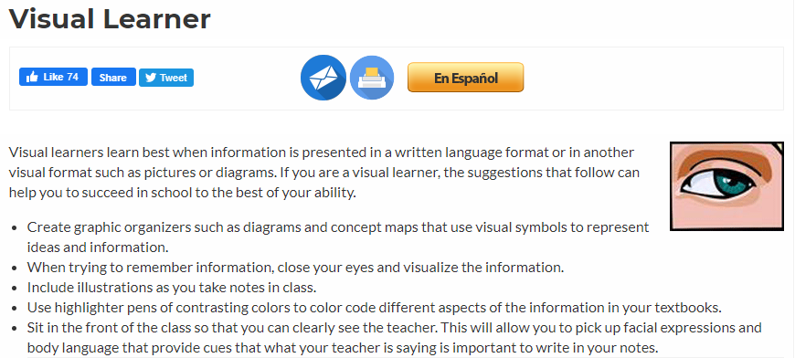

## Jacob King

The personality type INTP will be blunt and direct, approaching problems head on and focused, meaning less time will be spent on chit-chat. INTP personality types are imaginative and original, always striving to a solution to the problem at hand. Another strength of the INTP is their objectiveness. These strengths all collaborate to keep the INTP personality on task and by extension, the group as well. My result for learning style was tactile/kinesthetic. This means that I learn best with hands on activities, taking things apart and putting them back together again. If this were code, then it would be best for me to take it step by step, disassembling and seeing how it works. Communicating how someone’s code works is best communicated to me in this way. The final test was a career insight test, and I got careers that revolve around logic and mathematics.

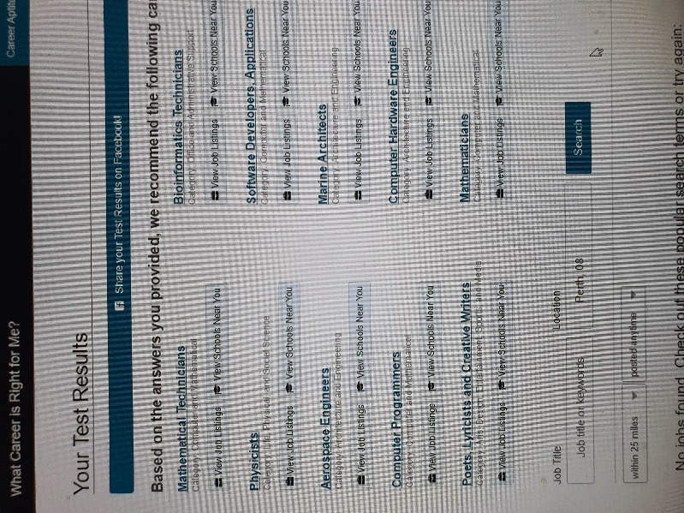 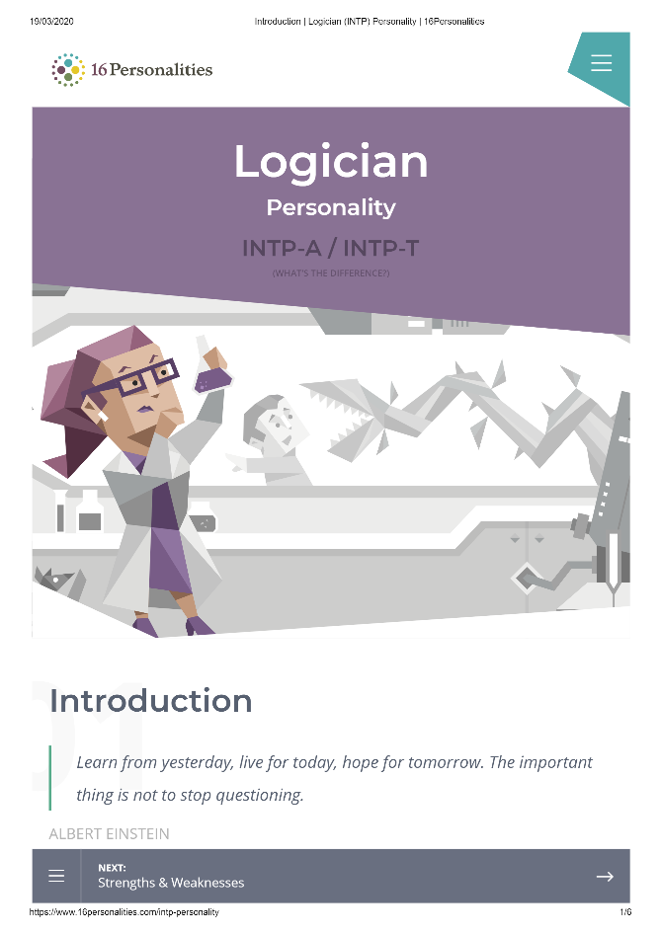

## 

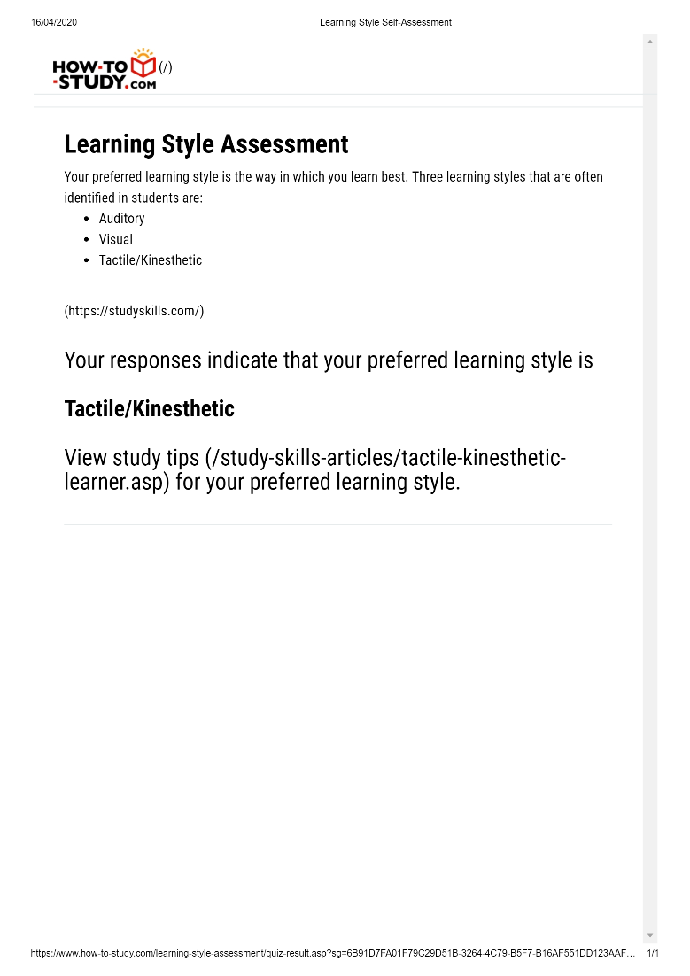

## Patrick Mamigonian

Some of the terms the online tests have used to describe my personality are ‘The Guardian’ and ‘The Protagonist”. While these are broad categories, they contained elements of confidence, influential, leadership and altruistic. I was particularly pleased to see this one statement “*Protagonists take a great deal of pride and joy in guiding others to work together to improve themselves and their community.*” which I feel encompasses my deeper motivations. On the other hand, the assessment of my weaknesses was equally accurate, in

describing me as overly idealistic and overly selfless, which can result in being spread too thin.

In a team environment there are a few elements of my characteristics that I need to be self-aware. The personality tests accurately indicate that I may like to lead the charge, be overly optimistic of achievable outcomes and place high expectations on members. This may be my psychological dominance, however over time I have become well conscious of these self attributes, and become a more effective team member, often encouraging others to take lead roles, and being a more facilitating leader.

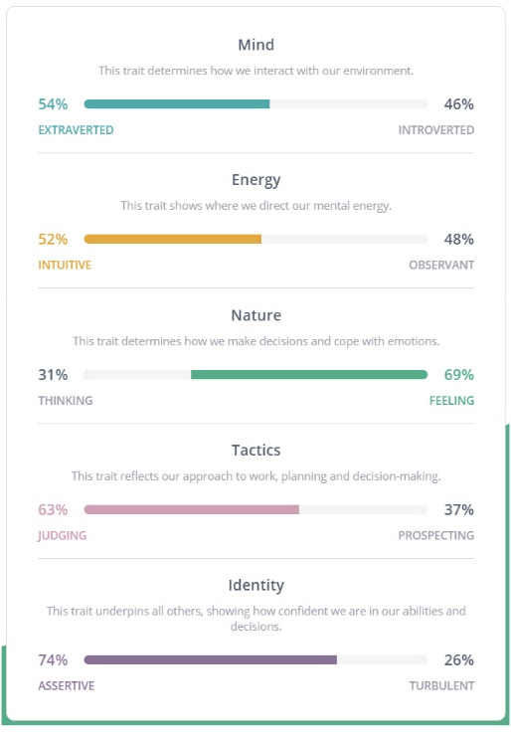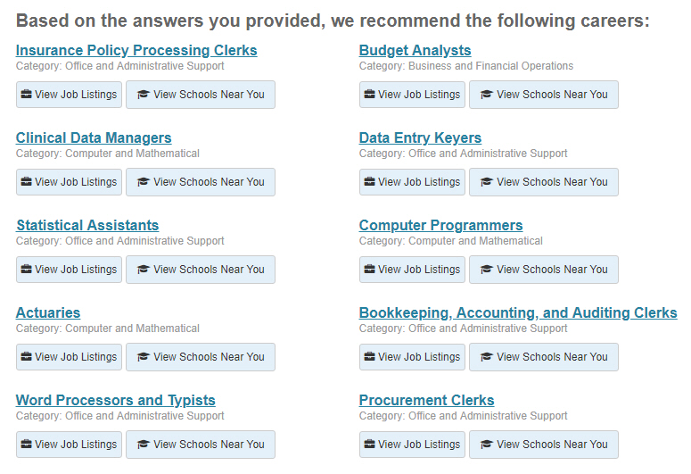 

## Patrick Jenner

Results show that I am a visual learner, a INFP, and would suit careers revolving around technical thinking like Statisticians, Physicists, and Computer Programmers.

