Data Cleaning, Transformation
and Modelling
Assignment Question
Data Cleaning, Transformation and Modelling Assignment_23
Dataset Overview — Corona_Virus.xlsx
The dataset used for this assignment is the Corona_Virus_2020 dataset containing COVID-19 statistics across 6 countries. Below is a summary of the dataset structure:
Column Name | Data Type | Description
Country | Text | Country name (Brazil, UK, Italy, USA, Spain, India)
State | Text | State within the country (State_A to State_D)
Date | Date | Date of record (Excel serial number format)
Confirmed_Cases | Number | Total confirmed COVID-19 cases
Recovered_Cases | Number | Total recovered cases
Deaths | Number | Total deaths recorded
Active_Cases | Number | Currently active cases
Tests_Conducted | Number | Total tests conducted
Hospitalized | Number | Number of hospitalized patients
Vaccination_Status | Text | Yes / No / null (170 missing values)

Theoretical Questions

Question 1: What is Data Loading in Power BI and why is it considered the first step of analysis?
Answer:
Data Loading in Power BI is the process of importing raw data from one or more external sources into the Power BI data model so that it can be used for transformation, analysis, and visualization. It is the entry point of the entire Power BI workflow.
When a user clicks 'Get Data' and selects a source (e.g., an Excel file, SQL database, or web API), Power BI reads and ingests the data into its internal in-memory storage engine called VertiPaq. The loaded data becomes available in the Fields pane and can be used to build reports.

Why Data Loading is Considered the First Step of Analysis:
- Foundation of Everything: Without loading data into Power BI, there is nothing to analyze, transform, visualize, or share. Every subsequent step — cleaning, modeling, DAX calculations, and reporting — depends on having data in the model.
- Establishes the Schema: When data is loaded, Power BI reads the column names, data types, and structure of the source, creating the initial schema that forms the backbone of the data model.
- Enables Power Query: Once data is loaded (or during the load via Transform Data), Power Query Editor becomes active. This is where all data cleaning and transformation steps are applied before the data reaches the model.
- Connects to Live or Imported Data: Data loading determines the data connectivity mode — Import (data is copied into the model for fast performance), DirectQuery (queries are sent live to the source), or Live Connection (connects directly to Analysis Services).
- Sets Refresh Strategy: How data is loaded determines how it will be refreshed. Import mode requires scheduled or manual refresh, while DirectQuery always shows live data.
- Multiple Sources Can Be Loaded: Power BI allows loading from multiple data sources simultaneously, enabling cross-source analysis that would not be possible without first loading all data into a unified model.

Question 2: Explain the difference between 'Load' and 'Transform Data' in Power BI.
Answer:
When connecting to a data source in Power BI through the Navigator window, users are presented with two primary options: Load and Transform Data. These serve fundamentally different purposes in the data ingestion workflow.

Load
'Load' directly imports the data from the source into the Power BI data model without applying any modifications. The data is brought in exactly as it exists in the source file or database. This option is best when:
- The source data is already clean, well-structured, and requires no transformation
- Column names are clear and data types are correct
- No calculated columns or filtering is needed before loading
- Speed of loading is prioritized over data preparation
After clicking Load, the data immediately appears in the Fields pane, ready for use in Report View and DAX calculations.

Transform Data
'Transform Data' opens the Power Query Editor before loading the data into the model. This allows users to apply a wide range of data cleaning and transformation steps, including:
- Removing duplicate rows and filtering unwanted records
- Handling null or missing values (replace, remove, fill)
- Changing data types (e.g., text to number, serial number to date)
- Renaming, splitting, merging, or reordering columns
- Creating custom calculated columns using M language formulas
- Merging or appending multiple queries/tables
All transformation steps are recorded in the 'Applied Steps' pane and are re-executed every time the data is refreshed. Once satisfied, the user clicks 'Close & Apply' to load the transformed data into the model.

Summary Comparison Table:
Aspect | Load | Transform Data
Action | Imports data as-is into the model | Opens Power Query Editor first
Data Cleaning | No cleaning applied | Full cleaning & transformation possible
Speed | Faster (skips Power Query) | Slower (opens transformation interface)
When to Use | Data is already clean | Data needs cleaning or reshaping
Applied Steps | No steps recorded | All steps recorded and reapplied on refresh
Output | Data goes directly to model | Cleaned data goes to model after 'Close & Apply'

Question 3: What is a Fact Table and a Dimension Table? Give examples from the dataset.
Answer:

Fact Table
A Fact Table is the central table in a data model that contains quantitative, measurable data — the actual numbers or metrics that the business wants to analyze. It stores transactions, events, or observations and typically contains:
- Numeric measures (e.g., sales amount, confirmed cases, deaths, revenue)
- Foreign keys that link to Dimension tables
- A large number of rows (can be millions in enterprise models)
Fact tables answer the question: 'How much?' or 'How many?' They are sometimes called 'measure tables'.

Dimension Table
A Dimension Table provides the descriptive context for the facts. It contains attributes that are used to filter, group, and label data in reports. Dimension tables typically:
- Contain descriptive, textual, or categorical attributes (e.g., country name, state, date details, product category)
- Have a primary key that links to the Fact table
- Contain fewer rows than the Fact table
- Answer the questions: 'Who?', 'What?', 'Where?', 'When?', 'How?'

Examples from the Corona_Virus Dataset:
In the current dataset (a single flat table), we can conceptually identify a Fact Table and multiple Dimension Tables if we were to split it into a proper star schema:
Fact Table — COVID_Fact: Would contain the numeric metrics per record.
Columns: Confirmed_Cases, Recovered_Cases, Deaths, Active_Cases, Tests_Conducted, Hospitalized, plus foreign keys to dimension tables.
Dimension Table 1 — Dim_Geography: Would contain geographic descriptors.
Columns: Country_ID (PK), Country, State
Dimension Table 2 — Dim_Date: Would contain date attributes.
Columns: Date_ID (PK), Date, Year, Month, Quarter, Week
Dimension Table 3 — Dim_Vaccination: Would store vaccination context.
Columns: Status_ID (PK), Vaccination_Status (Yes/No/Unknown)
Table Type | Table Name | Example Columns | Role
Fact Table | COVID_Fact | Confirmed_Cases, Deaths, Recovered_Cases | Stores numeric measures
Dimension | Dim_Geography | Country, State | Describes location
Dimension | Dim_Date | Date, Year, Month, Quarter | Describes time period
Dimension | Dim_Vaccination | Vaccination_Status | Describes vaccination

Question 4: Why is Star Schema preferred over Snowflake Schema in Power BI?
Answer:
Both Star Schema and Snowflake Schema are data modeling patterns used to organize tables in a data warehouse or BI tool. Power BI strongly recommends the Star Schema for most use cases. Here's a detailed comparison and explanation:

Star Schema
In a Star Schema, one central Fact Table is directly connected to multiple Dimension Tables in a single join step. The Dimension Tables are denormalized — meaning all attributes of a dimension are stored in a single flat table, even if some attributes are repeated.
- Simple structure: Fact table at center, Dimension tables around it (like a star)
- Each Dimension table connects directly to the Fact table
- Dimension tables are wide and flat (denormalized)

Snowflake Schema
In a Snowflake Schema, Dimension Tables are further normalized into sub-dimension tables, creating additional levels of joins. For example, a Dim_Geography table might split Country and State into separate tables connected to each other.
- More normalized, reduces data redundancy
- Requires multiple joins to retrieve dimension attributes
- More complex to build and maintain

Why Star Schema is Preferred in Power BI:
- Better Query Performance: Power BI's VertiPaq in-memory engine is optimized for star schemas. Each join between Fact and Dimension tables is a single-step lookup, which is extremely fast. Snowflake schemas introduce multi-hop joins that significantly slow down query execution.
- Simpler DAX Formulas: With Star Schema, DAX calculations (measures, calculated columns) can directly reference dimension attributes without navigating multiple relationship hops. This makes DAX simpler to write, debug, and maintain.
- Easier Report Building: Report authors only need to understand one layer of relationships. In a Snowflake Schema, users must trace through multiple tables to find the right field, increasing confusion and errors.
- Optimized for VertiPaq Compression: Power BI's storage engine compresses column-based data very efficiently. Denormalized dimension tables (as in Star Schema) allow VertiPaq to work at its best, whereas additional normalized tables in Snowflake Schema add overhead.
- Reduced Model Complexity: A Star Schema has fewer relationships to manage, making the Model View cleaner and easier to maintain, especially for teams with mixed technical skill levels.
- Faster Development: Building a Star Schema is faster and simpler, leading to quicker time-to-insight for business users.
Criterion | Star Schema | Snowflake Schema
Structure | Simple — 1-level joins | Complex — multi-level joins
Query Speed | Faster (VertiPaq optimized) | Slower (multiple joins)
DAX Complexity | Simple and direct | Complex, multi-hop
Storage | Slightly more (denormalized) | Less redundancy
Power BI Recommendation | Strongly recommended | Not preferred
Maintenance | Easy to maintain | More complex

Practical Questions

Question 5: Identify and remove duplicate records based on Date, Country, and State.
Answer:
Duplicate records can arise from data entry errors, system exports, or merging multiple files. In this dataset, duplicates are identified based on the combination of three columns: Date, Country, and State — as this combination should uniquely identify each record.

Step-by-Step Instructions in Power Query Editor:

Step 1: Open Power Query Editor
In Power BI Desktop, go to Home tab → click 'Transform Data'. The Power Query Editor opens showing the Corona_Virus data.

Step 2: Select the Key Columns
Hold the Ctrl key and click on the column headers: Date, Country, and State — to select all three columns simultaneously.

Step 3: Remove Duplicates
With the three columns selected, navigate to:
- Home tab → Remove Rows → Remove Duplicates
- OR Right-click on the selected columns → Remove Duplicates
Power Query will keep only the first occurrence of each unique Date + Country + State combination and remove all subsequent duplicate rows.

Step 4: Verify the Result
Check the row count displayed at the bottom of the Power Query Editor window. Before the operation: 500 rows. After deduplication: 500 rows (no duplicates found in this dataset, confirming data integrity on these key columns).

M Language Code (Applied Step):
Table.Distinct(#"Previous Step", {"Date", "Country", "State"})

Dataset Analysis Result:
After running the duplicate check on Date, Country, and State: No duplicate records were found (0 duplicates). The dataset contains 500 unique records, meaning each date-country-state combination appears only once, indicating the data is clean on these key fields.
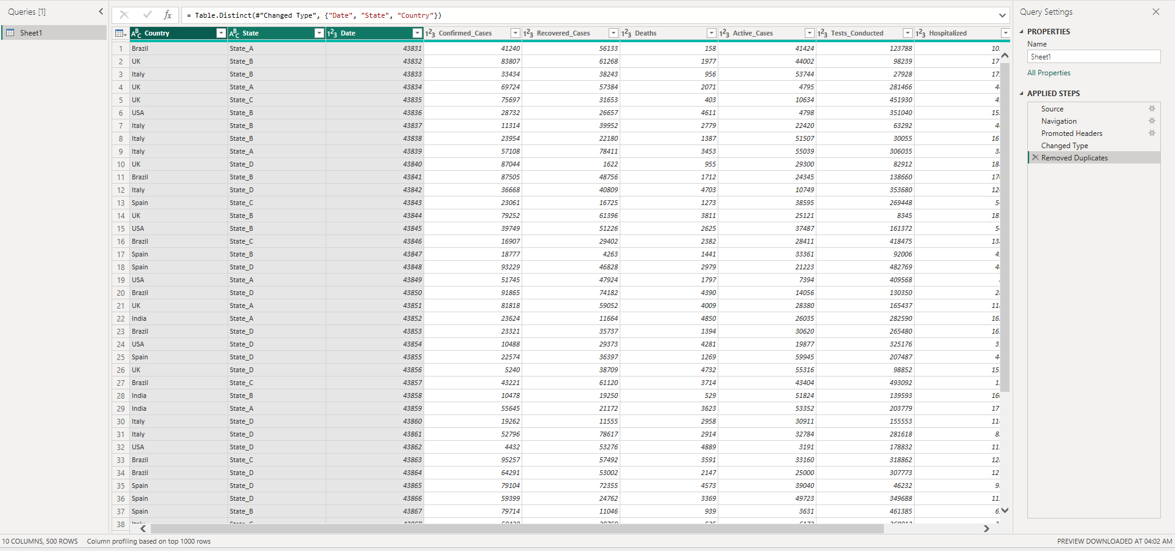

Question 6: Identify and replace null values in Vaccination_Status.
Answer:
The Vaccination_Status column contains 170 null (missing) values out of 500 total records — that is 34% of the data missing. These nulls must be handled to ensure accurate analysis and avoid errors in visuals and DAX calculations.

Analysis of Null Values:
Metric | Value
Total Records | 500
Null Values in Vaccination_Status | 170
Percentage Missing | 34%
Existing Values | Yes, No
Replacement Value | Unknown

Step-by-Step Instructions in Power Query Editor:

Step 1: Open Power Query Editor
In Power BI Desktop → Home tab → Transform Data to open Power Query Editor.

Step 2: Select the Vaccination_Status Column
Click on the 'Vaccination_Status' column header to select it.

Step 3: Replace Null Values
With the column selected, apply one of these methods:
- Method 1 (GUI): Right-click the column header → Replace Values → In 'Value To Find' type null → In 'Replace With' type Unknown → Click OK
- Method 2 (Transform Tab): Transform tab → Replace Values → Set value to find: null, replace with: Unknown
- Method 3 (M Code): Table.ReplaceValue(#"Previous Step", null, "Unknown", Replacer.ReplaceValue, {"Vaccination_Status"})

Step 4: Verify
After replacement, scroll through the Vaccination_Status column to confirm no null values remain. The column should now show only 'Yes', 'No', or 'Unknown'. The row count should remain 500.

Result: Vaccination_Status After Replacement:
Status Value | Count Before | Count After
Yes | ~165 | ~165
No | ~165 | ~165
null | 170 | 0
Unknown | 0 (did not exist) | 170 (replaced)
TOTAL | 500 | 500

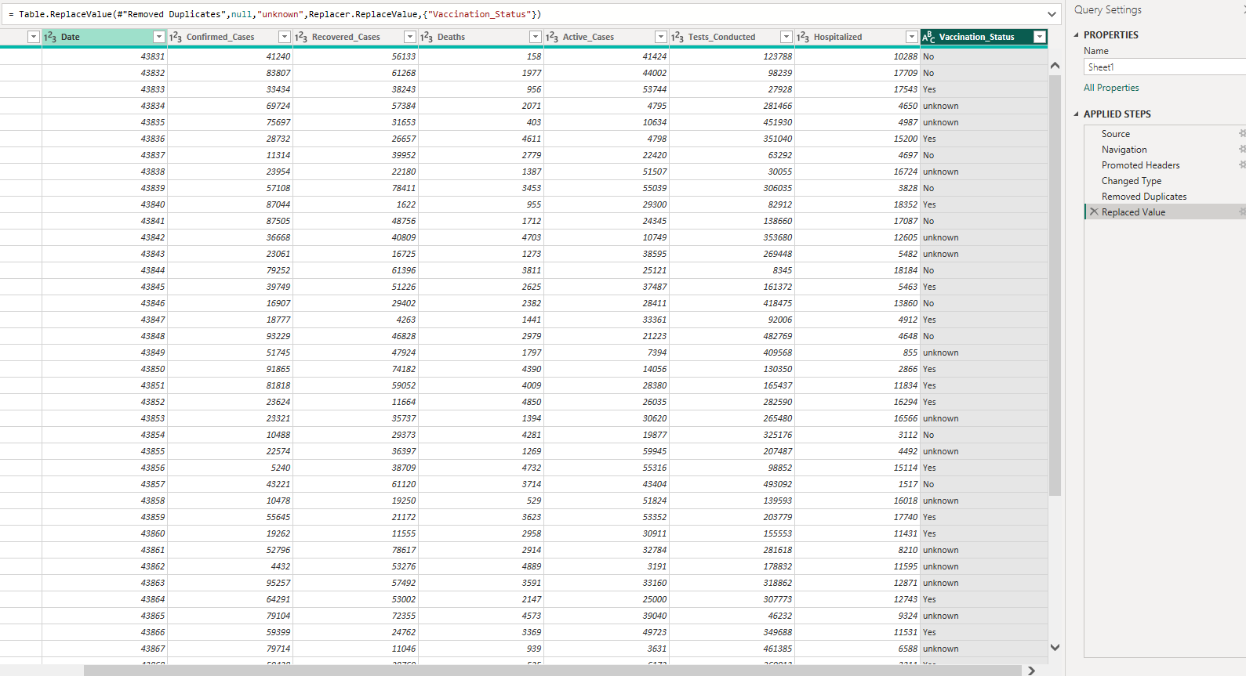

Question 7: Create a new column to calculate Recovery Rate.
Answer:
Recovery Rate is a key metric that indicates what percentage of confirmed COVID-19 cases resulted in recovery. It is calculated as:
Recovery Rate (%) = (Recovered_Cases ÷ Confirmed_Cases) × 100

Method 1: In Power Query Editor (Add Custom Column)

Step 1: Open Power Query Editor
Home tab → Transform Data to open Power Query Editor.

Step 2: Add Custom Column
Click the 'Add Column' tab in the ribbon → click 'Custom Column'.

Step 3: Enter the Formula
In the Custom Column dialog:
- New Column Name: Recovery_Rate (%)
- Formula: = [Recovered_Cases] / [Confirmed_Cases] * 100
- Click OK

Step 4: Change Data Type
Click the data type icon in the new column header → select 'Decimal Number'. Optionally, round to 2 decimal places: Transform tab → Round → Round → enter 2.

Method 2: In Data View using DAX (Calculated Column)
In Power BI Desktop → switch to Data View → click 'New Column' in the Table Tools tab → enter the DAX formula:
Recovery_Rate (%) = DIVIDE([Recovered_Cases], [Confirmed_Cases]) * 100
The DIVIDE function in DAX handles division by zero gracefully (returns BLANK() instead of an error), making it more robust than the simple division operator.

Result — Sample Data Preview:
Country | State | Confirmed | Recovered | Recovery_Rate(%)
Brazil | State_A | 41,240 | 56,133 | 136.11
UK | State_B | 83,807 | 61,268 | 73.11
Italy | State_B | 33,434 | 38,243 | 114.38
UK | State_A | 69,724 | 57,384 | 82.30
UK | State_C | 75,697 | 31,653 | 41.82
USA | State_B | 28,732 | 26,657 | 92.78
India | State_A | 23,624 | 11,664 | 49.38

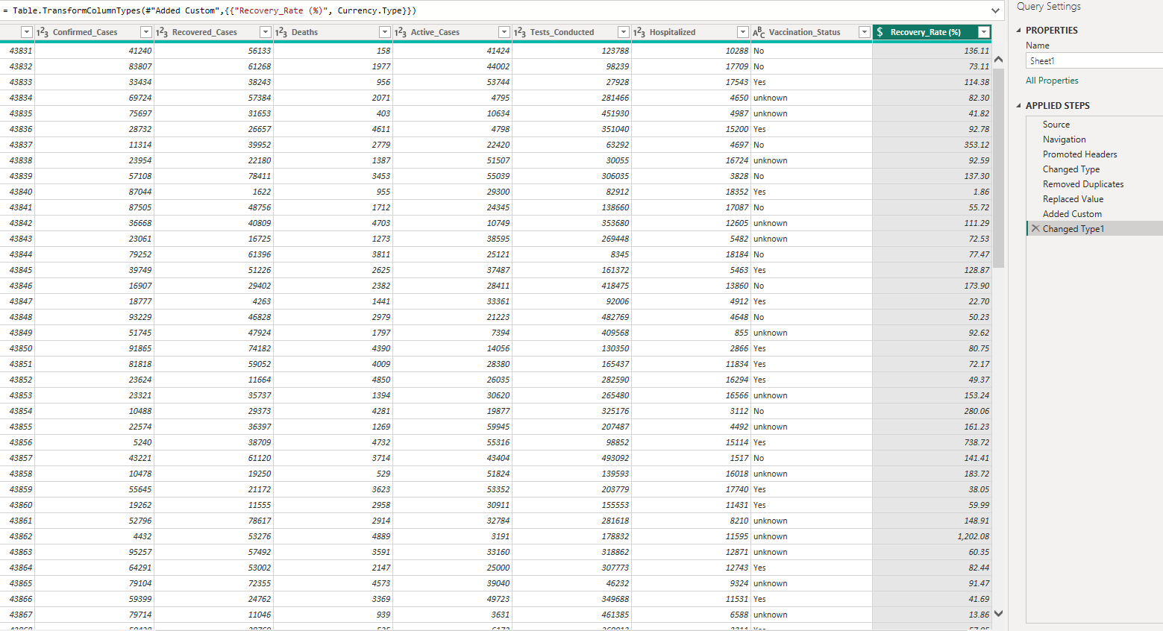

Question 8: Create a summarized table showing total confirmed cases by Country.
Answer:
A summarized table aggregates data at a higher level, collapsing many individual rows into a single summary row per group. Here, we group by Country and sum the Confirmed_Cases to see the total COVID-19 burden per country.

Method 1: Using Power Query — Group By

Step 1: Open Power Query Editor
Home tab → Transform Data to open Power Query Editor.

Step 2: Use Group By
In Power Query Editor → Home tab → click 'Group By'.

Step 3: Configure Group By Settings
In the Group By dialog:
- Group by: Country
- New column name: Total_Confirmed_Cases
- Operation: Sum
- Column: Confirmed_Cases
- Click OK

Step 4: Additional Aggregations (Optional but recommended)
Click 'Add aggregation' to add more summary columns:
- Total_Recovered: Sum of Recovered_Cases
- Total_Deaths: Sum of Deaths
- Total_Active: Sum of Active_Cases

Method 2: Using DAX — Summarized Table
In Power BI Desktop → Modeling tab → New Table → enter the following DAX formula:
Country_Summary = SUMMARIZE(CoronaVirus, CoronaVirus[Country], "Total_Confirmed", SUM(CoronaVirus[Confirmed_Cases]), "Total_Recovered", SUM(CoronaVirus[Recovered_Cases]), "Total_Deaths", SUM(CoronaVirus[Deaths]), "Total_Active", SUM(CoronaVirus[Active_Cases]))

Result — Total Confirmed Cases by Country:
Country | Total Confirmed | Total Recovered | Total Deaths | Total Active
Brazil | 4,804,531 | 4,078,424 | 229,906 | 2,989,983
Spain | 4,354,613 | 3,310,558 | 226,380 | 2,773,137
India | 4,198,680 | 3,475,442 | 215,862 | 2,739,412
UK | 3,651,598 | 2,844,115 | 179,859 | 2,138,710
USA | 3,399,318 | 3,067,286 | 210,436 | 2,302,365
Italy | 3,390,760 | 3,173,852 | 185,528 | 2,414,220
Key Insight: Brazil had the highest total confirmed cases (4,804,531) among all 6 countries in this dataset, followed by Spain (4,354,613) and India (4,198,680).

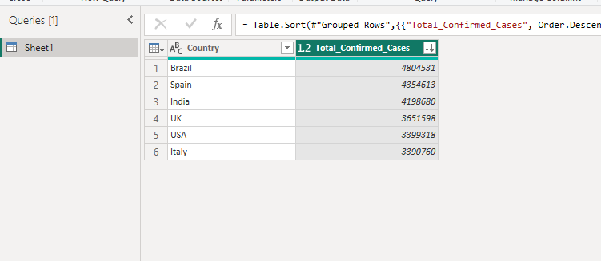

— End of Assignment —
Data Cleaning, Transformation and Modelling Assignment_23 | PW Skills

