TABLEAU BASICS
Assignment — Tableau_Basics_Assignment_28
Dataset Used: Sample – Superstore (Inbuilt dataset in Tableau)

Question1: Explain what Tableau is and why it is preferred over traditional spreadsheet tools for data analysis. Also mention any two industries where Tableau is commonly used and explain one use case.
Answer:
What is Tableau?
Tableau is a powerful, industry-leading Business Intelligence (BI) and data visualization tool developed by Salesforce. It enables users to connect to various data sources, transform raw data into meaningful visual insights, and share interactive dashboards — all without requiring any programming or coding knowledge.
Tableau supports a wide range of data connections including Excel, SQL databases, Google Sheets, cloud services (AWS, Azure) etc.
Why Tableau is Preferred Over Traditional Spreadsheet Tools (e.g., MS Excel)?
- Interactive Visualizations: Tableau creates dynamic, interactive charts and dashboards. Excel is primarily static and limited in interactivity.
- Handles Large Data: Tableau efficiently processes millions of rows of data. Excel struggles and slows down beyond ~1 million rows.
- Drag-and-Drop Interface: Building visualizations in Tableau is intuitive — no complex formulas or macros needed.
- Real-Time Data Connectivity: Tableau connects to live databases and refreshes data in real-time. Excel requires manual updates.
- Advanced Analytics: Tableau offers built-in forecasting, trend lines, clustering, and statistical analysis far beyond Excel's pivot tables.
- Collaboration & Sharing: Dashboards can be published to Tableau Server/Cloud and shared across organizations securely.
Two Industries Where Tableau is Commonly Used:
- Retail & E-Commerce: To analyze sales trends, inventory, customer behavior, and regional performance.
- Healthcare: To monitor patient outcomes, hospital resource utilization, disease trends, and operational efficiency.
Use Case — Retail Industry:
A retail chain uses Tableau to visualize its monthly sales data by product category and region. The sales manager views an interactive map showing which states are underperforming in the 'Technology' category. Using filters, they drill down to identify that the 'Central' region has consistently low profit margins in Q3. Based on this insight, the management restructures its pricing and promotional strategy for that region — directly improving profitability.

Q2. Fields Available in the Sample – Superstore Dataset
Question 2: After connecting to the Sample – Superstore dataset: a) List the main types of fields available. b) Identify any four Dimensions and any four Measures.
Answer:
a) Main Types of Fields in Sample – Superstore:
- Time-Based Fields: Fields related to dates and time periods. Example: Order Date, Ship Date.
- Geographical Fields: Fields that contain location information that Tableau can map. Example: Country, State, City, Postal Code, Region.
- Categorical / Textual Fields (Dimensions): Fields that describe qualitative attributes. Example: Category, Sub-Category, Segment, Ship Mode, Customer Name.
- Numerical Fields (Measures): Fields with quantitative/numerical values that can be aggregated. Example: Sales, Profit, Quantity, Discount.
- ID Fields: Unique identifiers for records. Example: Order ID, Customer ID, Product ID.
b) Four Dimensions and Four Measures:
Dimensions (Blue fields in the Data Pane — qualitative/categorical data):
- Category (e.g., Furniture, Office Supplies, Technology)
- Sub-Category (e.g., Chairs, Binders, Phones)
- Region (e.g., East, West, Central, South)
- Customer Name (individual customer names)
Measures (Green fields in the Data Pane — quantitative/numerical data):
- Sales (total revenue from orders)
- Profit (net profit after costs)
- Quantity (number of units sold)
- Discount (discount percentage applied to orders)

Q3. Bar Chart — Total Sales by Category
Question 3 : Create a Bar Chart showing Total Sales by Category. Explain which field goes to Rows, which goes to Columns, and which aggregation is applied to Sales.
Answer:
Steps to Create the Bar Chart:
Step 1: Open Tableau and connect to Sample – Superstore dataset.
Step 2: Navigate to a new Worksheet.
Step 3: From the Data Pane, drag 'Category' (Dimension) to the Rows shelf.
Step 4: From the Data Pane, drag 'Sales' (Measure) to the Columns shelf.
Step 5: Tableau automatically creates a horizontal bar chart. To make it vertical, click the 'Swap Rows and Columns' button (or press Ctrl+W).
Field Placement Explanation:
- Rows Shelf: Category — This places the three product categories (Furniture, Office Supplies, Technology) along the Y-axis, creating one bar for each category.
- Columns Shelf: SUM(Sales) — The numerical measure Sales goes on the X-axis and determines the length of each bar.
Aggregation Applied to Sales:
Tableau automatically applies SUM aggregation to the Sales field by default (shown as SUM(Sales) in the view). This means for each category, Tableau sums up all individual sales values to show the total revenue per category.
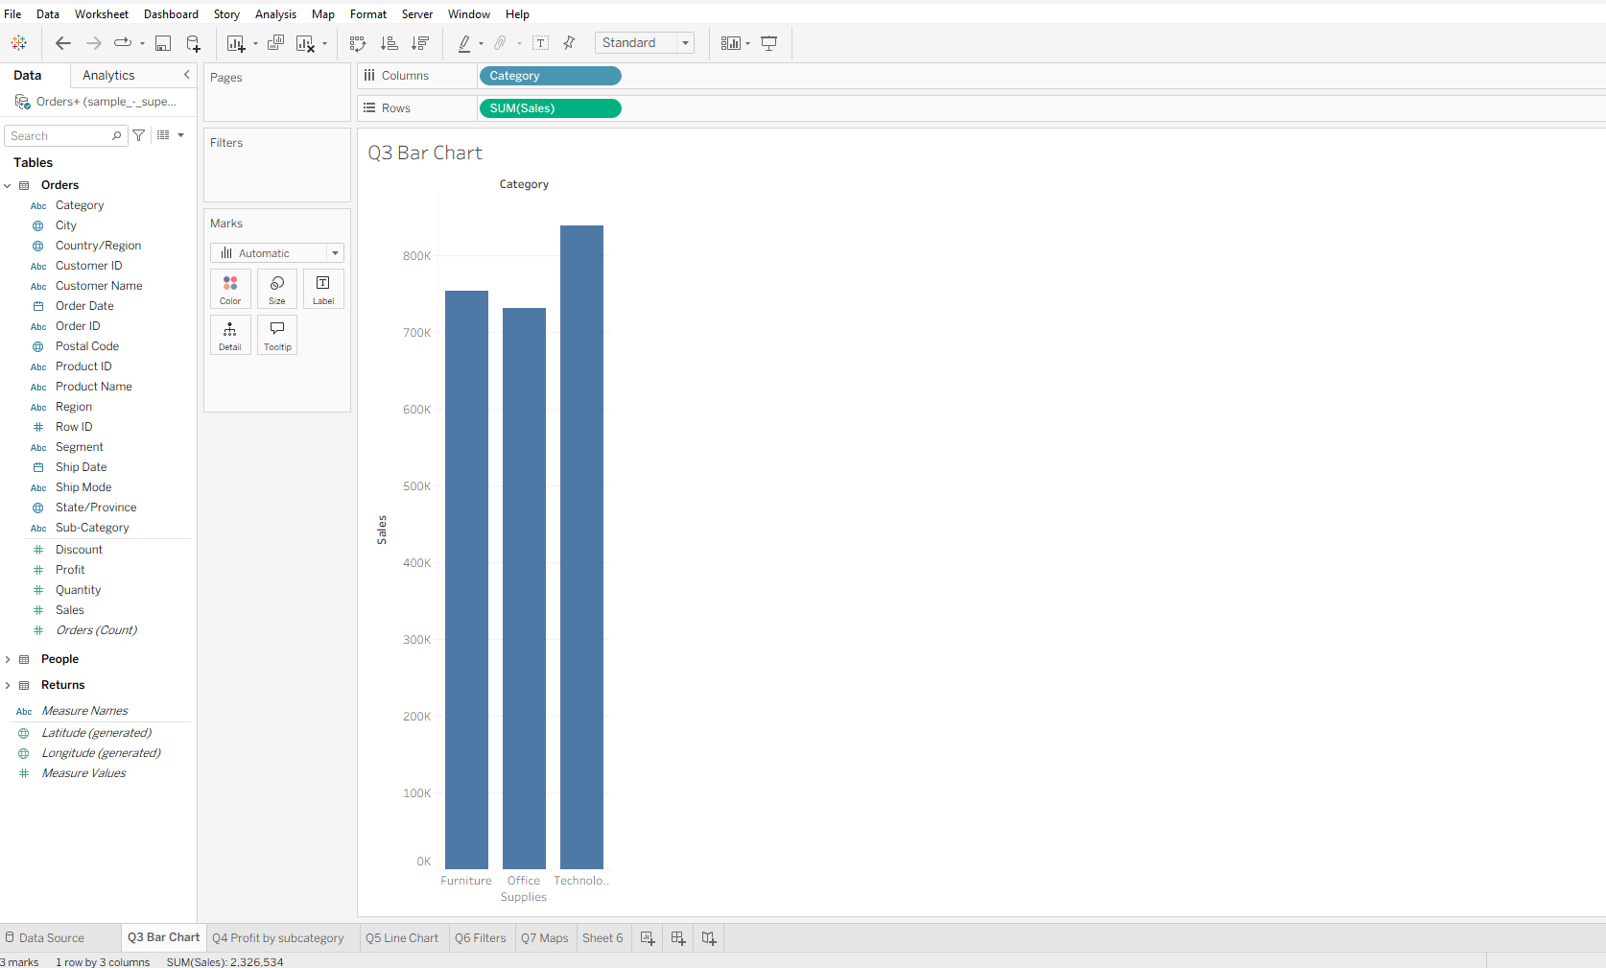

Q4. Comparing Sales and Profit — Profit by Sub-Category
Question: What insight can be gained by comparing Sales and Profit together? Then explain how you would create a chart to analyze Profit by Sub-Category.
Answer:
Insight from Comparing Sales and Profit Together:
Comparing Sales and Profit together reveals the profitability efficiency of each product or category. High sales do not always mean high profit — a product can have high revenue but low or negative profit due to high costs or heavy discounting.
Key insights that can be discovered:
- Profit Margin Analysis: Identify which categories/sub-categories generate sales but drain profit (e.g., Tables sub-category often shows negative profit in Superstore data despite having reasonable sales).
- Discount Impact: Excessive discounts in certain sub-categories can push profit into negative territory even with high sales volumes.
- Loss Leaders: Some products sell well but are sold at a loss — a critical finding for pricing strategy.
- Strategic Focus: Management can redirect resources toward high-profit sub-categories and reconsider or discontinue loss-making ones.
How to Create a Chart to Analyze Profit by Sub-Category:
Step 1: Open a new worksheet in Tableau.
Step 2: Drag 'Sub-Category' (Dimension) to the Rows shelf — this lists all sub-categories along the Y-axis.
Step 3: Drag 'Profit' (Measure) to the Columns shelf — Tableau applies SUM(Profit) automatically.
Step 4: Tableau generates a horizontal bar chart. To make negative profits visually distinct:
- Click on the Color mark in the Marks card → Select 'Profit' as the color field.
- Edit colors to show a diverging palette (Red for negative, Blue for positive profit).
Step 5: Sort bars by Profit (descending) to quickly identify top and bottom performers.
Step 6: Add labels (from the Marks card) to show exact profit values on each bar.
This visualization immediately highlights sub-categories like Tables and Bookcases with negative profits, enabling targeted business decisions.

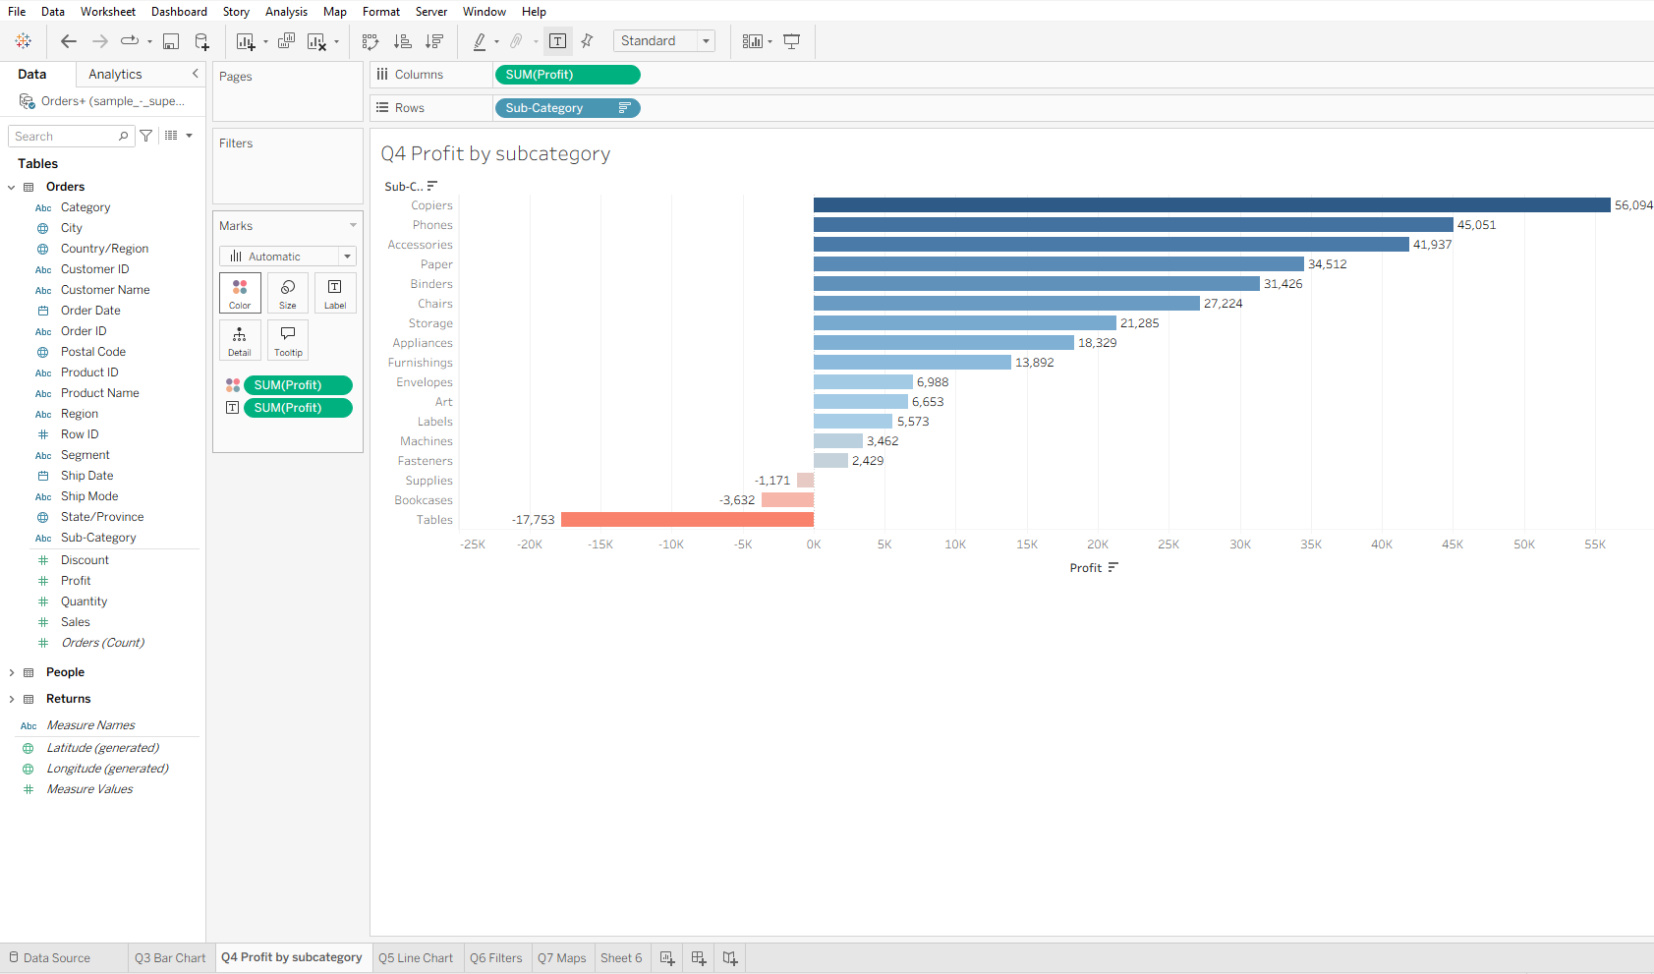

Q5. Line Chart — Sales Trend Over Order Date
Question: Create a Line Chart to show Sales Trend over Order Date. Which date level would you choose? Why are line charts suitable for time-based analysis?
Answer:
Steps to Create the Line Chart:
Step 1: Open a new worksheet in Tableau.
Step 2: Drag 'Order Date' (Time dimension) to the Columns shelf.
Step 3: By default, Tableau shows YEAR(Order Date). Right-click on the pill and change it to Month to see more granular trends.
Step 4: Drag 'Sales' (Measure) to the Rows shelf — Tableau shows SUM(Sales).
Step 5: Tableau automatically suggests a Line Chart. If not, select 'Line' from the Show Me panel (top-right).
Step 6: Optionally add a Trend Line via the Analytics pane to visualize the overall direction.
Which Date Level to Choose and Why:
- Month level is the best choice for Sales trend analysis in Superstore data. It provides enough granularity to see seasonal patterns without being too detailed (daily) or too broad (yearly).
- Year level is useful for long-term growth comparison across multiple years.
- Quarter level helps identify seasonal business cycles

Why Are Line Charts Suitable for Time-Based Analysis?
- Shows Continuity: Lines connect data points sequentially, showing how values evolve continuously over time — unlike bar charts that show isolated values.
- Trend Identification: It is easy to spot upward/downward trends, plateaus, and seasonal patterns.
- Multiple Series Comparison: Multiple lines can be overlaid (e.g., Sales vs. Profit over time) for direct comparison.
- Time is Ordered: Time has a natural order (past → present → future), and a line chart respects and communicates this order visually.
- Anomaly Detection: Sharp dips or spikes in the line instantly draw attention to unusual periods (e.g., COVID-19 impact on 2020 sales).

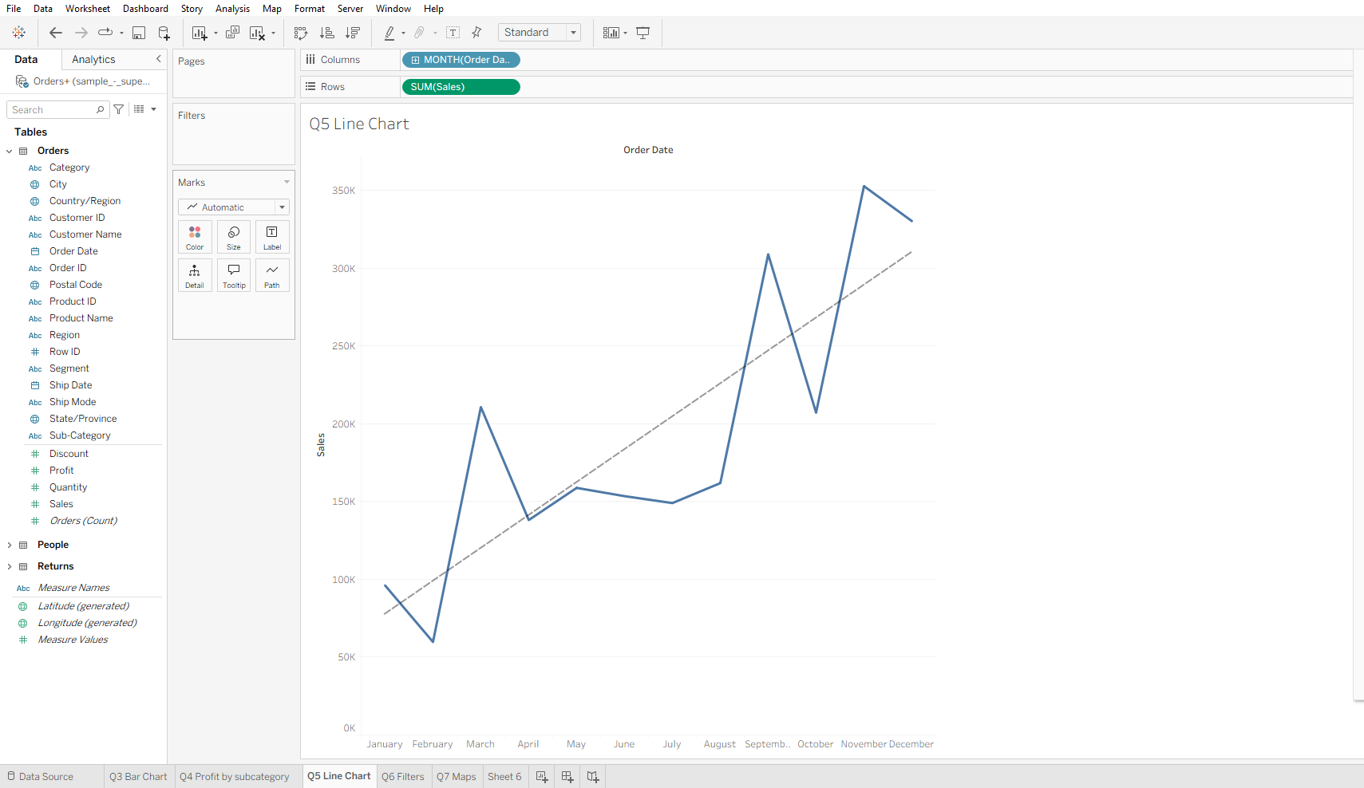

Q6. Applying Basic Filters — Region = West & Category = Technology
Question: Apply a Basic Filter to display data only for Region = 'West' and Category = 'Technology'. Explain the steps and mention which shelf is used.
Answer:
Which Shelf is Used for Filters:
The Filters Shelf is used to apply filters in Tableau. It is located at the top of the view, below the Pages shelf. Any field placed on this shelf acts as a filter to restrict the data shown in the visualization.
Step-by-Step Process to Apply Both Filters:
Filter 1 — Region = 'West':
Step 1: In the Data Pane, find the 'Region' field (Dimension).
Step 2: Drag 'Region' and drop it onto the Filters shelf.
Step 3: A dialog box appears — select 'General' tab → tick 'West' from the list of values (East, West, Central, South).
Step 4: Click OK. The view now shows only West region data.
Filter 2 — Category = 'Technology':
Step 1: In the Data Pane, find the 'Category' field (Dimension).
Step 2: Drag 'Category' and drop it onto the Filters shelf (below the Region filter).
Step 3: A dialog box appears — select 'General' tab → tick only 'Technology'.
Step 4: Click OK. The view now shows only Technology products in the West region.
Verification:
The Filters shelf will now show two pills: Region and Category. The visualization reflects data exclusively for West region Technology sales — useful for region-specific product performance analysis.
Optional — Show Filter as a Dropdown:
Right-click on the Region or Category pill in the Filters shelf → 'Show Filter' → a dropdown or checkbox filter control appears on the view for interactive use.

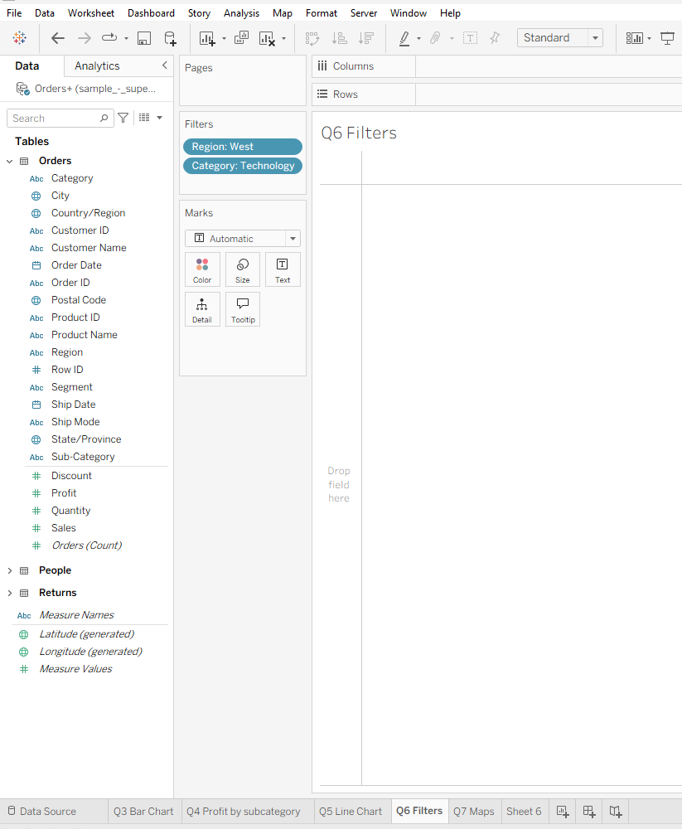

Q7. Geographical Analysis — Sales Map by State
Question: Explain the business importance of geographical analysis. Then describe how you would create a Map showing Sales by State using Sample – Superstore.
Answer:
Business Importance of Geographical Analysis:
Geographical analysis allows businesses to understand spatial distribution of performance metrics — answering questions like: 'Where are we selling the most?', 'Which states are underperforming?', and 'Where should we expand?'
- Regional Strategy: Identifies which states or regions generate the highest revenue vs. those that need attention.
- Logistics & Supply Chain: Helps optimize distribution centers, shipping routes, and delivery zones.
- Market Expansion: Pinpoints untapped geographic markets with high potential.
- Sales Territory Management: Aligns sales teams to high-opportunity regions.
- Demographic Insights: Combines with population or income data to understand market penetration.
- Competitive Analysis: Compares performance across regions to identify where competitors may be stronger.
How to Create a Map Showing Sales by State in Tableau:
Step 1: Open a new worksheet in Tableau connected to Sample – Superstore.
Step 2: In the Data Pane, find the 'State' field. Tableau automatically recognizes it as a geographic field (indicated by a globe icon).
Step 3: Double-click on 'State' — Tableau automatically creates a map view with states plotted as points.
Step 4: Drag 'Sales' (Measure) to the Color mark in the Marks card. Tableau applies a color gradient showing sales intensity per state.
Step 5: Drag 'Sales' to the Size mark as well to create proportional circles (or use a filled map by selecting 'Filled Map' from the Marks type dropdown).
Step 6: Edit Colors — use a sequential palette (light to dark blue) where darker shades represent higher sales.
Step 7: Add a Tooltip — drag State and Sales to the Tooltip mark so hovering over any state shows its details.
Step 8: Add State labels if needed for the map.
Insight from the Map:
California, New York, and Texas typically show the highest sales in the Superstore dataset, while states in the Central region show lower sales — guiding regional investment and marketing decisions.
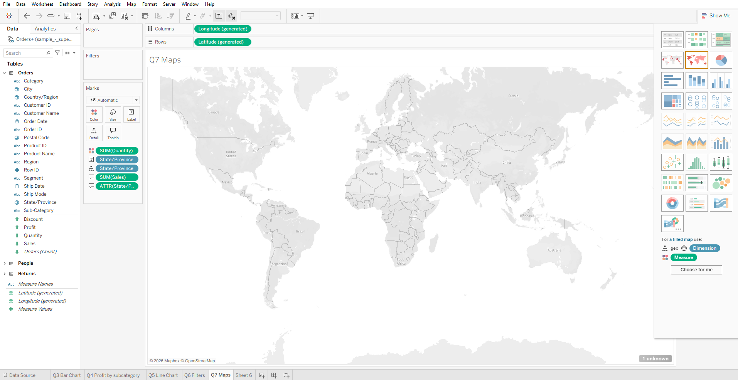

Q8. Worksheet vs Dashboard in Tableau
Question: What is the difference between a Worksheet and a Dashboard in Tableau? Why is a dashboard more useful for decision-makers?
Answer:
Worksheet:
A Worksheet in Tableau is a single-view canvas where one visualization is built at a time. It is the fundamental building block of Tableau where you drag fields, apply filters, and create individual charts (bar chart, line chart, map, etc.). Each worksheet contains exactly one view.
- Used for: Building individual charts, analyzing single metrics, creating components for dashboards.
- Limitation: Can only show one visualization at a time — limited for comprehensive business analysis.
Dashboard:
A Dashboard in Tableau is a combined view that brings together multiple worksheets, text boxes, images, and filters onto a single canvas. It provides a holistic, at-a-glance view of multiple related metrics simultaneously.
- Used for: Executive reporting, operational monitoring, KPI tracking, presenting insights to stakeholders.
- Advantage: Multiple views, interactivity, filter actions — clicking one chart filters others automatically.
Key Differences:
- Scope: Worksheet = single chart/view; Dashboard = multiple charts combined.
- Purpose: Worksheet = analysis/building; Dashboard = presentation/decision support.
- Interactivity: Dashboards support filter actions, highlight actions, and URL actions across views.
- Audience: Worksheets are for analysts; Dashboards are for managers and decision-makers.
Why Dashboards are More Useful for Decision-Makers:
- Comprehensive View: Decision-makers can see Sales, Profit, Regional Map, and Trend all on one screen — no toggling between worksheets.
- Time Efficiency: Executives have limited time — a dashboard delivers key KPIs instantly without data exploration.
- Interactive Filtering: Clicking 'West Region' on a map automatically filters all other charts for West-only data — enabling fast drill-down analysis.
- Story Telling: Dashboards tell a data story — 'Sales are up, but profit is down in the West due to high discounts in Technology.'
- Shareable & Publishable: Dashboards can be published to Tableau Server/Cloud and embedded in business portals for organization-wide access.

Q9. Tableau Prep — Data Cleaning & Preparation
Question: What is Tableau Prep, and why is it important in real-world data projects? Explain how to remove null values, remove duplicate records, and change incorrect data types.
Answer:
What is Tableau Prep?
Tableau Prep (full name: Tableau Prep Builder) is a dedicated data preparation and ETL (Extract, Transform, Load) tool within the Tableau ecosystem. It provides a visual, flow-based interface to clean, shape, and combine data before analysis in Tableau Desktop.
Unlike traditional data cleaning (SQL scripts, Python), Tableau Prep offers a visual, step-by-step flow where every transformation is shown graphically — making it accessible to non-technical users.
Why Tableau Prep is Important in Real-World Data Projects:
- Real-world data is messy: Databases contain nulls, duplicates, wrong formats, inconsistent naming, and merged fields that need splitting.
- Data quality directly impacts analysis quality: Dirty data leads to incorrect insights and poor business decisions.
- Automates repetitive cleaning: Once a Prep flow is built, it can be scheduled to run automatically on fresh data.
- No coding required: Business analysts can perform complex transformations without SQL or Python knowledge.
- Audit trail: Every step is visual and documented — making it easy to review and validate transformations.
How to Remove Null Values in Tableau Prep:
Step 1: Open Tableau Prep Builder and connect to your data source.
Step 2: Add a Clean Step to the flow by clicking the '+' icon after the input.
Step 3: In the Profile pane, locate the field with null values. Null values appear as a separate bar labeled 'Null' at the bottom of the field's distribution.
Step 4: Click on the 'Null' bar → Select 'Exclude' to remove rows where that field is null.
Step 5: Alternatively, click on the field → Use 'Filter Values' → Set condition to 'Is not null'.
Step 6: Verify in the data grid that null rows are removed. The row count should decrease.
How to Remove Duplicate Records in Tableau Prep:
Step 1: Add a Clean Step to the flow.
Step 2: Click 'More options' (three dots) on the step → Select 'Remove Duplicates'.
Step 3: Choose which fields define a duplicate (e.g., if Order ID + Product ID together must be unique, select both).
Step 4: Tableau Prep removes duplicate rows keeping one instance of each unique combination.
Step 5: Alternatively, use Aggregation step — group by all relevant fields and aggregate measures (SUM/AVG) to collapse duplicates.
How to Change Incorrect Data Types in Tableau Prep:
Step 1: Add a Clean Step to the flow.
Step 2: In the Profile pane, each field shows its data type icon (e.g., Abc = String, # = Number, Calendar = Date).
Step 3: Click on the data type icon of the field you want to change (e.g., a 'Sales' field incorrectly stored as String/Text).
Step 4: Select the correct data type from the dropdown — e.g., change 'String' to 'Number (Decimal)' for Sales.
Step 5: For Date fields (e.g., Order Date stored as text '01-01-2024'), click the Abc icon → Select 'Date' → Specify the date format pattern (MM-DD-YYYY).
Step 6: Review the field — Tableau Prep highlights errors in red if conversion fails for some values, allowing targeted fixes.

Q10. Business Scenario — Retail Manager Analysis
Question: A retail manager wants to know: Which category generates the highest profit? Which region performs poorly? How does sales change over time? Explain charts to use, key insights, and business decision support.
Answer:
a) Charts to Use for Each Business Question:
- Which category generates the highest profit? → Bar Chart (Category on Rows, SUM(Profit) on Columns, sorted descending). Color the bars with a red-to-green diverging palette to show negative vs. positive profit instantly.
- Which region performs poorly? → Filled Map (State/Region with SUM(Sales) and SUM(Profit) on Color). A choropleth map visually highlights underperforming regions in lighter/red shades.
- How does sales change over time? → Line Chart (Order Date by Month on Columns, SUM(Sales) on Rows). Add a trend line from the Analytics pane to show overall direction.
Ideal Dashboard Structure:
Combine all three charts into a single Dashboard with a Region filter that, when clicked on the map, automatically updates the bar chart and line chart — giving a region-specific performance view.
b) One Key Insight Management Could Derive:
Example Insight: 'The Technology category generates the highest sales but the Furniture category has lower profit margins — particularly because the Tables sub-category in the Central region is being sold at a loss. Despite increasing sales volume, the heavy discounting strategy in the Central region is eroding overall profitability.'
This insight immediately highlights: where the business is losing money, why it's happening (discounting), and in which region — providing a clear, actionable target.
c) How This Helps in Business Decision-Making:
- Pricing Strategy: Management can reduce or eliminate discounts on loss-making sub-categories (e.g., Tables, Bookcases) in the Central region.
- Product Portfolio Decisions: Products with consistently negative profit despite high marketing investment can be discontinued or repositioned.
- Regional Investment: The poorly performing region can receive targeted interventions — new sales campaigns, partner training, or logistics optimization.
- Seasonal Planning: The sales trend chart reveals Q4 spikes — allowing inventory and staffing to be pre-planned for peak demand.
- KPI Monitoring: By publishing this dashboard to Tableau Server, regional managers can monitor their own performance in real-time — enabling proactive (not reactive) decision-making.
- Budget Allocation: Finance teams can reallocate marketing and operational budgets from underperforming regions/categories to high-ROI areas.
In summary, Tableau transforms raw Superstore data into actionable intelligence — enabling the retail manager to make faster, evidence-based decisions that directly improve profitability and operational efficiency.

— End of Assignment: Tableau_Basics_Assignment_28 —
PW Skills | Dataset: Sample – Superstore

