**1. .Write a Java program to print "Hello, World!" to the console.**

**Solution:-**

**package** Lab;

**public** **class** HelloWorld {

**public** **static** **void** main(String[] args) {

System.***out***.println("Hello-World!");

}

}

**Output:-**

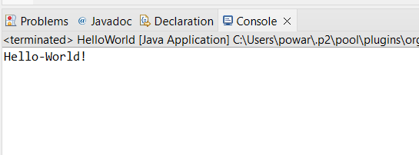

**2. Write a program to find the sum of two numbers entered by the user.**

**Solution**

**package** Lab;

**import** java.util.*;

**public** **class** SumOfTwoNumbers {

**public** **static** **void** main(String[] args) {

Scanner scanner = **new** Scanner(System.***in***);

System.***out***.print("Enter first number: ");

**int** num1 = scanner.nextInt();

System.***out***.print("Enter second number: ");

**int** num2 = scanner.nextInt();

**int** sum = num1 + num2;

System.***out***.println("Sum of the two numbers is: " + sum);

}

}

**Output:-**

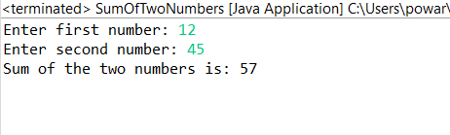

**3. Write a Java program to check whether a given number is even or odd.**

**Solution:-**

**package** Lab;

**import** java.util.Scanner;

**public** **class** EvenOrOdd {

**public** **static** **void** main(String[] args) {

Scanner scanner = **new** Scanner(System.***in***);

System.***out***.print("Enter a number: ");

**int** num = scanner.nextInt();

**if**(num % 2 == 0)

System.***out***.println(num + " is even.");

**else**

System.***out***.println(num + " is odd.");

}

}

**Output:-**

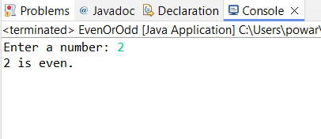

**4. Write a program to calculate the factorial of a number using recursion.**

**Solution**

**package** Lab;

**import** java.util.Scanner;

**public** **class** Factorial {

**public** **static** **void** main(String[] args) {

Scanner scanner = **new** Scanner(System.***in***);

System.***out***.print("Enter a number: ");

**int** num = scanner.nextInt();

**int** factorial = *calculateFactorial*(num);

System.***out***.println("Factorial of " + num + " is: " + factorial);

}

**public** **static** **int** calculateFactorial(**int** n) {

**if** (n == 0)

**return** 1;

**else**

**return** n * *calculateFactorial*(n - 1);

}

}

**Output:-**

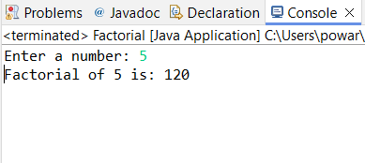

**5. Write a java program to find greatest of 2 numbers.**

**Solution**

**package** Lab;

**import** java.util.Scanner;

**public** **class** GreatestOfTwoNumbers {

**public** **static** **void** main(String[] args) {

Scanner scanner = **new** Scanner(System.***in***);

System.***out***.print("Enter first number: ");

**int** num1 = scanner.nextInt();

System.***out***.print("Enter second number: ");

**int** num2 = scanner.nextInt();

**int** max = (num1 > num2) ? num1 : num2;

System.***out***.println("The greatest number is: " + max);

}

}

**Output:-**

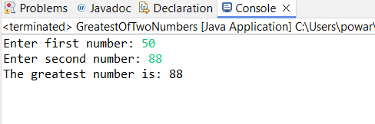

**6. Write a program to implement a basic calculator that takes input as a string expression and evaluates it.**

**Solution**

**package** Lab;

**import** java.util.Scanner;

**public** **class** BasicCalculator {

**public** **static** **void** main(String[] args) {

Scanner scanner = **new** Scanner(System.***in***);

System.***out***.print("Enter an expression: ");

String expression = scanner.nextLine();

**double** result = *evaluateExpression*(expression);

System.***out***.println("Result: " + result);

}

**public** **static** **double** evaluateExpression(String expression) {

// Implement your expression evaluation logic here

// For simplicity, let's assume the expression is in the form of "operand1 operator operand2"

String[] parts = expression.split(" ");

**double** operand1 = Double.*parseDouble*(parts[0]);

String operator = parts[1];

**double** operand2 = Double.*parseDouble*(parts[2]);

**double** result = 0;

**switch**(operator) {

**case** "+":

result = operand1 + operand2;

**break**;

**case** "-":

result = operand1 - operand2;

**break**;

**case** "*":

result = operand1 * operand2;

**break**;

**case** "/":

result = operand1 / operand2;

**break**;

**default**:

System.***out***.println("Invalid operator");

}

**return** result;

}

}

**Output:-**

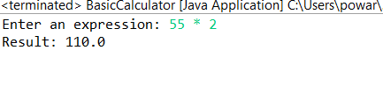

**7. Write a Java program to check if a given number is even or odd.**

**Solution:-**

**package** Lab;

**import** java.util.Scanner;

**public** **class** EvenOrOddAlternative {

**public** **static** **void** main(String[] args) {

Scanner scanner = **new** Scanner(System.***in***);

System.***out***.print("Enter a number: ");

**int** num = scanner.nextInt();

String result = (num % 2 == 0) ? "even" : "odd";

System.***out***.println(num + " is " + result + ".");

}

}

**Output:-**

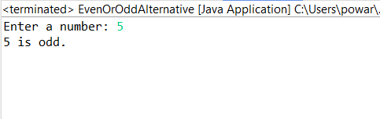

**8. Create a Java program that compares two numbers and prints the larger one.**

**Solution:-**

**package** Lab;

**import** java.util.Scanner;

**public** **class** CompareNumbers {

**public** **static** **void** main(String[] args) {

Scanner scanner = **new** Scanner(System.***in***);

System.***out***.print("Enter first number: ");

**int** num1 = scanner.nextInt();

System.***out***.print("Enter second number: ");

**int** num2 = scanner.nextInt();

**if** (num1 > num2)

System.***out***.println(num1 + " is larger.");

**else** **if** (num2 > num1)

System.***out***.println(num2 + " is larger.");

**else**

System.***out***.println("Both numbers are equal.");

}

}

**Output:-**

