12/10/21

12:32PM

* This project was referred from a video tutorial: <https://www.youtube.com/watch?v=OLBmtRFFwcQ&ab_channel=CodeWithGopi>

1:32PM

* I got into an error before and it was a very long error code <https://pastebin.com/H4D5PC9U> . It happens when I create a new data but the controller gives an error. But I was able to fix with this help <https://stackoverflow.com/questions/7583770/unable-to-update-the-entityset-because-it-has-a-definingquery-and-no-updatefu>
* The fix shows a screenshot below by deleting them, starting all over again with a new database and a primary key set.  
  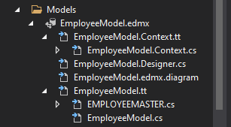 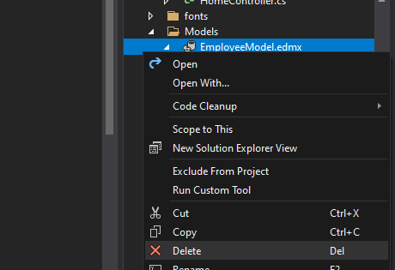
* After that fix, I still stumble upon another problem is I can’t see the details of the data I created and it looks empty except their options of edit, details, and delete buttons still there. But when pressing it sends me a bad request error or something. I don’t have the screenshots to it anymore because I already fixed it.
* I decide to delete the controller and its .cshtml files that was created by the controller and try it all over again after I updated the sql database of employee especially adding a primary key. 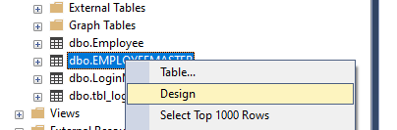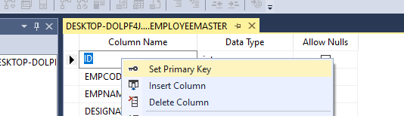  
  This was done through sql manager studio and went back to visual studio, deleted the old model and its .cshtml files that was created by and replacing it with a new model that has the primary key set.  
   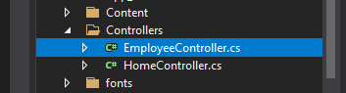 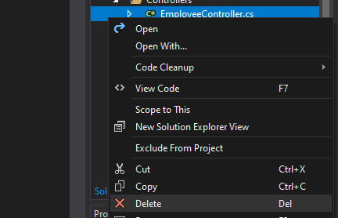 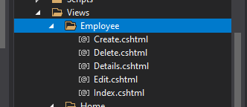 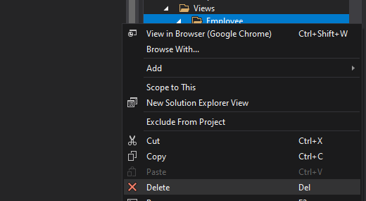
* After that, the results were magical after all those things I need to get through 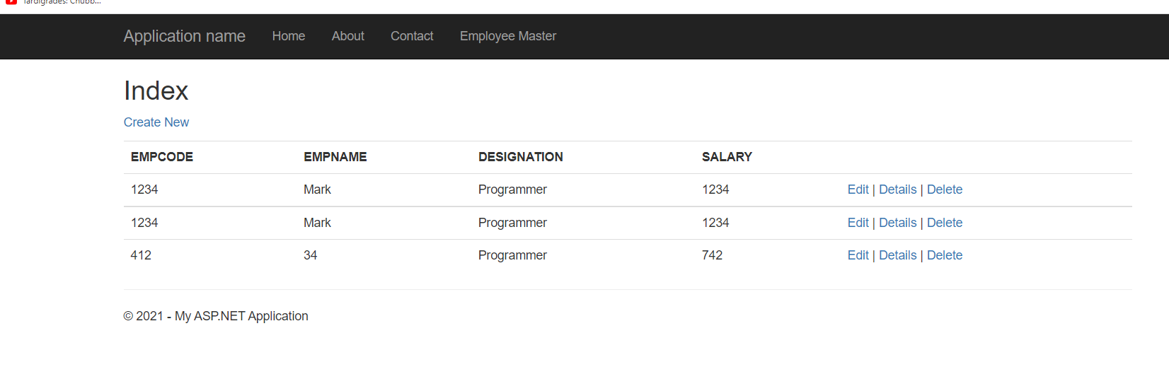those data I made before were already there which is fantastic. I knew they were added.
* I want to remember what were the steps in creating them.
* Models were added with an item called ADO.NET Entity Data Model. Before, it never happened with a popup to name the model first before proceeding because I was creating it from a new item. Moments later I recreated the model again but with direct approach to the item from the right click and I can name the model before proceeding. After that, the chosen model content was EF Designer from database. If there’s no connection, then I create a new connection by manually typing its server name, select database name, and test connection. Then I select a database to the desired system I needed. This instruction is NOT complete so go watch the tutorial video to see what exactly is needed and more explanations.
* When adding controller directly I’m told to name its controller. I choose to create Controller was added with MVC 5 Controller with views, using Entity Framework. Next I named its Model class and then I choose which data context class or SQL it may be (it will have options since I added the database). And that’s about it. The rest of the explanation is in the video tutorial.