8/1/22

2:01PM

* I’m relying a [video tutorial](https://www.youtube.com/watch?v=lpkaMKE081M&list=PL6bQeQE-ybqDmGuN7Nz4ZbTAqyCMyEHQa&index=2&ab_channel=PlugWorld) that I’m trying to make a multiplayer prototype.
* I get an **initial error** when I was trying to make an **Android export**. 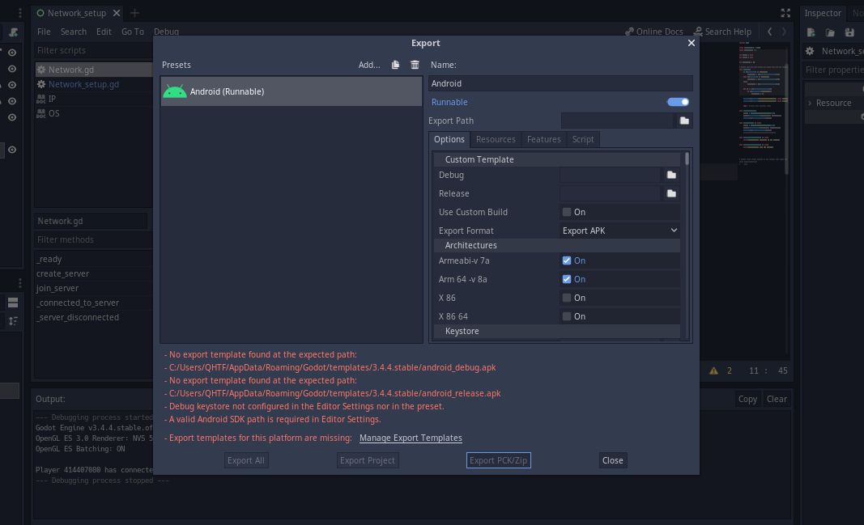 I need to download an export template but I only get errors and other message.  
  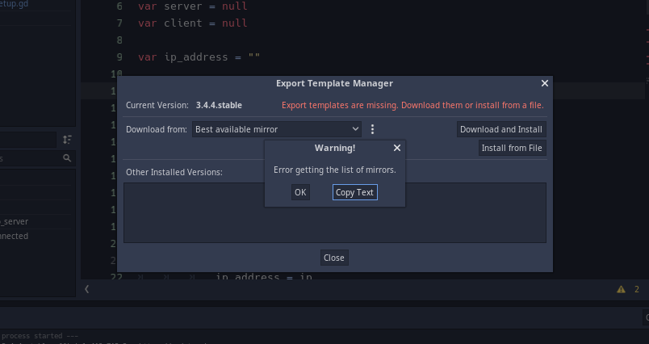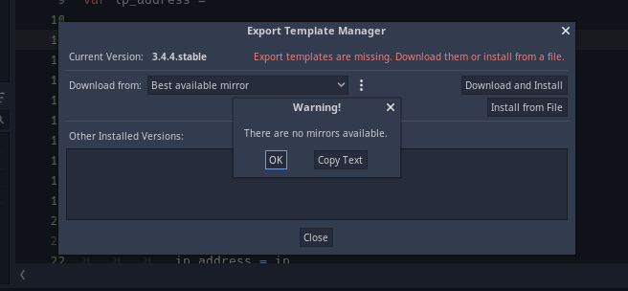I really don’t know why 3.4.4 doesn’t have an export template for Android. I’ll go ahead and check 3.4.x versions outside the current version if this would work…. Okay, I think godot engine’s main website is not accessible even if I had internet connection. This is kind of like imgur before I couldn’t gain access before I can access to it. I just have to wait for godot’s website server to be accessible because the issue is the same in 3.2.3 as well…. Later this evening at 8:33PM the server host is down, I’m glad I had this theory with me (other theories of mine include hackers preventing me from accessing it) is there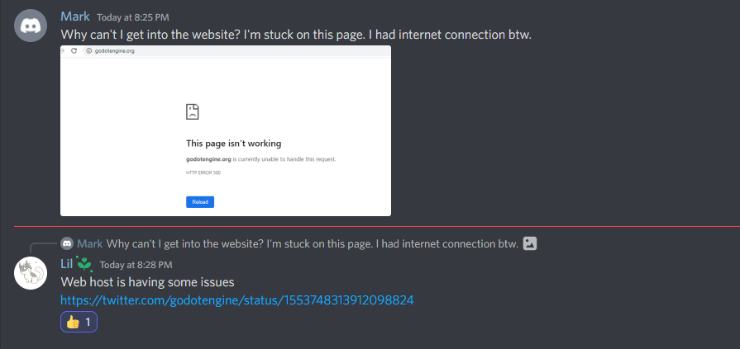Link: <https://twitter.com/godotengine/status/1553748313912098824>   
  I also need to download Android Studio was well. I can also check related issues of exporting in my game jam of Fine-Line. There’s a document I made so I can remember it. But be sure to check them in previous commits because I think I removed them in different commits.

8/2/22

1:36PM

* Good thing that the godot website is working normal as it is again. I can gain access to their downloadable files again.
* I relied on this [video tutorial](https://www.youtube.com/watch?v=vbJLbrdvVHk&ab_channel=FinePointCGI) to help me get started for the setup of my Android export.
* I need Android Studio so that I can compile my project as an .apk to be exported to Android. The easiest way is to install Android Studio. I heard there are other ways to compile my project to .apk without using Android Studio.
* I can simply download Android Studio in the website by googling it.
* Here’s the JDK [download page](https://adoptopenjdk.net/?variant=openjdk8&jvmVariant=hotspot) 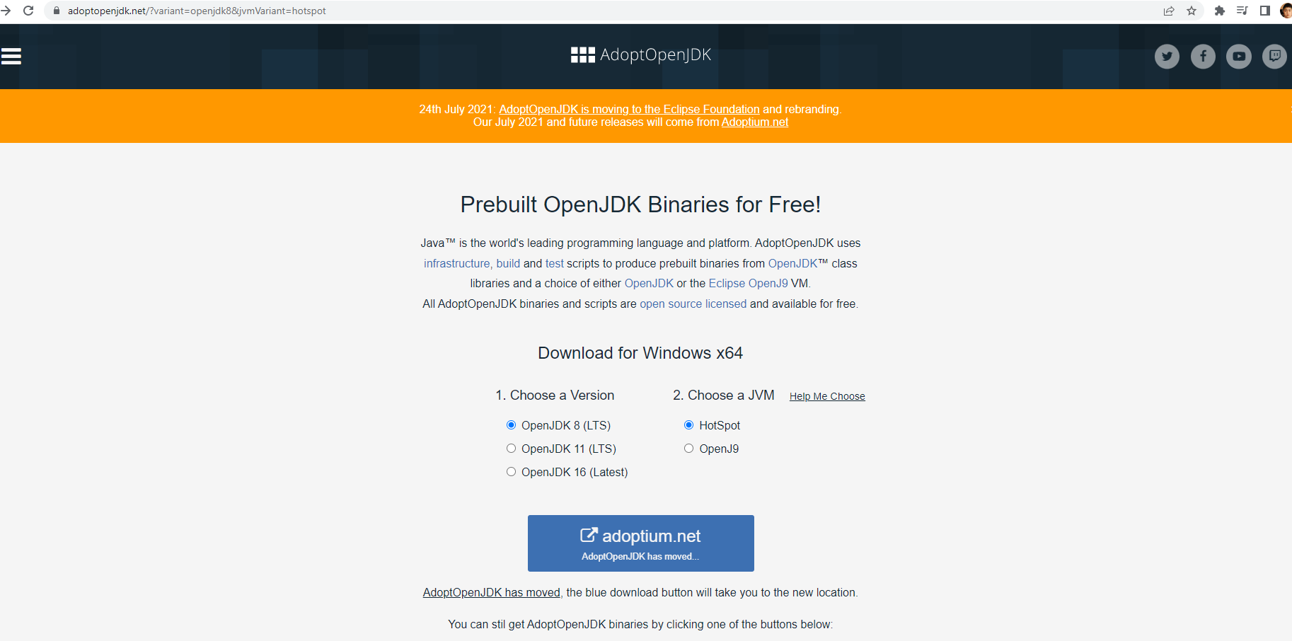 the download page took me a while to study its UI because it has changed drastically compared to the tutorial made last year.
* When **installing Android Studio and JDK**, I **couldn’t find the Android folder in my appdata’s local folder**. So I need to open Android Studio and I still need to download more files after I installed it from website. 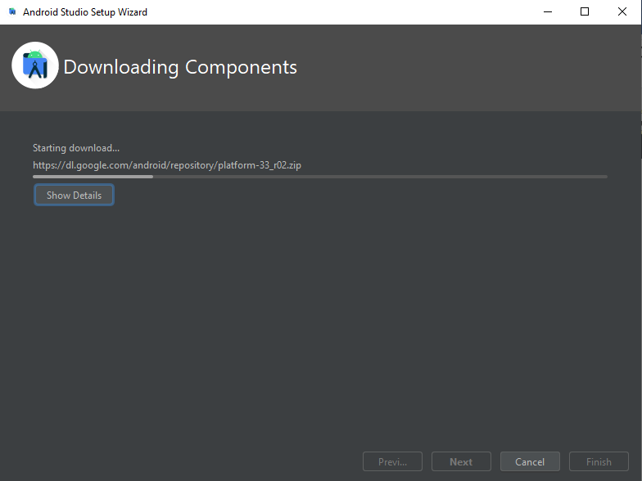this is the installation of the remaining components. At first, I thought all components have been downloaded after it has been intially intsalled but NOPE, I need to open the software and download the remaining files. I hope to get a glimpse of Android folder in my Appdata’s local folder I think.  
  Here is the finished result of the download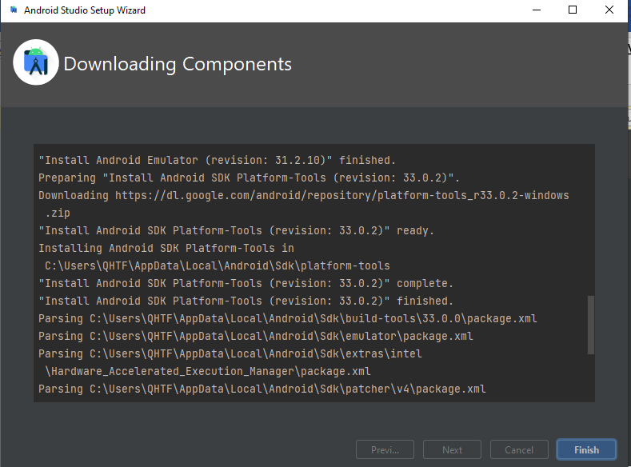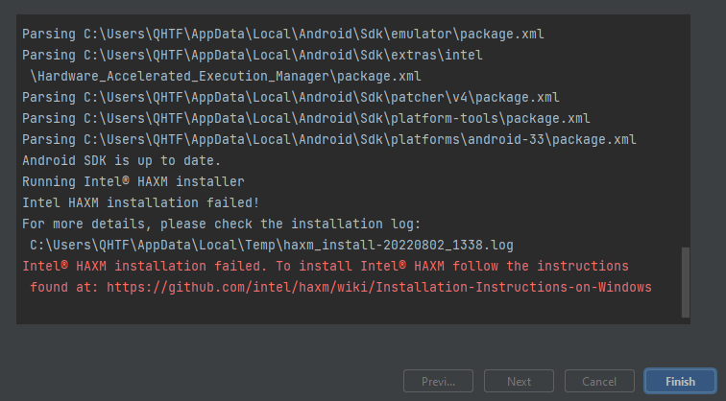I can see that there’s a directory that sends to Appdata’s local folder, this is great. But I also see a red text that states an installation has failed. It’s coming from Intel HAXM, I don’t know what that is yet but I’ll go ahead and ignore it for now.

2:43PM

* I really need to **apply android compiling files into my godot’s editor settings**. I think I never wrote in my game jam 39 project design doc how I started my android export except I say “I made an Android support!” I don’t know where did I put it. I couldn’t find it and don’t feel like checking up all 33 commits.
  + In the Editor Settings, I want to add the directory of **adb.exe** on how I set it up just in case when I’m in a new PC, I like to see and compare how I’d find its directory because directories change though.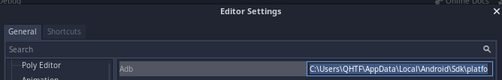adb belongs to SDK, better remember that.   
    Adb.exe directory: C:\Users\QHTF\AppData\Local\Android\Sdk\platform-tools\adb.exe
  + I like to add the **jarsigner** as well. This belongs to JDK (Java Development Kit). Expect to find java sources in this project because Android relies on java code sources to make an Android export.  
    C:\Program Files\Android\jdk\jdk-8.0.302.8-hotspot\jdk8u302-b08\bin\jarsigner.exe
  + for the **debug keystore**  
      
    C:/Users/QHTF/Documents/gen keystore/debug.keystore  
    debug keystore can be in any directory when I generate that keystore command to whatever directory it was located when I open cmd.exe  
    here is the command to generate it: keytool -keyalg RSA -genkeypair -alias androiddebugkey -keypass android -keystore debug.keystore -storepass android -dname "CN=Android Debug,O=Android,C=US" -validity 9999 -deststoretype pkcs12
  + Lastly, this is the **Android SDK path**. This isn’t included in the video tutorial and I can’t find it in his settings because of his 2021 outdated version of his game engine. I had to find solution for myself and adding directory fixed the issue I’m having. I found a help on Google with this [link](https://godotengine.org/qa/122338/valid-android-sdk-path-is-required-in-editor-settings-error) to direct me to find the remaining prerequisite. The rest is to guess what I will do next and here’s one below:  
    directory: C:/Users/QHTF/AppData/Local/Android/Sdk
* This is my **complete setup of my Android export setup directory** from the Editor Settings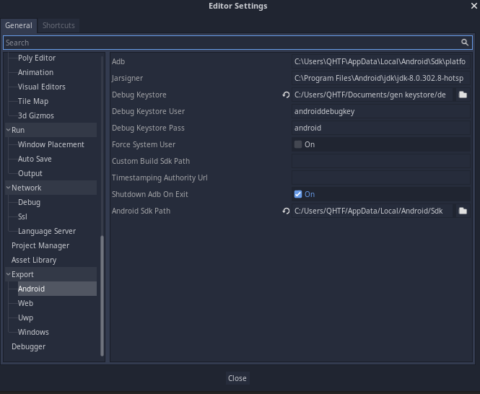this had completely kept all the errors away when I come and see the Android export and I don’t see any of those errors that fuels my fear of going into the unknown. I also worried if github fails to include the files that I may commit because I should expect my gwj39 repository in my project settings should have a documentation on how I setup my Android export. I’m a type of developer would end up erasing the documents that I don’t need just to keep my stuff clean.
* I get this error when export my project to Android (.apk) of **Could not find keystore, unable to export**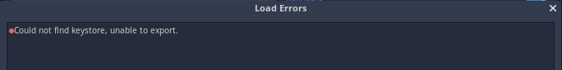the solution to this is to check the export with debug option. 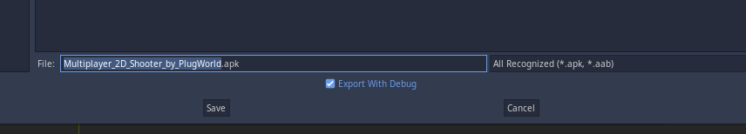Searching Google and this [link](https://stackoverflow.com/questions/68412312/godot-cannot-export-to-android-could-not-find-keystore-unable-to-export-how-to) helped me. I need to inform that I did unchecked before exporting it because I don’t like some debug message comes out in my mobile. But I got it all wrong.
* At 3:43PM, I **tested the game on android whether if I can join server to another platform on my laptop as Windows**. Turns out nothing came out into my console output in my laptop’s godot editor so that means it didn’t work. I’ll just have to finish the tutorial to see it for myself.