Karmayogi Polytechnic College, Shelve

**Department of Computer Technology**

**Micro-Project Proposal**

**Programming with python (22616)**



**“**Voice assistant for covid19 symptoms identification**”**

**Guided by:**

**Prof. Shaikh M.N**

Presented By:

1. Mst. Bagal Rohit Ravindrakumar (CM312)
2. Mst. Rokade Rohan Shivaji (CM328)
3. Mst. Lokare Prajval Dattatray (CM337)
4. Mst. Pawar Sachin Namdev (CM352)

During Academic Year **2020-21**

**Project Title:** Voice assistant for covid19 symptoms identification

**List of Members:** 1. Mst. Bagal Rohit Ravindrakumar (CM312)

2. Mst. Rokade Rohan Shivaji (CM328)

3. Mst. Lokare Prajval Dattatray (CM337)

4. Mst. Pawar Sachin Namdev (CM352)

**Projects Details:**

**E-R diagram:**

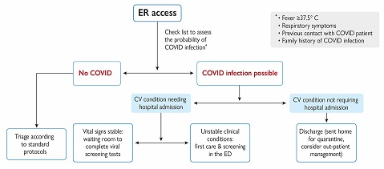

**Time required for completing the project and deadline.**

One week

**Idea of project:**

1. In this pandemic situation the doctors are so busy in their work, so we can’t meet doctors.
2. We can analyze the current health situation of your body by staying from home.
3. This software predicts the chances of having covid-19 and it will suggest you to what to do.

**Conclusion:**

The covid voice assistance helps you to predict chances of having covid and it will tell the probability

**Name and Sign of Faculty HOD**

**(Prof. Shaikh M.N) (Prof. Ghanawajeer D.J)**