J Unit5
Todays Agenda:
- what is test what is JUnit
- what is maven
- Assertion and annotation
- Life cycle
- Junit5 test architecture
A unit test is a small piece of code that calls your code and checks your answer that what you excepted
Analogy
you make a cake recipe before selling it you check it is it baked? Is it sweet enough?
a unit test that test that test check the computer in milliseconds every time you change the recipe
Without test you check by running a test and making around
With test you press one button and know weather everything works. Junit5 is a library that gives you the tools to write and run those checks
Every test follows the 3 steps
- Arrange
Set things up
- Act
Do that thing
- Assert
Check the answer
// Arrange: set things up
Calculator calc = new Calculator();
// Act: do the thing
int result = calc.add(2, 3);
// Assert: check the answer
assertEquals(5, result);

Maven
Maven is a project management and a built tool it does 3 jobs for you
it downloads libraries(like JUnit)
it compiles code for you
runs your test with one commands
Analogy
Imagine your are a chef (you wite the recipe in java code)
Maven is your kitchen manager you hand over your shopping list(pom.xml)
the manager buys it and set up the kitchen cooks and tell you the dish failed the test check
Folder structure should look like:
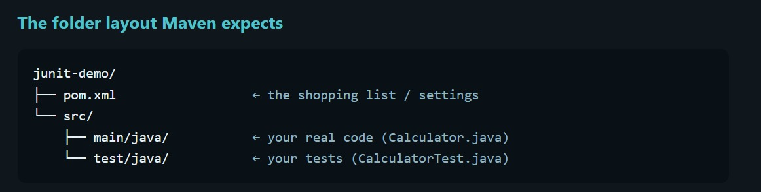

mvn -v
mvn -compiles
mvn -test
mvn clean test
Steps for Junit testing
1.Design and understand problem statement and solve pseudo code
2.Write code
3.Write test
4.Run a test

Architecture of Junit

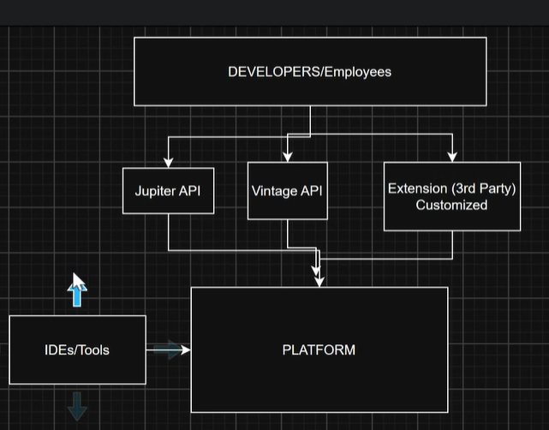
Junit Platforms
The engine route Start test talks to IDE’s and Maven Define how test engine plugin
It used by Vs code, intellije, maven
Junit Jupitor:
it is the new programming model: @test before each
Junit Vintage
A compatibility engine that runs old Junit 3 and 4 test on the new platform. It is used by the old project that haven’t yet migrated.
Analogy
the j unit platform is a building ,a project system and the ticket counter..and it can show u any movie. Jupiter is todays modern movie the only one u can write…vintage is an old movie that runs the same projector. The building doesn’t care what movie plays as long as matching engine (player) exist.
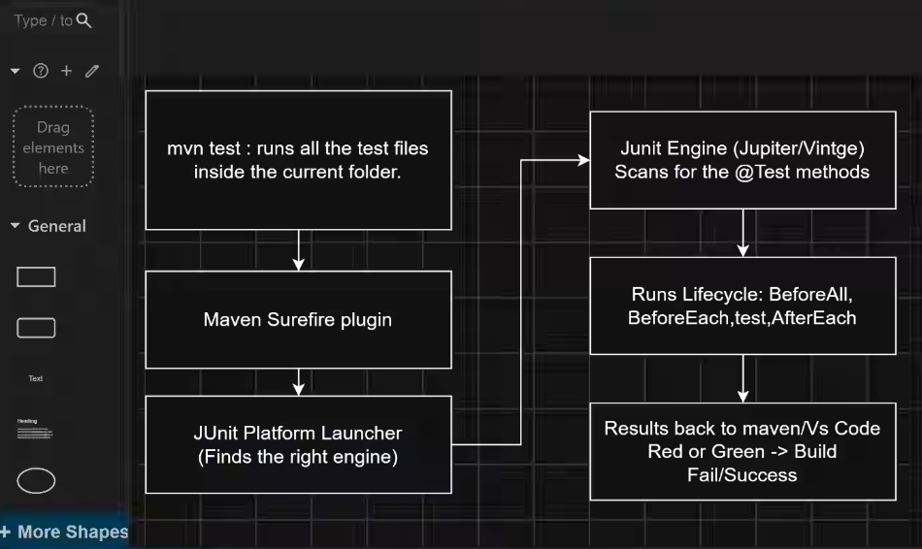
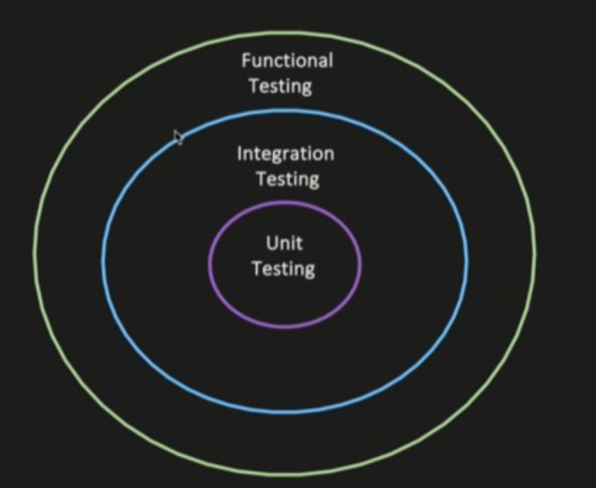

Types of Testing
- Unit Testing-testing of an individual method or unit
- Integration testing-testing of multiple modules or concurrence together, to test if a system case properly when wired together(Tho goal is not to test end to end user variable, it is just the multiple modules or system wired together, thus intended behaviour.
Use case- 1 : service>repository>DB
- During the revoke method in service layer
- Verify that dependency
- The flow should reach the DB layer
- Your test can assert that data was persisted properly into DB

Validate the messege

- Functional Testing-End to end testing of a feature or a business functionality, verify it works as expected

