Sample Tables

# Customer

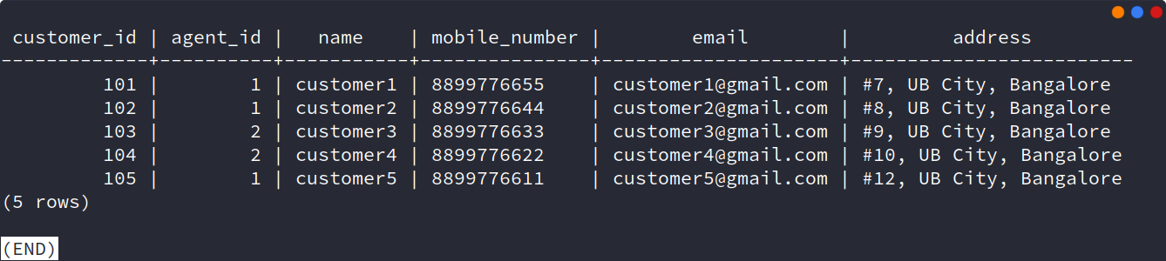

# Vehicle

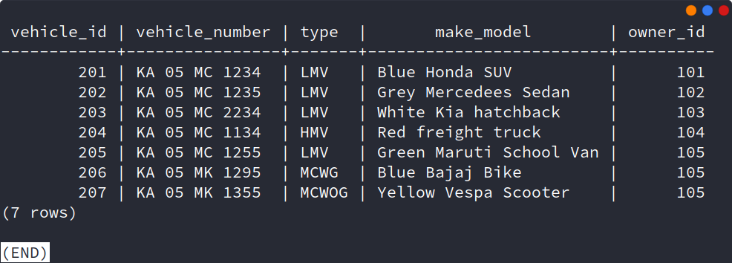

# Insurance

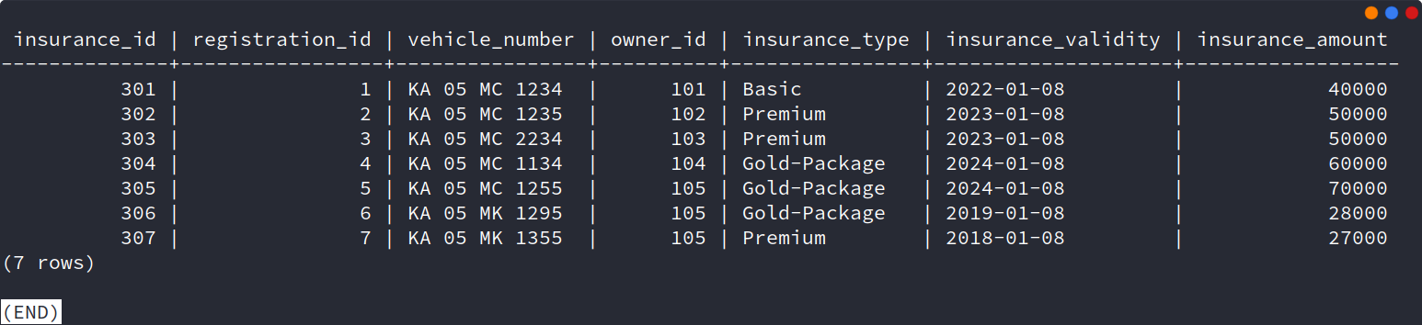

# Login Credentials

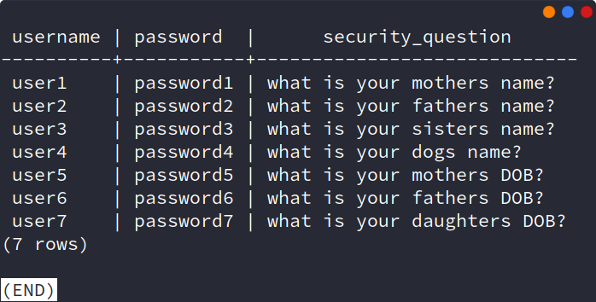

# Roles

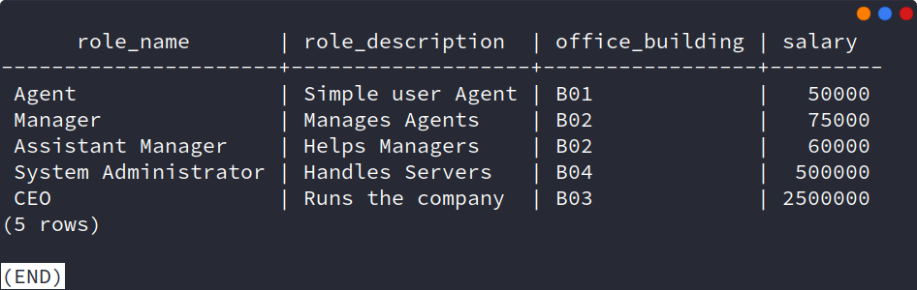

# Employee

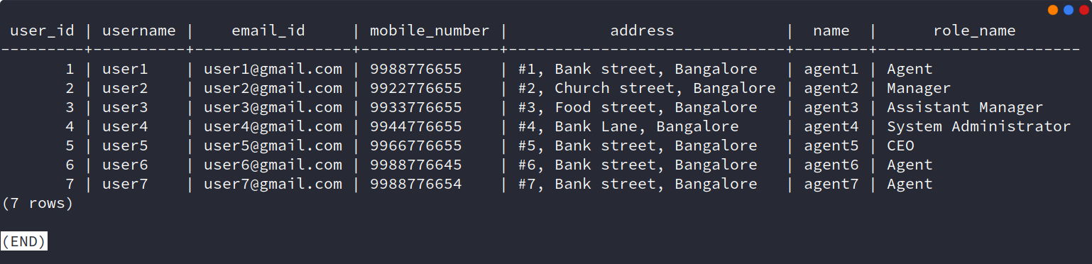

# Registration

