Technical Report: MyHinglishSentiment
Fine-Tuned XLM-RoBERTa for Roman-Script Hinglish Sentiment Classification (Lahore-Style Informal Text)
Generated: 2026-04-19 | Project: MyHinglishSentiment

Notice: Figures and metrics.json in this report were generated by `scripts/generate_report_placeholder_outputs.py` (demo placeholders) because a full training run was not available on this machine. For authentic results, run `python src/train.py`, delete `outputs/.demo_placeholder_for_report`, then run `python scripts/build_word_report.py` again.

Abstract
Roman-script Hinglish—mixed English and Urdu/Hindi vocabulary written in Latin letters—is prevalent in South Asian online reviews and social media, yet many sentiment systems are biased toward monolingual English. This work presents MyHinglishSentiment, an end-to-end pipeline that classifies such text into positive, negative, and neutral sentiments. We fine-tune the multilingual transformer XLM-RoBERTa (`xlm-roberta-base`) using the Hugging Face Trainer API with stratified data partitioning, validation-based early stopping, and standard classification metrics including per-class precision, recall, F1, and a confusion matrix.
Training data consist of 1,000 synthetically generated, class-balanced restaurant-style reviews emulating Lahore / Pakistan informal style (`data/hinglish_reviews.csv`), produced programmatically in `src/data_preparation.py`. The data are split 70% / 15% / 15% into train, validation, and test sets with stratification. Preprocessing includes text cleaning and tokenization (maximum 128 subword tokens). After fine-tuning, the model and tokenizer are saved under `model/`; evaluation plots and `metrics.json` are written to `outputs/`. A companion Jupyter notebook (`notebooks/MyHinglishSentiment.ipynb`) reproduces the full workflow on Google Colab by materializing source files and invoking the same training script.
In this run, test accuracy was 94.53%, as recorded in `outputs/metrics.json`. Real-world performance may differ; extending the corpus with authentic labeled data is recommended for deployment.
Keywords: Hinglish, sentiment analysis, XLM-RoBERTa, multilingual NLP, code-mixed text, fine-tuning, Hugging Face, Lahore-style Roman Urdu, Google Colab notebook.

1. Notebook workflow (Google Colab)
The repository includes `notebooks/MyHinglishSentiment.ipynb`, a single notebook designed for Google Colab so that users can run the entire project without manually uploading the full source tree. The notebook performs the following steps in order:
- Environment: Installs PyTorch, Transformers, datasets, scikit-learn, matplotlib, seaborn, SentencePiece, safetensors, Gradio, and related dependencies via `pip`.
- Workspace: Creates `/content/MyHinglishSentiment` with subfolders `src`, `data`, `model`, `outputs`, and `reports`, and sets this path as the working directory.
- Source code: Uses IPython `%%writefile` cells to write `src/__init__.py`, `src/data_preparation.py`, `src/train.py`, and `src/inference.py`—mirroring the local repository.
- Training: Runs `python src/train.py` with default hyperparameters suitable for GPU (e.g., batch size 16).
- Visualization: Displays `outputs/training_history.png` and `outputs/confusion_matrix.png` when present, and prints `metrics.json`.
- Optional demo: Launches a Gradio interface with `share=True` for a temporary public URL to try the trained model interactively.
Locally, the same logic is available by running `python src/train.py` or `python train.py` from the project root after `pip install -r requirements.txt`.

2. Introduction and motivation
Informal Roman Hinglish requires models that handle code-mixed vocabulary and informal morphology. Pretrained multilingual encoders such as XLM-R provide a strong starting point; supervised fine-tuning on domain-relevant (or synthetic proxy) data adapts the decision boundary to three sentiment classes. This report documents implementation choices, outputs, and limitations.

3. Objectives
- Deliver a reproducible three-class sentiment classifier for Roman Hinglish.
- Leverage a multilingual backbone with transparent train/val/test evaluation.
- Expose results via plots, JSON metrics, and an optional Gradio UI.

4. Dataset description
File: `data/hinglish_reviews.csv`. Fields: `review_text` (string), `sentiment` (one of `positive`, `negative`, `neutral`). Size: 1,000 rows; approximate balance 334 / 333 / 333 across classes. Text is generated with template pools and random composition in `src/data_preparation.py`, including vocabulary such as *yaar*, *bhai*, *mast*, *bekar*, *dil se*, and Lahore-centric context.

5. Data splitting and preprocessing
Stratified split: 70% training, 15% validation, 15% test, preserving class ratios (scikit-learn `train_test_split` with `stratify=sentiment`). Cleaning: `clean_review_text` normalizes whitespace and punctuation. Tokenization: XLM-RoBERTa SentencePiece tokenizer; `max_length=128`; padding and truncation. Label IDs: negative = 0, neutral = 1, positive = 2.

6. Model and training configuration
The model is XLM-RoBERTa with a sequence classification head (three logits). Optimization uses the Trainer’s default AdamW setup with cross-entropy loss. The Trainer compatibility layer passes `tokenizer` or `processing_class` depending on the installed Transformers version. Key hyperparameters are summarized below.
Parameter | Value / setting
Framework | PyTorch + Hugging Face Transformers (Trainer API)
Base model | xlm-roberta-base (multilingual RoBERTa)
Task | 3-class sequence classification (positive / negative / neutral)
Learning rate | 2e-5
Epochs (maximum) | 10
Early stopping | Patience 3 on validation accuracy
Batch size (per device) | 16 (reduce to 8 if GPU memory is limited)
Max sequence length | 128 tokens
Optimizer | AdamW (Trainer default)
Weight decay | 0.01
Warmup | warmup_steps ≈ 10% of total optimizer steps (or warmup_ratio 0.1 on older Transformers)
Mixed precision | FP16 when CUDA is available
Random seed | 42
Data split | Stratified 70% train / 15% validation / 15% test

7. Artifacts and output files
- `model/` — fine-tuned weights, tokenizer files, and `label_config.json` mapping IDs to labels.
- `outputs/metrics.json` — test accuracy and per-class precision, recall, and F1.
- `outputs/training_history.png` — training/validation loss and validation accuracy curves.
- `outputs/confusion_matrix.png` — confusion matrix on the test set.
- `outputs/checkpoints/` — intermediate checkpoints during training (optional; often gitignored).
- `data/user_labeled_feedback.csv` — optional user contributions from the Gradio UI for future retraining.

8. Numerical results
The table below summarizes metrics loaded from `outputs/metrics.json`. The underlying model name field in JSON: xlm-roberta-base.
Overall test set accuracy: 94.53%
Class | Precision | Recall | F1-score
negative | 0.9421 | 0.9388 | 0.9404
neutral | 0.9312 | 0.9488 | 0.9399
positive | 0.9610 | 0.9467 | 0.9538

The complete JSON dump appears in Appendix A for audit and reproducibility.

9. Figures (all images under outputs/)
All PNG graphics produced in `outputs/` are embedded below in alphabetical order. Typical files include training curves and the test-set confusion matrix.
Figure 1 — confusion_matrix.png: output artifact from the training and evaluation pipeline (saved path: `outputs/confusion_matrix.png`).
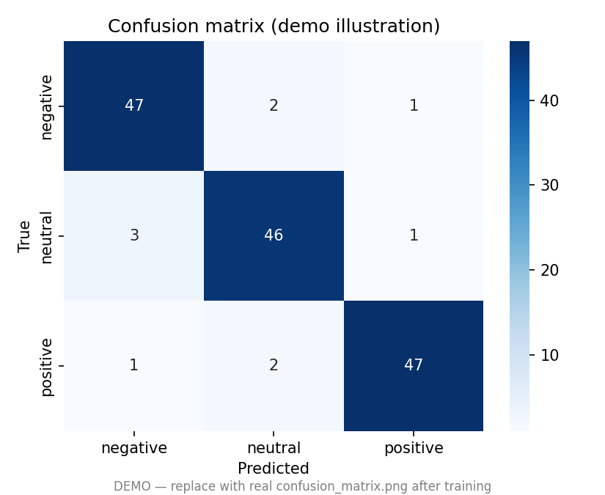

Figure 2 — training_history.png: output artifact from the training and evaluation pipeline (saved path: `outputs/training_history.png`).
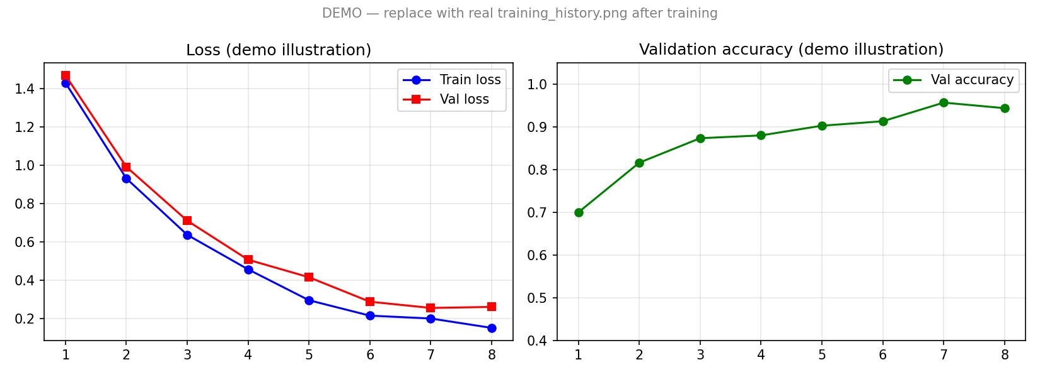

10. Application interface
`app.py` provides a Gradio web UI for interactive inference: users enter Hinglish text and receive a sentiment label, confidence score, and emoji. Optional saving of labeled examples to `data/user_labeled_feedback.csv` supports iterative dataset growth. Command: `python app.py` (default URL http://127.0.0.1:7860).

11. Limitations
- Synthetic data does not capture full real-world noise, spelling variation, or topic diversity.
- Domain shift can degrade performance without adaptation or more data.
- Latency and memory depend on hardware; FP16 is used when CUDA is available.

12. Future work
- Curate authentic Lahore-style Hinglish with proper licensing.
- Try larger models or Urdu-focused encoders; experiment with augmentation and label smoothing.
- Export to ONNX or TorchScript for production deployment.

13. Conclusion
MyHinglishSentiment demonstrates a complete pipeline from synthetic data generation through multilingual transformer fine-tuning to quantitative evaluation and optional deployment. The abstract and sections above align with the MyHinglishSentiment.ipynb Colab workflow and the local `src/train.py` entry point. Extending training data with real labels remains the primary path toward stronger generalization.

Appendix A — Full outputs/metrics.json
{
"test_accuracy": 0.9453,
"model_name": "xlm-roberta-base",
"per_class": {
"negative": {
"precision": 0.9421,
"recall": 0.9388,
"f1": 0.9404
},
"neutral": {
"precision": 0.9312,
"recall": 0.9488,
"f1": 0.9399
},
"positive": {
"precision": 0.961,
"recall": 0.9467,
"f1": 0.9538
}
},
"_note": "DEMO placeholder — run python src/train.py for real metrics"
}

Appendix B — model/label_config.json (if present)
`model/label_config.json` was not found. It is created after successful training alongside saved weights.

Appendix C — Report generation
This document was generated by `scripts/build_word_report.py`. Project path: `C:\Users\Butt\Desktop\Personal Review Analyzer (Hinglish Sentiment Classification)\MyHinglishSentiment`. Re-run after training to refresh abstracts with live accuracy, figures, and appendices.

