Example 10-4
David Vallado,
Center for Space Standards and Innovation
January 4, 2010

Meas = 1110 { 29 Jan 1995 02:38:37.000 UTCG ... 02 Feb 1995 04:57:26.000 UTCG, range azimuth and elevation.

Example10-4.sco (notes on setup and files)
- Scenario-Measurements-Files – The obs file has all the data in it, as listed above.
- Scenario-EarthDefinitiion-EOPData-Filename – This scenario uses the current file from http://www.celestrak.com/SpaceData/. It is stored in C:\Documents and Settings\All Users\Application Data\AGI\ODTK 6\DynamicEarthData\eop19620101.txt
- Scenario-EarthDefinitiion-FluxData-InputFile – This scenario uses the current file from http://www.celestrak.com/SpaceData/. It is stored in C:\Documents and Settings\All Users\Application Data\AGI\ODTK 6\DynamicEarthData\sw19571001.txt
- Satellite-OrbitState – The initial state of the satellite is inserted from an external file. This will not always be the case and you may need to perform OD to find the initial state.
- Satellite-MeasurmentStatistics – These are set for GPS raw observations
- Satellite-ForceModel – the specific force models are setup here for gravity, drag, srp, etc.
- Satellite-OrbitUncertainty – The initial RIC uncertainty values are set to 2/2/0.5 m and 0.01/0.001/0.00328223 m/s to model the expected accuracy of the initial ICESat orbit state.
- Smoother-Input-Files – This file will probably need to be reset once you run the Filter one time and have the files in the proper location.
- Smoother-Output-FilterDifferencingControls – Notice that this file is set to generate. This will automatically generate the difference file when you run the smoother
- Example10-4.dpl – this file is in the distribution directory, but should be placed in the directory where our files are stored, and the /styles subdirectory. This file makes plotting results much simpler. You may need to update the Static Product Builder Input file locations depending on your directory structure.

- Satellite data found from http://www.astronautix.com/chrono/19752.htm
1975 April 9 - 23:58 GMT - Launch Site: Vandenberg. Launch Complex: SLC2W. Launch Pad: -. Launch Vehicle: Delta. Model: Delta 1410. LV Configuration: Delta 1410 584/D109.
- Geos 3 Nation: USA. Payload: GEOS C. Mass: 341 kg (751 lb). Class: Solar. Spacecraft: Geos. Agency: NASA Wal. Perigee: 817 km (507 mi). Apogee: 848 km (526 mi). Inclination: 115.00 deg. Period: 101.60 min. COSPAR: 1975-027A. USAF Sat Cat: 7734. Geodynamics Experimental Ocean Satellite. The mission of GEOS 3 (Geodynamics Experimental Ocean Satellite) was to provide the stepping stone between the National Geodetic Satellite Program (NGSP) and the Earth and Ocean Physics Application Program. It provided data to refine the geodetic and geophysical results of the NGSP and served as a test for new systems. A major achievement was the flight of a radar altimeter. Further mission objectives: intercomparison of tracking systems, investigation of solid-earth dynamic phenomena through precision laser tracking, refinement of orbit determination techniques, determination of interdatum ties and gravity models, and support of the calibration and position determination of NASA Spaceflight Tracking and Data Network (STDN) S-band tracking stations. References: 2, 6.
and http://www.nic.funet.fi/pub/astro/textdoc/space/intmag.txt 7734 7.0 GEOS 3 75 27A 1.1- 1.2 m2
- 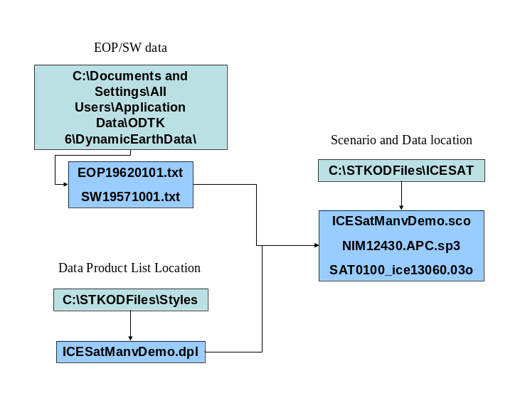
Figure 1: File Locationsxxxxxxxxxx. Several files are needed for the scenario and they reside in different locations.

The overall idea was to process the B3 measurements both with a batch Least Squares and a Kalman filter approach.

Begin by using the GIBBS technique to find the initial vector from the first ten observations. The answer is given in the text as

Nominal vector:
5975.2904 2568.6400 3120.5845 3.983846 -2.071159 -5.917095 km and km/s

This isn’t the best initial vector, but it shows the results from an off nominal vector. Setting the stages to 0 sec and just to 02:40:27 gives the results using the first 10 observations.

Running LS with just 10 obs,
5746.72 2680.15 3442.25 4.33965 -1.91991 -5.72175 km/s

The first test is to run the LS option and find an improved orbit. Setting up the LS is done in the scenario. The question is how much data, and what frequency to use. The initial setup takes the first “pass” and has a spacing of 60 seconds. This yields an answer, but about half the points are rejected. Changing to 30, 15, and 10 seconds reveals that at 15 seconds, there are many more obs accepted than rejected. At 10 seconds, the LS doesn’t converge in just 10 iterations. For our purposes, we use the 15 seconds spacing and find

5748.68 2680.02 3442.62 4.33037 -1.9212 -5.72461 km/s

Notice the similarity to the book result of

5748.6070 2679.9324 3442.7902 4.330460 -1.922874 -5.726562 km/s

A difference of only 205 m. Now we can examine how the filter processes the data.

Running the filter and smoother, we find the following results.
Setting the RIC to (because we don’t really know the accuracy of the initial estimate). Also, when there’s more variability in the initial LS estimate, it’s probably safe to assume the data is noisy, and hence, the initial RIC values should be larger.

3/5/1 km and .4 .8/.2 km/s
2/4/1 “ok”
Try chg drag ½ to 90 min
Try KPTQ to 15 m in range – not too bad. Work from here…

10 pts iod, seq, 500/1000/200 m .6/.4/.2 m/s not bad…

Try from scratch…
Setup scenario, sat, fac, etc.
5000/10000/2000 m .6/.4/.2
Do 10 seq IODworksheet
5950.772253246 2558.197424159 3107.556219245 3.984413449 -2.091634953 -5.957336932
Run filter and smoother - \
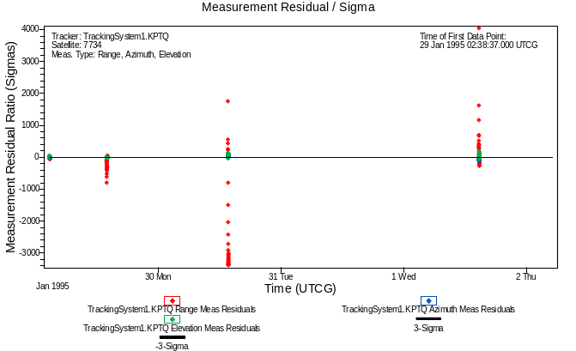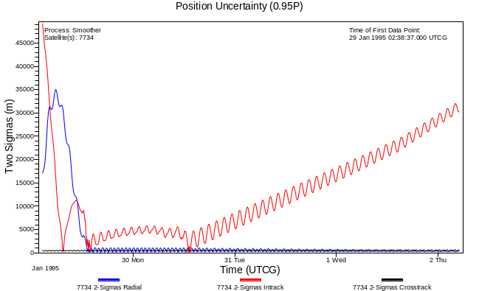
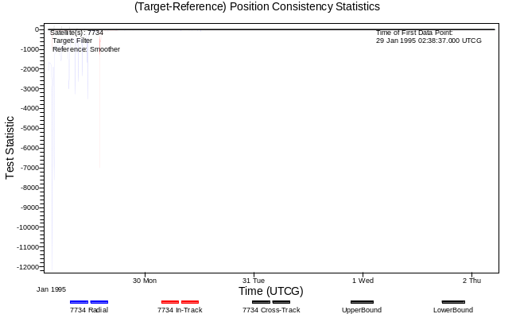
Obvious a better initial guess is needed.
Setup LS
29 Jan 1995 02:38:37.000 UTCG to 29 Jan 1995 06:38:37.000 UTCG, 15 sec, 69 obs. Runs all accepted
5748.658061000 2680.341974991 3442.113336858 4.327348267 -1.921489322 -5.725777249
Leave RIC values alone for now, although they could go down some “maybe”

Notice the similarity to the book result of
5748.6070 2679.9324 3442.7902 km 4.330460 -1.922874 -5.726562 km/s
This is the closet comparison of a BLS at this point…

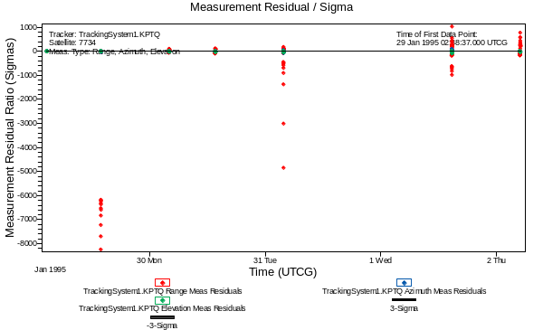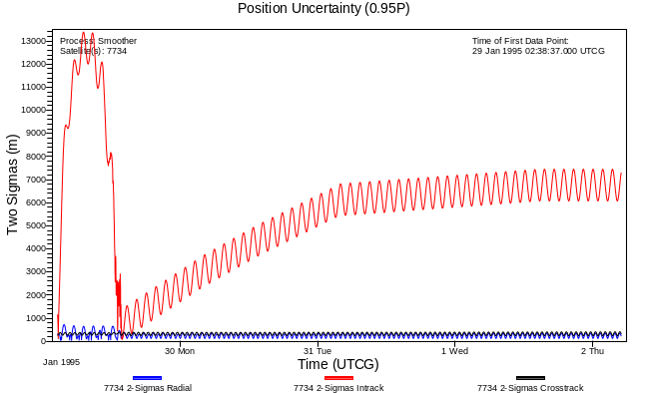
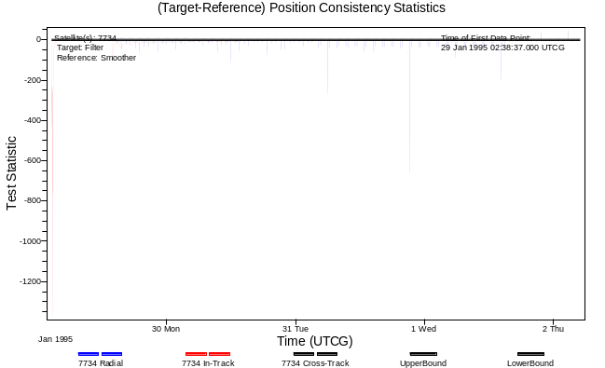

Probably take RIC values up some based on pos unc that appears to have some uncertainty, plus lots of meas still being rejected.
5000/10000/2000 m .6/.4/.2
Bc ½ 14400 to 180, srp ½ 2880 to 180
New ½ lifes improve initial spike (bring it down), but do nothing later on.

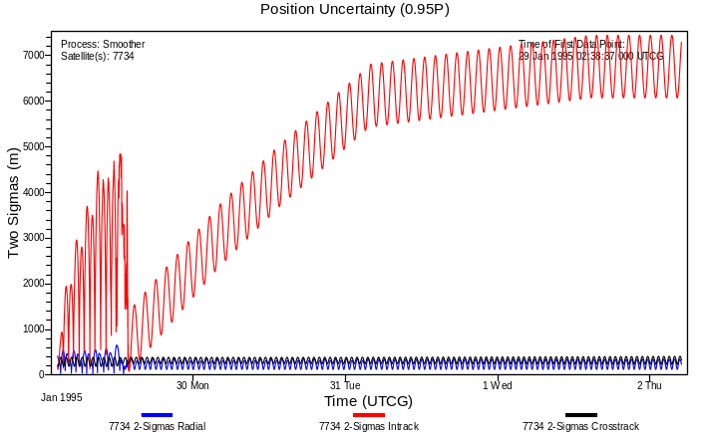

BC and srp estimates look ok –some changes, but a very small scela.

KPTQ WNS 92.5 to 200m, nah

15m and 6 min, 4 sigma limit– seemed ok, but filter didn’;t settle down…

Back to 92.5, 3 sigma. Then bc dencorr ½ to 1440 and srp ½ to 1440 min

No no no, go back to LS initial estimate…

Meas times
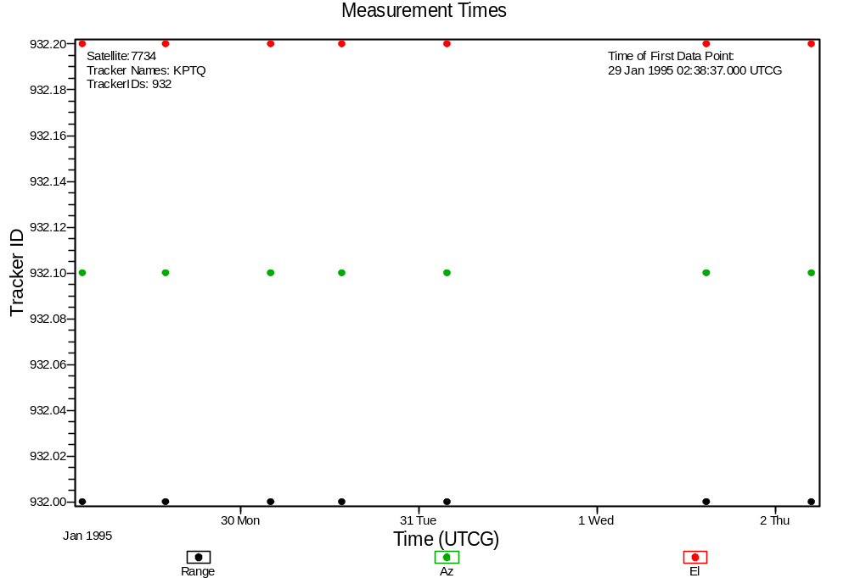

The first runs show the performance of the filter fitting the data. The residual ratios report shows the residuals divided by the sigmas – this gives a more “even” representation of the results than simply looking at the residuals. Note that the ratios should fall within a ± 3 sigma band, indicated by the horizontal lines in Fig. 2.

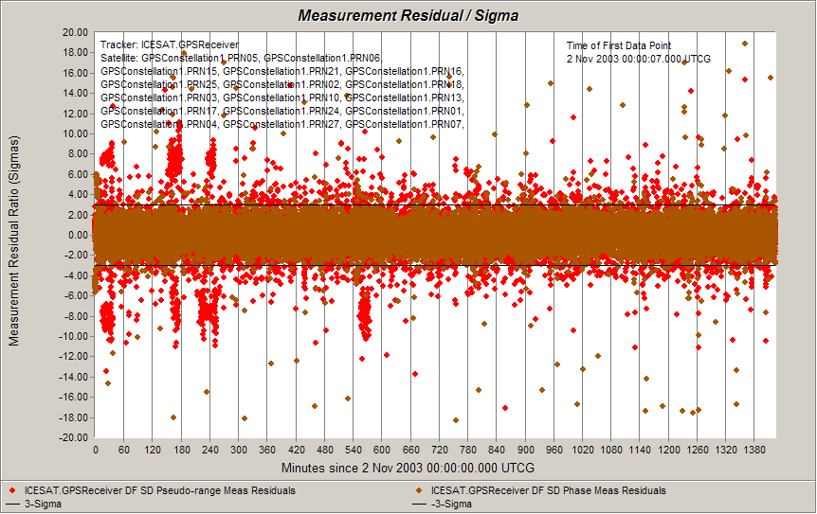
Figure 2: ICESat ODTK Residual Ratio – No Maneuver. The residual ratios are shown for the span of observations (1 day). The legend describes the rejected and accepted points. The data should fall within the ± 3 sigma limits.
The position uncertainty report shows very good agreement with the data (Fig. 3), generally 40-50 cm (two sigma) throughout the interval.
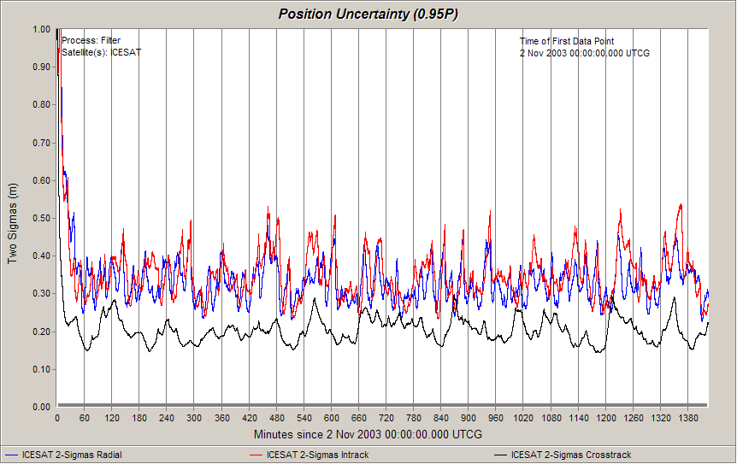
Figure 3: xxxxxxxx ODTK Position Uncertainty – No Maneuver. The position uncertainty for the entire span of the observations is shown. Radial In-track and Cross-track components are given, with in-track generally being the largest.

.

Summary and Conclusions
Using highly accurate, dense data, the filter can recover an unknown maneuver in less than ½ the orbital period. This should probably be considered a “best” case as the data is continuous, and spans the interval of the faux maneuver. Tests were run to simulate the effect of not knowing the data during and around the maneuver. The first case deleted about 1.5 hours and the second case deleted about 3 hours before and after the maneuver. The results did not change that much – underscoring the importance of data density and quality. However, in the second case, the filter properly identified the cross-track component as the dominant discrepancy with the data in the position consistency test. This may indicate the ability to model unknown maneuvers, or to obtain initial estimates of the maneuver for further processing. Additional study is warranted for satellites with far less data available.
The solution technique for determining a maneuver may also need some extra analysis. The usual procedure is to examine mean orbital elements as a means of determining maneuvers (and other maintenance parameters). The sequential filter allows us to recover a maneuver much quicker, without stopping and re-starting. In addition, reports such as the residual ratios, the positional uncertainty, and the filter-smoother consistency test give us greater confidence in the result. This combination provides a more timely and accurate assessment of what is happening with the data. Remember that most existing programs have been developed around batch least squares approaches which cannot perform the precise sequential processing of the filter through a maneuver, nor do many filters have mathematically derived process noise – bypassing the need to “tune” the filter. Although the mean elements show the recovery, the result is slower (several hours longer as seen in Fig. 13 vs Fig. 9) than the residual ratio and positional uncertainty approach. Any additional recovery time means less available mission operations time.

