From: Mike Loucks [mailto:loucks@see.com]
Sent: Tuesday, January 06, 2009 4:37 AM
To: Lowe, Jonathan
Cc: Hall, Bob
Subject: Frozen orbit, repeating ground track

Jonathan,

Enclosed is my latest scenario. I think it's ok, but we could probably work a bit more on it.

Let me explain what I did.

First, based on the orbit period of what you gave me, I assumed a repeat count of 244. I created a calc object called "ground track error" and gave it that count. Then I used a targeter (that I destroyed when I was done with it) to target the reference longitude so that the value of the ground track error was zero at the time of the initial state. I saved those corrections and got rid of the targeter.

Then I created a new targeter (obviously you don't have to do things this way, I'm just explaining why that targeter isn't there.) and inside this targeter I set up a set of keplerian elements that were close to the Mean values (Kozai) that I wanted. I can only specify these in osculating elements, but that's ok. I wanted the initial state to occur at the descending node (since that's where I'll be measuring the ground track error) so I made sure my first guess for true anomaly was 90 (since my starting arg of perigee is also 90). With those values of keplerian elements set, I changed the initial state so that the Cartesian elements were selected. This is necessary due to the bug I described earlier, which somehow hoses up the iterations when trying to target on Mean elements from osculating.

Then I created a targeter (“Target Sequence” for Initial State) that varied the Cartesian elements in order to give me the mean elements I wanted, plus the ground track error of zero at the start. I ran the targeter and got it to converge. Arg of Latitude = 0 (180..?) forces things to be at the descending node.

Then I get to the Loop structure. This structure came from a scenario John Carrico created, although I’ve modified it a little.

The first segment, “Prop2MaxError”, propagates until the ground track error is greater than 0.9 km (with a slight tolerance to keep below your 1 km number). So we start with a ground track error of zero, and propagate until the ground track error reaches +0.9 km. Note that we are only checking for this at the descending node.

The next segment, “Prop to Maneuver Start”, is what we use to set the placement of the maneuver. We will use this to try to keep our Arg of perigee roughly where we want it. What you see in the scenario is that I’ve chosen a value of -90 deg in Arg of Latitude (Q: Why?). John had used Mean-Mean Anomaly in his original scenario, but I like AOL better. I’ve set all the values for these segments the same in the loops.

When we get to our max positive error of greater than +0.9 km, we will do a maneuver to force us to drift in the other (- error) direction [in a] target sequence. The maneuver will be small, and the error will eventually trend back in the positive direction, approaching +0.9km. What we want to do is to target that turn around to happen near -1.0 km (-0.9km), our other max error limit. So we’ll burn away from the positive side and let natural forces (perturbations) turn us around on the other (- error) side.

The “turnaround” segment is a maneuver. It’s very small. The “PropToTurnAround” segment stops at every descending node, and looks (via a constraint) to see if the “ground track error” is “Greater than Minimum” i.e. we have reached our turn around. Note that the tolerance on this is 0.35 km. We’ll use this number because the ground track error has wiggles in it over time, and we don’t want to detect the small wiggles, but rather the overall trend. So when we see we have come back more than 0.35 km from the minimum, we’ll know we’ve hit a turnaround. Note that we are always testing for this at the descending node. The propagator tests every time it hits a node, and compares with all the others, including the initial state for this segment. That’s why we have the “PropToFirstDNode” segment, because we want the first state for this propagator to also be at the descending node. Finally we have one more segment in the targeter (PropToLastNode). I’m not sure we have to have this, but it’s fine. We measure the ground track error at this segment. The targeter will vary the “Turnaround” segment’s delta-v in order to force the turn around to take place at -0.6 km (set in the E.C. for Ground_Track_Error of targeting profile). Recall that we’ve put a 0.35 tolerance on the “greater than minimum” constraint, so this will be -0.95 km and should work.

So if you create a graph of ground track error (use the “Astrogator Pass Data” data provider group, so that it’s only measured at every pass, which we’ve defined as the descending node), you should get this:

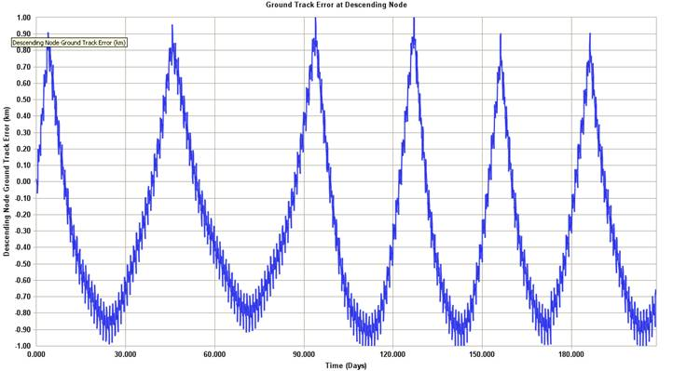

For a first guess, I’ve set the Mean argument of perigee to be 90.545 deg, as you suggested. A real frozen orbit won’t stick exactly to where you put it, but will move around. The way you’d really get it to move around is to place your ground track maneuvers in the right place. For now, I’ve chosen a Arg of Latitude of -90 deg. With this value used for every maneuver, our mean arg of perigee (also measured at the descending node) looks like this:

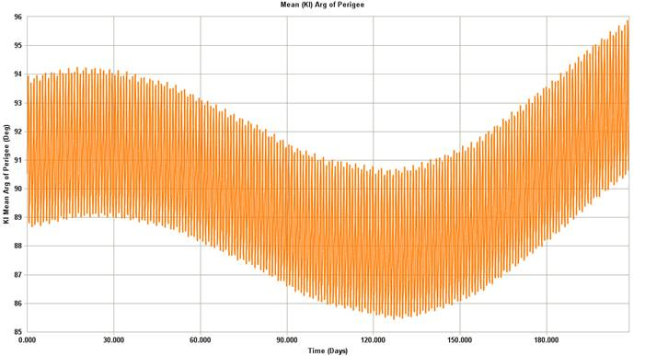

I didn’t go into great detail to get this precisely where we’d want it, but I could. The point is that I used the positioning of the maintenance maneuvers to get the Mean Arg of Perigee to do what I want. This is what you’d really do.

I used the spacecraft masses and areas you suggested, but I didn’t have a fuel number so I just used 10 km and didn’t have the maneuvers decrement the fuel.

To be clear, I set this up as a test case. The purpose of this test case is to demonstrate how such a problem could be set up in STK. This should not be substituted for real analysis (which I could do) nor should anyone take numbers from this scenario and use them as-is to baseline anything. This should be considered “back-of-the-envelope” analysis.

What I’m getting at here is that I don’t want someone with this un-named customer to show up 2 years from now at some government agency saying that “Mike Loucks said these numbers were right”. This is meant as a demo really, and shouldn’t be substituted for actual analysis (which again, I can be paid to do but is normally outside of what AGI provides for customers).

Take a look, and give me a call if you have questions. I’ve put a stop after the first loop so that the ephem isn’t too big. Take it out and run it (it will take 10 min or so) if you want to see the whole thing.

Mike

Michel E. Loucks | Owner, Principal Astrodynamics Scientist
Space Exploration Engineering Co.
687 Chinook Way, Friday Harbor WA 98250
 Office: 360 378 7168 |  Cell: 360 317 5527 | : loucks@see.com | : www.see.com

