**PILOT PPS MISOPHONIA – PILOT REPORT**

# Sample descriptives

Total of 7 participants – none of them reported sensory deficits (visual, tactile or auditory)

* Control group (HC)
  + 3 participants (2 males)
  + All right-hand dominance
  + Age = 41.7 (19.9)
  + Screening questionnaire = 65.0 (11.3)[1]
* Misophonia Group (MS)
  + 4 participants (3 females, 1 Non-Binary)
  + One left-hand dominance
  + Age = 39.0 (14.6)
  + Screening questionnaire = 142.0 (26.8)

# PPS task description (Figure 1)

* One neutral (Beep) and one trigger (Vid_10) frontal looming sound
* Audio volume 70%
* Tactile stimulation delivered after 0.5, 1, 1.5, 2, and 2.5 seconds after the trial starts
* Inter-trial interval 1.5 seconds
* Sound total duration 3 seconds
* N = 80 (16*5 distances) auditory tactile trials,
* N = 16 (20% of 80) catch auditory-only trials
* N = 8 unimodal tactile trials
* 2 blocks per sound type
* Tactile stimulation applied on the chest – intensity was adjusted so that the vibration was detected by the participant but it did not cause pain
* Audio volume: 70%

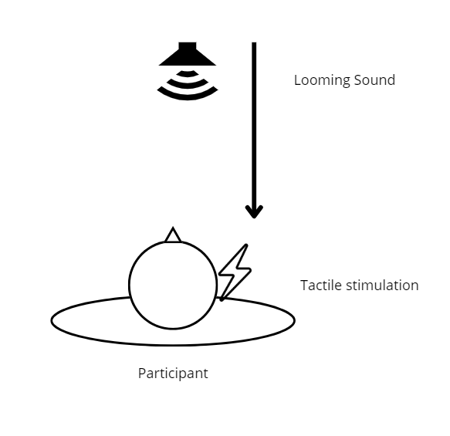

*Figure 1*. Participants must respond as quickly as possible to tactile stimulation applied on their chest while a task-irrelevant looming auditory stimulus is approaching them. There are three different types of trials: catch trial (only auditory stimulation), unimodal trial (only tactile stimulation delivered after different distances/seconds after the trial starting – baseline), and bimodal trial (the tactile stimulation is applied while the looming sound is approaching the participant after 5 different possible delays from the trial starting – critical trials).

# Analysis

No outliers were removed.

Descriptive statistics are reported.

No inferential statistical analysis ( t-test, ANOVA) was performed because of the limited sample size.

1. Reaction Times (RTs)- Descriptives for bimodal trials by Group, Stimulus and trigger.time

|  |  |  |  |  |  |  |  |  |  |  |  |  |  |  |  |  |  |  |  |  |  |  |  |  |  |  |  |  |  |  |  |  |  |  |  |  |  |  |  |  |  |  |  |  |  |  |  |  |  |  |  |  |  |  |  |  |  |  |  |  |  |  |  |  |  |  |  |  |  |  |  |  |  |
| --- | --- | --- | --- | --- | --- | --- | --- | --- | --- | --- | --- | --- | --- | --- | --- | --- | --- | --- | --- | --- | --- | --- | --- | --- | --- | --- | --- | --- | --- | --- | --- | --- | --- | --- | --- | --- | --- | --- | --- | --- | --- | --- | --- | --- | --- | --- | --- | --- | --- | --- | --- | --- | --- | --- | --- | --- | --- | --- | --- | --- | --- | --- | --- | --- | --- | --- | --- | --- | --- | --- | --- | --- | --- |
| |  |  |  | | --- | --- | --- | | **HC** | | | | **Stimulus** | **Trigger Time** | **Mean_RT (SD)** | | Neutral | 0.5 | 0.30 (0.13) | | Neutral | 1 | 0.27 (0.09) | | Neutral | 1.5 | 0.23 (0.05) | | Neutral | 2 | 0.23 (0.06) | | Neutral | 2.5 | 0.24 (0.08) | | Trigger | 0.5 | 0.29 (0.10) | | Trigger | 1 | 0.31 (0.13) | | Trigger | 1.5 | 0.25(0.08) | | Trigger | 2 | 0.25 (0.08) | | Trigger | 2.5 | 0.24 (0.06) | | |  |  |  | | --- | --- | --- | | **MS** | | | | **Stimulus** | **Trigger Time** | **Mean_RT (SD)** | | Neutral | 0.5 | 0.31 (0.10) | | Neutral | 1 | 0.29 (0.07) | | Neutral | 1.5 | 0.28 (0.08) | | Neutral | 2 | 0.28 (0.11) | | Neutral | 2.5 | 0.28 (0.09) | | Trigger | 0.5 | 0.30 (0.10) | | Trigger | 1 | 0.30 (0.11) | | Trigger | 1.5 | 0.30 (0.10) | | Trigger | 2 | 0.29 (0.07) | | Trigger | 2.5 | 0.29 (0.08) | |

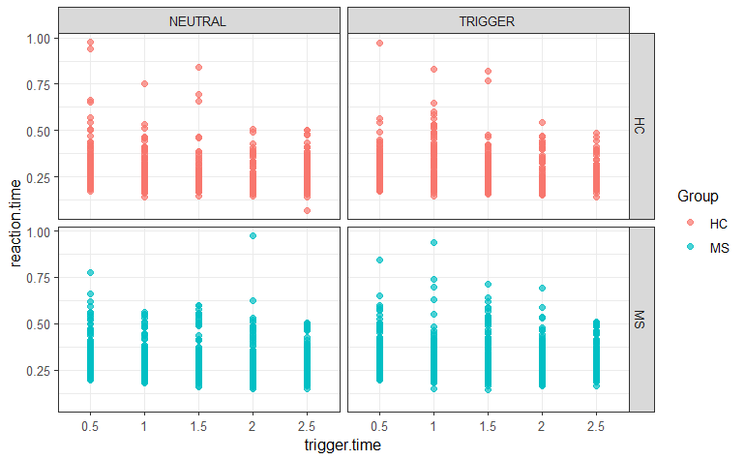

1. Peripersonal Space (PPS)

2.1 Corrected RTs calculation

Calculate the mean reaction time (Unimodal_mean) for each participant (ID) for unimodal trials (T). This represents the time they usually need to react to a tactile stimulus, and it is used as a baseline to normalize bimodal trial RTs.

Subtract to each reaction. time in bimodal trials (VT1, VT2, VT3, VT4, VT5) the Unimodal_mean for each participant (ID) to obtain Corrected_RT (diff_reaction_time).

|  |  |  |  |  |  |  |  |  |  |  |  |  |  |  |  |  |  |  |  |  |  |  |  |  |  |  |  |  |  |  |  |  |  |  |  |  |  |  |  |  |  |  |  |  |  |  |  |  |  |  |  |  |  |  |  |  |  |  |  |  |  |  |  |  |  |  |  |  |  |  |  |  |  |
| --- | --- | --- | --- | --- | --- | --- | --- | --- | --- | --- | --- | --- | --- | --- | --- | --- | --- | --- | --- | --- | --- | --- | --- | --- | --- | --- | --- | --- | --- | --- | --- | --- | --- | --- | --- | --- | --- | --- | --- | --- | --- | --- | --- | --- | --- | --- | --- | --- | --- | --- | --- | --- | --- | --- | --- | --- | --- | --- | --- | --- | --- | --- | --- | --- | --- | --- | --- | --- | --- | --- | --- | --- | --- |
| |  |  |  | | --- | --- | --- | | **HC** | | | | **Stimulus** | **Trigger Time** | **Corret_RT (SD)** | | Neutral | 0.5 | -0.01 (0.10) | | Neutral | 1 | -0.05 (0.08) | | Neutral | 1.5 | -0.07 (0.07) | | Neutral | 2 | -0.08 (0.06) | | Neutral | 2.5 | -0.07 (0.06) | | Trigger | 0.5 | -0.04 (0.09) | | Trigger | 1 | -0.01 (0.08) | | Trigger | 1.5 | -0.05 (0.07) | | Trigger | 2 | -0.05 (0.04) | | Trigger | 2.5 | -0.05 (0.04) | | |  |  |  | | --- | --- | --- | | **MS** | | | | **Stimulus** | **Trigger Time** | **Correc_RT (SD)** | | Neutral | 0.5 | -0.03 (0.10) | | Neutral | 1 | -0.06 (0.08) | | Neutral | 1.5 | -0.07 (0.10) | | Neutral | 2 | -0.06 (0.08) | | Neutral | 2.5 | -0.05 (0.09) | | Trigger | 0.5 | -0.05 (0.10) | | Trigger | 1 | -0.04 (0.10) | | Trigger | 1.5 | -0.04 (0.08) | | Trigger | 2 | -0.07 (0.06) | | Trigger | 2.5 | -0.05 (0.07) | |

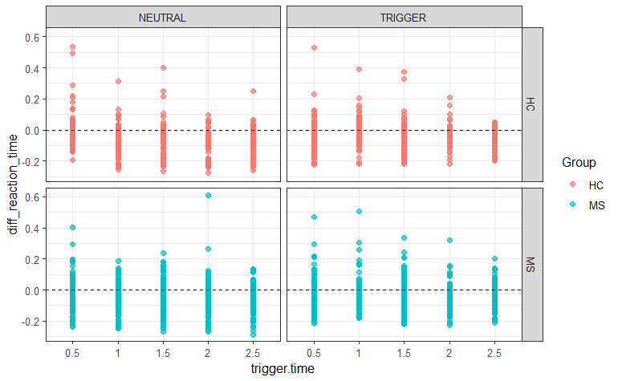

* 1. Linear Fitting (based on Serino et al. 2021[2])

Corrected RTs were fitted to a linear function and the relative slopes were extracted as indexes of segregation between the peripersonal and extrapersonal space. The following equation describes the linear function:

*y(x) = y0+ k · x*

where x represents the independent variable (i.e., the timing of tactile stimulation in ms), y the dependent variable (i.e., the reaction time), y0 represents the intercept at x = 0 and k is the slope of the linear function. Accordingly, the estimated parameters were the intercept (y0) and the slope (k) [3].

|  |  |  |  |  |  |  |
| --- | --- | --- | --- | --- | --- | --- |
| **Group** | **Stimulus** | **Mean_Slope** | **Sd_Slope** | **Mean_Intercept** | **Sd_Intercept** | **Mean_R^2** |
| HC | Neutral | *-0.03* | 0.01 | -0.01 | 0.02 | 0.79 |
| HC | Trigger | *-0.01* | 0.008 | -0.02 | 0.02 | 0.50 |
| MS | Neutral | *-0.01* | 0.01 | -0.04 | 0.06 | 0.27 |
| MS | Trigger | *-0.005* | 0.01 | -0.04 | 0.04 | 0.35 |

|  |  |
| --- | --- |
| Mean Slopes Stimulus * Group |  |
| Fitted Lines Stimulus * Group |  |

1. Sound Ratings (questionnaires)

VAS - concerning how much the sound made them upset and distressed - and Self Assessment Mannequin

|  |  |
| --- | --- |
| Neutral sound | Trigger sound |
| | Descriptive statistics | | | | | | | | | --- | --- | --- | --- | --- | --- | --- | --- | |  | | **Group** | | **Mean** | | **SD** | | | **Upset_neutral** |  | *HC* |  | *0.00* |  | *0.00* |  | |  |  | *MS* |  | *3.75* |  | *2.87* |  | | **Distress_neutral** |  | *HC* |  | *0.00* |  | *0.00* |  | |  |  | *MS* |  | *2.50* |  | *1.91* |  | | **Valence_neutral** |  | HC |  | 3.00 |  | 0.00 |  | |  |  | MS |  | 2.00 |  | 0.81 |  | | **Arousal_neutral** |  | *HC* |  | *1.67* |  | *1.15* |  | |  |  | *MS* |  | *3.75* |  | *0.95* |  | | **Dominance_neutral** |  | HC |  | 3.33 |  | 0.57 |  | |  |  | MS |  | 2.50 |  | 1.00 |  | |  | | | | | | | | | | Descriptives statistics | | | | | | | | | --- | --- | --- | --- | --- | --- | --- | --- | |  | | **Group** | | **Mean** | | **SD** | | | **Upset_trigger** |  | *HC* |  | *2.33* |  | *2.51* |  | |  |  | *MS* |  | *6.00* |  | *2.94* |  | | **Distress_trigger** |  | *HC* |  | *1.67* |  | *2.88* |  | |  |  | *MS* |  | *5.00* |  | *2.44* |  | | **Valence_trigger** |  | *HC* |  | *2.67* |  | *0.57* |  | |  |  | *MS* |  | *1.75* |  | *0.95* |  | | **Arousal_trigger** |  | HC |  | 3.33 |  | 1.15 |  | |  |  | MS |  | 3.75 |  | 0.50 |  | | **Dominance_trigger** |  | HC |  | 3.67 |  | 0.57 |  | |  |  | MS |  | 3.50 |  | 0.57 |  | |  | | | | | | | | |
| *In italics are reported noticeable discrepancies. | |

Other “trigger” sounds ratings

| Descriptives statistics | | | | | | | | | | | | | | | |
| --- | --- | --- | --- | --- | --- | --- | --- | --- | --- | --- | --- | --- | --- | --- | --- |
|  | | **Group** | | **V05_Upset** | | **V05_Distress** | | **V17_Upset** | | **V17_Distress** | | **V16_Upset** | | **V16_Distress** | |
| **Mean** |  | HC |  | 0.00 |  | 0.00 |  | 0.66 |  | 0.00 |  | 1.00 |  | 0.33 |  |
|  |  | MS |  | 6.25 |  | 3.75 |  | 5.25 |  | 4.25 |  | 7.50 |  | 5.50 |  |
| **SD** |  | HC |  | 0.00 |  | 0.00 |  | 1.15 |  | 0.00 |  | 1.73 |  | 0.57 |  |
|  |  | MS |  | 0.95 |  | 2.50 |  | 0.50 |  | 1.50 |  | 2.08 |  | 2.38 |  |
|  | | | | | | | | | | | | | | | |

1. One control did not perform the screening questionnaire – he did the task before we decided the questionnaire
2. Serino, S., Trabanelli, S., Jandus, C., Fellrath, J., Grivaz, P., Paladino, M. P., & Serino, A. (2021). Sharpening of peripersonal space during the COVID-19 pandemic. Current Biology, 31(14), R889-R890.
3. The code for the linear fitting was adapted from peripersonal space analysis we performed for patients with Anorexia