Training Sessions – Mapping Exercises

Prepared by Max G.A. Guddat & Anders M. Odgaard & Magda Kowalska, PlanEnergi & Marcus Hummel, e-think

Revised by Giulia Conforto, e-think

June 2020

Project Information

08

Fall

|  |  |
| --- | --- |
| * Project name | **Hotmaps** – Heating and Cooling Open Source Tool for Mapping and Planning of Energy Systems |
| * Grant agreement number | 723677 |
| * Project duration | 2016-2020 |
| * Project coordinator | Lukas Kranzl  Technische Universität Wien (TU Wien), Institute of Energy Systems and Electrical Drives, Energy Economics Group (EEG)  Gusshausstrasse 25-29/370-3  A-1040 Wien / Vienna, Austria  Phone: +43 1 58801 370351  E-Mail: [kranzl@eeg.tuwien.ac.at](mailto:kranzl@eeg.tuwien.ac.at)  [**info@hotmaps-project.eu**](mailto:info@hotmaps-project.eu)  [www.eeg.tuwien.ac.at](http://www.eeg.tuwien.ac.at/)  [www.hotmaps-project.eu](http://www.hotmaps-project.eu) |
| * Lead author of this report | Max Gunnar Ansas Guddat  PlanEnergi  +45 2386 2482  mgag@planenergi.dk &  Marcus Hummel  e-think  hummel@e-think.ac.at |

Legal notice

The sole responsibility for the contents of this publication lies with the authors. It does not necessarily reflect the opinion of the European Union. Neither the INEA nor the European Commission is responsible for any use that may be made of the information contained therein.

All rights reserved; no part of this publication may be translated, reproduced, stored in a retrieval system, or transmitted in any form or by any means, electronic, mechanical, photocopying, recording or otherwise, without the written permission of the publisher. Many of the designations used by manufacturers and sellers to distinguish their products are claimed as trademarks. The quotation of those designations in whatever way does not imply the conclusion that the use of those designations is legal without the consent of the owner of the trademark.

The Hotmaps project

The EU-funded project Hotmaps aims at designing a toolbox to support public authorities, energy agencies and urban planners in strategic heating and cooling planning on local, regional and national levels, and in line with EU policies.

In addition to guidelines and handbooks on how to carry out strategic heating and cooling (H&C) planning, Hotmaps will provide the first H&C planning software that is

* **User-driven**: developed in close collaboration with 7 European pilot areas
* **Open source**: the developed tool and all related modules will run without requiring any other commercial tool or software. Use of and access to Source Code is subject to Open Source License.
* **EU-28 compatible**: the tool will be applicable for cities in all 28 EU Member States

The consortium behind



Executive Summary

Exercises for the Hotmaps Online Training.

1 Exercise 1: Mapping of heat demand and resource potentials 5

Tutorial, Wiki and Handbooks 5

Disclaimers 6

1.1 User account 6

1.2 Overview Map 7

1.3 Climate Indicators 8

1.4 Visualisation of a heat demand density map 9

1.5 Heating and Cooling Demand 10

1.6 a heat demand with another city 12

1.7 Download the heat demand 12

1.8 Upload a raster file (heat density map) 13

1.9 Identify available RES potentials 14

1.10 Identify excess heat from conventional sources 16

Calculation Modules Exercises 16

2 Exercise 2: Calculation of decentral heat supply costs 18

2.1 CM - Demand projection 18

2.2 CM - Decentral heating supply 20

2.2.1 Decentral heating supply - Single family- Terraced houses 20

2.2.2 Decentral heating supply - Multifamily houses 21

2.2.3 Calculating the cost of individual heating technologies based on a mix of ten different building typologies. 22

1. Exercise 1: Mapping of heat demand and resource potentials

The Hotmaps toolbox is an energy mapping tool which allows capturing heating and cooling demand and potential of renewable sources at different territorial level. This provides a geographical representation of default data in the toolbox as well as local data sources uploaded directly to the toolbox. This document aims to demonstrate the functionality of the mapping tool through a range of exercises.

The exercises in this guide have the following structure:

* Task.
* Detailed step-by-step guide.
* Feedback with the space for own comments that could be later reported to the toolbox authors.

Some exercises have also an introduction and research question to answer to.

Tutorial, Wiki and Handbooks

Before addressing the mapping exercises, please watch this video tutorial: <https://www.hotmaps-project.eu/how-to-use-hotmaps/>

If at any time you fell that you want to understand better the toolbox functionalities, please visit the Hotmaps Wiki, always accessibleunder the link: <https://wiki.hotmaps.hevs.ch/en/Welcome>

If you feel that you would like to deepen further your understanding of the reasoning behind the Hotmaps calculation modules and the theory of strategic heating and planning, please refer to the Hotmaps Handbooks:

* [Summary of the Hotmaps Handbooks for strategic heat planning](https://www.hotmaps-project.eu/wp-content/uploads/2019/04/Summary-Hotmaps-Handbook.pdf)
* [Handbook 1 – Definition & experiences of strategic heat planning](https://vbn.aau.dk/da/publications/definition-amp-experiences-of-strategic-heat-planning)
* [Handbook 2 – Guidance for comprehensive assessment of efficient heating and cooling](https://vbn.aau.dk/da/publications/guidance-for-the-comprehensive-assessment-of-efficient-heating-an)
* [Appendix report to the Handbook for strategic heat planning: Case descriptions](https://vbn.aau.dk/da/publications/appendix-report-to-the-hotmaps-handbook-for-strategic-heat-planni)

Disclaimers

**SERVERS**: The Hotmaps toolbox is a living platform: as the research project evolves, new functionalities are refined and bugs are addressed and solved. The toolbox is hosted in two environments: the development server and the production server. The development server has the most up-to-date version, with most of issues and bugs solved, but it might be instable as developer keep working on it daily. The production server instead is a stable environment as it has the last released version, although there the most recently reported bugs had not been solved yet. We recommend that you complete your training on the Production server.

Production Server: [https://www.hotmaps.hevs.ch/map](https://www.hotmapsdev.hevs.ch/map)

Development Server: <https://www.hotmapsdev.hevs.ch/map>

**BROWSER**: The Hotmaps toolbox is fully compatible with Chrome and Firefox, while a number of incompatibilities have been reported when accessed through Microsoft Edge and Internet Explorer. Therefore, we recommend that you complete your training accessing the toolbox through Chrome or Firefox. At the time of writing this training material, June 2020, the recommended compatible versions are: Chrome version 83.0.4103.61 and Firefox version 76.0.1. For the most up to date indications, please see the disclaimer visualized accessing the development server.

* 1. User account

Exercise: Create a user account (register).

Step-by-step procedure:

* Click on the ‘Connect’ button in the top left corner and follow the instructions. Use your email address as username.
* Open your mailbox and click on the activation link in the email that you should have received. This step is fundamental to activate your account, if you skip it, you will not be able to access your account. In case you did not receive the email with the activation link, go through the registration a second time. If required, use another email address. If you still have issues, please contact the training team.
* Once you have created an account, click again on the to bottom on the top left corner which is now called ‘Account’. The account window will pop up in the middle of the screen.
* Here you can amend user details, preview available storage space and upload your own data from local drive as you will learn in section 1.8.
* You can leave the account window by clicking the cross in the top right corner or anywhere outside of the account window.

|  |
| --- |
| Please provide feedback on this functionality here: |

IMPORTANT NOTE: Please be aware that the browser window with the toolbox needs to be refreshed regularly, if left idle for some time, when refreshing it, the user may be signed off of his account, losing some of his latest work and having to sign back in.

* 1. Overview Map

Exercise: Generate an overview map of your city.

All exercises in this training will be done on the city of Tomaszów Mazowiecki. Please make sure that you use this city so that your results can be easily checked by the trainers and your questions and experience can be discussed with the other participants in the support sessions.

Step-by-step procedure:

* Access Hotmaps and select the ‘LAU2’ in the territorial NUTS scale on the right-hand side of the screen.
* Find the city of Tomaszów Mazowiecki on the map and select it. You can use the search tool in the top left corner ’Go to place’ and type there the location name or move the map with the mouse to the desired area and click on the bounding box that contains the city of Tomaszów Mazowiecki.
* Use the Windows snipping tool  to take a picture and insert it here:

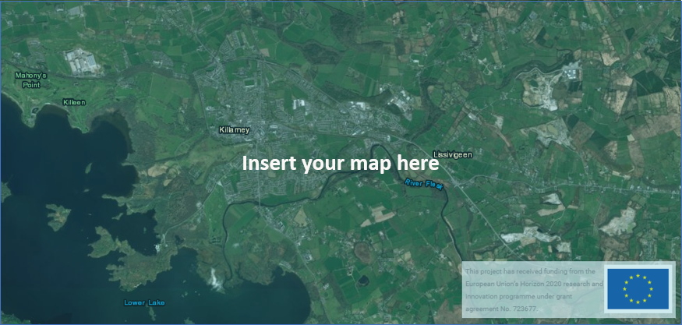

|  |
| --- |
| Please provide feedback on this functionality here: |

* 1. Climate Indicators

Exercise: List for the city of Tomaszów Mazowiecki the climate indicators: heating degree days (HDD) and cooling degree days (CDD).

Step-by-step procedure:

* Open the ‘Layers’ panel using the icon .
* Select ‘Heating degree days’ and ‘Cooling degree days’ from the left panel.
* Choose ‘Load results’.
* Copy and paste the required results from the right panel of Hotmpas, to the spreadsheet ‘Exercise 1 and 2.xls’ tab 1.3 Climate Indicators.

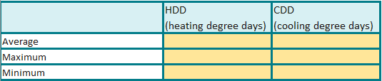

**Fill out in the spreadsheet**

|  |
| --- |
| Please provide feedback on this functionality here: |

* 1. Visualisation of a heat demand density map

Exercise: Generate a heat demand density map for your area based on the default data in the toolbox.

Step-by-step procedure:

* Zoom to the location that you want to analyse and click on the bounding box that contains the city of Tomaszów Mazowiecki. Hotmaps allows to selects the desired area at several territotial levels, clicking on the relevant cells or drawing the location boundaries with the drawing tool 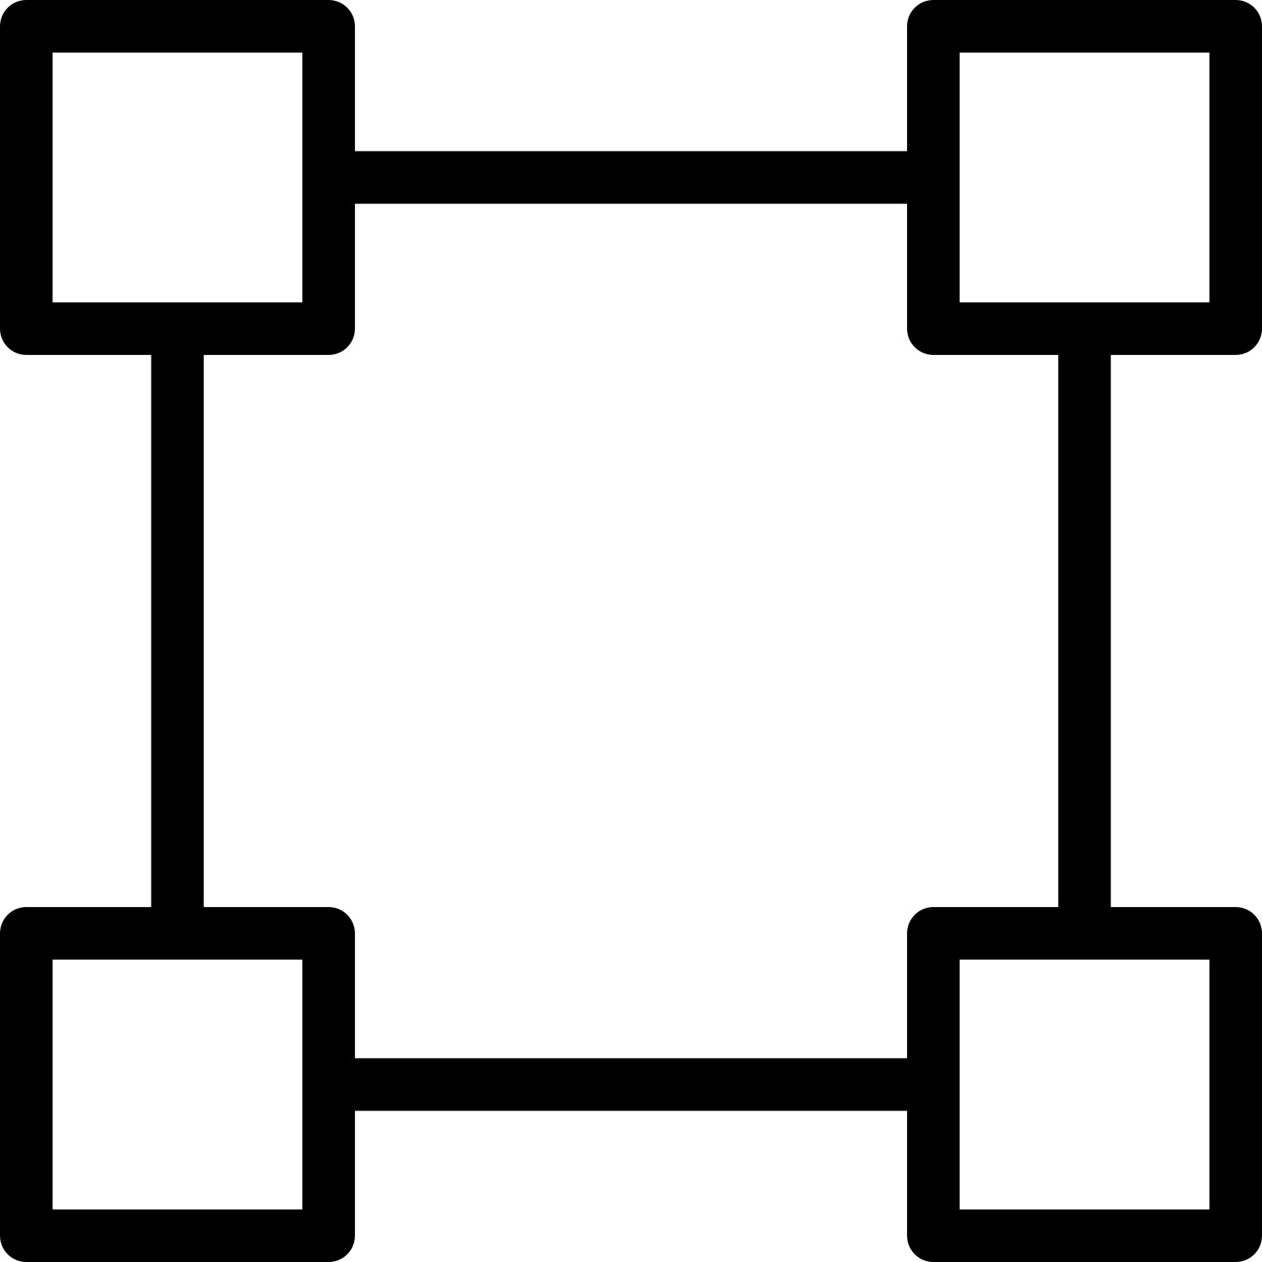.
* Select the layer ‘Heat density total’ and click on the symbol for Symbology of the ‘Heat density total’ layer  to see the color coding of the the heat demand density map.
* Save your current selection of cells and zoom level with the button ‘Save’  located in the top left menu. You will have to name your session and provide an optional description. You can retrieve it anytime through the button ‘Folder’  .
* Use the snipping tool  to take a picture including both the city map and the legend and insert it here:



IMPORTANT NOTE: The area you analyse should have at least 30 GWh of heat demand per year. It is also recommended to perform all analyses for the same area: Tomaszów Mazowiecki.

|  |
| --- |
| Please provide feedback on this functionality here: |

**IMPORTANT NOTE**: Please note that the heat demand density layers are expressed in terms of final energy, not in terms of useful energy. In order to calculate these layers in terms of useful energy, you can either scale the single output, multiplying them by the average efficiency factor for heating systems in the selected area, or you can use the calculation module “Scale heat and cool density map”, indicating the average efficiency factor for heating systems in the selected area, and the module will produce the heat demand density map in terms of useful energy. You can then download, save and use that map and data for further analysis.

* 1. Heating and Cooling Demand

Research question: What parameters can be considered in the heating and cooling mapping? What proportion of the total heating needs constitutes the residential and non-residential customers?

Exercise: Retrieve the heat and cold demand of the city of Tomaszów Mazowiecki based on LAU/NUTS borders and based on bespoke borders selected on your own.

Step-by-step procedure:

* Zoom to the location that you want to analyse, click on the bounding box that contains the city of Tomaszów Mazowiecki. Make sure you remain at the scale ‘LAU2’.
* Select the following categories in the left panel ‘Layers’:
* Heat Density Total
* Heat Density Residential Sector
* Heat Density Non-Residential Sector
* Cooling Density Total
* Population Total
* Gross Floor Area Total
* Gross Floor Area Residential
* Gross Floor Area Non-Residential
* Click ‘Load results’ these are shown together with the other layers previously selected. If you want to visualize only new results, unflag previously selected items.
* Manually copy and paste the required results in the NUTS/LAU column in the tab ‘1.5 Heating and cooling demand’ of the spreadsheet ‘Exercise 1 and 2.xls’. As some results have the same name for different layers, the layer is indicated in brackets e.g. Heat demand total (TOTAL) refers to the result ‘Heat demand total’ of the layer ‘Heat Dendisty Total’
* Go to the ‘Graphics’ section in the Results right panel to read the minimum and maximum heat demand respectively from the minimum and the maximum demand curve.

IMPORTANT NOTE: Please make sure that the layer Population is selected before loading results, as the toolbox can calculate the values “Heat demand per person” and “Theoretical cooling needs per person” only when the Population layer has been selected.



**To fill out in the spreadsheet**

|  |
| --- |
| Please answer the research question here: |

|  |
| --- |
| Please provide feedback on this functionality here: |

* 1. a heat demand with another city

Research question: How different is the heat demand for your city and the neighbouring city?

**Exercise: Compare the heat demand and other indicators just loaded for your own city, with the values for another city (e.g. a neighbouring city, a city with similar size, a partner city, your current city…)**

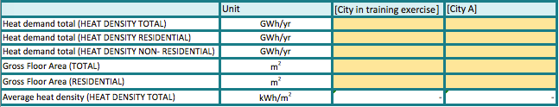

**To fill out in the spreadsheet**

|  |
| --- |
| Please provide feedback on this functionality here: |

* 1. Download the heat demand

|  |
| --- |
| Please answer to the research question: |

Research question: is it possible to collect and save the results of the energy mapping?

Exercise: Download the heat demand density map as a raster file and save it to your computer.

Step-by-step procedure:

* Download the heat demand density map as a raster file and save it to your computer by clicking on the ‘Download layer selection’ symbol  below the layer ‘Heat demand density’.

**IMPORTANT NOTE**: Please make sure to use one of the recommended browsers to complete this step. Issues such as not downloading any file or downloading an empty file have been reported when accessing the toolbox with other browsers. If the issue persists, please contact the training team.

**IMPORTANT NOTE**: Please remember as explained in paragraph 1.4 that the heat demand density layers are expressed in terms of final energy, not in terms of useful energy. In order to calculate these layers in terms of useful energy, you can either scale the single output, multiplying them by the average efficiency factor for heating systems in the selected area, or you can use the calculation module “Scale heat and cool density map”, indicating the average efficiency factor for heating systems in the selected area, and the module will produce the heat demand density map in terms of useful energy. You can then download, save and use that map and data for further analysis.

|  |
| --- |
| Please answer to the research question: |

* 1. Upload a raster file (heat density map)

|  |
| --- |
| Please provide feedback on this functionality here: |

Exercise: Upload the own data to the Hotmaps toolkit.

Step-by-step procedure:

* Unselect all the layers in the left panel.
* Log-in to your user account and then click on the ‘account’ button.
* Click on ‘Select files’ in the right bottom corner of the account window and proceed to your storage folder to upload your files.
* The format accepted is .tif. Looked up the file to upload from your computer using the ‘Select file’ button located at the bottom of the account window. Specify the category of data from the drop-down list to the left of the ‘Select file’ button. You should select the same category of data used for the raster file that you downloaded from your own selection of the ‘Heat density total’ layer in section 1.7.
* Click the ‘Upload layer’ button. The uploaded layer will emerge on at the top of the left layer panel and can be used in analogical ways as the embedded layers.

**IMPORTANT NOTE**: Please make sure to use one of the recommended browsers to complete this step. Issues such as not uploading any files or uploading an empty file have been reported when accessing the toolbox with other browsers.

|  |
| --- |
| Please provide feedback on this functionality here: |

* 1. Identify available RES potentials

Research question: What are the possibilities for the transition to renewable energy in the city? What are the available RE resources in the proximity and how much energy they are able to generate?

Exercise: Identify available RES potentials in and around the city of Tomaszów Mazowiecki.

Step-by-step procedure:

* Click again on the city of Tomaszów Mazowiecki and select the relevant layers for RES sources indicated in the relevant Group table in ‘Exercise 1 and 2.xls’ Click ‘Load Results’ and complete the ‘Figure’ column of the spreadsheet.
* Check the [WIKI](https://wiki.hotmaps.hevs.ch/en/Hotmaps-open-data-repositories#renewable-energy-source-potential) to know more about the different renewable energy potential data (what do they mean, how they have been calculated).
* Look at the collected numbers and try to assess which proportion of the identified RES sources can be realistically exploited for the energy production purpose based on your own knowledge. Indicate % in the corresponding column.

**IMPORTANT NOTE**: The parameter "exploitable potential" is not an output of thetoolbox. You are asked here to evaluate which share of the gross potential you consider exploitable in percentage. It is hard to give a qualified estimate if you do not know the specific city, but just try as this training is more about understanding how to use the toolbox. Close-to-real scenarios can always be developed once you work with strategies for cities you may know better than Thomaszow Mazowiecki, PL. The absolute exploitable potential is derived by multiplying the percentage times the gross potential. E.g. forest residues: 4MWh/ha/yr or 2,32 GWh/yr for the LAU2 region. If you find this figure too high you may assess that e.g. only 75% is realistically exploitable, i.e. 3 MWh/ha/yr or 1.74 GWh/yr.

**IMPORTANT NOTE**: For “spatial” RES potential please consider expanding the area of investigation to the hinterland of the city and not just harvest the areas close to the city center. Always check the max resolution of each RES: you may not find enough RES potential in the cell of the city you are analysing at LAU2 level, but there could be available potential in the cells around it (e.g. excess heat or waste water) or at a higher level (e.g. wind and geothermal potential = 0 at LAU2, but populated at NUTS3). At the same time, while considering a wider area, please do not go too far either, as some sources could not be exploitable if too distant (e.g. excess heat from an industrial site not in the same cell, but not further than 20-30km from the area selected for a distric heating assessment).

**IMPORTANT NOTE**: Pay attention to the indicated maximum resolution for each RES potential, as not all sources were spatialised at the maximum resolution of 1 hectare (ha). Some categories are available only down to the NUTS3 scale. Others have been disaggregated to the ha-resolution based on the original data sourced from NUTS3. Waste-water plants, on the other hand, are indicated specifically by the location points, and the results in the right panel will correspond to only the plants situated within the area of selection.

|  |
| --- |
| Answer to the research question(s): |

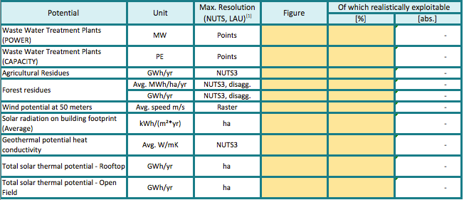

**To fill out in the spreadsheet**

|  |
| --- |
| Please provide feedback on this functionality here: |

* 1. Identify excess heat from conventional sources

Research question: are there available excess heat sources in the neighbourhood to supply the heating demand of the city? Are they sufficient to cover heating needs? To what extend?

Exercise: Identify excess heat from conventional sources in and around the city of Tomaszów Mazowiecki.

Step-by-step procedure:

* Go to the Layer-Group ‘Industry’ and select the following layers:
* Industrial Sites Emissions
* Industrial Sites Excess Heat
* Identify excess heat from conventional sources in the region and fill out the following table in the spreadsheet ‘Exercise 1 and 2.xls’, tab 1.10 Excess heat potentials.

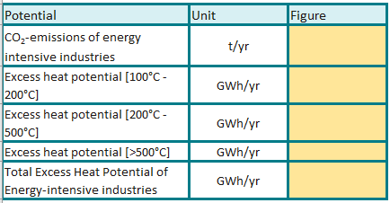

**To fill out in the spread-sheet**

|  |
| --- |
| Answer to the research question(s): |

|  |
| --- |
| Please provide feedback on this functionality here: |

Calculation Modules Exercises

**IMPORTANT NOTE**: In order to be able to use any calculation module it is necessary to select an area.

**IMPORTANT NOTE**: The more calculations are performed in parallel on the server, the longer it takes to receive results from the calculation modules. For some calculation modules and parameter settings this might take several minutes.

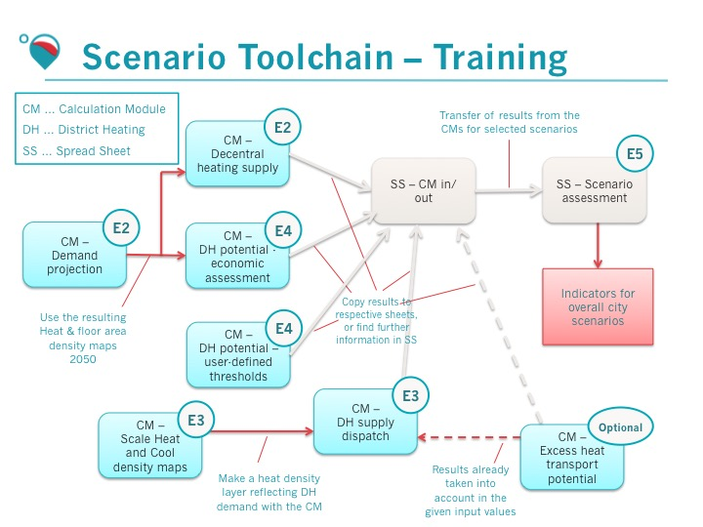

Figure 1: Scenario toolchain followed in the training

In course of the Hotmaps training you are going to use several Calculation Modules (CMs) of the Hotmaps toolbox. With these you are going to calculate scenarios and analyse sensitivities of different parts of the heating demand and supply systems of the test region of Tomaszow Mazowiecki. The following figure shows the different CMs to be used in the training.

Figure 1 shows which calculation modules are used (light blue boxes) and for which Exercise (small dot on the corner of the boxes), how they interact with other CMs (red arrows), the spreadsheet files (grey arrows). The results from most calculations with the CMs should be transferred to the spreadsheet file ‘Exercise 1 and 2.xls’. There they are compared against each other.

The training of the calculation modules is split into the calculation of decentral heat supply costs, calculation of district heating supply costs and calculation of district heating distribution costs. The findings of this alternative heat supply options are then combined into the complete and consistent scenarios for the region for the analysis and comparison.

For an overview of the filenames please watch the introductory presentation. For a more detailed explanation of each calculation module, please refer to the Hotmaps Wiki: <https://wiki.hotmaps.hevs.ch/en/Welcome>

1. Exercise 2: Calculation of decentral heat supply costs
   1. CM - Demand projection

This module generates both a heat demand density and a floor area density map in the form of raster files. The input to the module is a default development scenario of the heat demand and gross floor areas for each raster element as well as parameters to describe the relative deviation to these default developments.

Research question: What is the current energy demand for heating (2014) and what are scenarios how this demand might change in the future (2050) taking into consideration energy efficiency measures and the development of the building stock?

Exercise: Calculate different scenarios of heat demand development for the test region with different assumptions regarding the reduction of specific energy needs in buildings from different construction periods. Download the resulting heat demand and gross floor area density maps.

Step-by-step procedure:

* Go to the ‘Exercise 1 and 2.xls’ tab ‘2.1 Demand projection’ where you will find a list of input parameters for that CM.
* ‘Default data’ column indicates the parameters that are indicated in the Hotmaps tool by default. You should perform new scenarios (‘reference25’ etc.) by changing the parameters marked in dark blue (see colour code in the first sheet “Content” of the same spreadsheet file).
* Go to the Hotmaps toolbox and select the ‘LAU2’ in the territorial NUTS scale on the right-hand side of the screen.
* Find on the map and select the city of Tomaszów Mazowiecki. You can use the search tool in the top left corner ’Go to place’ and type there the location name or move the map with the mouse to the destined area and click on the bounding box that contains the city of Tomaszów Mazowiecki.
* In the left panel, go on “calculation modules” and then set the input parameters in the ‘CM – Demand projection’ according to the values presented in the spreadsheet file for the first scenario for this CM.
* Type in a name for the calculation you are going to perform (you can use a random title).
* Run the CM by clicking on the button “RUN CM”.
* When the calculation is ready you can find the calculated indicators in the results section in the right panel of the toolbox window, you can see also the results in the graphics tab.
* Notice the difference between the heated gross floor area in 2014 and in 2050, as well as for energy consumption. Report the figures in the spreadsheet. The figures for 2014 do not change in the performed runs, hence they can be read at any time.
* The calculation also yields two layers, these can be found in the layers section in the left panel (you have to close the calculation modules with ‘X’ and move to ‘Layers’) at the bottom of all available layers.
* Download the resulting layers and rename them according to the **layer names** suggested in the spreadsheet file.

**IMPORTANT NOTE**: Please be aware that this calculation module has shown a few issues, which now have been solved in the development server, but will still be present in the production server until the next release. The input parameter “Reduction of specific energy needs compared to reference scenario” has a minor effect on the output. Both the input parameters “Method to add newly constructed buildings to map”: “Add all new buildings” and “Replace only demolished buildings” calculate and add to the map a wrong number of new buildings, much higher (respectively factor 1000 and 100). Therefore the exercise is done with the input “No new buildings” for now.

Please note that in a real assessment, the CM - Demand Projection should use the heat demand in terms of useful energy, but for simplicity reasons, this training uses the heat demand in terms of final energy. In order to calculate the heat demand in terms of useful energy, you should use the calculation module “Scale heat and cool density map”, indicating the average efficiency factor for heating systems in the selected area. You could then save, download, and use the heat demand density map in terms of useful energy for further analysis.

|  |
| --- |
| Answer to the research question(s): |

|  |
| --- |
| Please provide feedback on this functionality here: |

* 1. CM - Decentral heating supply

**IMPORTANT NOTE:** Before you continue with the next steps, please follow the instructions provided in the ‘open_csv_easy.pptx’ to enable correct data copying from the csv file to the excel sheet. This is to unify decimal separator to a dot ‘.’, thousands separator to a comma ‘,’and list separator to a comma ‘,’.







Open csv file and copy the indicator values contained in the .csv file into the marked cells in the spreadsheet file for this CM. Make sure you copy only the required figures within CM section (your csv file can contain more results if other layers in Hotmaps toolkit are active).

This module calculates the costs of heat supply in buildings via decentral heating technologies. Inputs to the module are investment and O&M costs, energy prices, the hourly load profile of heat demand as well as depreciation time, interest rate and emission factors. The outputs are heat supply costs, final energy demand and CO2 emissions of various decentral heat supply technologies for a defined building.

Research question: What are the levelized costs of heat (LCOH) for individual heat supply?

Sub-question 1: What are the investment cost, operation cost and environmental impact of the individual heating technologies?

Sub-question 2: How is this differentiated for different buildings, varying by typology, age and size?

Sub-question 3: What are the possible low-carbon heat generation technologies?

Exercise: Set-up a building stock for the entire city, based on the shares of different types of buildings. Calculate and compare the costs, final energy demand and CO2 emissions of different types of buildings in the test region.

Step-by-step procedure:

* + 1. Decentral heating supply - Single family- Terraced houses
* Go to the tab ‘2.2.1 Decentral heating supply’ where you will find a list of all input parameters for that CM. In this first runs, we will analyse the useful energy consumption of Single family- Terraced houses, built in the 2 periods 1970 – 1979 and 2000-2010.
* In the toolbox, select the ‘CM - Decentral heating supply’.
* Set the input parameters according to the values presented in the spreadsheet file for the first scenario for this CM. The suggested values in the spreadsheet hereby reflect estimations of values in the **year 2050** (e.g. CO2 emission factor of electricity in 2050)
* Type in a name for the calculation you are going to perform (you can use a random title).
* Run the CM by clicking on the button “RUN CM”.
* When the calculation is ready you can find the calculated results in the right panel of the toolbox. Report the useful energy demand and the peak heat load for this type of buildings in the spreadsheet file.
* Then go to bookmark ‘Graphics’ and export results using the button ‘Export Graphs’ placed beneath all the graphs.
* Open csv file and copy the **indicator values** contained in the .csv file into the marked cells in the spreadsheet file for this CM. **Make sure you copy only the required figures within CM section** (your csv file can contain more results if other layers in Hotmaps toolkit are active), these data will be below the “heat load” data.
* Repeat the operation for Single family- Terraced houses, built in 2000-2010.
* Compare the useful energy demand and the final energy demands for the different technologies.
* Which technology has the lowest levelized cost of heat? Is it the same for the buildings built in 1970-1979 and 2000-2010?
* Which technologies show the lowest CO2 emissions?
  + 1. Decentral heating supply - Multifamily houses
* Repeat the exercise for the sheet **‘2.2.2 Decentral heating supply’** that analyses multifamily houses. Calculations for non-residential buildings have been performed in advance.
  + 1. Calculating the cost of individual heating technologies based on a mix of ten different building typologies.
* Based on the results obtained so far in this section estimation of the costs for CO2 emissions and energy consumptions of the different heating technologies in different building types, it is now possible to calculate a complete scenario for the energy community occupying a mix of building types.
* Go to the tab ‘2.2.3 Decentral heating supply’ and provide the input parameters in the yellow cells. This includes: the total final energy demand of the area, the CO2 price, the shares of energy consumptions for different building types, and the shares of the individual heating technologies in each building type (in % of the final energy consumptions). You can choose to assign any percentage to the different age categories of buildings, depending on which mix you consider more representative of the buildings stock in that area. Make sure that all percentages together sum up to a unit (100%).
* The Heat demand total can be obtained from the CM - Demand projection for based on the Energy consumption in 2050 (GWh/yr) in one of the two scenarios of your choice.
* The results comprise the entire costs of the heat supply and the CO2 emissions of the building stock (the output data table marked in red).

**IMPORTANT NOTES**: ‘Final’ energy demand accounts for generator efficiency and transmission losses. This in other words is the fuel consumption.

‘Useful’ energy demand is the pure heating demand, so the final energy demand reduced with the efficiency / losses factor. In case of e.g. heat pumps, the consumption of the heat source is not taken into account. Hence, the useful energy demand will be higher than the final energy demand as the heat pump have COP in a range between 3-6 and thus produce a few times more heat than they consume electricity.

In this simple scenario, there are buildings from only 2 construction periods (1970-1079 and 2000-2010). For each type of buildings, a share of the energy consumptions is allocated, as well as a share of heating technologies.

We assume in this exercise a total average energy saving of 30% in the period from 2014 to 2050 due to the effect of renovation activities on existing buildings, and the exchange of new buildings with higher efficiency standards replacing older ones less efficient.

The CO2 price can be chosen randomly. You can look up the current stock price in ETS per tCO2. However, this trading system has repeatedly collapsed, and we currently experience very low prices (around 30€). Many policy makers urge for higher CO2 prices to reflect both a desired market development and a higher ambition in terms of progressively increasing carbon reductions. A typical indicative future price could be 100-250 €/tCO2. You will see later on that the exercise 3.2 uses three CO2 prices: 30€, 50€ and 150€/tCO2, but these are two independent analysis of the CO2 emission costs.

In a real assessment, the heat demand in terms of useful energy should be used with this calculation module, as well as with the modules demand projection and when aasessing the expansion of the district heating grid. However, for simplicity reasons, you are not asked to produce the heat demand layer for useful energy: you simply copy paste the heat damand total value in terms of final energy in the speadsheet ‘2.2.3 Decentral heating supply’ cell E10. The spreadsheet then applies the average efficiency factor indicated in the same sheet cell B110, and runs the subsequent calculations on the estimated useful energy. In case you will use this spreadsheet with a heat density map scaled for useful energy, remember to set at 1 the efficiency factor in cell B110 of ‘2.2.3 Decentral heating supply’.

|  |
| --- |
| Answer to the research question(s): |

|  |
| --- |
| Please provide feedback on this functionality here: |