Training Sessions –Calculation Modules (CMs) Exercises

Prepared by David Schmidinger, Marcus Hummel, e-think

Revised by Magda Kowalska, PlanEnergi, Giulia Conforto, e-think

June 2020

Project Information

08

Fall

|  |  |
| --- | --- |
| * Project name | **Hotmaps** – Heating and Cooling Open Source Tool for Mapping and Planning of Energy Systems |
| * Grant agreement number | 723677 |
| * Project duration | 2016-2020 |
| * Project coordinator | Lukas Kranzl  Technische Universität Wien (TU Wien), Institute of Energy Systems and Electrical Drives, Energy Economics Group (EEG)  Gusshausstrasse 25-29/370-3  A-1040 Wien / Vienna, Austria  Phone: +43 1 58801 370351  E-Mail: [kranzl@eeg.tuwien.ac.at](mailto:kranzl@eeg.tuwien.ac.at)  [**info@hotmaps-project.eu**](mailto:info@hotmaps-project.eu)  [www.eeg.tuwien.ac.at](http://www.eeg.tuwien.ac.at/)  [www.hotmaps-project.eu](http://www.hotmaps-project.eu) |
| * Lead author of this report | David Schmidinger  e-think  +43 670 7017904  schmidinger@e-think.ac.at  &  Marcus Hummel  e-think  +43 670 70 15 799  hummel@e-think.ac.at |

Legal notice

The sole responsibility for the contents of this publication lies with the authors. It does not necessarily reflect the opinion of the European Union. Neither the INEA nor the European Commission is responsible for any use that may be made of the information contained therein.

All rights reserved; no part of this publication may be translated, reproduced, stored in a retrieval system, or transmitted in any form or by any means, electronic, mechanical, photocopying, recording or otherwise, without the written permission of the publisher. Many of the designations used by manufacturers and sellers to distinguish their products are claimed as trademarks. The quotation of those designations in whatever way does not imply the conclusion that the use of those designations is legal without the consent of the owner of the trademark.

The Hotmaps project

The EU-funded project Hotmaps aims at designing a toolbox to support public authorities, energy agencies and urban planners in strategic heating and cooling planning on local, regional and national levels, and in line with EU policies.

In addition to guidelines and handbooks on how to carry out strategic heating and cooling (H&C) planning, Hotmaps will provide the first H&C planning software that is

* **User-driven**: developed in close collaboration with 7 European pilot areas
* **Open source**: the developed tool and all related modules will run without requiring any other commercial tool or software. Use of and access to Source Code is subject to Open Source License.
* **EU-28 compatible and adaptable:** the tool will be applicable for cities in all 28 EU Member States by default and users can upload their own data

The consortium behind



Executive Summary

Exercises for the Training workshops in Hotmaps.

Calculation Modules Exercises 5

3 Exercise 3 - District heating supply costs 6

3.1 CM - Scale heat and cool density maps 6

3.2 CM – District heating supply dispatch 7

4 Exercises 4 - District heating distribution costs 9

4.1 CM - District heating potential areas: user-defined thresholds 9

4.2 CM - District heating potential: economic assessment 10

Calculation Modules Exercises

**IMPORTANT NOTE**: In order to be able to use any calculation module it is necessary to select an area.

**IMPORTANT NOTE**: The more calculations are performed in parallel on the server, the longer it takes to receive results from the calculation modules. For some calculation modules and parameter settings this might take several minutes.

In course of the Hotmaps training you are going to use several Calculation Modules (CMs) of the Hotmaps toolbox. With these you are going to calculate scenarios and analyse sensitivities of different parts of the heating demand and supply systems of the test region of Tomaszow Mazowiecki. The following figure shows the different CMs to be used in the training.

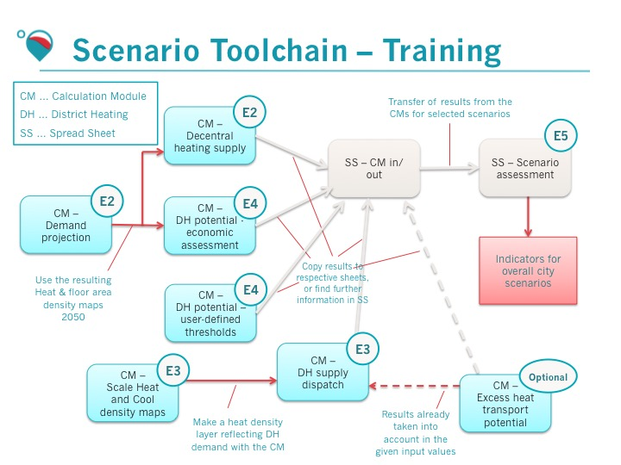

Figure 1: Scenario toolchain followed in the training

The figure shows a) which calculation modules are used (light blue boxes) and b) how they interfere with other CMs (red arrows) and the spreadsheet files (grey arrows). The results from most calculations with the CMs should be transferred to the spreadsheet ‘Exercises 3 and 4.xls’. There they are compared against each other.

The training of the calculation modules is split into the calculation of decentral heat supply costs, calculation of district heating supply costs and calculation of district heating distribution costs. The findings of this alternative heat supply options are then combined into the complete and consistent scenarios for the region for the analysis and comparison.

For an overview of the filenames please also look at the introductory presentation.

This document aims to demonstrate the functionality of the calculation modules through a range of exercises.

At any time you can explore further the reasoning behind the Hotmaps calculations directly from the dedicated toolbox WIKI under the link: <https://wiki.hotmaps.hevs.ch/en/Welcome>

1. Exercise 3 - District heating supply costs
   1. CM - Scale heat and cool density maps

This module scales the default layer with a given factor. The aim is to provide the possibility to generate a heat or cold demand density layer with any overall value.

Exercise: Calculate and download a heat demand density layer to be used for the CM – District Heating supply dispatch.

Step-by-step procedure:

* Go to the sheet “Scale heat density maps”, there you will find a list of all input parameters for that CM.
* In the toolbox, select the ‘CM - Scale heat and cool density maps’.
* Set the input parameters according to the values presented in the spreadsheet file for the first scenario for this CM.
* Type in a name for the calculation you are going to perform (you can use a random title).
* Run the CM by clicking on the button “RUN CM”.
* Report the current heat consumption (heat demand total) and the scaled heat consumption (Heat density total multiplied by factor) the spreadsheet file, and verify that the scaling ratio corresponds to the one you set as input.
* The calculation yields a ‘heat demand layer’, this can be found in the layers section at the bottom of all available layers.
* Download the resulting layer and rename it according to the name suggested in the spreadsheet file.

|  |
| --- |
| Please provide feedback on this functionality here: |

**IMPORTANT NOTE:** With this module we create a layer that represents the heat demand that we assume to be supplied by district heating in the analysed area. For this exercise we only use one example demand for further calculations with CM District Heating Supply Dispatch.

* 1. CM – District heating supply dispatch

This module calculates the cost-minimal operation of a portfolio of heat supply technologies in a defined district heating system for each hour of the year. The inputs to the module are hourly profiles for the heat demand in the network, for the potential heat supply from different sources and for energy carrier prices. Furthermore, cost and efficiency parameters for each technology are required. The module yields the costs of heat supply, the share of energy carriers used and the implied CO2 emissions. The module can also be used to optimise the capacities of installed heat supply technologies.

Research question: What shares of the feasible district heating grids can the identified heating sources cover and what are the consequences for these scenarios (economic and environmental)?

**Exercise: Calculate and compare different scenarios of district heating supply dispatch based on an economic optimisation of operation.**

**In this exercise, you will calculate the outputs of the CM (especially the costs of the DH heat supply) for different CO2 prices and for 3 different portofolios of technologies:**

* **Portofolio 1: a biomass-fired heat boiler of 30 MW and a 16 MW heat pump,**
* **Portofolio 2: a waste incineration plant (producing only heat no electricity) with a excess heat capacity of 10 MW, a biomass-fired heat boiler of 30 MW and a 6 MW heat pump,**
* **Portofolio 3: a waste incineration plant (producing only heat no electricity) with a excess heat capacity of 20 MW, a biomass-fired heat boiler of 20 MW and a 6 MW heat pump.**

In our hypothesis, no investment cost is considered for the waste incineration plant, as the 1st goal of this equipment is not the energy production.

**IMPORTANT NOTE**: Before the exercise, log in to your account and upload the layer saved during exercise 3.1. Remember to upload it at the correct category ‘Heat density total’.

**Step-by-step procedure:**

* Go to the sheet “DH supply dispatch”, there you will find a list of all input parameters for that CM.
* In the toolbox, select the ‘CM - District heating supply dispatch’.
* Set the input parameters according to the values presented in the spreadsheet file for the first scenario for this CM.
* Type in a name for the calculation you are going to perform (you can use a random title).
* Run the CM by clicking on the button “RUN CM”.
* When the calculation is ready you can find the calculated results in the right panel of the toolbox. This time you need to download two CSV files per simulation, first using the button “Export indicator” in the bookmark ‘Indicator’, then ‘Export Graphs’ placed beneath all the graphs in the bookmark ‘Graphics’.
* Open csv file and copy the indicator values contained in the .csv file into the marked cells in the spreadsheet file for this CM. Make sure you copy only the required figures within CM section (your csv file can contain more results if other layers in Hotmaps toolkit are active).
* When you have calculated different scenarios, compare them against each other. (a few scenarios are already complete as an example).
* For the same CO2 price, which portofolio has the lowest levelized cost of heat?
* Which one produces the less CO2?
* ‘Total demand final’ is the Heat demand total that can be read from the indicators in the right panel if the layer “hdm-dispatch” is turned on in the ‘Layers’ section of the left panel.

**IMPORTANT NOTE:** The tool considers multiple variables, so even though some RES could be available and at reasonably low costs, e.g. solar thermal, it might still not consider exploiting that potential at all because the dispatch mode does not include the option to model heat storage.

Please consult the Wiki for a better explanation of the different input and output values of this module. Note for instance that investment costs are indicated Eur/MW thermal and ramping costs as Eur/MWh thermal.

Please double check the unit of measure of your output, as the toolbox adjusts the unit of measure to results that are very small or very big. This issue has been solved on the development server but it is still present on the production server at the moment.

Please note that if the highest load in the district heating system over the year is higher than the capacities defined in the input data, then the calculation module will return the following error when run in dispatch mode: "Notification: The installed capacities are not enough to cover the load".

Conversely, if the capacities defined in the input data are higher than the highest load in the district heating system over the year, the module will return an error in investment mode, as no new capacity needs to be developed: “Notification: Problem proven to be infeasible or unbounded.” As this error might not be too clear, the next realease will use the following message, currently available on the development server: “The installed capacity of π-MW for π-technology exceeds the maximum permissible value of π-MW”.

|  |
| --- |
| Please answer to the research question(s): |

|  |
| --- |
| Please provide feedback on this functionality here: |

1. Exercises 4 - District heating distribution costs
   1. CM - District heating potential areas: user-defined thresholds

This module generates a shape file of potential district heating areas based on the following input data: a heat demand density map with 1 hectare (ha) resolution, a heat demand threshold for the heat demand in each cell of the heat demand density map and a heat demand threshold for groups of connected cells with heat demand above the previous threshold (=coherent area).

Research question: How much of the total heat demand can potentially be supplied by district heating networks and at which thresholds?

Sub-question 1: What is the demand density threshold beyond which it is no longer feasible to develop DH?

Exercise: Calculate and compare different scenarios of potential district heating areas based on the two threshold values used in the module.

Step-by-step procedure:

* Go to the sheet “DH user defined thresholds”, there you will find a list of all input parameters for that CM.
* In the toolbox, select the ‘CM - District heating potential areas: user-defined thresholds’.
* Set the input parameters according to the values presented in the spreadsheet file for the first scenario for this CM.
* Type in a name for the calculation you are going to perform (you can use a random title).
* Run the CM by clicking on the button “RUN CM”.
* When the calculation is ready you can find the calculated indicators in the results section in the right panel of the toolbox.
* Click the button “Export indicators” to download a .csv file and copy the containing indicators into the yellow cells.
* The calculation also yields 3 layers:
  + DH areas – raster, showing the potential DH areas,
  + heat density map in potential DH areas - raster, a clipping of the input heat density map based on the potential DH areas
  + DH areas and their potentials – shapefile, a shapefile of the potential DH areas.
* These can be found in the layers section in the left panel (you have to close the calculation modules with ‘X’ and move to ‘Layers’) at the bottom of all available layers. Take a screenshot of these layers and insert it here.

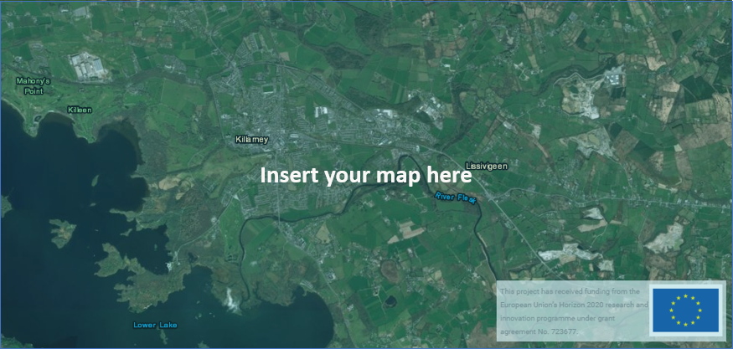

**IMPORTANT NOTE:** To see these output layers, you might need to unselect the other layers. In case you still don’t see them, try to zoom-out, as there is often a visualisation bug. You can also download them and reupload them using your personal account (you need to log in before), it always solves the problem. When you have calculated different scenarios, compare them against each other (a few scenarios are already complete as an example).

|  |
| --- |
| Please answer to the research question(s): |

|  |
| --- |
| Please provide feedback on this functionality here: |

* 1. CM - District heating potential: economic assessment

This module generates a shapefile of potential district heating areas based on an assessment of the heat distribution costs. Inputs to the module are heat demand and gross floor area density maps, costs of network expansion, development of heat demand and connection rates, depreciation time, interest rate and a threshold for the accepted heat distribution costs. Furthermore, it calculates the costs of transmission lines between identified district heating areas.

Research question: What is the feasible coverage of district heating in terms of heat production and shares of total final heat demand in the region?

Sub-question 1: How does the costs for the transmission and distribution grid develop with changes in DH shares?

Exercise: Calculate and compare different scenarios of district heating expansion based on an economic assessment of network construction.

**IMPORTANT NOTE**: Before the exercise, log in to your account and upload the layers saved during exercise 1 and 2Demand Projection Remember to upload them at the correct category, ‘Heat density total’ and ‘Gross floor area total’, respectively.

In this exercise, you will calculate where it is economically feasible to expand a DH system between 2020 (first year of investment) and 2050 (last year of investment), according to different market shares in 2020 (current market share in DH areas) and 2050 (expected market share in DH areas), and different grid costs ceilings. These potential areas to expand the DH system are the areas where the total grid cost (transmission and distribution) (EUR/MWh) doesn’t exceed the grid cost ceiling. These grid costs include the costs of pipes and their installations in the ground.

In a real assessment, the heat demand in terms of useful energy should be used with this calculation module. However, for simplicity reasons, in this training you are not asked to produce the heat demand layer for useful energy. You will use as inputs the layers saved during exercise 1 and 2 Demand Projection which represents the heat density and gross floor areas as expected in 2050 in terms of final energy. Therefore, we also consider 0% of accumulated energy savings, as the inputs layers already represents the future situation which includes energy savings compared to now.

The number of hours at which the DH system runs at full load (input parameter called “full load hours”) is used to estimate the peak load and find the suitable dimension for the transmission grid, which impacts the costs of the grid.

Please note also that the interest rate is expressed as fraction (input value 0-1) on the production server, while it is expressed in percentage (input value 1-100) on the development server.

Step-by-step procedure:

* Go to the sheet “DH economic assessment”, there you will find a list of all input parameters for that CM.
* In the toolbox, select the ‘CM - District heating potential: economic assessment’.
* Set the input parameters according to the values presented in the spreadsheet file for the first scenario for this CM.
* Type in a name for the calculation you are going to perform (you can use a random title).
* Run the CM by clicking on the button “RUN CM”.
* When the calculation is ready you can find the calculated indicators in the results section in the right panel of the toolbox.
* Click the button “Export indicators” to download a .csv file containing the calculated indicators.
* Open csv file and copy the **indicator values** contained in the .csv file into the marked cells in the spreadsheet file for this CM. **Make sure you copy only the required figures within CM section** (your csv file can contain more results if other layers in Hotmaps toolkit are active).
* The calculation also yields 4 layers:
* Heat demand density in the last year of the investment period, calculated based on the energy savings input ratio, in raster format,
* Heat demand covered by DH in the last year of the investment, a raster file of the heat demand covered by DH in each hectare.
* Coherent areas (economic and non-economic) shapefile, a shapefile of the areas where it if economically feasible to develop DH.
* Transmission lines shapefile, a shapefile showing the transmission DH grids between the different coherent areas.
* These can be found in the layers section in the left panel (you have to close the calculation modules with ‘X’ and move to ‘Layers’) at the bottom of all available layers. Take a screenshot of these layers and insert it here.

**IMPORTANT NOTE:** To see these output layers, you might need to unselect the other layers. In case you still don’t see them, try to zoom-out, as there is often a visualisation bug. You can also download them and reupload them using your personal account (you need to log in before), it always solves the problem.

When you have calculated different scenarios, compare them against each other (a few scenarios are already completed as an example).

|  |
| --- |
| Please answer to the research question(s): |

|  |
| --- |
| Please provide feedback on this functionality here: |