Training Sessions –Scenarios Assessment Exercises

Prepared by Magda Kowalska, PlanEnergi

Revised by Giulia Conforto, e-think

June 2020

Project Information

08

Fall

|  |  |
| --- | --- |
| * Project name | **Hotmaps** – Heating and Cooling Open Source Tool for Mapping and Planning of Energy Systems |
| * Grant agreement number | 723677 |
| * Project duration | 2016-2020 |
| * Project coordinator | Lukas Kranzl  Technische Universität Wien (TU Wien), Institute of Energy Systems and Electrical Drives, Energy Economics Group (EEG)  Gusshausstrasse 25-29/370-3  A-1040 Wien / Vienna, Austria  Phone: +43 1 58801 370351  E-Mail: [kranzl@eeg.tuwien.ac.at](mailto:kranzl@eeg.tuwien.ac.at)  [**info@hotmaps-project.eu**](mailto:info@hotmaps-project.eu)  [www.eeg.tuwien.ac.at](http://www.eeg.tuwien.ac.at/)  [www.hotmaps-project.eu](http://www.hotmaps-project.eu) |
| * Lead author of this report | David Schmidinger  e-think  +43 670 7017904  schmidinger@e-think.ac.at  &  Marcus Hummel  e-think  +43 670 70 15 799  hummel@e-think.ac.at |

Legal notice

The sole responsibility for the contents of this publication lies with the authors. It does not necessarily reflect the opinion of the European Union. Neither the INEA nor the European Commission is responsible for any use that may be made of the information contained therein.

All rights reserved; no part of this publication may be translated, reproduced, stored in a retrieval system, or transmitted in any form or by any means, electronic, mechanical, photocopying, recording or otherwise, without the written permission of the publisher. Many of the designations used by manufacturers and sellers to distinguish their products are claimed as trademarks. The quotation of those designations in whatever way does not imply the conclusion that the use of those designations is legal without the consent of the owner of the trademark.

The Hotmaps project

The EU-funded project Hotmaps aims at designing a toolbox to support public authorities, energy agencies and urban planners in strategic heating and cooling planning on local, regional and national levels, and in line with EU policies.

In addition to guidelines and handbooks on how to carry out strategic heating and cooling (H&C) planning, Hotmaps will provide the first H&C planning software that is

* **User-driven**: developed in close collaboration with 7 European pilot areas
* **Open source**: the developed tool and all related modules will run without requiring any other commercial tool or software. Use of and access to Source Code is subject to Open Source License.
* **EU-28 compatible and adaptable:** the tool will be applicable for cities in all 28 EU Member States by default and users can upload their own data

The consortium behind

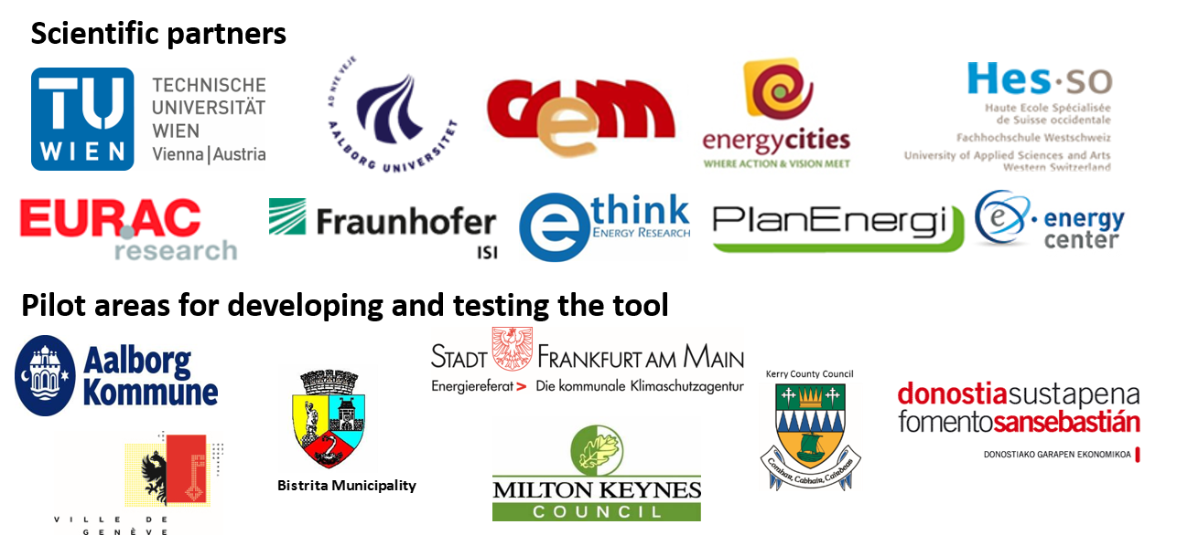

Executive Summary

Exercises for the Training workshops in Hotmaps.

5 Scenario Assessment Exercises 5

5.1 Ref. 2.2.1 CM – Decentral heating supply 5

5.2 Ref. 4.2 CM – DH economic assessment 5

5.3 Ref. 3.2 CM – DH supply dispatch 6

5.4 Ref. Final Table 6

1. Scenario Assessment Exercises

This part of exercises aims to collect the results from the earlier work in the Calculation Modules section and collate the key indicators in the final table and in the graphic format.

The scenarios are built upon the common case with the decentral heating supply options. This is the further examined in a sensitivity analysis for the set of three

* District heating systems, that vary by a DH penetration level,
* Centralised heating supply technologies (Dispatch module) that vary by the capacity of the energy generators.

This is only an example approach to run the sensitivity assessment. This could be tackled from the other perspective, when the centralised heat supply options are maintained fixed and the impact of the different decentralised technologies on the business case is investigated.

* 1. Ref. 2.2.1 CM – Decentral heating supply

Exercise: Import the results for the decentral heat supply technologies. This would be used as a common reference case for all investigated scenarios.

Step-by-step procedure:

* Open the spreadsheet files for this session ‘Exercises 1 and 2.xls’ and ‘Exercise 5.xls’.
* Go to the sheet **“2.2.3 Decentral heating supply”,** the scroll down to find the outputs summarising costs, carbon emissions and energy consumption figures for the final and useful energy. **This is collated in the column marked in red.**
* Copy the findings summarised for the investigated buildings mix which are marked in red into the indicated column (Summary Table) of spreadsheet ‘Exercise 5.xls’.
* The figures will populate automatically for the remaining scenarios as a fixed common basis for future calculations.

* 1. Ref. 4.2 CM – DH economic assessment

Exercise: Import the results for the DH cost assessment. You can use a data set for three different level of DH penetrations.

Step-by-step procedure:

* Open the spreadsheet file for this session ‘Exercises 3 and 4.xls’ and ‘Exercise 5.xls’.
* Go to the sheet **‘4.2 DH economic assessment’.**

Copy the results for the three scenarios according to the indicated Runs in the indicated columns of spreadsheet ‘Exercise 5.xls’.

* They all should refer to the same 'Heat density total', please select hdm_25.
* The figures will populate automatically for the remaining scenarios as a fixed common basis for future calculations.
  1. Ref. 3.2 CM – DH supply dispatch

Exercise: Import the results for the centralised heat supply options via DH. You can use a data set for three different capacity configuration of the energy generators. Use the data for the same carbon emission fee.

Step-by-step procedure:

* Open the spreadsheet file for this session ‘Exercises 3 and 4.xls’ and ‘Exercise 5.xls’.
* Go to the sheet **‘3.2 DH supply dispatch’.**

Copy the results for the three scenarios according to the indicated Runs in the indicated columns of spreadsheet ‘Exercise 5.xls’ .

* They all should refer to the same CO2 emission price and can vary by the selected capacity of the heat generators.
* The figures will populate automatically for the remaining scenarios as a fixed common basis for future calculations.
  1. Ref. Final Table

Exercise: Analyse the results. Compare energy consumptions, environmental impacts and costs of different heat supply technologies depending on if this is a centralised system via DH or decentralised (individual) heating.

Step-by-step procedure:

* Go to the sheet “Final Table” of the spreadsheet ‘Exercise 5.xls’.
* Review the results in the table and on the graphs.
* Write a short characteristic and main conclusions for the completed scenarios in the table located in the right part of the sheet.

|  |
| --- |
| Please provide feedback on this CM here: |