Training Sessions – Trial & Error & Feedback

Prepared by Max G.A. Guddat & Anders M. Odgaard, PlanEnergi &   
Marcus Hummel & David Schmidinger, e-think

Date 2020-02-19

Project Information

08

Fall

|  |  |
| --- | --- |
| * Project name | **Hotmaps** – Heating and Cooling Open Source Tool for Mapping and Planning of Energy Systems |
| * Grant agreement number | 723677 |
| * Project duration | 2016-2020 |
| * Project coordinator | Lukas Kranzl  Technische Universität Wien (TU Wien), Institute of Energy Systems and Electrical Drives, Energy Economics Group (EEG)  Gusshausstrasse 25-29/370-3  A-1040 Wien / Vienna, Austria  Phone: +43 1 58801 370351  E-Mail: [kranzl@eeg.tuwien.ac.at](mailto:kranzl@eeg.tuwien.ac.at)  [**info@hotmaps-project.eu**](mailto:info@hotmaps-project.eu)  [www.eeg.tuwien.ac.at](http://www.eeg.tuwien.ac.at/)  [www.hotmaps-project.eu](http://www.hotmaps-project.eu) |
| * Lead author of this report | Max Gunnar Ansas Guddat  PlanEnergi  +45 2386 2482  mgag@planenergi.dk &  Marcus Hummel  e-think  hummel@e-think.ac.at |

Legal notice

The sole responsibility for the contents of this publication lies with the authors. It does not necessarily reflect the opinion of the European Union. Neither the INEA nor the European Commission is responsible for any use that may be made of the information contained therein.

All rights reserved; no part of this publication may be translated, reproduced, stored in a retrieval system, or transmitted in any form or by any means, electronic, mechanical, photocopying, recording or otherwise, without the written permission of the publisher. Many of the designations used by manufacturers and sellers to distinguish their products are claimed as trademarks. The quotation of those designations in whatever way does not imply the conclusion that the use of those designations is legal without the consent of the owner of the trademark.

The Hotmaps project

The EU-funded project Hotmaps aims at designing a toolbox to support public authorities, energy agencies and urban planners in strategic heating and cooling planning on local, regional and national levels, and in line with EU policies.

In addition to guidelines and handbooks on how to carry out strategic heating and cooling (H&C) planning, Hotmaps will provide the first H&C planning software that is

* **User-driven**: developed in close collaboration with 7 European pilot areas
* **Open source**: the developed tool and all related modules will run without requiring any other commercial tool or software. Use of and access to Source Code is subject to Open Source License.
* **EU-28 compatible**: the tool will be applicable for cities in all 28 EU Member States

The consortium behind

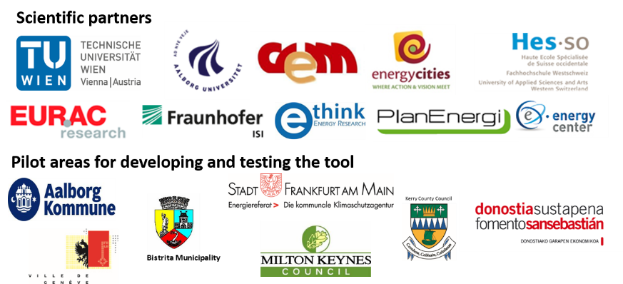

Executive Summary

Exercises for the Training workshops in Hotmaps, beginning December 2019.

1 Introduction 5

2 Trial and error 6

3 Feedback on the tool 7

1. Feedback on the tool & training

Please write a short feedback note on your experience with this first use of the toolbox.

The Tool

**What is your impression of the user-friendliness of the Hotmaps toolbox?**

Please mark an “x” in each row of the following table in the column that fits your impression. Please write comments on the different aspects below the table.

|  |  |  |  |
| --- | --- | --- | --- |
|  | Friendly to use | ok | Not friendly to use |
| General tool functionalities | | | |
| Orientation and navigation |  |  |  |
| Selection |  |  |  |
| Download of data / layers |  |  |  |
| Create and use the user account |  |  |  |
| Mapping | | | |
| Mapping of demands |  |  |  |
| Mapping of potentials |  |  |  |
| Calculation Modules | | | |
| CM - Demand projection |  |  |  |
| CM - DH User defined Thresholds |  |  |  |
| CM - Excess heat transport potential |  |  |  |
| CM - DH potential economic assessment |  |  |  |
| CM - Decentral Heating Supply |  |  |  |
| CM - Scale Heat and Cool Density Maps |  |  |  |
| CM - District Heating supply dispatch |  |  |  |
| Documentation / wiki regarding … | | | |
| … default data |  |  |  |
| … general tool functionalities |  |  |  |
| … calculation modules |  |  |  |

Comments:

….

**How useful are the different calculation modules provided in the toolbox for your future work?**

Please mark an “x” in each row of the following table in the column that fits your impression. Please write comments on the different aspects below the table.

|  |  |  |  |
| --- | --- | --- | --- |
|  | useful | ok | Not useful |
| CM - Demand projection |  |  |  |
| CM - DH User defined Thresholds |  |  |  |
| CM - Excess heat transport potential |  |  |  |
| CM - DH potential economic assessment |  |  |  |
| CM - Decentral Heating Supply |  |  |  |
| CM - Scale Heat and Cool Density Maps |  |  |  |
| CM - District Heating supply dispatch |  |  |  |

Comments:

…

**How are you planning to use the Hotmaps database and toolbox in your future work?**

Please provide a short written feedback here

….

**How often are you planning to use the Hotmaps database and toolbox in your future work?**

E.g. once a year, once a month, several times a month …

….

The afterlife of the Hotmaps-project

The project team is currently working on a business plan to ensure that the tool and its functionalities will continue to be available (and further developed) to planners, consultancies etc. in the years to come. In order to fund the operational costs as well as the ongoing development of tools and data, possible income sources have been identified. Ideas are to provide training activities against costs or a (premium) membership for interested communities, planners and other external partners.

**In order to meet the needs and considerations of possible future users, we would appreciate your answers regarding the following:**

* Do you use similar tools or energy planning tools in your daily work? If yes, which one(s)?
* How much do you pay to use these tools per year (€/license/year approx.) and how many users does this license cover?
* How do you pay (monthly, yearly, a one-shot license, recurrent fees)?
* Would you be willing to pay for a training event like the one you have just attended (for free)?
  + If yes, how much (€/participant/event)?
* Would you pay to use the tool in the future (in the state you tested throughout the last two days)?
  + If yes, how much (€/year pr. user)?
* Would you pay to have a premium access to be able to store more data in your user account?
  + If yes, how much (€/year pr. user)?
* Would you pay to have a premium access so that the calculations are done faster (less waiting time to have the results of the calculation modules)?
  + If yes, how much (€/year pr. user)?
* Would you pay to have access to additional features?
  + If yes, which features would you expect/wish?
  + If yes, how much (€/year pr. user)?

1. Trial and error

This last exercise is for trial and error in the Hotmaps Tool to get to know the tool better – Trial and error. You can e.g.:

* Explore further layers, not covered in the Mapping phase
* Add (additional) bottom-up data of your own
* Expand the geographic uplands for given R.E.-potentials in the mapping
* Expand the number of thresholds in calculation modules to elaborate sensitivities
* Produce maps to be used in your (preparation of) strategic work with heating and cooling planning in your region.

For this, please create new documents (word and spreadsheets) based on the guidelines, provided by the trainers and leave out layers or calculation modules, that you wish to skip.