

Thank you to all the passionate participants of Trust in Play, that inspired us to create Snake.City and share with you.

**INTRODUCTION**

Are you passionate about games as well as urban spaces? Do you enjoy interacting with technology while experiencing the real/tangible reality?

Then Snake.City is the right opportunity for you to learn how to create your own urban game.

You will be guided step by step on how to create new game using pervasive technology.

We will explain to you how to create the game server and the programming game code, and on to finally realise your own Snake.City inspired game!

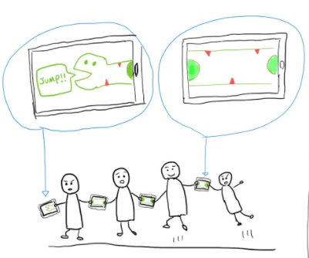

**Figure 1. An early sketch of gameplay inspired by Bounden**

**But first, a bit more explanation about Snake.City!**

In Summer 2019, a group of programmers, urban planners and architects were recruited in Amsterdam as the first trainees of the European School of Urban Game Design - Trust in Play.

Between 2019 and 2020 in Amsterdam and Athens, attendees enjoyed meetings, workshops and conducted experiments. We learned and tested game mechanics and coded while bouncing off our different backgrounds and expertise.

A few working teams got formed and the one composed by Tomo, Gavin and Giulia, decided to undertake the voyage towards the realisation of the first Snake.City.

**WHAT DO YOU NEED TO PLAY THE GAME?**

Access to WIFI & a smartphone per player

**HOW SNAKE.CITY WORKS?**

**Context**

The game can be played anywhere - parties, festivals, university campus, schoolyards, and conferences. We think it works particularly well in festival locations, where, for example, we can make use of the logon process people go through on public WiFi to provide a convenient and very public link to the game.

However, before we tell you more, we need to talk about COVID-19. When we started this project, we were living in a world without COVID-19.

It depends where you live and the local rules, but it might not be a good idea to rush out and play closely with strangers in these worrying times.

That said, there are three big reasons you might be interested in Snake.City.

First, the three of us wanted to learn new tech that would make multi-player physical games possible. We want to share that tech with you.

Secondly, we are worried that we will forget how to play nicely with each other. If you have house mates or friends within your bubble, Snake.City might help you reconnect.

Lastly, we think Snake.City is fun. You might too.

**Gameplay**

The game requires to place your thumb on your smartphone with another person who is also placing his/her thumb on your phone, and in turn, they do the same with a third person, and so on: a human chain connected by smartphones devices will be the final result.

When any person removes a finger, the snake is broken, and the time is up.

The game records the time and length of each active snake and we will eventually create a global leader board and map of all the Snake.City created around the world.

To start the game, a player will go onto the website [https://snake.city](https://snake.city/) who becomes the snake's head.

They will invite their friends or strangers to join their snake as that new person holds the phone with them. That person will be invited to pass on a code and invite new players to join the snake e.g. <https://snake.city/vipercobra>. Two names of the snake for each unique snake will provide a unique enough key for the time being.

**INSPIRATIONS**

There were many ideas behind the Snake.City, from single moments of inspirations to playing an actual follow my leader snake game devised by Simon.

In this section we are going to mention some games that were influentially and that we think you should check out.

## **Bounden**

<https://playbounden.com/>

Shows clearly where to place fingers - we are inspired by the detail and it suggested how we make both detect and instruct people to form a chain of players

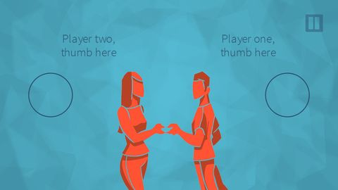

**Figure 2. Bounden screenshot**

## **Noby Noby Boy**

<https://en.wikipedia.org/wiki/Noby_Noby_Boy>

Eventually we want to show an interactive map of where people might be playing Snake.City. The following games

## **Ocarina**

This mobile game has a magical map of people playing its ocarina in the world. You can listen to people from all over the world playing familiar songs, as we are connected through their music.

<https://apps.apple.com/us/app/ocarina/id293053479>

## **Paperstorm.it**

This game helps people to protest through an interactive map where you drop papers.

<https://studiomoniker.com/projects/paperstorm>