**Method**

Across the four video games, all gameplay variables are held constant. Players had a rapid-fire tool and a slow-but-powerful tool (in the violent condition, these were a chaingun and a shotgun). All four versions of the game used the same levels so that level geography and the placement of supplies and enemies were the same across conditions. Levels were designed to be easy to navigate, reducing time spent exploring the map and maximizing the player’s time spent interacting with game characters. In the case that the player’s health was reduced to zero, he would start again from the most recent of six checkpoints.

The modified games were also programmed to track players’ in-game behavior and performance. Across the gameplay session, the game tracked the number of times the player had to restart the level, the number of enemies slain or zorched, the number of times the rapid-fire tool was used, the number of times the slow-but-powerful tool was used, the furthest point reached by the player, and the number of times the player was hit by an enemy.

In the nonviolent condition, the story explained that the booger aliens are lost and confused, and when the player has “zorched” them all home, he sees a scene of the aliens playing together on their homeworld. By comparison, in the violent condition, the story explained that the aliens must all be slain, and when the player has killed them all, he sees a scene of the player character posing with his shotgun. The cover story also explained whether enemies would or would not attack the player per the difficulty manipulation.

When starting the game, participants were monitored for a few minutes to make sure that they successfully completed the first level of the game and moved on to the second level, at which time the participant was left to play alone.

The assistant then quit the game by pressing Alt+F4. (This bypasses a “Are you sure you want to quit?” prompt that can sometimes contain aggressive language.) The research assistant then navigated to a folder containing an E-Prime task in preparation for the purported second portion of the experiment.

**Results**

**Primary analysis**

The following sensitivity analyses reproduce the Violence × Difficulty × 2D:4D analyses with alternative methods designed to account for the non-normality of the outcome (see Figure S1).

**Censored regression.** To attempt to ameliorate the potential ceiling effect, a censored regression model was fit with the ‘censReg’ package for R (Henningsen, 2013). This fits a censored-regression Tobit model and attempts to model values that exceed the maximum of the scale.

Application of this analysis to 2 Violence × 2 Difficulty ANOVA found no significant effects of violence (*t*(270) = 0.87, *p* = .386, *r* = .05 [-.07, .17]), difficulty (*t*(270) = 1.23, *p* = .219, *r* = .07 [-.05, .19]), or their interaction (*t*(270) = -1.68, *p* = .092, *r* = -.10 [-.22, .02]). A significant effect of irritation with the partner’s feedback was observed, but applying this as a covariate did not affect the primary results.

Main effects of 2D:4D on aggression were again negligible. Left 2D:4D did not predict aggression, *t*(264) = -0.94, *p* = .345, *b* = -.21 [-.64, .22], nor did right 2D:4D, *t*(265) = 0.57, *p* = .57, *b* = .12 [-.31, .56]. Application of composite irritation as a covariate did not influence the estimated effect. Higher-order interactions of 2D:4D with factors of Violence or Difficulty were not supported by the results (all |*t*| < 1), with the exception of a Difficulty × Violence × Right 2D:4D interaction that was barely significant after adjusting for irritation (*p* = .044).

**Logistic regression.** Another possibility is that participants completed the coldpressor assignment in one of two ways: either they followed instructions and randomly assigned the other participant to a value between 1 and 9, or they decided to aggress and assign the other participant the maximum value. To model this possibility, I treated the response variable as a dichotomous outcome. Participants assigning values 1-8 were treated as one category (nonaggressive response) and participants assigning value 9 were treated as the other (aggressive response). Logistic regression was performed to test whether the odds of aggressing were influenced by the experimental assignment.

We conducted a 2 Violence × 2 Difficulty ANOVA with a logistic link function. Violence did not appear to influence aggression, *z* = 2, *p* = .836, *OR* = 1.03 [0.79, 1.34]. Difficulty also had a minimal effect on aggression, *z* = 2, *p* = .121, *OR* = 1.23 [0.95, 1.61]. Application of composite irritation as a covariate to these models revealed an effect of composite irritation, *z* = 2, *p* < .001, *OR* = 2.11 [1.5, 3.03], but did not increase the estimated effects of violence, difficulty, or their interaction.

Main effects of 2D:4D on aggression were again negligible. Left 2D:4D did not predict aggression, *z* = 2, *p* = .703, *OR* = 0.95 [0.72, 1.24], nor did right 2D:4D, *z* = 2, *p* = .689, *OR* = 1.06 [0.81, 1.39]. Application of composite irritation as a covariate did not influence the estimated effect. Higher-order interactions of 2D:4D with factors of Violence or Difficulty were not supported by the results (all |*t*| < 1.53).

**Exploratory results**

We explored the relationships among players’ ratings of the game, in-game performance, history of video game use, and aggressive behavior. Exploratory factor analyses used parallel analysis to determine the number of factors, followed by an oblimin rotation. Questions about the players' experience of the game had a four-factor structure, with factors representing enjoyment, challenge, difficulty with the game controls, and experience of violent content. Of these, only enjoyment was significantly related to aggression, *t*(245) = 2.66, *p* = .008, *r* = .17 [.04, .29]. Experienced challenge was not related to aggression, contrary to our hypotheses regarding mental fatigue and aggression (*t*(245) = 0.75, *p* = .452, *r* = .05 [-.08, .17]). Discomfort with the game controls was also not related to aggression, *t*(245) = 0.17, *p* = .866, *r* = .01 [-.12, .14], contrary to previous findings by Przybylski et al., 2014.

History of game use was found to have a two-factor structure, with the first factor reflecting experience with video games in general and the second factor reflecting experience with first-person shooters in specific. One of the six items, "I've often played games like the one I played today," had to be discarded to prevent a Heywood case. Neither factor significantly predicted aggression (general experience, *t*(245) = -0.09, *p* = .93, *r* = -.01 [-.13, .12]; FPS experience, *t*(245) = 0.58, *p* = .566, *r* = .04 [-.09, .16]). These results are not consistent with reports of cross-sectional associations between use of violent video games and aggression.

In-game behaviors did not behave well in factor analysis and created Heywood cases. We explored the correlation table directly. Participants who defeated more monsters and fired more bullets were slightly less aggressive (monsters defeated, *t*(272) = -2.51, *p* = .013, *r* = -.15 [-.26, -.03]; bullets fired, *t*(272) = -2.51, *p* = .013, *r* = -.15 [-.26, -.03]), but this finding should be regarded with caution given this test's exploratory nature and modest *p*-value.

Figure S1. Histograms of cold pressor duration per condition.

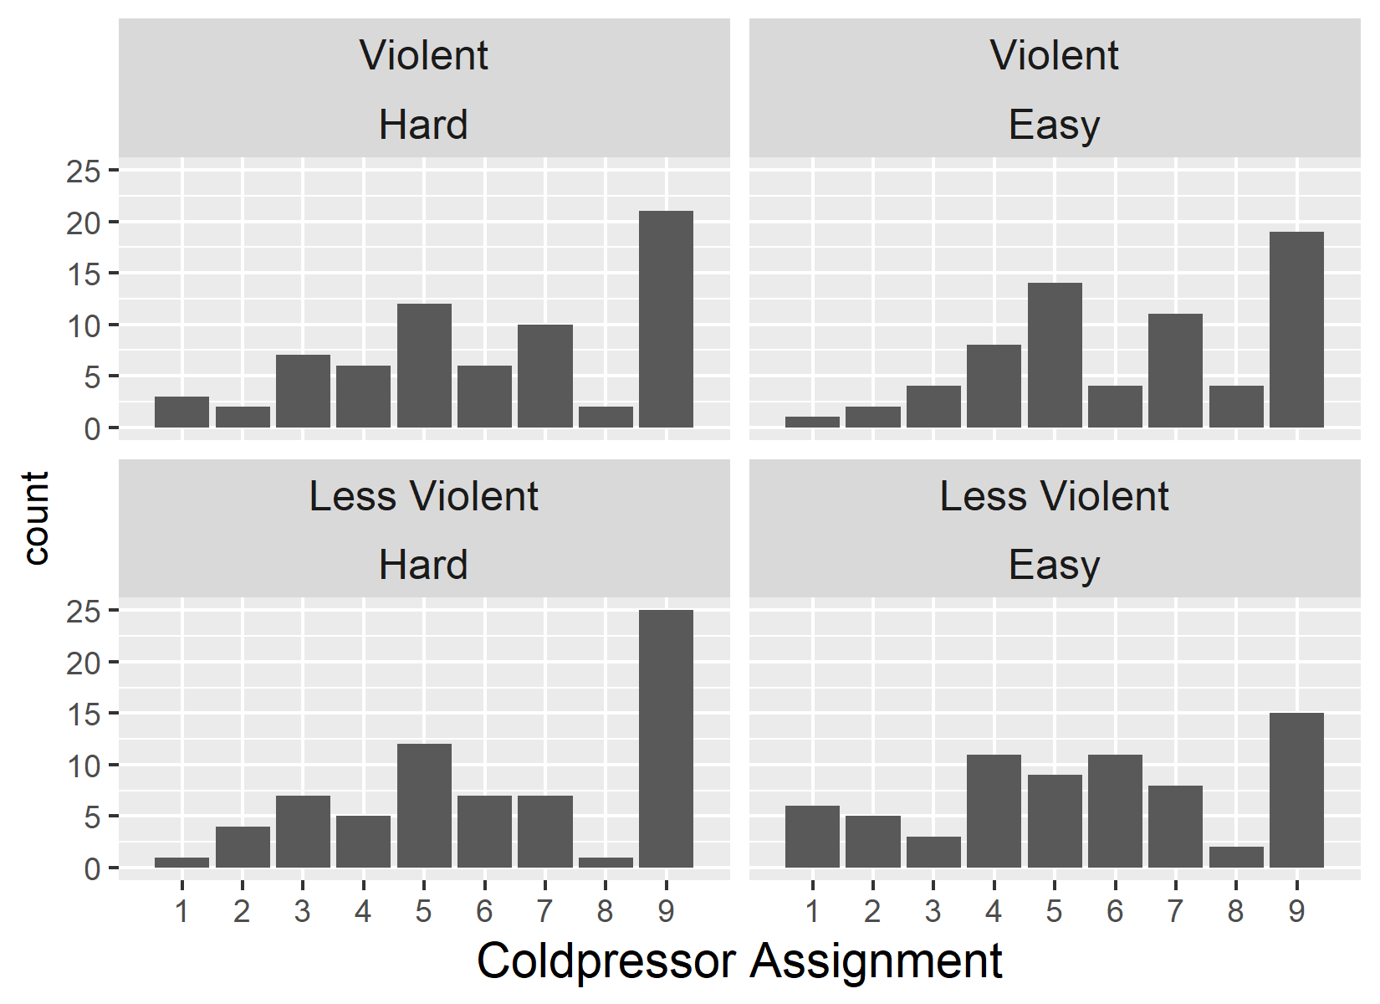

Histograms of aggression in each cell of the 2 (Violence) x 2 (Difficulty) design. The obtained data are non-normal and suggest that analyses should include approaches for categorical data.