Software Engineering for Autonomous Systems

Project:
AutoClime GEO

Student:
Giuseppe Gasbarro, matricola: 271395
Table of Contents

Introduction 3
Goals of the System 3
Managed Resources 4
Sensors and Effectors 4
Architectural Pattern of the Autonomic Manager 5
Adaptation Goals of the Autonomic Manager 6
Decision Function Approach 7
System Description based on Self-Adaptation Taxonomy 8

Introduction

In the context of modern environmental monitoring, the reliability of data is often compromised by the inherent volatility of hardware sensors and the limited energy resources of remote stations. AutoClime GEO is an autonomic, self-adaptive system designed to address these challenges by implementing a closed-loop control architecture based on the MAPE-K (Monitor-Analyze-Plan-Execute plus Knowledge) framework. Unlike traditional, passive sensor networks, AutoClime GEO treats weather monitoring as a managed resource capable of self-healing and dynamic optimization.
By integrating a deep-learning Transformer model within its Knowledge base, the system moves beyond simple threshold checks to sophisticated AI-driven behavioral analysis. It autonomously navigates the trade-off between high-frequency data collection and battery preservation, ensuring that the information saved to the database is not only timely but also verified against predicted thermal and environmental trends.
By leveraging RabbitMQ as a control plane and Django as a centralized autonomic manager, AutoClime GEO can orchestrate complex adaptation strategies—such as scaling sensor sampling rates during anomalies or isolating "broken" hardware while triggering spatial redundancy from neighboring stations. This introduction sets the stage for a system where high-level goals of data integrity and operational longevity are translated into real-time, concrete actions performed by a distributed fleet of managed actuators.

Goals of the System

AutoClime GEO is designed to act as an autonomic environmental monitoring system that balances high-fidelity data collection with resource constraints. The system manages the environmental quality of a distributed sensor grid with respect to two competing factors: data veracity (accuracy) and energy efficiency (longevity).
The specific high-level goals are:
- Self-Healing (Data Integrity): To ensure that the "Knowledge Base" (the database) reflects atmospheric reality rather than hardware malfunctions. The system must autonomously identify and isolate sensors that deviate significantly from AI-predicted trends.
- Self-Optimization (Energy Management): To prolong the operational life of remote stations. The system must dynamically adjust the frequency of data transmission based on the current battery level and the volatility of the weather.
- Self-Configuration (Redundancy): To maintain geographic coverage. If a sensor is decommissioned due to failure, the system must automatically reconfigure neighboring nodes to increase their sampling rate, filling the observational gap.
- Administrative Oversight: To allow human operators to inject high-level policy goals (e.g., "Strict Mode" during storms) by manually defining thresholds that can act based on variable values.

Managed Resources

The primary managed resource in this system is the IoT weather station. Each station is treated as an autonomous agent with finite resources (battery life) and specific capabilities (sensing accuracy).
The system manages these resources at two levels:
- The physical station: The hardware unit located at specific GPS coordinates, containing the sensors and a microcontroller.
- The virtual sensor node: The database representation of a specific variable (e.g., "Rome_Station_Temperature") which can be logically isolated or flagged as "Broken" to prevent data pollution.

Sensors and Effectors

The Autonomic Manager interacts with the managed resources through a defined set of Monitors (Sensors) and Actuators (Effectors) described in the following table.

Managed Resource | Sensors (Monitoring Input) | Effectors (Execution Output)
Environmental Sensor Unit | Raw Telemetry: Temperature (°C), Humidity (%), Wind Speed (km/h), Precipitation (mm). | SCALE RATE / SWITCH OFF: A command sent via RabbitMQ to physically power down or modify the sending rate of a specific sensor based on the perceived value.
Power Management Unit | Battery Voltmeter: Reports current charge level (0-100%). | SCALE_RATE / SWITCH OFF: A command to decrease the sending rate if the sensor has a low battery level to prevent the high consumption or to switch off the sensor to let it recharge its battery.
Data Integrity Unit | Variance Monitor: Checks the deviation between detected data and predicted value. | ISOLATION FLAG: A database operation that marks is_broken=True. This logically disconnects the sensor from the analytics pipeline even if the hardware is still running.  SWITCH OFF: If the sensor still sends “anomalous” data, this command is sent.
Network Grid | Spatial Location: GPS coordinates (Lat,Lon). | REDUNDANCY TRIGGER: A command sent to the nearest neighbour station to increase its sampling rate (e.g. SCALE_RATE(2.0)) when a primary node fails or decrease its sending rate.

Architectural Pattern of the Autonomic Manager

The architectural core of AutoClime GEO is defined by a Centralized Autonomic Manager, a pattern where the intelligence and decision-making capabilities are consolidated into a single, external controller. This approach moves the MAPE-K loop away from the resource-constrained edge devices and into a high-performance environment.
The choice to implement a centralized architecture is primarily dictated by the computational requirements of the analysis phase. While the sensors are physically distributed across a wide geographic area, the reasoning system relies on a Transformer Machine Learning model. Executing such intensive inference tasks on edge hardware would be inefficient; hosting the "intelligence" on a central Django-based server ensures the system has the necessary processing power to perform accurate autoregressive forecasting.
A significant advantage of this centralized degree of decentralization is the ability to maintain a global Knowledge. A localized manager, residing on an individual sensor, possesses only a siloed view of its own telemetry. In contrast, the centralized manager aggregates data from the entire grid, allowing it to distinguish between different types of anomalies. This comparative analysis of spatially distributed data points is a critical "Knowledge" component that enables more accurate adaptation decisions.
The central Django server functions as the orchestration engine for the autonomic loop, integrating various technical resources to achieve self-adaptation:
- Monitor: A dedicated RabbitMQ Consumer thread serves as the primary ingestion point, continuously receiving telemetry from the distributed fleet.
- Analyze & Plan: This phase employs a hybrid decision-making approach that bridges proactive and reactive timeframes:
  - Hourly Inference: Every hour, an asynchronous Celery task triggers model inference to generate environmental forecasts.
  - Knowledge Update: These predictions are used to proactively create or update the SensorGoal knowledge base, which defines the "safe zone" for expected behavior.
  - Validation Analysis: Upon arrival, each new telemetry value is reactively analyzed against the stored predicted value to calculate variance.
  - Strategy Planning: If the data is verified as non-anomalous, the manager applies specific battery and variable goal strategies to optimize the system state. If an anomaly is detected, the system transitions to a self-healing plan (based on predefined rules and strike-count policies) to determine if the resource requires parameter scaling or structural isolation.
- Execute: Once a decision is reached, a RabbitMQ Publisher transmits control commands (such as SCALE_RATE or SWITCH) back to the edge actuators, closing the loop and realizing the adaptation.

Adaptation Goals of the Autonomic Manager

The autonomic manager aims to maintain the system in a steady state where data reliability is high and energy consumption is optimized.
- Monitored Characteristics (Immediately Available):
  - Real-time Value ($x_{t}$): The raw value arriving from the sensor.
  - Battery Level ($B_{t}$): The current energy status.
  - Consecutive Anomalies ($k$): A counter tracking how many times the sensor has failed validation.
- Analyzed Characteristics (Induced by Reasoning):
  - Predicted Value (${\hat{x}}_{t}$): Generated by the Transformer ML Model. This represents the "expected truth" based on historical patterns.
  - Variance ($V_{t}$): Calculated as $\left|x_{t}-{\hat{x}}_{t}\right|$. This is the primary metric for the adaptation logic.
- The Adaptation Logic:
  - IF $V_{t}> Threshold$ : The system infers a potential fault.
    - Adaptation: Transition from "Monitoring" to "Investigating" (Increase Rate).
  - IF $k ≥ 3$ (3-Strikes): The system infers a permanent hardware failure.
    - Adaptation: Transition from "Investigating" to "Isolating" (Switch OFF).
  - IF $B_{t}< 40\%$ : The system infers critical energy depletion.
    - Adaptation: Transition to "Power Saving" mode (Decrease Rate).
  - IF $B_{t}< 20\%$ : The system infers critical energy depletion.
    - Adaptation: Transition to "Recharging" mode (Switch OFF).
  - IF $x_{t}\left[>, <, =\right] Threshold$ (defined by Admin): The system infers critical thermal values.
    - Adaptation: Transition from "Monitoring" to "Investigating" (Increase Rate) within a 5 km radius.

Decision Function Approach

The decision function of the Autonomic Manager employs a hybrid approach combining AI-based analysis with rule-based planning.
- AI-Based Analysis (The "Knowledge"):
  - A pre-trained Transformer Neural Network is utilized to serve as the reference model for environmental behavior. This allows the system to deal with complex, non-linear weather patterns that a simple static threshold rule could not capture. The AI provides the "Context" ($x_{t}$).
- Rule-Based Planning (The "Logic"):
  - The execution of actions follows a deterministic Finite State Machine (FSM) logic, specifically a "3-Strike" Policy.
  - Rule 1: IF variance > max_variance AND strikes < 3 THEN status = WARNING; action = SCALE_RATE(5.0)
  - Rule 2: IF variance > max_variance AND strikes == 3 THEN status = BROKEN; action = SWITCH(OFF)
  - Rule 3: IF battery < 40 THEN action = SCALE_RATE(0.5) and action = SCALE_RATE(1.5) to the nearest neighbour
  - Rule 4: IF battery < 20 THEN action = SWITCH(OFF) and action = SCALE_RATE(2) to the nearest neighbour
  - Rules [5..n]: these rules are based on human-defined thresholds. When an incoming value meets a specific condition (using operators such as <, > or =), the manager triggers an action targeting all resources within a 5 km radius of the originating station.

This hybrid approach to adaptation decision criteria is structured so that the AI Model directly drives the Rule-Based logic. In this framework, the Transformer model functions as the primary source of Knowledge, outputting the predicted values that serve as the mandatory benchmarks for all incoming telemetry.
The AI-driven rules function as an autonomous guardrail: when a monitored value is received, the system compares it against the AI's prediction to determine if an anomaly is occurring. If the variance is too high, the rules dictate that the value must be discarded to maintain data integrity, and the system executes a structural adaptation by switching the sensor off if the failure persists. This ensures that while the AI provides the sophisticated "reasoning" to understand the environment, the rules provide a predictable and safe execution path for self-protection and self-healing.

System Description based on Self-Adaptation Taxonomy

Based on the taxonomy of self-adaptation presented in Figure 1, AutoClime GEO can be characterized as a sophisticated autonomic system that employs a hybrid approach to manage distributed environmental resources.
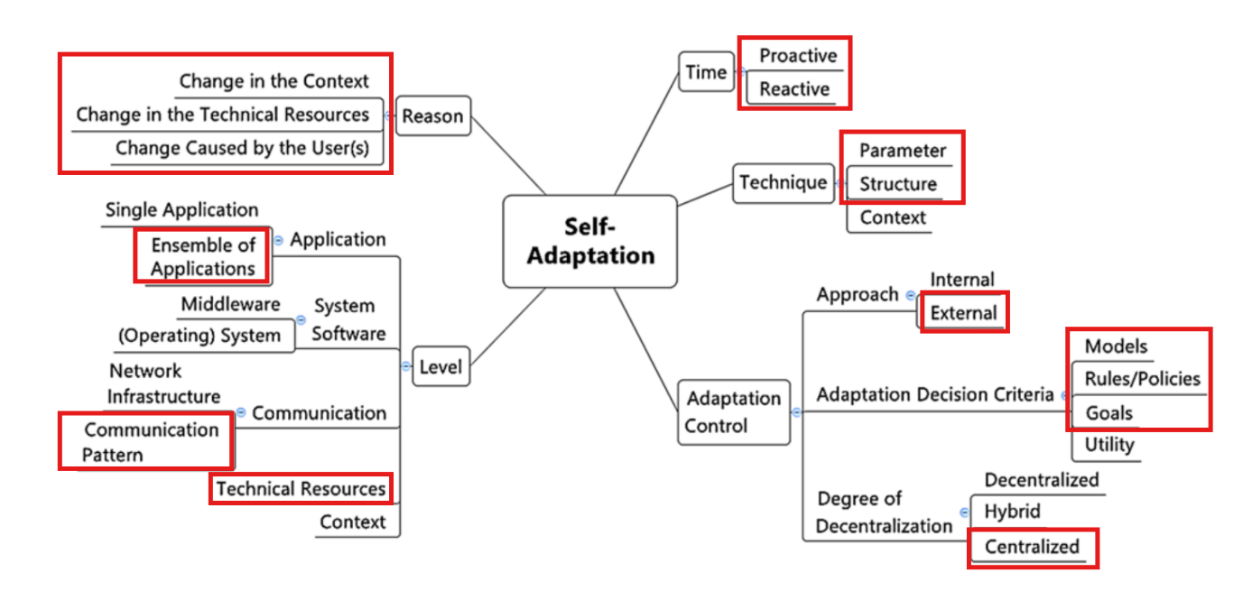
Reason: The system's adaptive behaviors are triggered by multiple factors. Primarily, it responds to a Change in the Technical Resources, such as battery depletion or sensor hardware malfunctions detected through variance analysis. It also adapts to a Change in the Context as weather patterns shift, which is anticipated by the AI model. Furthermore, the system accommodates a Change Caused by the User(s) when administrators manually override thresholds or operational states.
Time: AutoClime GEO exhibits both Reactive and Proactive characteristics. It is reactive when it immediately adjusts to a low-battery signal or an anomalous reading, and proactive in that it uses its AI model to predict future states and set the standard for normal behavior beforehand.
Technique: The adaptation is realized through Parameter techniques, such as dynamically tuning the data sampling frequency (SCALE_RATE), and Structure techniques, by logically isolating a broken sensor and reconfiguring the network to rely on a nearest neighbor.
Adaptation Control: The control logic is External to the managed resources, residing in the centralized Django manager rather than on the sensors themselves. The architecture is therefore Centralized, allowing for global decision-making. The Adaptation Decision Criteria are multifaceted, combining Models (the Transformer AI for prediction), explicit Rules/Policies (the deterministic 3-strike logic for failure isolation), and high-level Goals (maintaining data integrity and energy sustainability).
Level: The adaptation manifests across multiple levels. It operates at the Application level, where the central manager coordinates the ensemble of station applications. It also directly impacts the Technical Resources (the sensors and batteries) and influences the Communication Pattern by altering the frequency and routing of messages over the RabbitMQ network.

