**Listado**

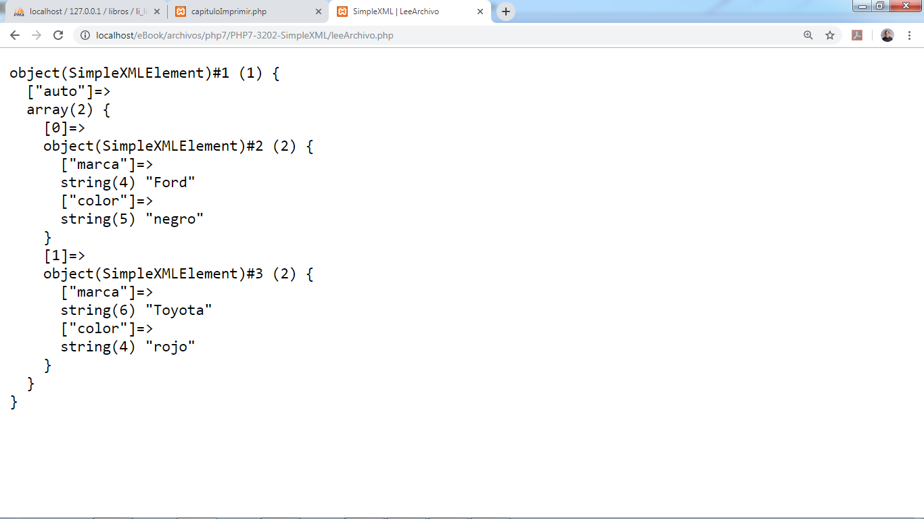

Imagen: 2.1.

|  |  |
| --- | --- |
| 1 | <?php |
| 2 | require_once 'vendor/autoload.php'; |
| 3 | $documento = new \PhpOffice\PhpWord\PhpWord(); |
| 4 | $seccion = $documento->addSection(); |
| 5 | $seccion->getStyle()->setPageNumberingStart(1); |
| 6 | $encabezado = array('size' => 16, 'bold' => true); |
| 7 | $seccion->addText('Listado', $encabezado); |
| 8 | $seccion->addTextBreak(1); |
| 9 | //Creamos el header |
| 10 | $header = $seccion->addHeader(); |
| 11 | $header->addWatermark('img/logoPHP7marcaAgua.png', array('width'=>450)); |
| 12 | //Estilo de tabla |
| 13 | $tableStyle = array( |
| 14 | 'borderSize' => \PhpOffice\PhpWord\Shared\Converter::cmToTwip(.02), |
| 15 | 'borderColor' => 'gray', //color del borde |
| 16 | 'cellMargin' => 80, //margen de la celda |
| 17 | 'alignment' => \PhpOffice\PhpWord\SimpleType\JcTable::CENTER, |
| 18 | 'cellSpacing' => 25); |
| 19 |  |
| 20 | $documento->addTableStyle( |
| 21 | "tablaEstilo", |
| 22 | $tableStyle); |
| 23 |  |
| 24 | $seccion->addImage("img/PHP7-3202-SimpleXML.png", |
| 25 | array( |
| 26 | 'width' => 400, |
| 27 | 'height' => 235, |
| 28 | 'alignment' => \PhpOffice\PhpWord\SimpleType\Jc::CENTER |
| 29 | ) |
| 30 | ); |
| 31 | $seccion->addText("Imagen: 2.1."); |
| 32 | $seccion->addTextBreak(1); |
| 33 |  |
| 34 | $table = $seccion->addTable("tablaEstilo"); |
| 35 | // |
| 36 | //Lee el archivo para ser listado |
| 37 | // |
| 38 | $archivoID = fopen("documento.php", "r"); |
| 39 | $i = 0; |
| 40 | $c = array(); |
| 41 | while(!feof($archivoID)){ |
| 42 | //1024 es 1 k o hasta encontrar \n o \r |
| 43 | $linea = fgets($archivoID, 1024); |
| 44 | $c[] = htmlentities($linea); |
| 45 | //&lt; < |
| 46 | } //llaves |
| 47 | // |
| 48 | foreach ($c as $value) { |
| 49 | //if ($i>0) { |
| 50 | $table->addRow(); |
| 51 | $table->addCell(300)->addText($i+1); |
| 52 | $table->addCell(10000)->addText($c[$i]); |
| 53 | //} |
| 54 | $i++; |
| 55 | if($i>=count($c)) break; |
| 56 | } |
| 57 | // |
| 58 | fclose($archivoID); |
| 59 | // Guardar documento como OOXML file... |
| 60 | $salida = \PhpOffice\PhpWord\IOFactory::createWriter($documento, 'Word2007'); |
| 61 | $salida->save('documento.docx'); |
| 62 | header("Cache-Control: public"); |
| 63 | header("Content-Description: File Transfer"); |
| 64 | header("Content-Disposition: attachment; filename=documento.docx"); |
| 65 | header("Content-Type: application/zip"); |
| 66 | header("Content-Transfer-Encoding: binary"); |
| 67 | readfile("documento.docx"); |
| 68 | exit; |