What Doaa did until today ?

I designed the front end pages for the program by using HTML and CSS .

Why I used HTML and CSS , and not design program as (balsamiq) ?

because I am very familiar with Html and CSS . And to create a simple and uncomplicated design that is applicable .

Not : This design is not the final design and it subject to change .

1. Featured Services page design :

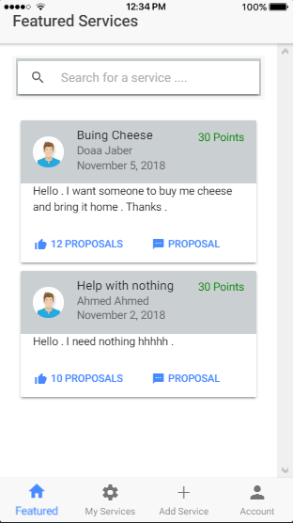

1. Add Service page design :

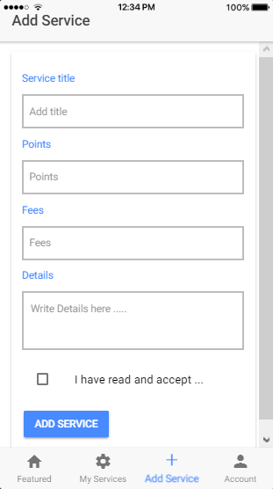

1. Account Page design :

