TITLE OF MANUSCRIPT
(Times New Roman 14 pt, Bold, Uppercase)

First Author¹*, Second Author², etc (Times New Roman, 11 pt, Bold)
¹Institution, address, city, postal code (Times New Roman, 10 pt)
²Major subject, faculty, university, address, city, postal code
*E-mail: corresponding_author@domain.com (Times New Roman, 11 pt, italic)

Received: Reviewed: Accepted: (filled by editor)

ABSTRACT

Abstract in English using Times New Roman font, size 10 pt, single spacing. Abstract is not a merger of several paragraphs, but it is a full and complete summary that describes content of the paper. It should contain background and or objective, methods, results, and main conclusions from the research. It should not contain any references or displayed mathematical equations. It consists of one paragraph and should be no more than 250 words in English.

Keywords: key, words, Paper (3 – 5 keywords)

Manuscript Criteria:
Grammar Structure > 90%
Similarity Check < 15%
AI Detection < 30%

- Introduction (Times New Roman, 12 pt, Bold)

The paper contains 4 subtitles namely: Introduction, Methods, Results and Discussion, and Conclusions. The introduction includes the following: research background, problem formulation, research objectives, supporting theories, and hypotheses (if any).

Paper is written in A4 paper format (210 mm x 297 mm) with top, bottom, left and right margins of 2.5 cm. The form of the paper is in the form of 2 columns with a distance between columns of 1 cm. Paper is written in Times New Roman font size 10 pt. The length of the paper should be a maximum of 20 pages, including attachments. Spacing between paragraphs is 1 single space.

References in the paper are written using Arabic numerals and are sorted according to the order of citations in the Paper. Numbers are written in square brackets, for example:
“. . .end of the line for my research [13].”
“The theory was first put forward in 1987 [1].”
“Scholtz [2] has argued. . . .”
“For example, see [7].”
“Several recent studies [3, 4, 15, 22] have suggested that. . . .”

Sub of subtitle. Sub of subtitles are written bold and without numbers. Sub of subtitles are parts of the text that need to be explained in more detail. The script is written immediately after the word subtitle. General words such as: Background, Objectives, Research Problems, Data, etc. do not need to be subtitled. It should be directly explained in the introduction.

If there is a chemical or mathematical equation, it should be placed symmetrically on the column. The equation number is placed at the right end in parentheses, and the numbering is done sequentially. If there is a series of equations that has more than one line, then the number is written in the last line. Abbreviated form, such as Eq. (1) is used to refer the equation in a sentence.

$ka=-\left(\frac{∂u}{∂x}+\frac{∂v}{∂y}\right)$

- Methods (Times New Roman, 12 pt, Bold)

The research method must be written in a scientific way. It must be rational, empirical, and systematic. The research method contains a description of the research procedure, time and place, materials and equipment, and the methods being used. The research method must be clearly described and in accordance with the research objectives.

- Result and Discussion (Times New Roman, 12 pt, Bold)

This section describes the results of the research and at the same time provides a comprehensive discussion of the research. Results can be displayed in the form of pictures or tables so that readers are able to understand more easily. Tables and figures are placed immediately after they are mentioned in the text and are placed at the top or bottom of each page and should not be in between sentences. If the tables and figures are too small for the 2-column text format, then 1-column size is allowed. The table format follows the example shown in Table 1. Images must be provided in a proportionate size and high resolution for the best appearance, so that all information in the image is legible.

Table 1 Eclipse stages for the Lampung area
No | Stages | Time (WIB) | Time  (UTC)
1 | Eclipse Begin (I) | 15:19 | 08:19
2 | Ring eclipse begin (II) | 16:38 | 09:38
3 | The peak of the annular solar eclipse | 16:42 | 09:42
4 | The end of the annular solar eclipse (III) | 16:45 | 09:45
5 | The end of the eclipse (IV) | 17:52 | 10:52

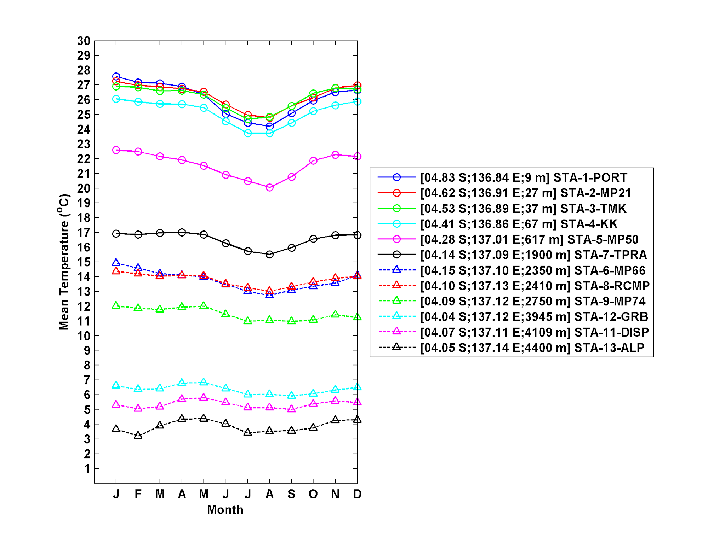
Figure 1 Monthly average temperature per altitude

- Conclusion (Times New Roman, 12 pt, Bold)

Conclusions can be specific or general. Specific conclusions are the results of data analysis or the results of hypothesis testing about the phenomenon under study. General conclusions is generalizations or linkages with similar phenomena in other areas from previous publications. Conclusions must be able to answer research questions and problems. The thing to note is the consistency triangle (problems-goals-conclusions must be consistent).

Suggestion (Times New Roman, 12 pt, Bold)

If necessary, suggestions can contain recommendations, concrete follow-ups, or policy implications for the conclusions reached.

Acknowledgement (Times New Roman, 12 pt, Bold)

Acknowledgments are given as appreciation to the parties involved in the preparation of the paper or in the research. In this section it is stated who should be thanked, both in terms of organizations/institutions, sponsors, or individuals.

References (Times New Roman, 12 pt, Bold)

References should be using reference manager (Mendeley, Zotero, EndNote, etc). References should contain of minimum 25 libraries with doi included. References proportion of 80% primary references (journal articles, proceedings, theses) and at least 80% published in the last 5 years. Citation and bibliography must be written in IEEE style.

E-books
[1] L. Bass, P. Clements, and R. Kazman, Software Architecture in Practice, 2nd ed. Reading, MA: Addison Wesley, 2003. [E-book] Available: Safari e-book.

Journal Article Abstract (accessed from online database)
[1] M. T. Kimour and D. Meslati, “Deriving objects from use cases in real-time embedded systems,” Information and Software Technology, vol. 47, no. 8, p. 533, June 2005. [Abstract]. Available: ProQuest, http://www.umi.com/proquest/. [Accessed November 12, 2007].

Print Documents
Books
Single Author
[1] 2003. W. K. Chen, Linear Networks and Systems. Belmont, CA: Wadsworth Press,

Edited Book
[2] J. L. Spudich and B. H. Satir, Eds., Sensory Receptors and Signal Transduction. New York: Wiley-Liss, 2001.

Selection in an Edited Book
[3] E. D. Lipson and B. D. Horwitz, “Photosensory reception and transduction,” in Sensory Receptors and Signal Transduction, J. L. Spudich and B. H. Satir, Eds. New York: Wiley-Liss, 2001, pp-1-64.

Three or More Authors
[4] R. Hayes, G. Pisano, and S. Wheelwright, Operations, Strategy, and Technical Knowledge. Hoboken, NJ: Wiley, 2007.

Book by an Institutional or Organizational Author
[5] Council of Biology Editors, Scientific Style and Format: The CBE Manual for Authors, Editors, and Publishers, 6th ed., Chicago: Cambridge University Press, 2006.

Manual
[6] Bell Telephone Laboratories Technical Staff, Transmission System for Communication, Bell Telephone Lab, 2005.

Technical Report
[8] K. E. Elliott and C. M. Greene, “A local adaptive protocol,” Argonne National Laboratory, Argonne, France, Tech. Report. 916-1010-BB, 7 Apr. 2007.

Government Publication
[11] National Aeronautics and Space Administration, NASA Pocket Statistics. Washington, DC: Office of Headquarters Operations, 2007.

Paper Published in Conference Proceedings
[12] J. Smith, R. Jones, and K. Trello, “Adaptive filtering in data communications with self improved error reference,” In Proc. IEEE International Conference on Wireless Communications ’04, 2004, pp. 65-68.

Thesis or Dissertation (unpublished)
[14] H. Zhang, “Delay-insensitive networks,” M. S. thesis, University of Chicago, Chicago, IL, 2007.

Journal Articles
Article in Journal (paginated by annual volume)
[8] K. A. Nelson, R. J. Davis, D. R. Lutz, and W. Smith, “Optical generation of tunable ultrasonic waves,” Journal of Applied Physics, vol. 53, no. 2, Feb., pp. 1144-1149, 2002.

Article in Professional Journal (paginated by issue)
[9] J. Attapangittya, “Social studies in gibberish,” Quarterly Review of Doublespeak, vol. 20, no. 1, pp. 9-10, 2003.

Article in Monthly or Bimonthly Periodical
[10] J. Fallows, “Networking technology,” Atlantic Monthly, Jul., pp. 34-36, 2007.

Article in Daily, Weekly, or Biweekly Newspaper or Magazine
[11] B. Metcalfe, “The numbers show how slowly the Internet runs today,” Infoworld, 30 Sep., p. 34, 2006.

