M6 : Machine Learning Miniproject

Léo Besançon & Larissa Geiser

2024-05-16

# 1. Data loading and description

data <- read.csv('ObesityDataSet_raw_and_data_sinthetic.csv')  
dim(data)

## [1] 2111 17

sum(is.na(data)) #no missing value

## [1] 0

head(data)

## Gender Age Height Weight family_history_with_overweight FAVC FCVC NCP  
## 1 Female 21 1.62 64.0 yes no 2 3  
## 2 Female 21 1.52 56.0 yes no 3 3  
## 3 Male 23 1.80 77.0 yes no 2 3  
## 4 Male 27 1.80 87.0 no no 3 3  
## 5 Male 22 1.78 89.8 no no 2 1  
## 6 Male 29 1.62 53.0 no yes 2 3  
## CAEC SMOKE CH2O SCC FAF TUE CALC MTRANS  
## 1 Sometimes no 2 no 0 1 no Public_Transportation  
## 2 Sometimes yes 3 yes 3 0 Sometimes Public_Transportation  
## 3 Sometimes no 2 no 2 1 Frequently Public_Transportation  
## 4 Sometimes no 2 no 2 0 Frequently Walking  
## 5 Sometimes no 2 no 0 0 Sometimes Public_Transportation  
## 6 Sometimes no 2 no 0 0 Sometimes Automobile  
## NObeyesdad  
## 1 Normal_Weight  
## 2 Normal_Weight  
## 3 Normal_Weight  
## 4 Overweight_Level_I  
## 5 Overweight_Level_II  
## 6 Normal_Weight

The data comes from more than 2’000 individuals. It consists of an evaluation of 16 physical and behavioral attributes. The last column indicates the weight class of the individual.

## 1.1. Data harmonization

To be able to use this dataset with the different algorithms, we need to modify the variables encoded with characters into numbers.

#################### DATA HARMONIZATION  
  
# gender : 0 = female, 1 = male  
data$Gender[data$Gender == 'Female'] <- 0  
data$Gender[data$Gender == 'Male'] <- 1  
data$Gender <- as.numeric(data$Gender)  
  
# family history with overweight  
data$family_history_with_overweight[data$family_history_with_overweight == 'no'] <- 0  
data$family_history_with_overweight[data$family_history_with_overweight == 'yes'] <- 1  
data$family_history_with_overweight <- as.numeric(data$family_history_with_overweight)  
  
# FAVC (frequency of highly caloric food)  
data$FAVC[data$FAVC == 'no'] <- 0  
data$FAVC[data$FAVC == 'yes'] <- 1  
data$FAVC <- as.numeric(data$FAVC)  
  
# CAEC (snacking between meals)  
data$CAEC[data$CAEC == 'no'] <- 0  
data$CAEC[data$CAEC == 'Sometimes'] <- 1  
data$CAEC[data$CAEC == 'Frequently'] <- 2  
data$CAEC[data$CAEC == 'Always'] <- 3  
data$CAEC <- as.numeric(data$CAEC)  
  
# smoke  
data$SMOKE[data$SMOKE == 'no'] <- 0  
data$SMOKE[data$SMOKE == 'yes'] <- 1  
data$SMOKE <- as.numeric(data$SMOKE)  
  
# SCC (calories monitoring)  
data$SCC[data$SCC == 'no'] <- 0  
data$SCC[data$SCC == 'yes'] <- 1  
data$SCC <- as.numeric(data$SMOKE)  
  
# CALC (alcohol consumption)  
data$CALC[data$CALC == 'no'] <- 0  
data$CALC[data$CALC == 'Sometimes'] <- 1  
data$CALC[data$CALC == 'Frequently'] <- 2  
data$CALC[data$CALC == 'Always'] <- 3  
data$CALC <- as.numeric(data$CALC)  
  
# MTRANS (mode of transportation)  
data$MTRANS <- as.factor(data$MTRANS) # better to encode with numbers ? i don't think so  
  
# NObeyesdad (obesity)  
data$NObeyesdad <- as.factor(data$NObeyesdad)  
colnames(data)[colnames(data) == 'NObeyesdad'] <- 'Obesity'  
  
# results  
head(data)

## Gender Age Height Weight family_history_with_overweight FAVC FCVC NCP CAEC  
## 1 0 21 1.62 64.0 1 0 2 3 1  
## 2 0 21 1.52 56.0 1 0 3 3 1  
## 3 1 23 1.80 77.0 1 0 2 3 1  
## 4 1 27 1.80 87.0 0 0 3 3 1  
## 5 1 22 1.78 89.8 0 0 2 1 1  
## 6 1 29 1.62 53.0 0 1 2 3 1  
## SMOKE CH2O SCC FAF TUE CALC MTRANS Obesity  
## 1 0 2 0 0 1 0 Public_Transportation Normal_Weight  
## 2 1 3 1 3 0 1 Public_Transportation Normal_Weight  
## 3 0 2 0 2 1 2 Public_Transportation Normal_Weight  
## 4 0 2 0 2 0 2 Walking Overweight_Level_I  
## 5 0 2 0 0 0 1 Public_Transportation Overweight_Level_II  
## 6 0 2 0 0 0 1 Automobile Normal_Weight

# 2. 1st technique : k-means clustering

We think that K-means clustering is a good technique for this dataset. We already know that we have 7 categories for obesity, so it is interesting to see if the technique is able to separate the data into the right clusters.

## 2.1. Data visualisation

We use the ´psych´ package to visualize the data

#################### DATA VISUALISATION  
  
pairs.panels(data[1:16],  
 ellipses = F,  
 pch= 21,  
 bg = data$Obesity)

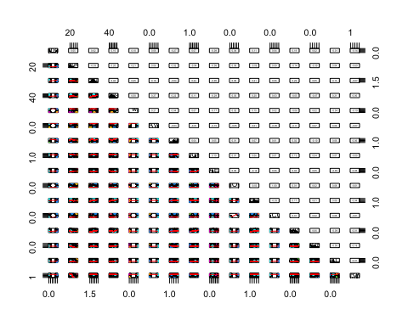 The best segregating variables seem to be ´weight´ and ´height´

## 2.2. K-means algorithm

We use the k-means algorithm from the ´stats´ package.

#################### K-MEANS ALGORITHM  
  
datakmeans <- data.frame(data$Weight, data$Height, data$Obesity)  
  
# call kmeans again but this time passing the centers calculated in the previous step  
km <- kmeans(datakmeans[,1:2], 7)  
  
# plot of the results  
plot(datakmeans[1:2],   
 col=km$cluster,   
 pch=19)  
legend(165, 1.8,   
 c("1","2", "3", "4", "5", "6", "7"),  
 pch=19,   
 col=c(1:7))

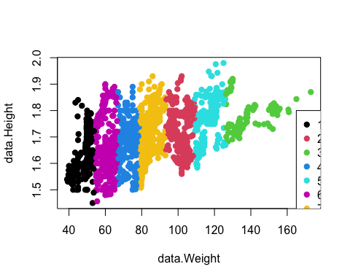

The clusters aren’t in the right order. We modify the cluster “names” to then measure accuracy :

#################### K-MEANS CLUSTER ORDERING  
  
# re-order kmeans clusters according to mean weight  
ordered_center <- order(km$centers[,1])  
ordered_labels <- match(km$cluster,ordered_center)  
# plot of the results  
plot(datakmeans[1:2],   
 col=ordered_labels,   
 pch=19)  
legend(165, 1.8,   
 c("1","2", "3", "4", "5", "6", "7"),  
 pch=19,   
 col=c(1:7))

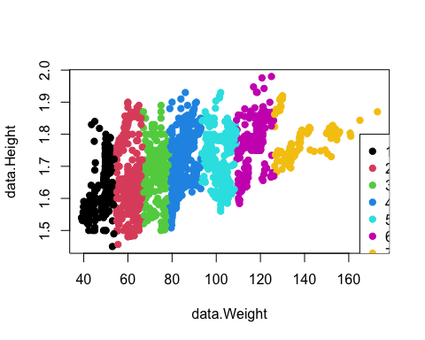

The clusers are now in the right order. We measure the accuracy of the technique with a confusion matrix :

#################### K-MEANS CONFUSION MATRIX  
cm <- table(label=data$Obesity, cluster=ordered_labels)  
cm ; cat( sum(diag(cm)) / sum(cm) )

## cluster  
## label 1 2 3 4 5 6 7  
## Insufficient_Weight 208 64 0 0 0 0 0  
## Normal_Weight 57 141 73 16 0 0 0  
## Obesity_Type_I 0 0 28 156 146 21 0  
## Obesity_Type_II 0 0 0 1 61 215 20  
## Obesity_Type_III 0 0 0 0 81 110 133  
## Overweight_Level_I 2 53 144 91 0 0 0  
## Overweight_Level_II 0 22 59 183 26 0 0

## 0.2174325

The technique is not very accurate, only 21% of the clustering is right.

# 3. 2nd technique : Decision tree

## 3.1. Separate train and test sets

#################### TRAIN AND TEST SETS  
  
n <- nrow(data)  
sel <- sort(sample.int(n, n/4))  
data.train <- data[-sel,]  
data.test <- data[sel,]

#################### DECISION TREE ALGORITHM  
  
h <- rpart(Obesity ~ . , data = data.train, method ='class', cp=0, xval=500)  
  
fancyRpartPlot(h, caption = NULL, type = 1)

## Warning: labs do not fit even at cex 0.15, there may be some overplotting

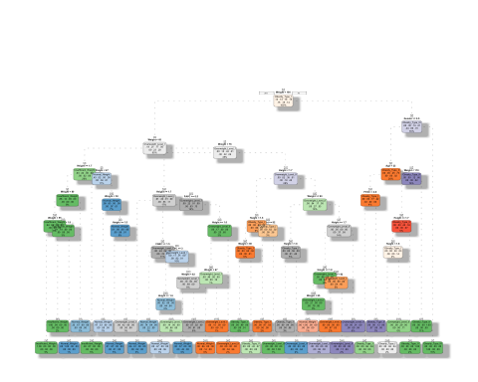

The tree is too big, we need to truncate it. We adjusted the cp value until we had 7 categories.

#################### DECISION TREE PRUNING  
  
plotcp(h)

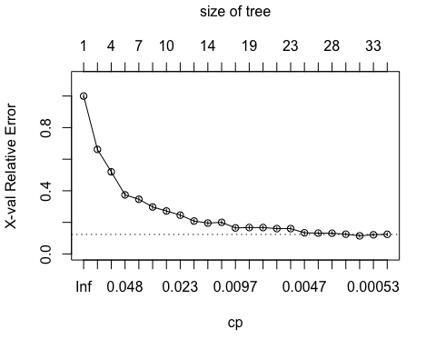

h_pruned <- prune(h, cp=0.03)  
  
fancyRpartPlot(h_pruned, caption=NULL, type=2)

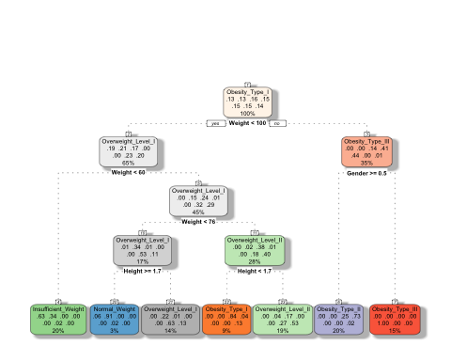

The second tree looks better, and we have indeed our 7 categories. We can now measure its accuracy :

#################### DECISION TREE EVALUATION  
  
obesity_pred <- predict(h_pruned, data.test, type= 'class')  
  
conf_table <- table(true=data.test$Obesity, predicted = obesity_pred)  
  
n <- sum(conf_table)  
error = (n - sum(diag(conf_table)))/n  
  
cat(sprintf("The relative prediction error is %4.1f%%",error*100))

## The relative prediction error is 33.0%

For such a dataset and mini-project, an error of ´{r} error*100´% is not that bad.