Alienated by his weaker literacy skills

Worried that current fishing is too unsustainable

Fears the craft he loves will die out

Intimidated by the internet

Newer sustainable fishing methods are shared online

People sharing their knowledge online in tourist zones

**Think and Feel**

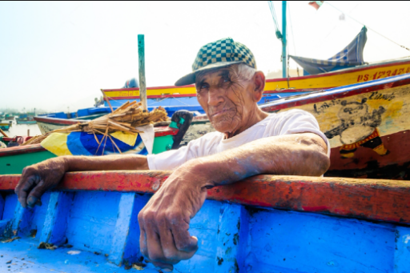

There is support for all ability levels digitally

Young people engaging with online content

**See**

**Hear**

People are being inspired to keep fishing after connecting better with others

Fishing practices creating environmental damage

Tells his grandchildren his fishing tricks

Helps his community and tries to foster a connection

Enjoys teaching others what he knows

Works hard to provide for his family in his old age

**Say and Do**

Able to share the joys of sustainable fishing to the youth

Unable to preserve his knowledge for the next generation

Fishing craft is getting hurt by malpractice

It is hard to read and write so learning is challenging

Hard to find information in his language that he can understand

Gains an avenue to learn and teach through

Sustains the fishing craft for future generations

**Gain**

**Pain**