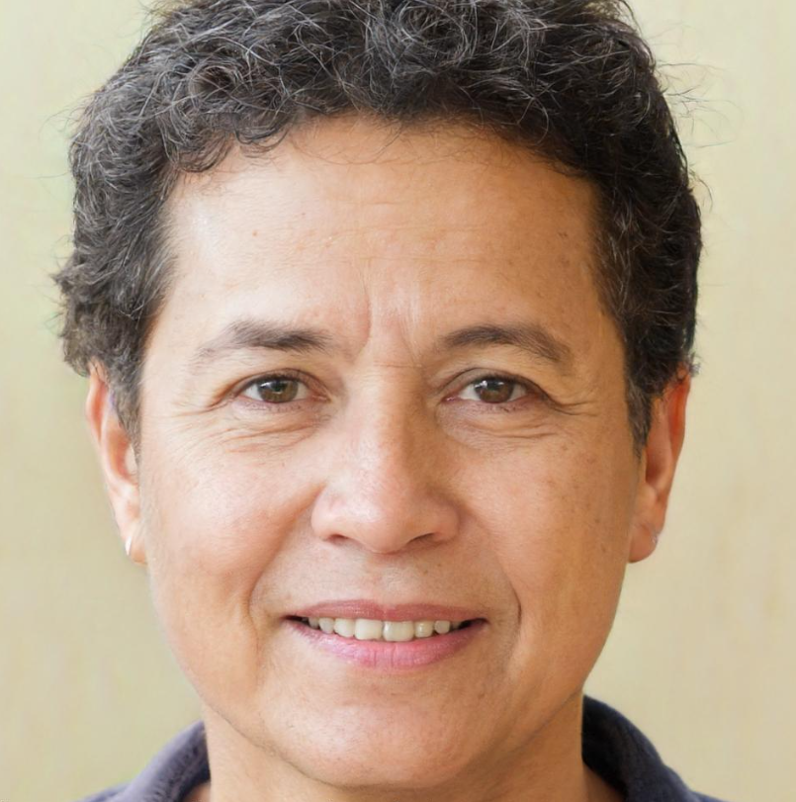

*“I want a place for the new, young fishers to learn how to be safe and educated on best practices.”*

**AGE:** 40 years old

**OCCUPATION:** Fisherman

**FRUSTRATIONS:**

* The internet is vast and surfing it is confusing.
* People getting hurt by following bad safety practices.
* The youth are unable to access good quality information easily.
* Preserving generational knowledge is challenging.

**NEEDS:**

* High quality information in one place.
* Easy ways to share knowledge.
* Able to download good advice for offline use.
* Support for community members who are unable to read and write.
* A way to communicate with other members.

***Fernandez Garcia***