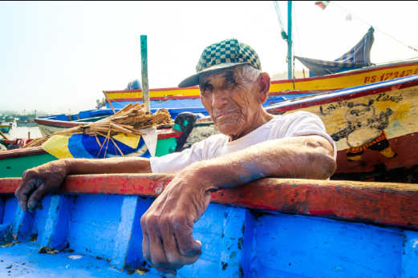

*“I want our way of life to persist for the next generations to enjoy.”*

**AGE:** 76 years old

**OCCUPATION:** Fisherman

**FRUSTRATIONS:**

* Current fishing practices are unsustainable.
* Fear that the craft may die out.
* There is no guarantee his knowledge will be passed down to those that need it.
* The new generation is ill equipped to ensure the longevity of the community.
* Weak literacy skills

**NEEDS:**

* Place to share his knowledge.
* Ways to learn new methods of sustainable fishing.
* Community hub to maintain the generational pride of the craft.
* Low barrier to entry for use.
* Support for those with weaker literacy skills.

***Pedro Díaz***