# INDEX

Slogan: GO See the world!

Text:

It's time for a new adventure Go See! The World.

find places to GO See!

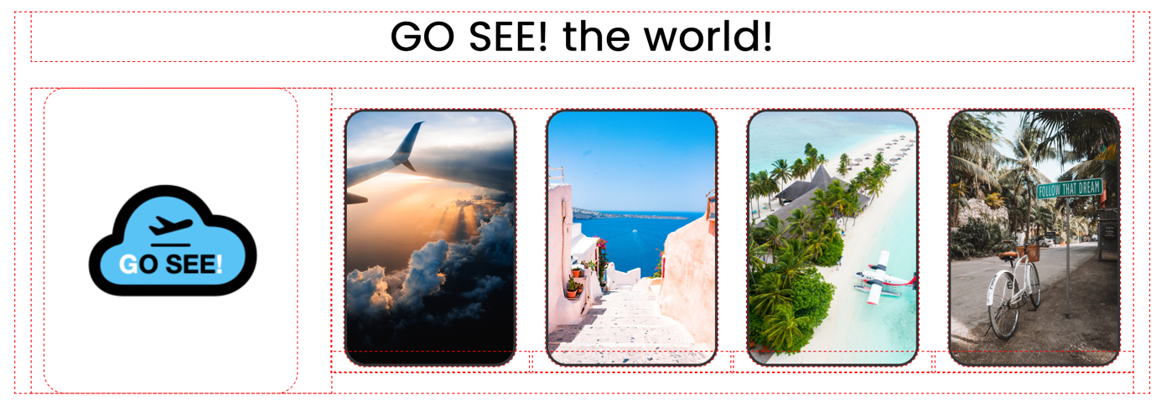

Welcome To GO SEE Travel Agency, Your Gateway To Unforgettable Travel Experiences. Whether You're Dreaming Of Pristine Beaches, Ancient Wonders, Or Vibrant Cities, We're Here To Make Your Travel Aspirations A Reality. With Our Expertise And Personalized Service, Let Us Take You On A Journey Of Discovery, One Incredible Destination At A Time.

Your One Stop Shop For All Of Your Traveling Needs. 2023 Is The Year That Global Travel Is Expected To Finally Reach Pre-Pandemic Levels As Countries Ditch The Last Of Their Covid-19 Restrictions And The World Returns To The “New Normal”. Based On The Latest Travel Trends, Sure Travel Predicts That These Destinations Will Be Sought After In 2023.

## Explore our top travel destinations:

* **PARIS:** The City of Love and Romance
* **BALI:** Paradise Found
* **NEW YORK:** The City That Never Sleeps
* **TOKYO:** Where Tradition Meets Futuristic Marvels
* **SYDNEY:** Sun, Sand, and Surf

**Reviews**

#Reviews image

Check out some of our reviews online.

**Our customers love us!**

"GO SEE Travel Agency made our dream vacation a reality. The attention to detail and personalized service were exceptional!" - Mark and Sarah, Happy Travelers

"Thanks to GO SEE, we discovered hidden gems and had the trip of a lifetime. Highly recommended!" - Emma, Adventurer Extraordinaire

"I can't imagine planning a trip without GO SEE. They took care of everything, allowing us to relax and enjoy every moment." - David and Lisa, Repeat Customers

# About:

**About US**

GO SEE! is a proudly South African business by origin that is interested in making all of your traveling needs as easy and as smooth as possible for our clients, so that you can get your holiday started. With our reputable travel agents throughout the world we have been able to deliver a best in class personalised experience for our clients.

**Why choose Us?**

GO SEE! is a proudly South African business by origin that is interested in making all of your traveling needs as easy and as smooth as possible for our clients, so that you can get your holiday started. With our reputable travel agents throughout the world we have been able to deliver a best in class personalised experience for our clients.

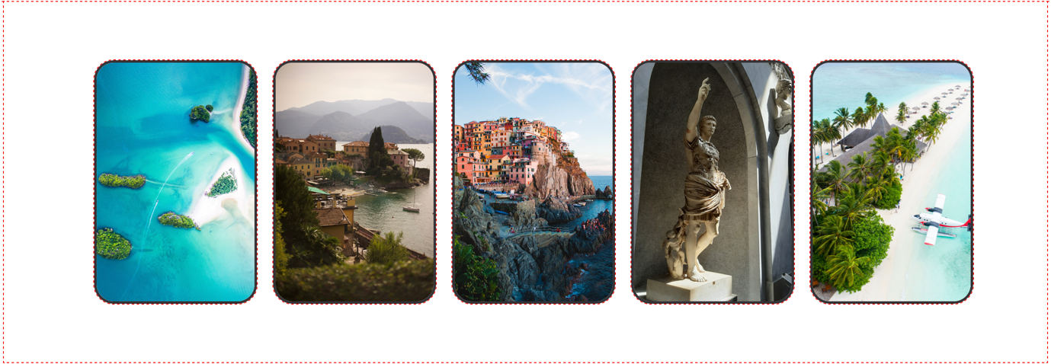

* Accommodation, Holidays, Cruises, Tours, insurance, you name it—we do it
* Business travel? That's our business too.
* Complex tricky group bookings for a hard to organise event? Not a drama.
* If it's travel related, we are your people.

**Our Values**

We acknowledge the continuous journey towards reconciliation we contribute to many countries in which we operate in. our roots were laid out 30 years ago, and we continue to make meaningful contributions to charities around the world that fall in line with our companies values and purpose. We wish to make the places in which we operate in better than we found it thus improving the community we are based in as well, through many initiatives we are achieving that goal.

# Destination:

**Destinations**

**Rome: Eternal City of History and Culture**

Explore the eternal city of Rome and immerse yourself in its rich history and culture. Visit iconic landmarks like the Colosseum, Roman Forum, and Vatican City, home to St. Peter's Basilica and the Sistine Chapel. Indulge in authentic Italian cuisine, stroll through charming piazzas, and make a wish at the Trevi Fountain. With its ancient ruins, Renaissance art, and vibrant atmosphere, Rome offers a captivating experience for every traveller.

**Cape Town: Where Nature Meets Urban Sophistication**

Experience the breath-taking beauty of Cape Town, nestled between the Atlantic Ocean and Table Mountain. Take a cable car ride to the summit of Table Mountain for panoramic views of the city and coastline. Explore the colourful Bo-Kaap neighbourhood, visit the historic Robben Island, and drive along the stunning Cape Peninsula to see the Cape of Good Hope. Sample world-class wines in the nearby Winelands and enjoy the vibrant food scene in Cape Town. With its stunning landscapes, diverse wildlife, and cosmopolitan vibe, Cape Town offers an unforgettable adventure.

**Rio de Janeiro: The Marvellous City**

Get ready to samba in the vibrant city of Rio de Janeiro. Relax on the famous beaches of Copacabana and Ipanema, and take in the breath-taking views from the iconic Christ the Redeemer statue on Corcovado Mountain. Explore the colourful neighbourhood of Santa Teresa, visit the historic Sugarloaf Mountain, and witness the energy of a local football match at Maracanã Stadium. With its lively carnival, stunning natural landscapes, and infectious joie de vivre, Rio de Janeiro is a city that captivates the soul.

Gallery

#contains copyright free images gathered from unsplash.com

# Blog:

**Blog**

**News 1**

We have travelled across the globe to bring our travellers the best holidays. Read all about our trips and journey with us to discover new places and revisit popular destinations. Our blogs cover everything from destination inspiration and worldwide events, to new hotels that we offer as part of our holiday packages, and other newsworthy information to keep you up to date with what is happening in the travel world.

**News 2**

We have travelled across the globe to bring our travellers the best holidays. Read all about our trips and journey with us to discover new places and revisit popular destinations. Our blogs cover everything from destination inspiration and worldwide events, to new hotels that we offer as part of our holiday packages, and other newsworthy information to keep you up to date with what is happening in the travel world.

**Blogs posts coming soon...**

# Contact:

**Address:** 144 Peter Rd, Ruimsig, Roodepoort 1724

**Email:** jef@GOSEE.za

**Contact number:** +2775 763 0912

**Opening hours:** 5am - 6pm

**Location**

*integrated map showing the location of the business thanks to the embed feature of google maps..