Incorrect Calculation Of Fines
Test Script: IncorrectCalculationOfFinesTest.java
Expected:
The test should have run smoothly with no assert failed error as the patron should have been issued a loan amount of $1
Results:
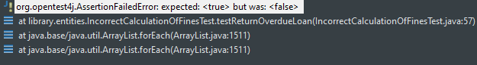
The test failed with an assert failed error as when the patron tried to return their late book the system did not issue them a fine, therefore causing the test to fail.

