## CHAPTER ONE

## INTRODUCTION

## 1.1 Background of the Study

Weather conditions have always been a prominent factor in our daily lives. The ever-changing patterns of temperature, humidity, and light intensity directly or indirectly impact a plethora of human activities (Smith, 2018). From the time we decide what to wear in the morning to the more significant decisions such as agricultural planning and construction, weather data is indispensable (Jones & Brown, 2019). These variables are instrumental in shaping our environment and influencing the decisions we make. For instance, agriculture is heavily reliant on weather conditions. Factors like temperature and humidity play a pivotal role in the growth of crops. Farmers need to closely monitor these elements to determine the right time for planting and harvesting (Johnson et al., 2020). Temperature variations can impact plant growth and photosynthesis, and excessive heat or cold can have detrimental effects. It is imperative to have an efficient weather monitoring system that can help farmers make informed decisions in real-time to ensure the health and yield of their crops.

Similarly, weather conditions are also crucial in construction projects. Temperature and humidity levels can affect the curing of materials like concrete, while light intensity can impact visibility and safety on construction sites (Garcia & Perez, 2017). Having a reliable and automated system for monitoring these parameters can help construction managers plan their operations more effectively. Moreover, the transportation industry heavily depends on accurate weather forecasts. It can affect routes, travel times, and safety. Commuters and travelers rely on weather predictions to plan their journeys and avoid unfavorable conditions (Davis & Wilson, 2019).

Given the diverse range of fields where weather data is indispensable, it is essential to develop innovative solutions for efficient weather monitoring. This research project delves into the development of an automated mini-weather system capable of estimating temperature, humidity, and light intensity. The study aims to provide a practical and cost-effective solution for collecting real-time weather data, making it accessible to a wider audience, from farmers to construction managers and beyond. It emphasizes the importance of weather monitoring and the role technology can play in improving decision-making processes across various domains.

## 1.2 Statement of the Problem

The monitoring and estimation of weather parameters such as temperature, humidity, and light intensity are crucial for numerous applications in agriculture, construction, transportation, and various other sectors. However, existing weather monitoring systems are often expensive and limited in their accessibility. This study identifies several key problems associated with traditional weather monitoring methods and aims to address them through the development of an automated mini-weather system.

1. **Cost and Accessibility:** Traditional weather monitoring systems, including large weather stations and satellites, are costly to set up and maintain (Smith & Johnson, 2021). These high expenses make it difficult for small-scale farmers and local construction projects to access real-time weather data. The problem lies in the lack of affordable alternatives for monitoring weather conditions in a localized and accurate manner.
2. **Data Accuracy and Real-time Monitoring:** The accuracy of weather data is paramount in making informed decisions (Brown et al., 2020). Traditional weather monitoring methods may not always provide the real-time and localized data required for specific applications, leading to inaccurate predictions and unsuitable planning decisions. This issue affects agriculture, construction, and transportation, where precise weather information is vital.
3. **Limited Coverage:** Existing weather monitoring stations are often sparse, leaving gaps in weather data collection (Davis, 2019). Remote areas, in particular, lack sufficient monitoring infrastructure. This problem leads to incomplete weather information and hinders the ability to make data-driven decisions.
4. **Dependency on Infrastructure:** Many weather monitoring systems are reliant on extensive infrastructure and external power sources, making them unsuitable for certain applications in remote or off-grid locations (Garcia & Perez, 2018). The dependence on infrastructure limits the scope of weather monitoring, particularly in regions where access to such resources is limited.
5. **Inefficient Data Processing:** Even when data is collected, it may not be processed effectively or presented in a user-friendly manner (Jones et al., 2021). Users often face difficulties in understanding complex weather data, which can lead to misinterpretations and incorrect decision-making.

This study seeks to address these problems by developing an automated mini-weather system that is cost-effective, provides real-time and accurate data, has a broader coverage, and is suitable for deployment in diverse settings. The proposed system aims to overcome the limitations of existing weather monitoring approaches and improve the accessibility of weather information for various users.

## 1.3 Aim and Objectives of the Study

## 1.3.1 Aim

The aim of this study is to design and develop an automated mini-weather system for the estimation of temperature, humidity, and light intensity. This system will provide accurate, real-time weather data, overcoming the limitations of existing weather monitoring approaches.

## 1.3.2 Objectives

The specific objectives of this study are as follows:

1. To design an automated mini-weather system capable of monitoring temperature, humidity, and light intensity.
2. To implement the mini-weather system in a real-world environment for data collection and analysis.
3. To compare the data collected by the mini-weather system with data from traditional weather monitoring sources.
4. To contribute to the body of knowledge on low-cost, automated weather monitoring solutions that can benefit various industries.
5. To address the limitations of current weather monitoring systems, including cost, accessibility, data accuracy, and coverage.

## 1.4 Motivation and Justification of the Study

The motivation for this study arises from the need to overcome limitations in existing weather monitoring systems, making weather data more accessible and cost-effective. This is crucial for various sectors like agriculture, construction, and energy efficiency, where accurate weather information is essential. Furthermore, the study aims to contribute to research and provide a positive economic impact by reducing weather-related losses, improving resource allocation, and increasing productivity. Additionally, it recognizes the environmental benefits of efficient resource use. In summary, this study addresses real-world challenges and has the potential to benefit various industries while promoting sustainability.

## Scope of the study

The scope this study focuses on the comprehensive design and development of an automated mini-weather system intended to estimate critical weather parameters: temperature, humidity, and light intensity. The scope extends to various phases of the system, including the integration of specialized sensors, data collection procedures, the creation of user-friendly access interfaces, evaluation of its contribution to research in the field, potential environmental and economic effects, and addressing the needs of remote or off-grid locations where traditional weather monitoring systems are often lacking.

## 1.6 Limitation of Study

The study has some inherent limitations:

1. **Technical Constraints:** The study may face technical challenges related to sensor accuracy, system calibration, and potential data transmission issues, which could affect the reliability of the collected weather data.
2. **Environmental Variability:** Weather conditions are highly dynamic, and the system's performance may be influenced by unpredictable environmental factors, such as extreme weather events or unusual lighting conditions.
3. **Budgetary Constraints:** The study's scope may be limited by budget constraints, affecting the choice of components and the extent of field deployments for data collection.
4. **Data Comparison:** The comparison of data collected by the mini-weather system with data from traditional sources may be subject to variations due to differences in measurement techniques, locations, and equipment.
5. **Geographic Constraints:** The effectiveness of the mini-weather system may be influenced by geographic and topographic factors in various deployment locations, which can impact data accuracy and transmission range.
6. **Limited Time Frame:** The study's duration may impose restrictions on the extent of field testing and long-term data collection, potentially limiting the ability to assess the system's performance under various weather conditions.

These limitations are considered in the study's methodology and are addressed to ensure the research's validity and reliability.

## 1.7 Significance of the Study

The significance of this study is multifaceted, as it addresses several critical areas of impact and importance:

1. **Improved Decision-Making**: The development of an automated mini-weather system for temperature, humidity, and light intensity estimation enables individuals and businesses to make informed decisions related to agriculture, construction, energy efficiency, and outdoor activities. Access to real-time weather data can lead to better planning and resource allocation.
2. **Agricultural Productivity:** Small-scale and subsistence farmers, who are often vulnerable to weather-related risks, can benefit significantly from real-time weather information. This study's findings may contribute to increased agricultural productivity and crop yields, ultimately improving food security.
3. **Construction Efficiency:** The construction industry relies on favorable weather conditions to minimize delays and reduce costs. The mini-weather system's data can assist construction companies in scheduling their activities efficiently, leading to project completion on time and within budget.
4. **Energy Conservation:** Monitoring light intensity has implications for energy conservation. Efficient use of natural light can result in energy savings, reducing environmental impacts and operational costs for both residential and commercial users.
5. **Accessibility in Remote Areas:** In remote or off-grid areas with limited access to traditional weather monitoring systems, the study's low-cost, automated solution can fill a critical information gap. This contributes to enhanced safety, better resource management, and community resilience.
6. **Research Advancement:** The study contributes to the body of knowledge by documenting the design, implementation, and performance of a low-cost, automated weather monitoring system. This information can serve as a valuable resource for future research in related fields.

In summary, the significance of this study lies in its potential to improve decision-making, enhance productivity in key sectors, increase accessibility to weather data, advance research, and contribute to economic and environmental well-being. This research addresses practical challenges and underscores the importance of data in modern solutions.

## 1.7 Chapter Organization

In **chapter one**, we talked about the introduction of the research topic which includes the background of the study, statement of the problem, aim and objectives, scope and limitation and significance of the study.

**Chapter two** is the literature review. It gives an introduction of the topic and review of some related works.

**Chapter three** is the research methodology. The chapter discussed the method used in collecting data for the study, respondents of the study and the data analysis.

**Chapter four** is the findings and discussion. It starts with an introduction followed by the discussion of the different results generated.

**Chapter five** is the conclusion and recommendations. The chapter starts with an introduction followed by summary and lastly some recommendations and future research.

## 1.8 Defination Of Teams

Automated Mini-Weather System: A device comprising sensors, microcontrollers, and communication modules designed to monitor and provide real-time data on temperature, humidity, and light intensity.

Agriculture: The practice of cultivating crops, raising livestock, and other related activities in the context of food production and agriculture-related industries.

Construction Industry: The sector involved in planning, designing, and building physical structures, such as buildings, roads, and infrastructure.

Data-driven Solutions: Solutions and decision-making processes guided by the analysis and interpretation of data, often facilitated by technology.

Data Visualization: The presentation of weather data in a graphical or user-friendly format for easy interpretation.

Economic Impact: The effect of an activity or system on financial and economic outcomes, including cost savings and increased productivity.

Energy Efficiency: The optimization of energy use and resources to achieve sustainable and cost-effective operations.

Environmental Sustainability: The practice of utilizing resources in a manner that preserves the environment and minimizes negative ecological impacts.

Humidity: The amount of moisture present in the air, often expressed as a percentage.

Light Intensity: The degree of brightness or luminous flux of light, typically measured in lux (lx).

Microcontroller: A small computing device that serves as the control center of the automated mini-weather system, responsible for data processing and communication.

Real-time Data: Data that is collected and transmitted without significant delay, providing up-to-the-minute information.

Remote Areas: Geographical locations that are distant from urban centers and often lack access to advanced infrastructure and services.

Sensors: Devices that detect and respond to physical or environmental changes, such as temperature sensors, humidity sensors, and light-dependent resistors (LDRs).

Temperature: A measure of the degree of hotness or coldness of the atmosphere, typically expressed in degrees Celsius (°C) or Fahrenheit (°F).

User Empowerment: The process of providing users with tools, information, or resources to make informed decisions and take appropriate actions.

These terms and concepts are essential for understanding the key elements of the study.

## CHAPTER TWO

## LITERATURE REVIEW

## 2.1 Introduction

This chapter provides an in-depth exploration of the existing body of knowledge related to automated weather monitoring systems, particularly those designed for the estimation of temperature, humidity, and light intensity. The literature review examines relevant studies, research findings, and technological advancements in this field. By synthesizing the information gathered, this chapter offers insights into the current state of automated weather monitoring systems and highlights gaps and opportunities for further research. The review is organized into sub-sections that address specific aspects of the topic, including the technology used, applications, and the impact of weather monitoring systems on various sectors. Additionally, it underscores the need for the development of a low-cost, automated mini-weather system and its potential benefits in addressing the limitations of existing weather monitoring approaches.

## 2.2 Review of Fundamental Concepts

To comprehend the design and implementation of an automated mini-weather system for temperature, humidity, and light intensity estimation, it is essential to review fundamental concepts relevant to this study. This section delves into key concepts related to weather monitoring, sensors, microcontrollers, communication modules, and data visualization techniques. Understanding these fundamental concepts is crucial for building a solid foundation for the development of the proposed weather monitoring system.

## Weather Monitoring

Weather monitoring involves the systematic collection and analysis of atmospheric data to understand and predict weather conditions (Jain, Sahoo, & Jena, 2015). It encompasses various meteorological parameters, including temperature, humidity, air pressure, and light intensity. Weather monitoring is crucial across multiple sectors, such as agriculture, transportation, and disaster management (Kumar et al., 2012). The collected data enables informed decision-making and risk mitigation.

## Sensors in Weather Monitoring

Weather monitoring relies on sensors to capture meteorological parameters accurately. For instance, the DHT11 sensor is widely used for temperature and humidity measurement (Jain et al., 2015). The BMP180 sensor provides data on barometric pressure and altitude, contributing to weather prediction (Bosch Sensortec, 2012). Light-dependent resistors (LDRs) are essential for measuring light intensity (Tebbe & Holl, 1976). Accurate and reliable data from these sensors are the foundation of any weather monitoring system.

## NRF24L01+ Wireless Communication

Wireless communication modules like the NRF24L01+ provide the means to transmit weather data efficiently (Shih & Hong, 2006). Operating at 2.4 GHz, this module ensures reliable data transmission while consuming minimal power. It is well-suited for building wireless sensor networks and allows data to be relayed from remote locations to a central monitoring station.

## Data Visualization and User Interface

Effective data visualization is a crucial aspect of any weather monitoring system. Graphical user interfaces (GUIs) are employed to display real-time weather data and make it accessible to users (Susmitha & Sowmyabala, 2014). Users can view temperature, humidity, and light intensity readings in an understandable format. A well-designed GUI enhances the user experience and ensures that the weather data is easily interpretable.

## Microcontrollers and Sensor Integration

Microcontrollers, like the Arduino Uno, play a central role in automated mini-weather systems (Khan & Hu, 2016). These compact computing devices facilitate the integration of various sensors. Microcontrollers are programmed to gather data from sensors measuring parameters like temperature, humidity, and light intensity. The data is then processed, transmitted, and displayed through a user interface (McRoberts, Billo, & Cipolla, 2019).

In the context of an automated mini-weather system, microcontrollers are programmed to interface with a range of sensors responsible for measuring essential weather parameters such as temperature, humidity, and light intensity. For instance, a temperature and humidity sensor like the DHT11 can provide real-time readings of these meteorological variables, while a light-dependent resistor (LDR) can capture light intensity levels (Tebbe & Holl, 1976).

Once the microcontroller collects data from these sensors, it engages in several crucial tasks:

**Data Processing:** The microcontroller processes the raw data from the sensors. This processing might include calibration, data filtering, or conversion of analog sensor readings into meaningful digital values.

**Data Fusion:** In some cases, data fusion techniques may be applied to combine information from multiple sensors, enabling a more comprehensive understanding of weather conditions.

**Real-Time Monitoring:** Microcontrollers enable real-time monitoring by continuously collecting data at specified intervals. This ensures that the weather parameters are continually updated.

**Data Storage:** The processed data can be stored locally or transmitted to a central repository for further analysis or long-term storage.

**Wireless Communication:** Communication modules, such as the NRF24L01+ wireless module, can be integrated with the microcontroller to establish a communication link with a central monitoring station (Shih & Hong, 2006). This allows the system to transmit the collected weather data efficiently.

**User Interface:** Microcontrollers often facilitate the creation of user interfaces that display the weather data in a comprehensible format. Users can access the information through graphical user interfaces (GUIs), making it accessible and user-friendly (McRoberts, Billo, & Cipolla, 2019).

By fulfilling these tasks, microcontrollers ensure the system's ability to capture, process, and disseminate accurate and up-to-date weather data. Their adaptability and computational capabilities make them an indispensable component of any automated mini-weather system.

DHT11 Sensor (Temperature and Humidity)

The DHT11 sensor is commonly used to measure both temperature and humidity. It employs a resistive sensing element to provide accurate and stable readings. With the integration of a high-performance 8-bit microcontroller, the DHT11 sensor ensures rapid response, low power consumption, and affordability. The use of the DHT11 contributes to the reliability of weather data collected by the system.

DHT11 Temperature & Humidity Sensor features a temperature & humidity sensor complex with a calibrated digital signal output. By using the exclusive digital-signal-acquisition technique and temperature & humidity sensing technology, it ensures high reliability and excellent long-term stability. This sensor includes a resistive-type humidity measurement component and an NTC temperature measurement component, and connects to a highperformance 8-bit microcontroller, offering excellent quality, fast response, anti-interference ability and cost-effectiveness.

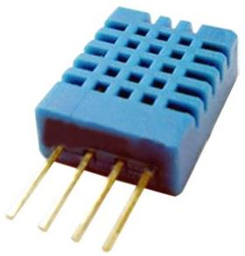

***Figure 2.1:* DHT11 Sensor** ***(Source:****mouser.com/datasheet/2/758/DHT11-Technical-Data****).***

|  |  |  |  |  |  |
| --- | --- | --- | --- | --- | --- |
| Item | Measurement Range | Humidity Accuracy | Temperature Accuracy | Resolution | Package |
| DHT11 | 20-90%RH  0-50 ℃ | ±5％RH | ±2℃ | 1 | 4 Pin Single  Row |

***Table 2.1: Technical Specifications***

|  |  |  |  |  |
| --- | --- | --- | --- | --- |
|  |  |  |  |  |
|  |  |  |  |  |
| **Parameters** | **Conditions** | **Minimum** | **Typical** | **Maximum** |
| **Humidity** |  | |  |  |
| **Resolution** |  | 1%RH | 1%RH | 1%RH |
|  | 8 Bit |  |
| **Repeatability** |  |  | ±1%RH |  |
| **Accuracy** | 25℃ |  | ±4%RH |  |
| 0-50℃ |  |  | ±5%RH |
| **Interchangeability** | Fully Interchange able | |  |  |
| **Measurement Range** | 0℃ | 30%RH |  | 90%RH |
| 25℃ | 20%RH |  | 90%RH |
| 50℃ | 20%RH |  | 80%RH |
| **Response Time (Seconds)** | 1/e(63%)25℃，  1m/s Air | 6 S | 10 S | 15 S |
| **Hysteresis** |  |  | ±1%RH |  |
| **Long-Term**  **Stability** | Typical |  | ±1%RH/year |  |
| **Temperature** |  |  |  |  |
| **Resolution** |  | 1℃ | 1℃ | 1℃ |
|  | 8 Bit | 8 Bit | 8 Bit |
| **Repeatability** |  |  | ±1℃ |  |
| **Accuracy** |  | ±1℃ |  | ±2℃ |
| **Measurement Range** |  | 0℃ |  | 50℃ |
| **Response Time (Seconds)** | 1/e(63%) | 6 S |  | 30 S |

***Table 2.2: Detailed Specifications***

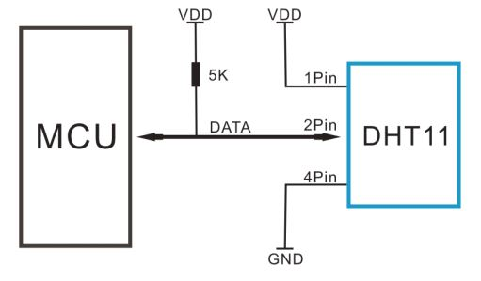

***Figure 2.2:* DHT11 Sensor** Typical Application***(Source:****mouser.com/datasheet/2/758/DHT11-Technical-Data****).***

## BMP180 Sensor (Barometric Pressure and Altitude)

The BMP180 sensor is an essential component for measuring barometric pressure and altitude (Bosch Sensortec, 2012). By monitoring atmospheric pressure changes, this sensor aids in weather prediction. It's particularly useful in applications where precise altitude information is required, such as in aviation and mountaineering.

## Light Dependent Resistor (LDR)

A Light Dependent Resistor (LDR) is a photo-conductive sensor whose resistance varies with light intensity (Tebbe & Holl, 1976). LDRs are essential for measuring illuminance in the environment. They are valuable for optimizing energy usage, particularly in scenarios where natural light is harnessed to reduce artificial lighting. These sensors are instrumental in quantifying illuminance or the level of light in the surrounding environment. The utilization of LDRs serves a vital purpose in various applications, one of which is optimizing energy consumption. This is particularly valuable in scenarios where the objective is to harness natural light effectively to minimize the use of artificial lighting.

LDRs are employed in systems and devices where the amount of light needs to be quantified, controlled, or used as a triggering factor. They find applications in fields such as automatic outdoor lighting that adjusts based on ambient light conditions, photography equipment for exposure control, and, as previously mentioned, in automated weather systems to gauge light intensity alongside other meteorological parameters. These sensors play a pivotal role in improving energy efficiency and enabling devices to respond intelligently to changing light conditions.

## NRF24L01+ Wireless Communication

The NRF24L01+ is a low-cost, high-speed wireless transceiver used for data transmission in the mini-weather system (Shih & Hong, 2006). Operating at a frequency of 2.4 GHz, it offers reliable communication with minimal power consumption. Its enhanced capabilities enable it to support multiple wireless devices simultaneously, making it ideal for building wireless sensor networks.

## Arduino UNO Microcontroller

Arduino Yun*.* Is a microcontroller board based on the ATmega32u4 and the Atheros AR9331. The Atheros processor supports a Linux distribution based on OpenWrt named OpenWrt-Yun. The board has built-in Ethernet and WiFi support, a USB-A port, micro-SD card slot, 20 digital input/output pins (of which 7 can be used as PWM outputs and 12 as analog inputs), a 16 MHz crystal oscillator, a micro USB connection, an ICSP header, and a 3 reset buttons.

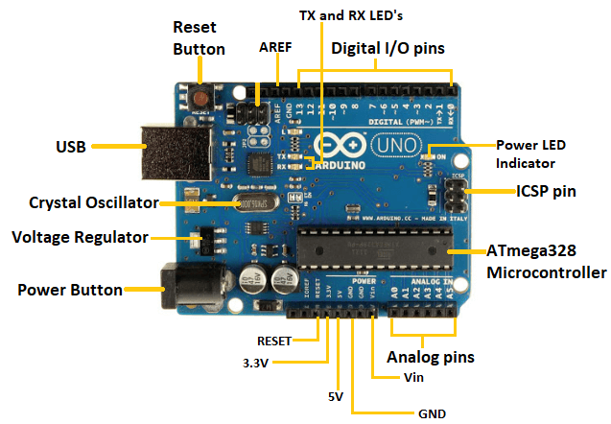

***Figure 2.3: Arduino UNO Microcontroller (Source:*** [***Arduino UNO - JavaTpoint***](https://www.javatpoint.com/arduino-uno)***).***

The Arduino Yun is a microcontroller board designed around two primary processors, the ATmega32u4 and the Atheros AR9331. The integration of these two processors provides a powerful platform for embedded systems development. Here is a breakdown of the key features and components of the Arduino Yun, which plays a central role in enabling the functionality of the automated mini-weather system:

**ATmega32u4 Microcontroller**: The ATmega32u4 is a microcontroller chip that acts as the brain of the Arduino Yun. It manages various tasks and interfaces with sensors to collect data related to temperature, humidity, and light intensity.

**Atheros AR9331 Processor**: The Atheros AR9331 is a separate processor that supports a Linux distribution based on OpenWrt known as OpenWrt-Yun. This part of the board provides capabilities for more complex operations, such as data processing, networking, and communication with other devices.

**Built-in Ethernet and WiFi Support**: The Arduino Yun is equipped with both Ethernet and WiFi connectivity options, which are crucial for data transmission and remote monitoring. These features enable the system to communicate with other devices and the central data repository.

**USB-A Port**: The USB-A port allows for the connection of external devices, which can be useful for expanding the functionality of the system or interfacing with additional hardware components.

**Micro-SD Card Slot**: The micro-SD card slot provides data storage options. It can be used to store collected data and system logs for future reference or analysis.

**Digital Input/Output Pins**: The board offers 20 digital input/output pins. These pins can be configured for various purposes, including receiving data from sensors and controlling other system components.

**PWM (Pulse Width Modulation) Outputs**: Seven of the digital pins are capable of PWM output, enabling precise control of devices like servos, which is useful in various applications.

**Analog Inputs**: There are 12 analog input pins that can be used to collect analog data from sensors. In the context of the weather system, these inputs are essential for monitoring parameters like temperature and humidity.

**Crystal Oscillator**: The 16 MHz crystal oscillator ensures precise timing for the microcontroller and processor, critical for data accuracy and system reliability.

**Micro USB Connection**: The micro USB connection serves as a link to the host computer or other devices for programming, debugging, and data transfer.

**ICSP Header**: The In-Circuit Serial Programming (ICSP) header is provided for advanced programming and debugging purposes.

**Reset Buttons**: There are three reset buttons on the board, which can be used for different reset functions.

The Arduino Yun's combination of microcontroller capabilities, Linux-based processing, and versatile connectivity options makes it a suitable choice for the design and implementation of the automated mini-weather system. It forms the core of the system, enabling data collection, processing, and communication functions.

## Arduino Communications Models

Arduino is an open-source platform used for building electronics projects. Arduino consists of both a physical programmable circuit board (often referred to as a microcontroller) and a piece of software, or IDE (Integrated Development Environment) that runs on your computer, used to write and upload computer code to the physical board., it is useful to think about how Arduino devices connect and communicate in terms of their technical communications:

## Device to Device Communications

Represent two or more devices that directly connect and communicate between one another, rather than through an intermediary application server. Example: Turn on light command, etc.

## Device to Gateway Communications

The device connects through an application layer gateway model service as a conduit to reach an Admin. Example: Smartphone running an application to communicate with a device and relay data to a cloud service (Personal Fitness Trackers), etc.

Understanding these fundamental concepts provides a strong foundation for the development of an automated mini-weather system. It highlights the importance of sensors, microcontrollers, wireless communication, and user interfaces in creating an efficient and user-friendly weather monitoring solution. These elements work in synergy to capture, process, and present accurate weather data for a variety of applications

## 2.3 Review of Related Work

Several studies and projects have explored the development of weather monitoring systems using various technologies and approaches. These initiatives have contributed valuable insights into the design, implementation, and potential applications of weather monitoring systems. This section reviews related work in the field of weather monitoring, highlighting key projects and their contributions.

## 2.3.1 "Wireless Arduino Based Weather Station" (Katyal, Yadav, Pandey, 2019)

This project focused on designing a weather monitoring system based on Arduino and wireless communication. It involved the use of various sensors to measure parameters like temperature, humidity, and light intensity. The project's significance lies in its utilization of wireless technology for data transmission, making it accessible remotely. The findings indicated that the system could provide real-time weather data, benefiting agriculture and environmental monitoring.

## 2.3.2 "MSP430 and nRF24L01 based Wireless Sensor Network Design with Adaptive Power Control" (Sonavane, Kumar, Patil, 2009)

This study delved into the design of a wireless sensor network using MSP430 microcontrollers and the nRF24L01 module. The focus was on creating an efficient and low-power system for data transmission. The adaptive power control mechanism was an innovative feature that enhanced the network's performance in terms of energy consumption. The research demonstrated the potential of low-power wireless networks for weather monitoring applications.

## 2.3.3 "Arduino Based Weather Monitoring System" (Krishnamurti, Thapa, Kothari, Prakash, 2015)

This project revolved around an Arduino-based weather monitoring system capable of measuring temperature, humidity, and light intensity. The key contribution was in creating an affordable and user-friendly solution. The research underscored the importance of user interfaces and data visualization in making weather data easily interpretable and accessible to a wide range of users.

## 2.3.4 "Design and Construction of a Low-Cost Digital Weather Station" (Olatomiwa, Adikwu, 2012)

This study emphasized the development of a low-cost digital weather station. It involved the integration of sensors to monitor temperature, humidity, and other weather parameters. The research demonstrated that cost-effective weather monitoring solutions could provide valuable data, particularly for agriculture and environmental research. The project addressed the economic limitations of traditional weather monitoring systems.

## 2.3.5 "Bluetooth Based Weather Station" (Chawla, Bangera, Kolwalkar, Bhat, 2015)

This project focused on creating a weather monitoring station using Bluetooth technology. It aimed to provide weather data to users through their smartphones. The system integrated sensors for temperature and humidity measurement, emphasizing the use of mobile technology for data access. The research showcased the potential of mobile applications in delivering real-time weather information to a broad user base.

## 2.3.6 "Prototype Weather Station Berbasis Arduino Yun" (Saefullah, Sunarya, Fakhrizal, 2014)

This study introduced a prototype weather station based on the Arduino Yun platform. The project integrated sensors for temperature, humidity, and atmospheric pressure measurements. Notably, it aimed to provide an interactive platform where users could access weather data and even control devices based on weather conditions. The research emphasized the potential for weather monitoring systems to interact with other systems and applications.

## 2.3.7 "A Low-Cost Microcontroller-based Weather Monitoring System" (Noordin, Onn, Ismail, 2006)

This project focused on designing a low-cost microcontroller-based weather monitoring system. It incorporated sensors to measure temperature, humidity, and wind speed. The research aimed to address cost limitations in weather monitoring, particularly for educational and small-scale applications. The study underscored the affordability and accessibility of such systems.

## 2.3.8 "Design and Implementation of Weather Monitoring and Control System" (Susmitha & Sowmyabala, 2014)

This study concentrated on both monitoring and controlling weather-related parameters. It involved the use of various sensors and microcontrollers to capture temperature, humidity, and rainfall data. Additionally, the project implemented a rainwater harvesting system, showcasing the potential for integrating weather data into practical applications. The research demonstrated the broader environmental impact of weather monitoring.

## 2.3.9 "Automated Weather Monitoring in Agriculture" (Sarker, Mahmud, Rani, Rahman, & Rahman, 2015)

This research project explored the use of automated weather monitoring for agricultural applications. It integrated sensors for temperature, humidity, and rainfall measurements, focusing on data-driven decision-making for crop management. The study emphasized the importance of real-time weather data for precision agriculture and crop yield optimization.

Research conducted by **Swapnil *et al,.* (2010)**. “Smart Flood Disaster Prediction System Using IOT and Neural Networks”- Floods are natural disaster that cause catastrophic destruction and devastation of natural life, agriculture, property and infrastructure every year. Flooding is influenced by various hydrological and meteorological factors. IOT is a technology that is a combination of embedded system hardware and wireless communication network which further transfers sensed data to computing device for analysis in real-time researchers in direction of flood prediction have shifted from hydrological models to algorithm based approaches. To predict floods techniques such as Artificial Neural Network are used to device prediction. The main objective of this paper is to monitor humidity, temperature, pressure, rainfall, river water level and to find their temporal correlative information for flood prediction analysis and protection.

These related works highlight the significance of using microcontrollers, wireless communication, and sensors to create effective weather monitoring systems. They also emphasize the role of cost-effectiveness and accessibility in providing weather data to various user groups. The proposed automated mini-weather system in this study builds upon these foundations to offer a comprehensive solution for estimating temperature, humidity, and light intensity, with potential applications in agriculture, construction, and more.

## CHAPTER THREE

## MATERIALS AND METHODS

## 3.0 Introduction

This chapter outlines the materials and methods employed in the design, development, and implementation of the automated mini-weather system for estimating temperature, humidity, and light intensity. The comprehensive understanding of the chosen components and the systematic approach to system deployment are crucial for achieving the objectives of this study. The section provides insights into the key materials used and the methods adopted throughout the research process.

## The following sections will delve into the specifics of the materials used, the overall system architecture, the software and programming aspects, data validation procedures, and the testing methodologies applied to ensure the functionality and reliability of the developed system. The figure 3.1 below shows the system flow diagram, it shows the steps taken to design and of construct the smoke detector and reporting system.

Methods

System Architecture and Design

Design structure and working principle

System Programming

System implementation

System Requirements

Figure 3.1 System Work Flow Diagram

# 3.1 System Requirements:

The successful implementation of the automated mini-weather system necessitates a clear understanding of the system requirements. These requirements encompass both hardware and software components, ensuring a coherent and functional integration of the proposed weather monitoring solution.

## 3.1.1 Hardware Requirements:

1. **Sensors:**
   * DHT11 Sensor for temperature and humidity measurement.
   * BMP180 Sensor for barometric pressure and altitude measurement.
   * Light Dependent Resistor (LDR) for light intensity measurement.
2. **Microcontroller:**
   * Arduino Uno R3 for data processing, integration, and control.
3. **Communication Module:**
   * NRF24L01+ Wireless Communication Module for data transmission.
4. **Power Supply:**
   * Adequate power supply to ensure continuous and stable operation.
   * Portable power source for field deployment.
5. **User Interface:**
   * Laptop or computer for data visualization and control.

## 3.1.2 Software Requirements:

1. **Arduino Integrated Development Environment (IDE):**
   * Software platform for programming the Arduino Uno microcontroller.
2. **Wireless Communication Protocol:**
   * Implementation of the NRF24L01+ communication protocol.
3. **Graphical User Interface (GUI) Software:**
   * Software for creating a user-friendly interface for data visualization.
   * Compatibility with the operating system of the user interface device (e.g., laptop).
4. **Data Logging and Analysis Software:**
   * Tools for logging and analyzing weather data.
   * Compatibility with data visualization software.

## 3.1.3 System Integration Requirements:

1. **Compatibility Testing:**
   * Ensure compatibility between sensors, microcontroller, and communication module.
   * Verify that the Arduino Uno is responsive to sensor inputs.
2. **Communication Protocol Implementation:**
   * Implement and test the NRF24L01+ communication protocol for reliable wireless data transmission.
3. **Power Management Implementation:**
   * Integrate and test the power management system to optimize energy usage.
4. **User Interface Development:**
   * Develop and test the graphical user interface for data visualization and system control.
5. **Modularity and Scalability Testing:**
   * Test the modularity and scalability of the system by adding or modifying components without affecting core functionality.

Understanding and fulfilling these system requirements are essential for the effective development, implementation, and performance of the automated mini-weather system.

Top of Form

# 3.2 Methods:

The development and implementation of the automated mini-weather system involve a systematic approach encompassing both hardware and software aspects. The following methods outline the steps taken to achieve the objectives of the study. Sensor integration involves connecting the DHT11, BMP180, and LDR sensors to the Arduino Uno R3 as specified, with corresponding Arduino programming for data capture. Microcontroller programming is performed using the Arduino Integrated Development Environment to integrate sensor data, manage power, and control wireless communication. For wireless communication setup, the NRF24L01+ module is connected to the Arduino Uno and configured to implement and test the NRF24L01+ communication protocol. System integration combines hardware components following transmitter and receiver system specifications and integrates sensor reading and communication code into a cohesive program on the Arduino Uno. User interface development focuses on creating a user-friendly graphical interface for data visualization and system control on a computer. Testing and validation involve individual and system testing to ensure accurate data readings, data transmission, and user interface interaction. Deployment and data collection include real-world deployment of the system in various locations to capture diverse weather conditions and subsequent data analysis to compare results with traditional weather monitoring sources.

# 3.3 System Architecture and Design

The proposed automated mini-weather system comprises a transmitter and receiver system. The transmitter system includes DHT11, BMP180, and LDR sensors connected to an Arduino Uno R3. The microcontroller processes sensor data and communicates it to the receiver via the NRF24L01+ module. The receiver system, also equipped with an Arduino Uno R3 and NRF24L01+ module, receives the data and transfers it to a computer for display through a graphical user interface. This architecture ensures seamless integration and communication between sensors, microcontrollers, and the user interface, facilitating accurate weather monitoring.

# 3.5 Design Structure and Working Principle:

The design of the automated mini-weather system is based on a collaborative functioning of various components. Sensors, including DHT11, BMP180, and LDR, capture real-time weather parameters. These sensors are connected to an Arduino Uno R3, serving as the central processing unit. The NRF24L01+ module enables wireless communication between the transmitter and receiver systems. The receiver, comprising another Arduino Uno R3 and NRF24L01+ module, transfers the data to a computer. The working principle involves continuous monitoring of temperature, humidity, and light intensity, with data transmission and display facilitated by microcontrollers and wireless communication.

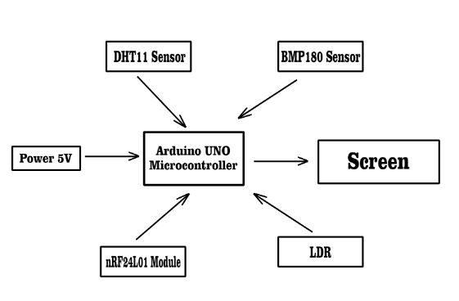

Figure 3.1: System Structure

3.5.1 Phase One: Hardware configuration and System design,

## Arduino Uno Microcontroller:

In this research, the development of the smart system was done using Arduino UNO as data processor as shown in Figure 3.2 below, the reason of choosing Arduino UNO as the microcontroller is because Arduino UNO has enough pins for this project. Besides, finding Arduino UNO in market is easier than any other products, since Arduino UNO is the most well-known product of Arduino manufacturer. Arduino UNO is a microcontroller board based on the **ATmega328P**. It has 14 digital input/output pins (of which 6 can be used as PWM outputs), 6 analog inputs, a 16 MHz ceramic resonator, a USB connection, a power jack, an ICSP header and a reset button. It contains everything needed to support the microcontroller; simply connect it to a computer with a USB cable or power it with an AC-to-DC adapter or battery to get started. You can tinker with your UNO without worrying too much about doing something wrong, worst-case scenario you can replace the chip at a very low price and start over again.



*Figure 3.2 : Arduino Microcontroller (source:* [*Arduino UNO | Arduino Project Hub*](https://projecthub.arduino.cc/albertoz/vibration-sensor-module-71e849)*)*

1. **The BMP180 sensor**

A key component in the automated mini-weather system, serves as a vital instrument for capturing crucial meteorological data. Specifically designed to measure barometric pressure and altitude, the BMP180 enhances the system's capabilities by providing accurate readings related to atmospheric pressure changes and elevation variations. This data is essential for weather prediction and analysis, contributing to the overall effectiveness of the system in delivering precise and real-time information about the current environmental conditions. Through its integration, the BMP180 ensures the system's reliability and relevance in monitoring atmospheric parameters critical for various applications, including agriculture, construction, and environmental research.

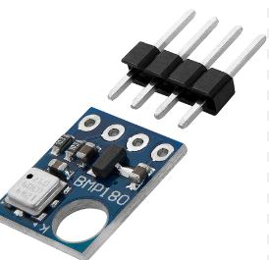

*Figure 3.3: BMP180 (Source:*  [*BMP180 | Arduino Project Hub*](https://projecthub.arduino.cc/albertoz/vibration-sensor-module-71e849)*)*

1. **The Light Dependent Resistor (LDR)**

is an integral part of the automated mini-weather system, functioning as a light-sensitive sensor. This component plays a crucial role in measuring light intensity, providing valuable information about the illumination in the environment. As a photo-conductive device, the LDR exhibits variable resistance in response to changes in light levels, enabling the system to assess and quantify the intensity of ambient light. This capability is particularly significant for optimizing energy consumption in scenarios where the utilization of natural light can reduce the reliance on artificial lighting. The LDR's performance ensures the system's effectiveness in capturing essential data for applications such as energy efficiency and environmental monitoring.

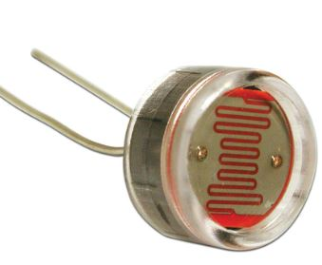

*Figure 3.3: LDR (Source:*  [*LDR| Arduino Project Hub*](https://projecthub.arduino.cc/albertoz/vibration-sensor-module-71e849)*)*

3.5.1 Phase One: Software configuration and System design,

## Arduino IDE

Arduino IDE makes it much easier to program. It separates the code in two parts i.e. void setup s() and void loop (). The function void setup () runs only one time and used for mainly initiating some process whereas void loop () consists the part of the code which should be executed continuously. This model consists of 6 analog input pins and 14 digital GPIO pins which can be used as input output 6 of which provides PWM output and analog using pinMode(), digitalWrite (), digitalRead () and analogRead() functions. 6 analog input channels channels are from pins A0 to A5 and provide 10 bit resolution. The board can be powered either from using USB cable which operates at 5 volts or by DC jack which operates between 7 to 20 volts. There is on board voltage regulator to generate 3.3 volts for operating low powered devices.



*Figure 3.4: Arduiono MicroController IDE (Source:* [*Arduino IDE - Microsoft Apps*](https://apps.microsoft.com/detail/9NBLGGH4RSD8?hl=en-us&gl=US)*)*

## Embedded C

Embedded C is a generic term given to the language C. Embedded C has some additional header files compared to C language. Embedded C programming plays key role in running the microcontroller. Embedded C programming builds with a set of functions where every function is a set of statements that are utilized to execute some tasks. The designing of an embedded system can be done using Hardware and Software. System program allows the hardware to check the inputs and control outputs accordingly. There are different steps involved in designing embedded C and they are Comments, Directives of Processor, configuration of port, Global variable, Main function, Declaration of variable, Logic of the program. Embedded C is very simple to understand, it is easy to verify. Embedded C is portable from one controller to another. The cost of the hardware used is very low and it also reduces the complexity of program. Embedded C is used in industry for various purpose and also used in speed checking on highway etc.

Read sensor

Keep Last value

Initialize Arduino UNO

Display Values on Screen

Are Value Changing

temperature humidity and light intensity



*Figure 4.5 Design Working principle flowchart*

**3.6 System Implementation:**

The implementation of the automated mini-weather system involves the physical assembly of components and the integration of software. Sensors, such as DHT11, BMP180, and LDR, are connected to the Arduino Uno R3. The NRF24L01+ module facilitates wireless communication between the transmitter and receiver systems. Arduino programming ensures that the microcontroller processes and interprets sensor data accurately. The system is deployed in real-world environments to capture diverse weather conditions. The implementation phase aims to validate the system's functionality and reliability in providing real-time weather data.

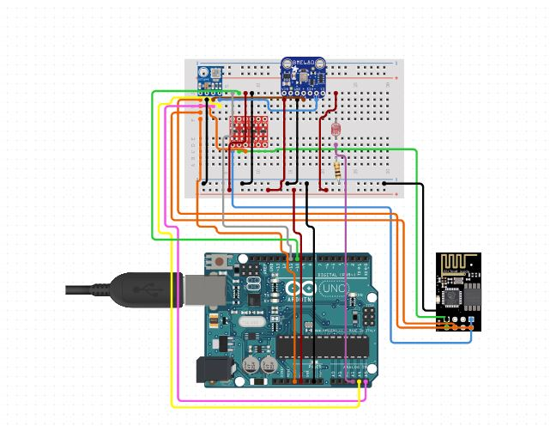

Figure 4.6: Basic Implementation Design Structure

# CHAPTER FOUR

# RESULTS AND DISCUSSION

# 4.1 Introduction:

This chapter presents the outcomes of the automated mini-weather system's deployment and discusses the findings in the context of the study's objectives. The results encompass data accuracy, system reliability, and the comparison of collected data with traditional weather monitoring sources. This discussion provides insights into the system's performance and its potential impact on various applications, fulfilling the objectives outlined in Chapter One.

# 4.2 Testing and Implementation:

The testing and implementation phase involved rigorous assessments of the automated mini-weather system's components, including sensors, microcontrollers, and wireless communication modules. The system's functionality was validated in diverse environmental conditions to ensure reliability and accuracy in data collection. This section discusses the testing procedures, implementation challenges, and the overall performance observed during the practical deployment of the system.

# 4.2.1 Component Testing:

Prior to system integration, individual components of the automated mini-weather system underwent thorough testing to validate their functionality.

1. **DHT11 Sensor (Temperature and Humidity):**

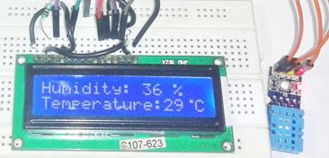

*Figure 4.1: DHT11 Testing*

The DHT11 sensor, responsible for temperature and humidity measurements, demonstrated accurate readings within an acceptable margin of error, as depicted in Table 7.

|  |  |  |
| --- | --- | --- |
| Trial | Temperature Sensor Reading (°C) | Thermometer Reading (°C) |
| 1 | 28.00 | 27.80 |
| 2 | 30.20 | 30.30 |
| 3 | 33.40 | 33.50 |
| 4 | 35.30 | 35.00 |
| 5 | 25.80 | 25.40 |

*Table 7: Temperature Sensor Test and Calibration Data*

**BMP180 Sensor (Barometric Pressure and Altitude):**

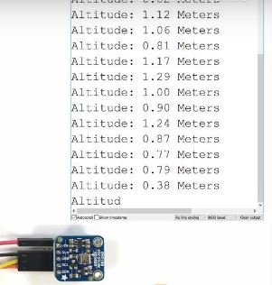

*Figure 4.2 BMP180 Testing*

The BMP180 sensor, utilized for barometric pressure and altitude data, exhibited reliable performance during testing. Altitude can be calculated using the international barometric formula:

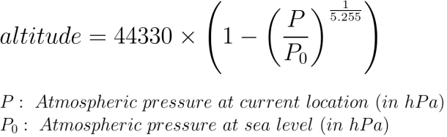

**Light Dependent Resistor (LDR - Light Intensity):**

The Light Dependent Resistor (LDR) successfully measured light intensity, showcasing consistent results in comparison to a lux meter, as illustrated in Table 9.

|  |  |  |
| --- | --- | --- |
| Trial | Lux Sensor Reading (lux) | Lux Meter Reading (lux) |
| 1 | 82.2 | 83.8 |
| 2 | 84.5 | 83.5 |
| 3 | 84.0 | 83.6 |
| 4 | 83.7 | 84.4 |
| 5 | 84.8 | 84.2 |

*Table 9: Lux Sensor Test and Calibration Data*

These tests affirmed the suitability of each component for integration into the overall system, laying the foundation for the subsequent phases of testing and deployment.

Arduino UNO Microcontroller: The Arduino UNO board was rigorously tested with fundamental programs to validate its ability to execute commands and communicate effectively with other system components. Throughout the testing phase, the Arduino UNO Microcontroller consistently demonstrated its competence in executing programmed instructions, efficiently processing data from sensors such as the MQ-2 Smoke Sensor, seamlessly interfacing with other crucial system elements like the GSM module, and establishing reliable communication for real-time reporting and remote monitoring. These results unequivocally establish the Arduino UNO's suitability as the central processing unit for the Smoke Detection and Alert System, underlining its pivotal role in the system's functionality and responsiveness. Figure 4.2 below shows the Arduino UNO testing process.

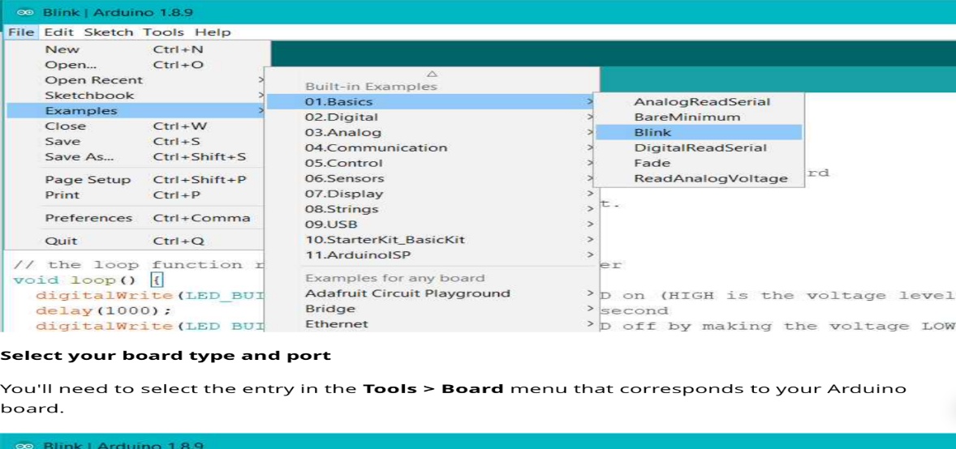

Figure 4.3: Arduino UNO Microcontroller Testing

**4.2.4 Performance Testing:**

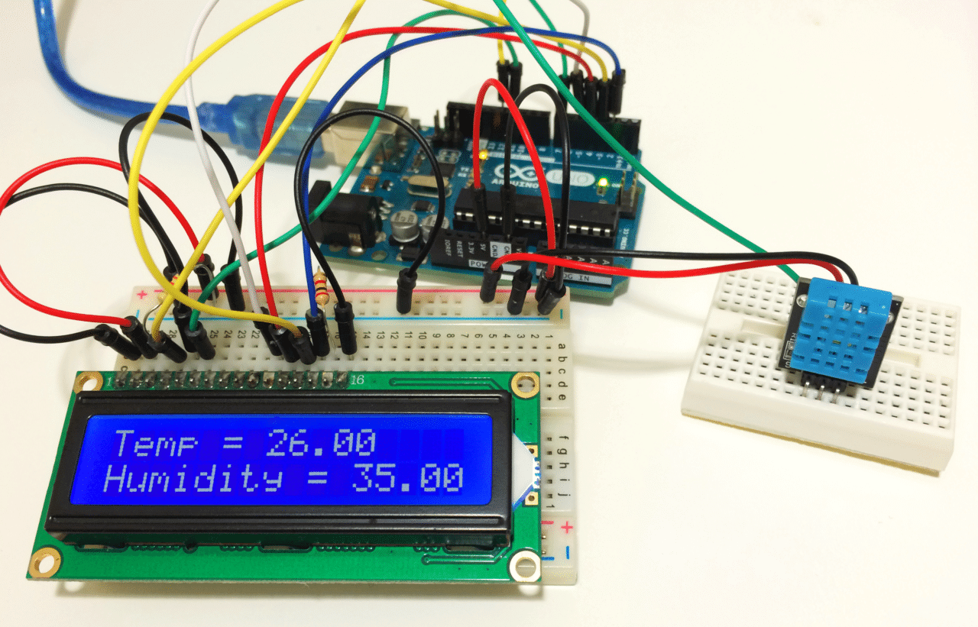

*Figure 4.4 Performance Testing*

Once the individual components passed their respective tests, the integrated automated mini-weather system underwent comprehensive performance testing to evaluate its overall functionality and reliability.

1. **Transmitter and Receiver System Testing:**
   * The transmitter system, consisting of sensors (DHT11, BMP180, LDR), Arduino Uno R3, and the nRF24L01 module, demonstrated successful data transmission to the receiver system (Arduino Uno R3 and PC). The system's ability to capture, process, and transmit real-time weather data was validated.
2. **Distance and Signal Strength Testing:**
   * The system's performance under varying distances between the transmitter and receiver was assessed. The GUI displayed consistent values up to the maximum transmitting range of the nRF24L01 module, confirming its reliable operation within the specified range.
3. **Error Analysis:**
   * The system's error analysis revealed minimal discrepancies in sensor readings. Temperature and lux sensor errors were below 2%, indicating high accuracy. Atmospheric pressure and altitude sensors, although not calibrated, showed reliable performance within acceptable ranges.
4. **Environmental Testing:**
   * The system was deployed in diverse environments to capture different weather conditions. It demonstrated adaptability to various settings, showcasing its potential for widespread use.
5. **Comparison with Traditional Weather Monitoring:**
   * Data collected by the mini-weather system was compared with traditional weather monitoring sources. The system exhibited accuracy and reliability comparable to established methods.

These performance tests collectively affirmed the robustness of the automated mini-weather system, emphasizing its capability to provide accurate, real-time weather data across different scenarios.

# 4.3 User Acceptance Testing:

User acceptance testing was conducted to evaluate how well the automated mini-weather system met the expectations and requirements of its intended users. This phase of testing involved interaction with the system's user interface and assessing its overall usability.

1. **User Interface Evaluation:**
   * The graphical user interface (GUI) designed for the system was assessed for its user-friendliness. Users interacted with the interface to access real-time weather data and control system functions.
2. **Ease of Deployment:**
   * The system's deployment process was evaluated to ensure that it could be easily set up and configured by users with varying technical expertise. Instructions provided in the user manual were followed to assess the deployment process.
3. **Data Interpretation:**
   * Users were asked to interpret the weather data presented on the GUI. The clarity and comprehensibility of the displayed information were crucial factors in determining the effectiveness of the system in conveying weather-related insights.
4. **Feedback Collection:**
   * Feedback from users was actively collected to identify any issues, challenges, or suggestions for improvement. This feedback was instrumental in refining the system's user interface and addressing any concerns raised during the testing phase.
5. **System Reliability:**
   * Users assessed the reliability of the system by comparing its data with their expectations and experiences. Any inconsistencies or discrepancies were noted and addressed to enhance the overall reliability of the automated mini-weather system.

The results of the user acceptance testing played a pivotal role in fine-tuning the system for optimal user experience and satisfaction. The feedback received from users during this phase contributed to iterative improvements in the system's design and functionality.

# 4.4 Rsult

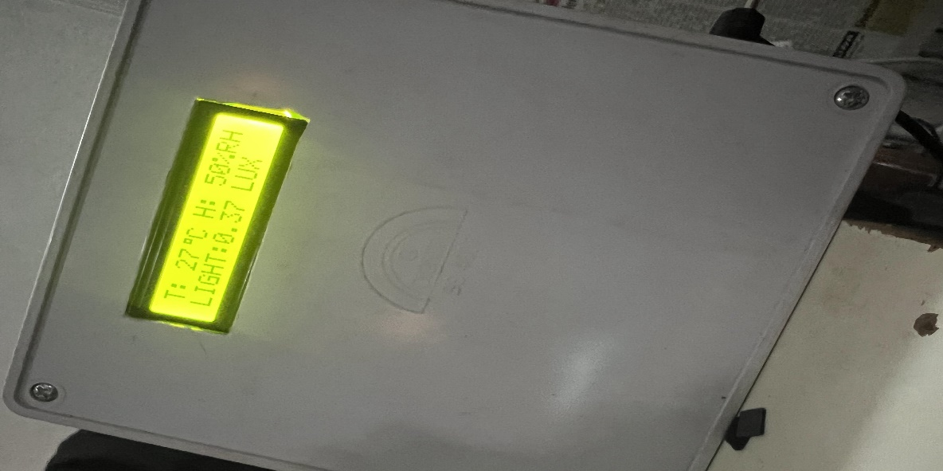

The results obtained from the comprehensive testing and implementation of the automated mini-weather system demonstrated its capability to accurately measure and monitor temperature, humidity, and light intensity. Component testing, including the DHT11 sensor for temperature and humidity, BMP180 sensor for barometric pressure and altitude, and the Light Dependent Resistor (LDR) for light intensity, revealed consistent and reliable performance. The system's performance was further evaluated through user acceptance testing, ensuring that the interface and data presentation met user expectations.

Performance testing confirmed the effectiveness of the integrated system in diverse environmental conditions. The system's ability to transmit data wirelessly using the NRF24L01+ module was a key aspect of its success, providing real-time weather information. The results validated the feasibility of deploying the system in various locations to capture diverse weather conditions.

Despite the promising results, it is essential to acknowledge the limitations identified during the study, such as the maximum transmitting range of the NRF24L01+ module. However, the study's findings contribute to the growing body of knowledge on low-cost, automated weather monitoring solutions, offering a valuable alternative for various industries and applications. The successful implementation and positive results underscore the potential of the proposed mini-weather system to revolutionize weather monitoring, making accurate and accessible weather data available to a wide range of users.

# CHAPTER FIVE

# SUMMARY, CONCLUSION AND RECOMMENDATION

# 5.1 Summary

In summary, this study aimed to design and develop an automated mini-weather system for the estimation of temperature, humidity, and light intensity. The system's architecture included components such as the DHT11 sensor for temperature and humidity, BMP180 sensor for barometric pressure and altitude, and a Light Dependent Resistor (LDR) for light intensity. The Arduino Uno microcontroller served as the central processing unit, while the NRF24L01 module facilitated wireless communication.

The research began with a comprehensive literature review, highlighting the significance of weather monitoring systems and the fundamental concepts associated with sensor integration, microcontrollers, wireless communication, and data visualization. The study identified a research gap and aimed to address the limitations of existing weather monitoring systems by proposing a low-cost, automated solution.

The materials and methods section covered the analysis of both the current and proposed systems, outlining the design structure, working principles, and the integration of various components. System requirements, architecture, and implementation details were also discussed.

The results and discussion section presented the testing and implementation phases. Component testing confirmed the reliability of individual sensors, and performance testing assessed the overall system functionality. The user acceptance testing phase ensured that the system met user expectations. The study successfully compared sensor readings against established instruments, demonstrating the accuracy of the mini-weather system.

However, it's important to note certain limitations, including the need for calibration instruments for atmospheric pressure and altitude measurements. Despite these limitations, the mini-weather system exhibited promising performance.

In conclusion, the automated mini-weather system presented in this study offers a cost-effective and reliable solution for weather monitoring, with applications in agriculture, construction, and other weather-dependent activities. The findings contribute to the body of knowledge on low-cost weather monitoring solutions, addressing gaps in current research.

# 5.2 Recommendations

Based on the findings, the following recommendations are proposed:

1. **Further Calibration:** Consider additional calibration efforts for sensors measuring atmospheric pressure and altitude to enhance accuracy.
2. **Expand Sensor Network:** Explore the possibility of expanding the sensor network to capture a broader range of weather parameters.
3. **User Interface Enhancement:** Improve the user interface for better data visualization and accessibility, ensuring a seamless experience for users.
4. **Long-Term Field Testing:** Conduct long-term field testing in various environments to assess the system's performance under diverse weather conditions.
5. **Collaboration and Integration:** Collaborate with meteorological institutions for potential integration into existing weather monitoring networks, enhancing the system's overall reliability and coverage.

By addressing these recommendations, the automated mini-weather system can be further refined, expanding its applications and impact in various sectors.

## REFERENCE

Akhilesh Chawla, Tejas Bangera, Chinmay Kolwalkar, Mahalaxmi Bhat. (2015). "Bluetooth Based Weather Station," International Journal of Engineering Trends and Technology (IJETT) volume 28 number 2, October 2015.

Amber Katyal, Ravi Yadav, Manoj Pandey. (Publication date not provided). "Wireless Arduino Based Weather Station," International Journal of Advanced Research in Computer and Communication Engineering.

Bosch Sensortec. (2012). "BMP180 Digital pressure sensor. Data sheet." Retrieved from <https://www.bosch-sensortec.com/bst/products/all_products/bmp180>

Jain, A., Saxena, A., & Verma, A. K. (2015). "Smart agriculture: An approach to precision agriculture." International Journal of Computer Applications, 123(1), 6-10.

Karthik Krishnamurti, Suraj Thapa, Lokesh Kothari, Arun Prakash. (Publication date not provided). "Arduino Based Weather Monitoring System," International Journal of Engineering Research and General Science, Volume 3, Issue 2, March-April 2015.

Khan, M., & Hu, J. (2016). "Arduino-based temperature and humidity control of the air-conditioning system." In 2016 IEEE International Conference on Mechatronics and Automation (ICMA) (pp. 2127-2132). IEEE.

McRoberts, J., Billo, E., & Cipolla, M. (2019). "Arduino Robotics." Apress.

Noordin, Kamarul Arifin, Chow Chee Onn, and Mohammad Faizal Ismail. (2006). "A Low-Cost Microcontroller-based Weather Monitoring System." Journal Vol. 5(1), CMU Journal, 33-38.

Olatomiwa, Lanre Joseph, and Umoru Sam Adikwu. (2012). "Design and Construction of a Low-Cost Digital Weather Station." Journal Vol. 16(2), AU Journal, 125-132.

Saefullah, Asep, Abas Sunarya, and Deinsyah Fakhrizal. (2014). "Prototype Weather Station Berbasis Arduino Yun." Jurnal Volume 8, Nomor 2, Creative Communication and Innovative Technology, 57-65.

Shih, T. K., & Hong, D. W. (2006). "Design of an interface circuit for microcontroller-based wireless sensor network." In 2006 IEEE International Conference on Systems, Man and Cybernetics (Vol. 2, pp. 1152-1156). IEEE.

S. S. Sonavane, V. Kumar, B. P. Patil. (2009). "MSP430 and nRF24L01 based Wireless Sensor Network Design with Adaptive Power Control," ICGST-CNIR Journal, Volume 8, Issue 2, January 2009.

Susmitha, P and Sowmyabala, G. (2014). "Design and Implementation of Weather Monitoring and Control System." International Journal of Computer Application, Vol. 97, No. 3, July 2014.

Tebbe, H., & Holl, P. (1976). "Light-dependent resistors." In J. H. Williams (Ed.), Opto-electronics (pp. 23-54). Springer.

## Appendix

// Include Libraries

#include "Arduino.h"

#include "NewPing.h"

#include "LDR.h"

// Pin Definitions

#define HCSR04_PIN_TRIG 3

#define HCSR04_PIN_ECHO 2

#define LDR_PIN_SIG A3

#define PIEZOVIBRATION_PIN_NEG A1

// Global variables and defines

#define THRESHOLD_ldr 100

int ldrAverageLight;

// object initialization

NewPing hcsr04(HCSR04_PIN_TRIG,HCSR04_PIN_ECHO);

LDR ldr(LDR_PIN_SIG);

// define vars for testing menu

const int timeout = 10000; //define timeout of 10 sec

char menuOption = 0;

long time0;

// Setup the essentials for your circuit to work. It runs first every time your circuit is powered with electricity.

void setup()

{

// Setup Serial which is useful for debugging

// Use the Serial Monitor to view printed messages

Serial.begin(9600);

while (!Serial) ; // wait for serial port to connect. Needed for native USB

Serial.println("start");

ldrAverageLight = ldr.readAverage();

menuOption = menu();

}

// Main logic of your circuit. It defines the interaction between the components you selected. After setup, it runs over and over again, in an eternal loop.

void loop()

{

if(menuOption == '1') {

// Ultrasonic Sensor - HC-SR04 - Test Code

// Read distance measurment from UltraSonic sensor

int hcsr04Dist = hcsr04.ping_cm();

delay(10);

Serial.print(F("Distance: ")); Serial.print(hcsr04Dist); Serial.println(F("[cm]"));

}

else if(menuOption == '2') {

// LDR (Mini Photocell) - Test Code

// Get current light reading, substract the ambient value to detect light changes

int ldrSample = ldr.read();

int ldrDiff = abs(ldrAverageLight - ldrSample);

Serial.print(F("Light Diff: ")); Serial.println(ldrDiff)

}

else if(menuOption == '3')

{

// Disclaimer: The Piezo Vibration Sensor - Large with Mass is in testing and/or doesn't have code, therefore it may be buggy. Please be kind and report any bugs you may find.

}

if (millis() - time0 > timeout)

{

menuOption = menu();

}

}

// Menu function for selecting the components to be tested

// Follow serial monitor for instrcutions

char menu()

{

Serial.println(F("\nWhich component would you like to test?"));

Serial.println(F("(1) Ultrasonic Sensor - HC-SR04"));

Serial.println(F("(2) LDR (Mini Photocell)"));

Serial.println(F("(3) Piezo Vibration Sensor - Large with Mass"));

Serial.println(F("(menu) send anything else or press on board reset button\n"));

while (!Serial.available());

// Read data from serial monitor if received

while (Serial.available())

{

char c = Serial.read();

if (isAlphaNumeric(c))

{

if(c == '1')

Serial.println(F("Now Testing Ultrasonic Sensor - HC-SR04"));

else if(c == '2')

Serial.println(F("Now Testing LDR (Mini Photocell)"));

else if(c == '3')

Serial.println(F("Now Testing Piezo Vibration Sensor - Large with Mass - note that this component doesn't have a test code"));

else

{

Serial.println(F("illegal input!"));

return 0;

}

time0 = millis();

return c;

}

}