Software Engineering Coursework
Contents
Aims of the system: 4
The current system downsides: 4
Opposition for the implementation of the new system: 4
Requirement 1: 5
Professional issues: (Employers to clients) 5
Ethical issues: 5
Legal issues: 6
Social issues: 6
Requirement 2: 7
PROBLEM: 7
Waterfall methodology: 7
Merits: 7
Constraints: 7
V-model: 8
Merits: 8
Constraints: 8
V-Model Software Life Cycle: 8
Comparison: 8
PEOPLE: 9
Stakeholders: 9
PROJECT: 9
Human resources 9
Technical resources 10
Physical resources 10
Breakdown of the budget 10
PRODUCT: 10
Requirement 3: 11
The functional requirements: 11
The non-functional requirements: 12
Requirement 4: 12
Step 1: Entity Relationship Diagram (ERD) 12
Requirement 5: 14
Requirement 6: 18
Use Case Diagram: 18
UML Sequence Diagrams 19
Summary: 21
Self-Assessment Sheet: 23
Group members work contribution form: 27

Aims of the system:
Features that need to be added into the system:
- Mobile app
- Registration – register their personal data (including zone, seat number and vehicles)
- Assess control systems: gated entry points (RFID tags, license plate recognition or QR code scanning
- Surveillance cameras – quick identification of unauthorised access
- Real-time monitoring and alerts – sent to security if unauthorised access attempts to enter the venue.
- Emergency monitoring – takes live locations of attendees, system provides the quickest and safest route in case of emergencies. If a lot of attendees are affected, then related emergency services could be called.
- Prevent unauthorised access
- Control undesired movements of crowds
- Quick responding to emergencies
- Safety and security are number one priority
- Improve management by registering attendees with all important credentials.

The current system downsides:
- Crowd safety and security measures must be manually implemented or managed isolated.
- No real-time safety and security features because of the huge operational overheads of the existing system.

Opposition for the implementation of the new system:
The director thinks that the app will not be widely used, he would rather develop the current system to provide real-time support rather than spending thousands on developing an app and real time monitoring system.
Representatives would rather stick to the manual system on site to deal with attendees, they believe their friendly and welcoming approach is irreplaceable. They are also reluctant to go through training with the upgraded system to deal with security and safety more effectively.
------------------------------------------------------------------------------------------------------------------

Requirement 1:
Legal, social, ethical and professional issues

The new system should be created in the public's interest as they will be its primary users. The system should understand and comply with the correct legislation, respect rules and regulations and be in the best interest of public health and safety.

Professional issues: (Employers to clients)
Employers should act professionally, with no bias or discrimination as to who registers and enters the venue. They should also respect the privacy and confidentiality of clients; this should be through the Data Protection Act 2018. This act, according to British Law, consists of:
- using information fairly, lawfully and transparently
- used for specific and explicit purposes
- used in an adequate way that is limited to what is necessary
- accurate and kept up to date
- kept no longer than necessary
- handled with appropriate security
Additionally, they should be honest about products and services, this includes not making public statements unless the individual is qualified to do so because it will stress and cause issues with attendees.

Ethical issues:
It is in the best interest of the company to create an app that will ensure we have the trust and compliance of the attendees. Firstly, we should respect the privacy of users because the system will need personal and sensitive information. If an attendee is not willing to share it then they are not able to enter the venue, this could cause issues for the safety of staff and may welcome unauthorized access if they overcome this process. The database should not share information with third parties unless we have the correct consent because if an attendee asks, we should provide all the information stored about them. Our system is based around a database therefore safe storage of information is important so if anyone with unauthorized access enters the database, they should not be able to see or obtain information. And if we need to check back on details to verify them it should be easy to find. This also ensures data integrity, to discourage from repeating data and tampering.

Legal issues:
Legal compliance must be implemented for a database system, especially because it stores data. If they follow these requirements, privacy and information security become essential to business practice. Firstly, the app should need the user’s consent before obtaining any personal and sensitive information, this could be through the validation check before they must enter their details otherwise you would have to deny them access to the venue because it could cause issues other stakeholder’s safety and security. Another priority is protecting attendees’ information, this is to help them against spamming, phishing and robocalling. Implementing the right policies and technical reinforcements because this will be how client’s information will be supported, stored, collected, used and shared. Measures are needed here to show and prevent privacy concerns and risks. Finally, the business should understand how clients are meant to interact with the business model. This is through test runs with many different stakeholders to make sure that they add the correct and necessary details when using the app.

Social issues:
Social issues must be considered to ensure the app is developed responsibly and implemented with the correct features. The main priority should be data privacy security because protecting the attendees’ sensitive information is vital to prevent data misuse and breaches. We also need to implement control levels on the database system, so only the authorized people have the right to access the database, modify it and remove data. Finally, the database should be designed to minimize bias in data collection, storage and retrieval. The data validation checks should be transparent and free from discriminatory bias.
---------------------------------------------------------------------------------------------------------------

Requirement 2:

PROBLEM:
- Managing crowd – Handling huge crowds at the stadium could be difficult, making it challenging to control entry and exit, prevent unauthorized access, and manage facilities like toilets, resulting in longer queues and waiting times.
- Unauthorized access – Larger crowds increase the chance of unauthorized individuals bypassing barriers and checkpoints, whether intentionally or not. Allowing entry without a ticket reduces safety, leading to overcrowding and increases the risk of theft, vandalism, and criminal activity taking place.
- Emergency response – In a crowded environment, emergency responders struggle to reach individuals in need, delaying help, creating panic and accident risks due to crowd rushes.

PROCESS

Waterfall methodology:
The waterfall model is used to manage projects and develop software in a linear sequence of 6 development phases such as requirements, design, implementation, testing, deployment, maintenance. which must be completed before moving on.

Merits:
- Simple Structure – Clear, defined phases help organize the development of applications, access control, real-time monitoring system and CCTV. These complex tasks can be handled sequentially minimizing confusion and potential errors.
- Defined Requirements – Clear requirement defines the project scope, ensuring of upgrading the systems to stay within the budget £1.8 million and 18-Months timeline.
- Ease of Management – Waterfall model’s structured sequential plan keeps phases on schedule, aids resource management, and simplifies project monitoring, making development smoother.

Constraints:
- Lack of flexibility – Waterfall model is rigid and does not change well to adjustments once development begins. This can be costly and time-consuming if modifications are needed later.
- Late Tests – Testing occurs only after development, causing potential errors to be discovered later, taking extra time to fix them.
- High Risk – If the apps or its features do not match the staff’s requirements, user needs may be overlooked, negatively affecting the system.

V-model:
The V-Model(Chosen Model) process is split into verification and validation with coding in between. Verification includes requirement gathering, system analysis, software design, and module design. Validation includes acceptance, system, integration, and unit testing.

Merits:
- Early Testing – Each phase has its own testing catching errors early. Flaws will quickly be identified minimizing risks of errors later.
- Structured – Provides clear track of requirements, analysis, design, and module design ensuring thorough testing and verification.
- Quality Control – Provides high quality products by integrating the user's requirements, enhancing safety, crowd control, and monitoring system.

Constraints:
- Higher Costs – Increased testing phases increase expenses, potentially exceeding the budget £1.8 million and extending the 18–month timeline.
- Limited Flexibility – Like the waterfall model, it is rigid, mid-project changes are costly and time-consuming extending the budget and the deadline.

V-Model Software Life Cycle:
- Gather requirements such as user needs, emergency response protocols, and security specifications.
- In System analysis, design the app’s interface and the system architecture.
- Develop the Code for the monitoring system and app. Integrate the security protocol.
- During Verification, perform tests for the system, unit, and integration.
- Validation ensures user needs are matched to product.
- Deployment – Execute the system
- Maintenance addresses any issues discovered.

Comparison:
Waterfall Methodology is linear with phases completed before the next one starts. V-Methodology is an extension of this, shaped like a V where each verification phase has matching validation tests. In waterfall model, testing only happens after the development which risks finding errors later. The V-Model catches errors earlier by testing throughout, but it is more expensive than the simpler, cheaper Waterfall model.

PEOPLE:

Stakeholders:
- Mr. Jackson manages the budget and suggests ideas such as developing a mobile app, improving the monitoring system, and enhancing crowd management. He is eager for these features to be executed for the stadium’s benefit
- Mr. Morrison handles security, management, and crowd control, and disagrees with Mr. Jackson’s new app idea due to cost concerns. He prefers upgrading the current system to save money and make it easier for staff. He plans to meet with staff to understand their needs regarding the new system.
- End Users
- Staff can efficiently manage crowd flow, respond to emergencies, enhance security, and detect unauthorized access using monitoring system and access control system.
- Attendees will use the registration app, check in, ticket validation, and emergency guidance to help reduce crowding and ensure safety.

PROJECT:
- The goal is to enhance safety and security amongst the crowd improve the management at the Stadium. The includes a mobile app for attendees and staff to check in via QR code. And an enhanced monitoring system for security managers to oversee surveillance, control unauthorized access, and respond to emergencies quickly.
- List of resources:

Human resources
- Project managers oversee the overall project to be delivered withing budget and on time. They organize the correlation between technical team, stadium management and end users.
- Developers develop monitoring systems and mobile apps by creating, developing, testing, and deploying the application.
- Security staff monitor the attendees relying on monitoring and crowd management systems to track movement and respond to emergencies.
- IT support provides support by carrying out trials on the system by troubleshooting the issue ensuring the system is reliable to use.
- End users use the mobile app to verify tickets, entry, and emergency information.

Technical resources
- Software tools: Cloud service to store data, and version control system to manage changes to source code over time.
- Monitoring system: CCTVs, Access control points with QR scanners, and RFID system tracks the movement of attendees.
- Networking and Hardware Infrastructure: High speed internet service, data processing using servers to monitor crowds and data storage system to store data such as CCTV footage.

Physical resources
- Emergency equipment – First aid, and communication devices to help manage emergencies.
- Access points – A physical barrier to scan QR code for entry and verification.
- Security stations – Place for security managers to check and control access through cameras.

Breakdown of the budget
- Development costs – 50% (£900,000)
- Training costs – 25% (£450,000)
- Security equipment – 15% (£270,000)
- Maintenance costs – 10% (£180,000)

PRODUCT:
- Requirements document outlines project goals for stadium security, including app features, emergency management and monitoring crowd.
- System design document illustrates the app’s layout and integration with the security system
- Source code and executables – Development team will create the app’s main code, database schemas and APIs to connect to the stadium security. For attendees to check in executable software will be deployed.
--------------------------------------------------------------------------------------------------------------

Requirement 3:
- Definition of functional requirement: end user specifies demands in the contract, functionality must be incorporated into the system, there's an input which an operation performs on and return an expected output.
- Definition of non-functional (non-behavioral) requirements: qualities/ goals that the system must satisfy/achieve, priorities can vary from one project to another.

The functional requirements:
- A mobile app for the user registration system--> Registration must be implemented. Visitors must pre-register their personal data, zone, seat numbers and vehicle details. This data must be verified before temporary access is granted.
- Access control system--> Install gated entry points with access control systems (such as RFID tags, license plate recognition or QR code scanning) so that only authorized attendees and vehicles can enter the premises.
- Real time surveillance --> Surveillance cameras (such as CCTV cameras) to be used in parking spaces and entrances to identify unauthorized access.
- Real time alerts --> A centralized monitoring system should be implemented to provide real time alerts to security personnel or attendees of unauthorized people or vehicles.
- Emergency monitoring and guidance system --> System that can monitor the live location of attendees and guide them through emergency exit points
- Automated emergency notifications --> Emergency services are called (such as police, ambulance, fire brigade etc.) depending on the number of affected attendees.
- Crowd control --> The app should check the number of attendees and report to the security if there's any congestion.
- Security personnel having access to manually control the crowd --> Security personnel should be able to control measures manually if necessary.
- Attendance tracking --> A record should be kept of the entry and exit data of attendees, vehicles and staff.
- User friendly interface --> The app should be user friendly for all attendees to input data, view data and access information easily.

The non-functional requirements:
- Performance --> System needs to support real-time data and processing.
- Reliability --> System should be reliable and not crash even at a peak time of usage.
- Scalability --> System should be able to support large amounts of data due to large amounts of attendees/ events.
- Security --> Personal data of attendees and access should be stored securely to prevent misuse.
- Usability --> Interface should be easy to use for attendees and easy for staff to be trained on and help attendees with incase any problems with the app arise.
---------------------------------------------------------------------------------------------------------------

Requirement 4:

Step 1: Entity Relationship Diagram (ERD)

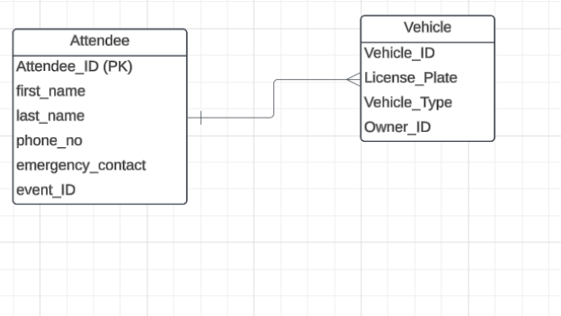

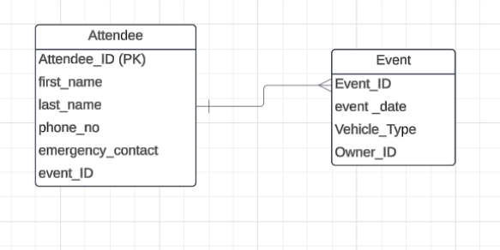

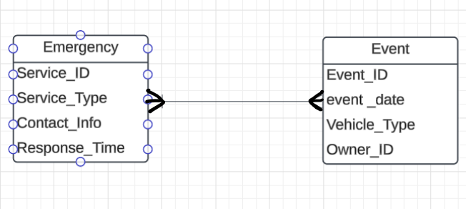

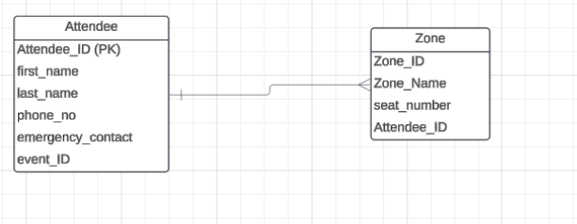

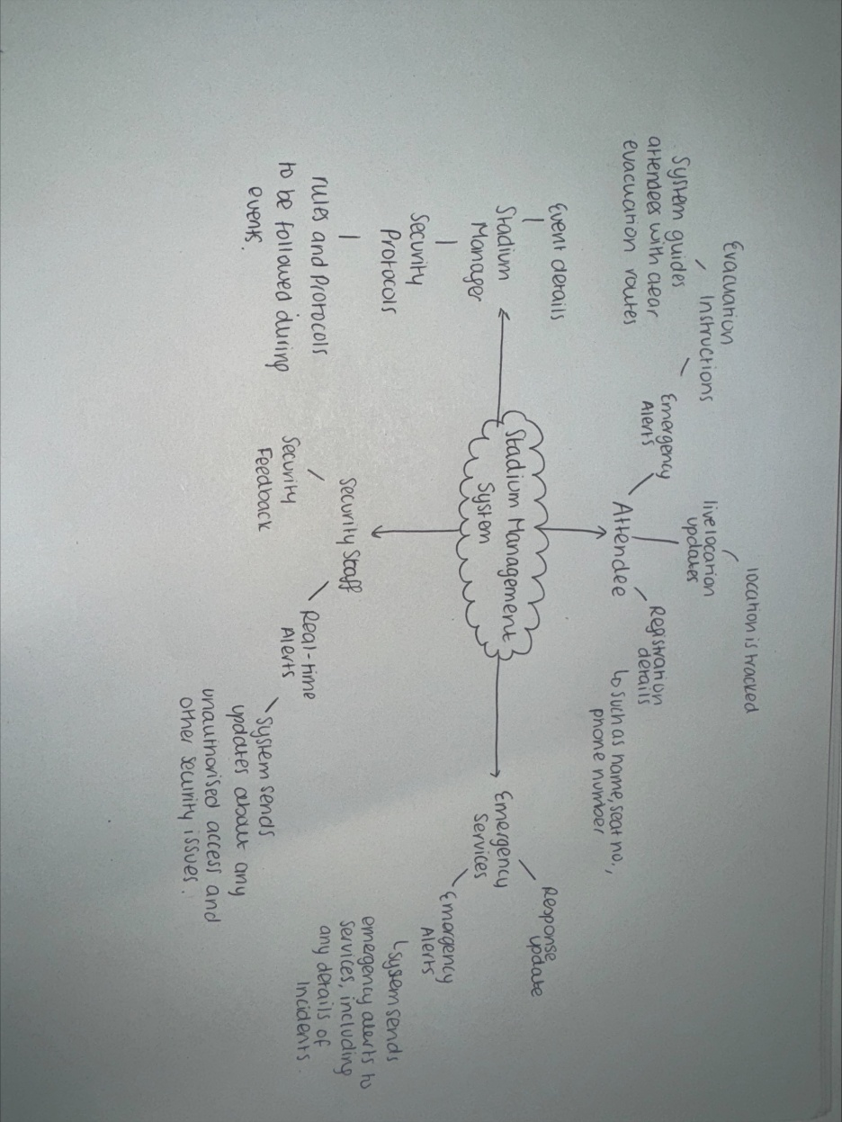

----------------------------------------------------------------------------------------------------------------

Requirement 5:
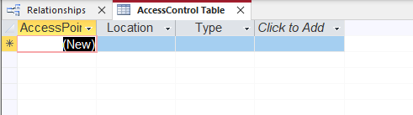

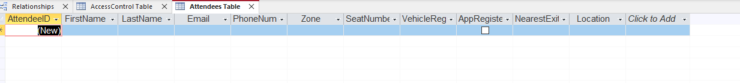

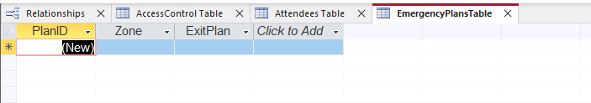

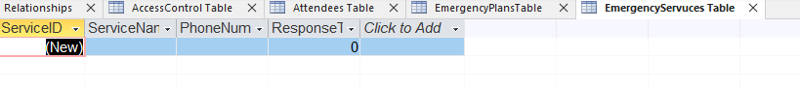
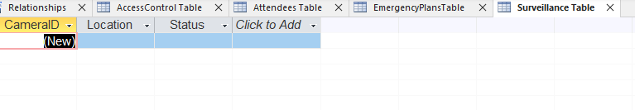

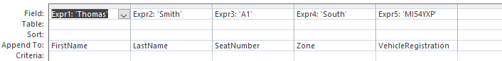
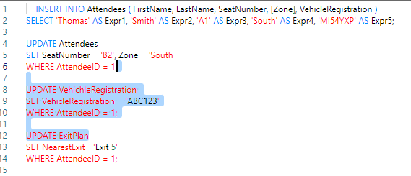

---------------------------------------------------------------------------------------------------------------
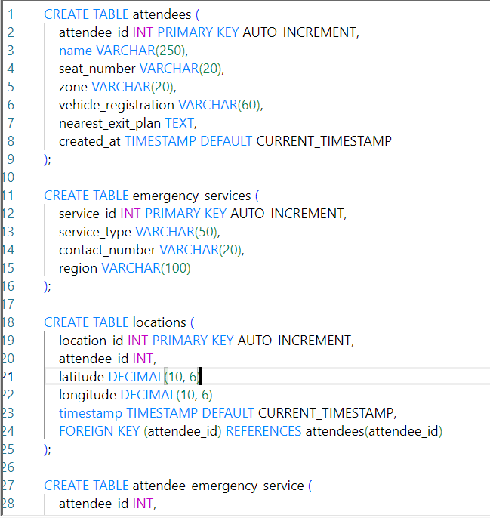
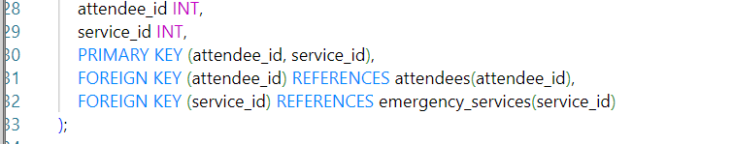

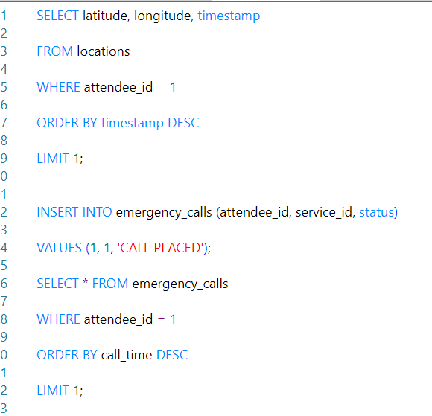

------------------------------------------------------------------------------------------------------------

Requirement 6:

Use Case Diagram:
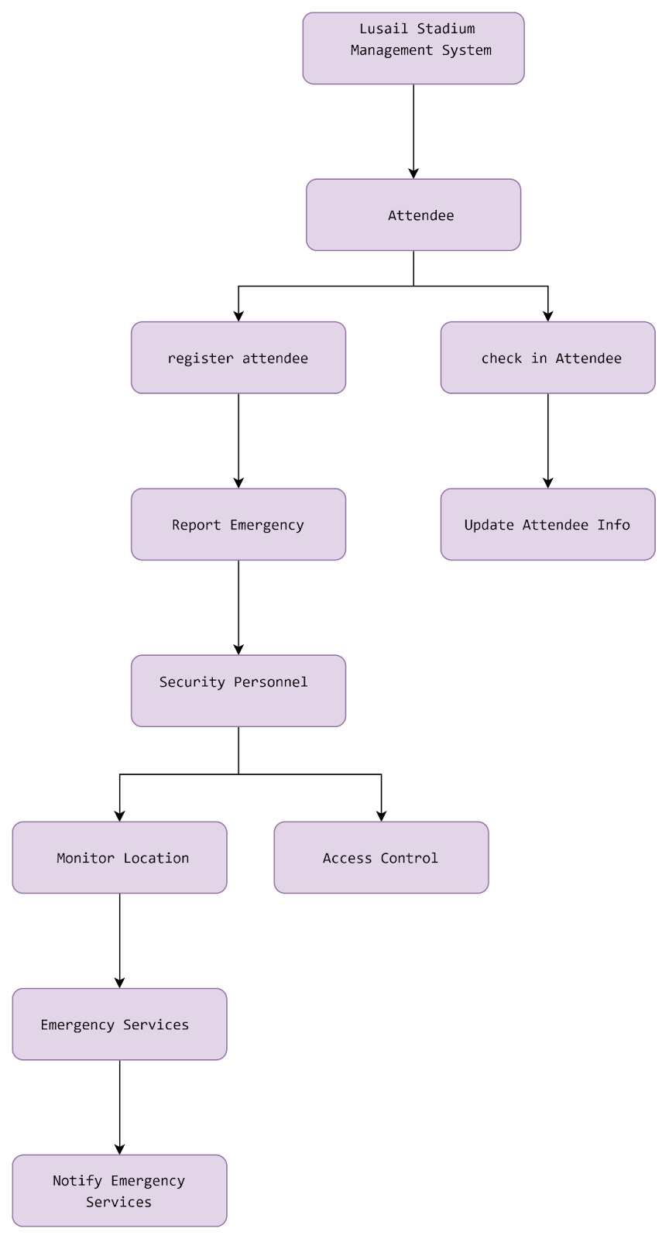

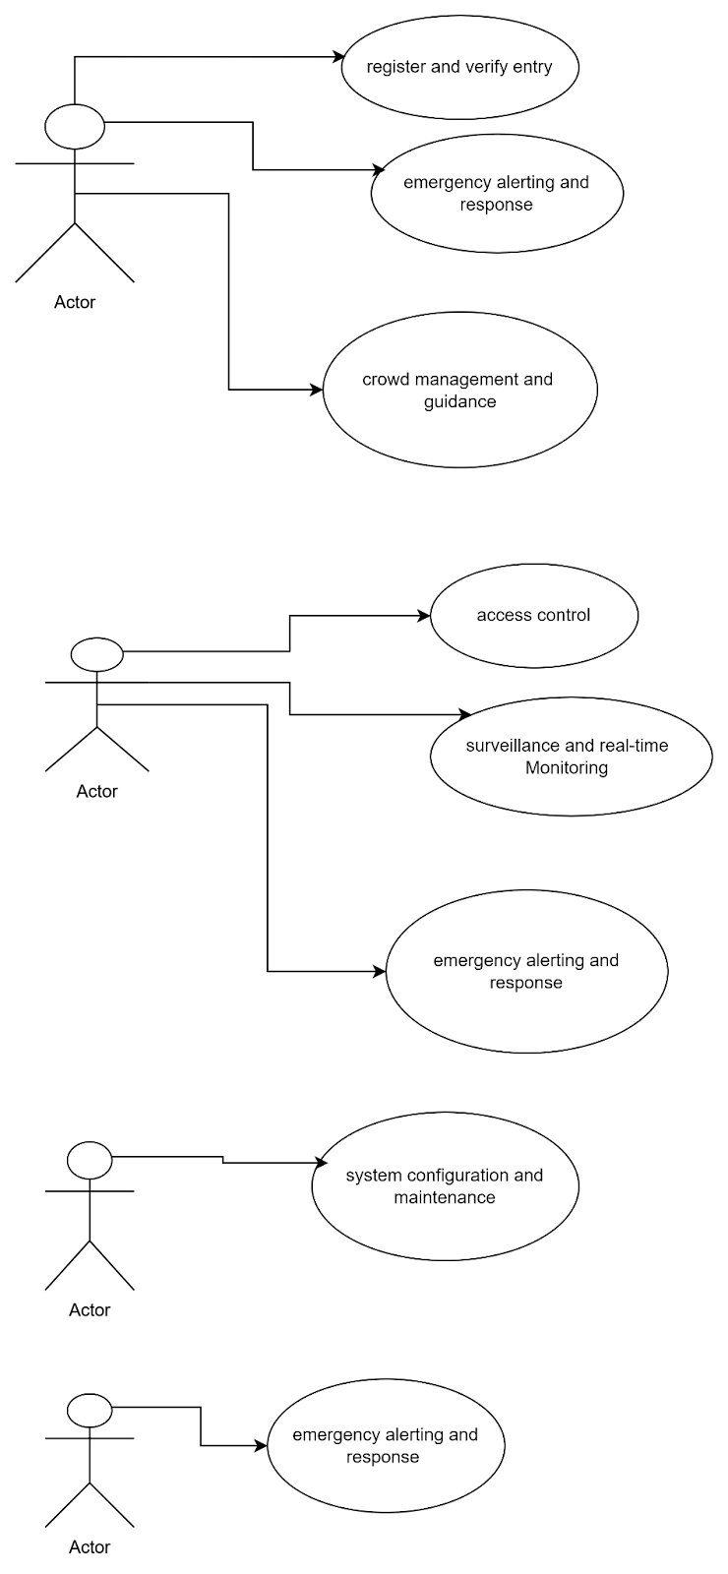

UML Sequence Diagrams
Use Case 1: Register Attendee
This sequence diagram shows the process of an attendee registering through the mobile app.
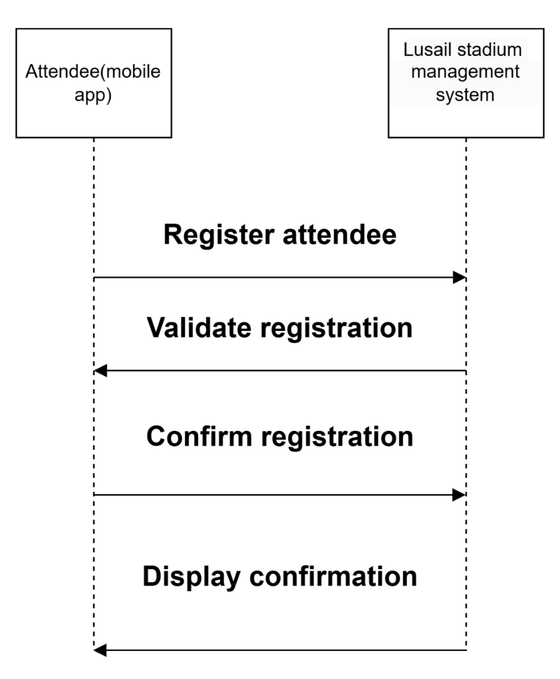
Use Case 2: Report Emergency
This sequence diagram shows how an attendee can report an emergency through the app, and how the system notifies the emergency services.
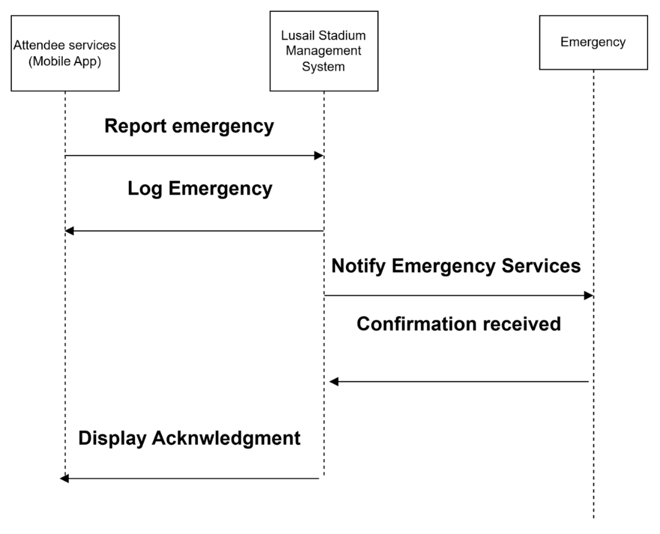

Summary:
The proposed system design leverages object-oriented analysis and design principles to create a flexible and reusable architecture. The Use Case Diagram outlines the interactions between actors and the system, while the sequence diagrams offer a detailed view of the processes involved in key use cases. This design approach ensures that the system can adapt to future changes and enhancements while supporting clarity and organization.

---------------------------------------------------------------------------------------------------------------

Proof of working together:
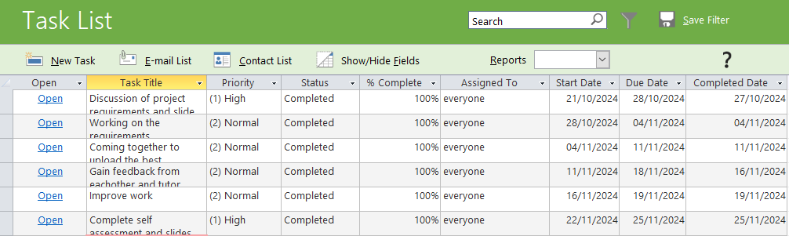

Self-Assessment Sheet:
Marks mapping:
80-100  Exceptional | 70-79  Excellent | 60-69  Very Good | 50-59 Good | 40-49  Satisfactory | 0-39 Fail
A | B | C | D | E | F

 | A | B | C | D | E | F | Comments
the 5 Ps  - Problem:  - Process  - Project |  |  | X  X  X |  |  |  | The 5’ps are detailed and explained amazingly, it includes everything that was described on the specification.

- Product  - People |  |  | X  X |  |  |  | The model chosen should have reasons for why it was chosen for this project with advantage and disadvantage
functional and non-functional requirements: |  |  | x |  |  |  | The functional and non-functional requirements are fully accurate and relate back to the case study, it is also explained clearly.
Structured design,  - Entity Relationship  Diagram  - Data Flow Diagrams.  - SQL queries |  |  | X  X  X |  |  |  | The diagrams and queries are clear and understandable, it is easy to read, and information is given to describe what the diagrams and queries are about.  An improvement that could be made was making additional links between the different tables in the relational diagram which could better express the one to one/one to many and many to many relationships.
 |  |  | x
UML Design  Use Case Diagram -  Design Class diagrams  Sequence Diagrams |  |  | X  X  x |  |  |  | The diagrams are concise, comprehensive, and thorough with relevant detail.

Group members work contribution form:

Team member name | Student ID | individual overall work contribution (%) | Signature
Student1: Nabilah Akther | 1378376 | 16.7% | NA
Student2: Ruhina Munvar | 1391010 | 16.7% | RM
Student3: Shanjida Chowdhury | 1378082 | 16.7% | SC
Student4: Hana Mohamadshakir | 1370690 | 16.7% | HM
Student5: Ihsaan Eloutmani | 1389932 | 16.7% | IE
Student6: Gizem Kumrili | 1313271 | 16.7% | GK
 |  | Total 100%

Individual contributions for each task:
The contribution should indicate the effort each member contributed to a task, even if in some cases the solution of only one student was chosen for as the final one.

Describe each task you performed  (For example, the creation of a Use case diagram) |  |  |  |  |  | total
Task:  Discuss the legal, social, ethical and professional issues (LSEPI) that ought to be considered for the new system. | 20% | 16% | 16% | 16% | 16% | 100%
Task: the 5 Ps relevant to the given case study and document them | 16% | 20% | 16% | 16% | 16% | 100%
Task: A list of functional and non-functional requirements – STUDENT 6 WHICH IS BELOW | 16% | 16% | 16% | 16% | 16% | 100%
Task: Produce a preliminary design using traditional, SSAD, covering the full functionality of the proposed improved system | 16% | 16% | 16% | 16% | 20% | 100%
Task: Implement a database based on the design produced as per above requirements. | 16% | 16% | 20% | 16% | 16% | 100%
Task: Create the proposed system design using object-oriented analysis and design, | 16% | 16% | 16% | 20% | 16% | 100%

Describe each task you performed  (For example, the creation of a Use case diagram) | 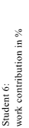
Task: Discuss the legal, social, ethical and professional issues (LSEPI) that ought to be considered for the new system. | 16%
Task: the 5 Ps relevant to the given case study and document them | 16%
Task: A list of functional and non-functional requirements | 20%
Task: Produce a preliminary design using traditional, SSAD, covering the full functionality of the proposed improved system | 16%
Task: Implement a database based on the design produced as per above requirements. | 16%
Task: Create the proposed system design using object-oriented analysis and design, | 16%

Bibliography:
Stratvert, K. (2021). How to use Microsoft Access - Beginner Tutorial. [online] www.youtube.com. Available at: https://www.youtube.com/watch?v=ubmwp8kbfPc

Oppermann, A. (2023). What Is the V-Model? (Definition, Examples) | Built In. [online] builtin.com. Available at: https://builtin.com/software-engineering-perspectives/v-model.
‌Earteza Auvee (2023). Waterfall vs. V Model: The Ultimate Comparison. [online] Impala Intech. Available at: https://impalaintech.com/blog/waterfall-vs-v-model/.
Kumar, D. (2019). Software Engineering | SDLC V-Model - GeeksforGeeks. [online] GeeksforGeeks. Available at: https://www.geeksforgeeks.org/software-engineering-sdlc-v-model/.

GeeksforGeeks (2017). Unified Modeling Language (UML) | Sequence Diagrams. [online] GeeksforGeeks. Available at: https://www.geeksforgeeks.org/unified-modeling-language-uml-sequence-diagrams/.
Hustadt, U. (n.d.). Professional Ethics BCS Code ACM Code. [online] Available at: https://cgi.csc.liv.ac.uk/~ullrich/COMP516/notes/lect25-4.pdf.
UK Government (2018). Data Protection Act. [online] GOV.UK. Available at: https://www.gov.uk/data-protection.
UKEssays.com. (2017). Database Management: Law, Ethics and Security. [online] Available at: https://www.ukessays.com/essays/computer-science/database-management-law-ethics-9552.php

The PowerPoint:
