# Part II – Election Years (Alla)

# Pick an election year – the group chose 2012 and 2016

# Retrieve 10 most popular name per gender in republican and democratic states in the year of election -

## Name DF was construction from importing and concatenating data form 51 text files downloaded from SSN website.

### Most challenging part was to import all files at the same time.

## State classification (D/R) DF was constructed via importing a csv file of data copied form Wikipedia.

### Initially I saved the data to excel file and attempted to import that. The import worked but working with the data was running number of errors. After multiple failed attempts I saved the summary in csv and imputed that. Encoding = ISO-8859-1 resolved all the issues.

## Top 10 names for the year overall, as well as, for Republican and Democratic States were derived by –

### Selecting specific year out of the overall DF and apply number of groupby and sort criteria’s in combination with the list of the States identified as R or D in step 2bi.

### Overall outcome of the election year was constructed by merging Blue and Red state DF’s and replacing NaN (absent of count for names that exist only in Red or Blue category) with zero.

## US Map was constructed to show State classification with help of geopandas and shapely.geometry.

### State coordinates data (states_21basic/states.shp) was downloaded from <https://www.arcgis.com/home/item.html?id=b07a9393ecbd430795a6f6218443dccc>

### US Map was color-coded based on the State list determined in 2.b

### Top 10 names were applied to the map as a text via for loop driven by the name list pulled out of Red/Blue top 10 names DF determine din 2.c.i.

## All df’s and maps were downloaded to csv or png files.

# Analyze and explain commonalities between republican (traditional) and democratic (progressive)

## In Part 1 of our analysis we determined that for entire baby population from 1910 to 2018 Male babies represent 52% and Female babies represent 48% of all newborns. With that diversity of names was opposite, Males 44.3% and Females 55.7%. Therefore, a smaller population of girls carries larger diversity of given names.

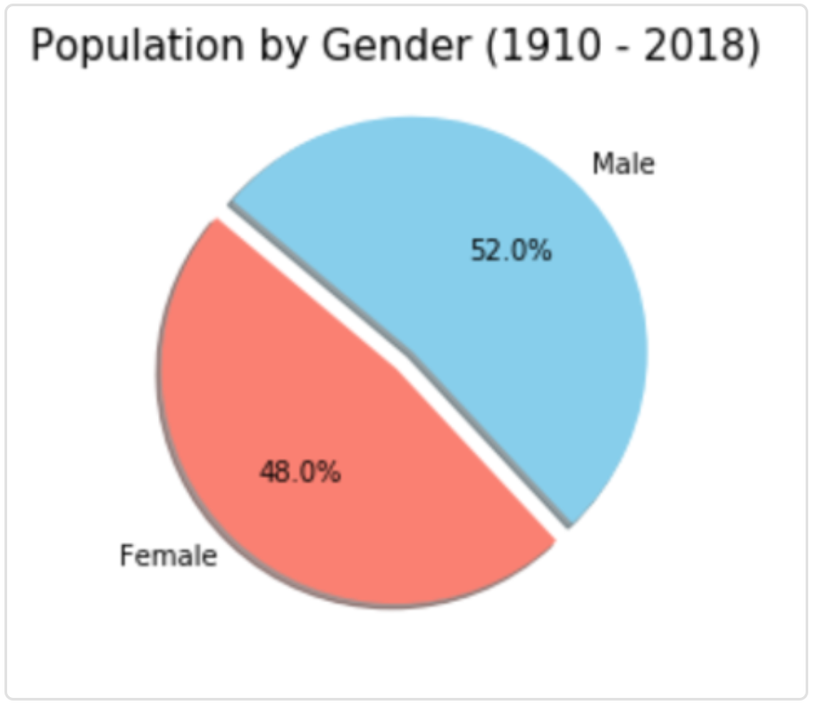 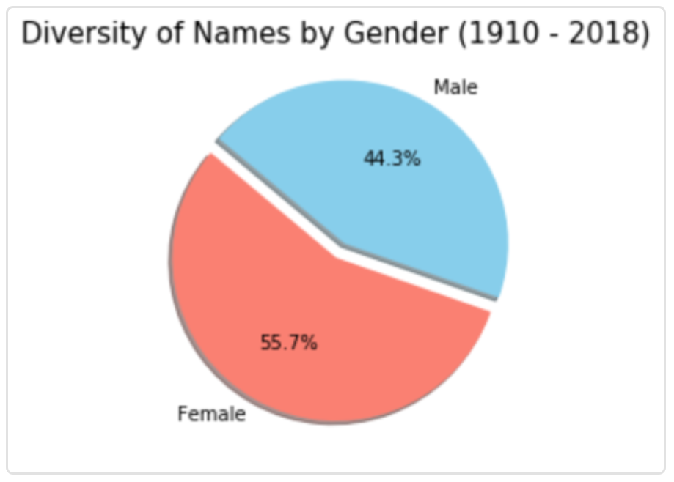

## Surprisingly, the top 10 most popular names were consistent for Female population between Red and Blue States with exception of 1 variance, while Male population showed 4 variances for both 2012 and 2016 election years.

## 2012 Summary:

## 

## 2016 Summary:

## 

## Note: Sofia is just a variation of spelling, next nae on the Blue list was Amelia.

## Overall, top 10 names for Female and Male populations were mostly traditional for both Red and Blue States.

## We compared out findings to a recent article <https://www.realsimple.com/work-life/family/kids-parenting/red-and-blue-state-baby-names> (from 2016 based on prior year data), which claimed that a) Red state parent go for unique spellings, gender neutral names; b) Blue state parents seem to choose more traditional, but not so much ethnically diverse names.

## Our top 10 list did not match at all. We were able to identify unique spelling trend in Red state male names, but we were not able to verify preference of the gender neutral names.

## We based out analysis on entire US data registry from SSN, while the article based its analysis on top 500 names in US based on prior year, which was not an election year, so calls determination of Red/Blue States in question.