**[Coffee](http://www.medindia.net/nutrition-data/coffee-instant-decaffeinated-powder.htm" \t "_blank)** is a great beverage – one that’s been used over the years and also has a fair share of romanticism attached to it. But the next time you decide to gulp down some caffeine – be it to stay awake before an exam, to get back to piled up work, to improve athletic performance on the track field, or just to get a high – do it in as healthy a way as possible. 

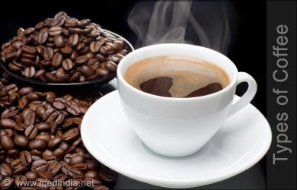

Most people when looking at the menu in a coffee house have no clue on what to order and have no idea of the difference between a cappuccino from an Espresso or an Americano. The list below will help you appreciate the menu better and also help you decide what is best for your palate –  
  
Coffee can be had on its own as in Espresso or with added milk, lemon or brandy.   
  
***Espresso***  
  
Espresso has no milk, just pure coffee. Most traditional coffee recipes revolve around a single or double espresso shots. If you are a coffee connoisseur then you should try and learn how to make one.   
  
It is generally made from a single 1 oz shot of coffee made with 7 Gms of finely ground coffee extracted at between 18 and 25 seconds. There are many recopies and this is small selection to choose from –   
  
**Americano (American)** – This is espresso shot that is diluted to taste with hot water. The name was given to insult Americans who the Europeans believed were not up to drinking full espressos.   
  
**Black coffee**: Coffee served with no milk.  
  
***Cappuccino***  
  
Cappuccino usually consists of equal parts espresso, steamed milk, and frothed milk. All this makes the coffee taste more diluted and weaker. Some coffee shops will sprinkle cinnamon or flaked chocolate on top and other will add more milk than others. All shops make some variance to suit the taste of regular customers.

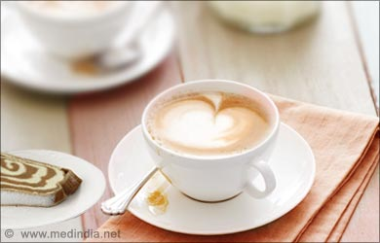

***Dry Cappuccino***  
  
This is a regular cappuccino but without steamed milk and small amount of foam.  
  
***Flavored coffee***  
  
These are made to taste and more a local tradition. A great variety exists in different parts of the world. The flavor can be either a mix of syrups, spices (eg. cinnamon), flavorings or nutmegs that are added to the coffee and give coffee a different taste.  
  
***White coffee***  
  
A black coffee with milk added.  
  
***Cafe Latte***  
  
Cafe Latte has more milk than a cappuccino. **It is one**part espresso with at least **three to five parts** ofsteamed hot milk with a small amount of froth on top.**Latte** in Italian means ‘milk’, so be careful ordering one when in Rome.  
  
***Cafe au Lait***  
  
Similar to ‘ Caffe Latte’ with an equal milk to coffee in the **ratio of 1:1*,*** It is made from**brewed coffee and not from espresso**. The taste is milder and less intense due to it consisting 50% milk.

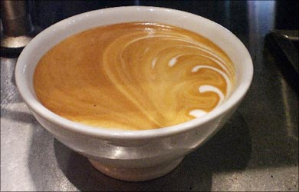

***Cafe Breva***  
  
A cappuccino made with **half and half milk, instead of whole milk**. The theory is that the mix gives a richer, creamier flavor. You should be aware, before trying this for yourself, that half and half is much harder to foam.  
  
***Cafe Macchiato***  
  
A shot of espresso with steamed milk added. The **ratio of coffee to milk is approximately 4:1*.***  
  
***Cafe Latte Fredo***  
  
It is a type of cold coffee*.* Cafe Latte Fredo is an espresso mixedwith cold milkin similar proportions as a Cafe Latte that is usually shaken well with *ice*in a cocktail shaker.  
  
***Cafe Mocha***  
  
Quite popular with the ladies or after dinner coffee. It is **one part espresso with one part chocolate syrup and two or three parts of frothed milk*.*** You could also ask for some whipped cream. Mocha was the popular coffee port route in the 17th century.   
  
***Espresso con Panna***  
  
Another espresso that is topped with a small amount of whipped cream.  
  
***Espresso Granita***  
  
A kind of cocktail coffee! It is one shot of espresso that is mixed with a teaspoon of soft brown sugar and on this is added a splash of brandy. It is then frozen, crushed and served in a parfait glass with whipped cream.  
  
***Frappe***  
  
This is a cold espresso and popularly ordered in some cafes in Europe and Latin America during summer months. Generally prepared using 1-2 teaspoons of instant coffee with sugar, water and ice. The brew is next placed in a long glass with ice, and milk turning it into a big coffee milkshake.  
  
***Turkish Coffee or Known also as Greek Coffee***  
  
A different preparation from the usual coffee. It is thicker and made usually made in an ‘cezve’ which is a long-handled, open, brass or copper pot. Finely ground coffee and water are boiled together to making a mix of muddy and thick coffee. Once it is made it is served in smaller cups called ‘Demitasse’ cups. Sugar and sometimes cardamom pods or spices (more Arabic) are added before it is brewed and all this is left for sometime to allow it to settle before it is sipped. In Greek coffee Chicory is used and cracked cardamom pods to Turkish coffee.  
  
***Indian (Madras) filter coffee***  
  
The popular ‘South Indian’ filter coffee is made from fresh ground, dark-roasted coffee Arabica or Peaberry beans. It is left for a few hours to drip-brew in a traditional metal coffee filter. It is served with coffee to milk ratio of usually 3:1.

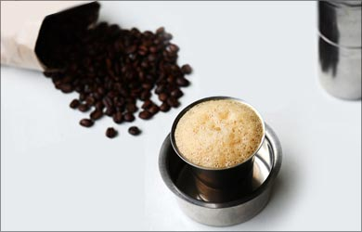

***Instant coffee (or soluble coffee)***  
  
These have become very popular over the years due more to convenience and some people are not even aware that there are so many other tastes to try out and when served the real coffee fail to appreciate the aroma and its taste. The coffee is available in packets as granules or soluble powder.   
  
***Hammerhead or Shot in the Dark***  
  
This is a mix of espresso and drip coffee in a regular-sized coffee cup. Many cafes rename this drink further to their own names or as per to their needs.  
  
***Iced coffee***  
  
This is a regular coffee served with ice, and sometimes milk and sugar.

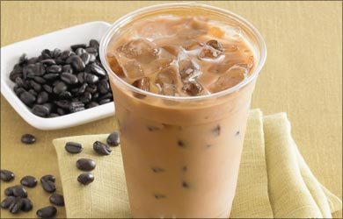

***Cuban coffee***  
  
Cuban coffee is a type of espresso, which is sweetened with natural brown sugar as it is being brewed. A common method for making Cuban espresso is to add few drops of the espresso to the sugar and mix vigorously till it results in a creamy, light brown paste. The remaining espresso is then added to the light brown paste creating a light brown foam layer, atop the [**coffee**](http://www.medindia.net/medical-quiz/quiz-on-coffee.asp). 

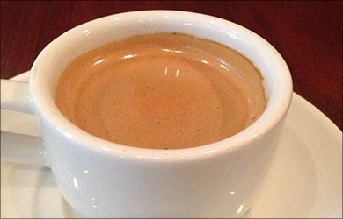

***Arabica coffee***  
  
Coffee Arabica also known as ‘mountain coffee’ is a species of coffee that is believed to produce the finest [**coffee beans**](http://www.medindia.net/news/green-coffee-bean-supplements-may-not-help-burn-fat-says-study-120434-1.htm). The beans from this plant contain less caffeine than any other coffee plants. Coffee Arabica has aromatic tones that offer a smooth, pleasing taste.

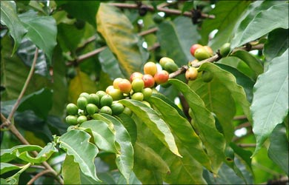

***Irish coffee***  
  
If you want to have whiskey with coffee try this coffee. It consists of coffee that is spiked with Irish whiskey, with added cream on top. Best suited for a cold winter night to keep you warm.  
  
***Kopi Tubruk***  
  
If you visit islands of Java and Bali in Indonesia you can try this coffee. It is similar to Turkish or Greek coffee as it very thick.  
  
***Lungo***  
  
This is 2-3 shot of espresso and has more water to pass through coffee grounds.  
  
***Ristretto***  
  
The name means ‘restricted’. It is like Lungo, but exactly the opposite as it has less water with 0.75 oz espresso.   
  
***Melya***  
  
Coffee with honey. Made by using coffee that is mixed with 1 teaspoon of unsweetened powdered cocoa and drizzled honey. It can be served with cream.

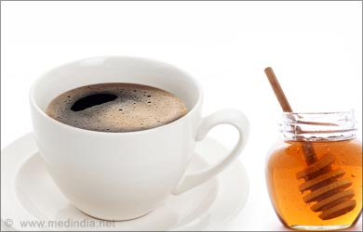

***Vietnamese Coffee***  
  
Uses more and like south Indian coffee uses a metal mesh. Hot water is dripped through the metal mesh and after this the intense brew is poured over ice and sweetened with condensed milk.  
  
If you are a heavy coffee drinker and wish to reduce the number of cuppa, there are also several coffee substitutes available in the market. These include green tea, licorice tea, black tea, ginseng tea, or even decaf. Some have negligible caffeine content while others (like decaf) have much lesser caffeine constituency than regular coffee.