CprE 381: Computer Organization and Assembly-Level Programming

Project Part 1 Report

Team Members: __Lincoln Hatlestad__

___Doyle Chism___

__Jesse Gillingham___

Project Teams Group #: 6_2

Refer to the highlighted language in the project 1 instruction for the context of the following questions.

[Part 1 (d)] Include your final MIPS processor schematic in your lab report.

TODO

[Part 2 (a.i)] Create a spreadsheet detailing the list of M instructions to be supported in your project alongside their binary opcodes and funct fields, if applicable. Create a separate column for each binary bit. Inside this spreadsheet, create a new column for the N control signals needed by your datapath implementation. The end result should be an N*M table where each row corresponds to the output of the control logic module for a given instruction.

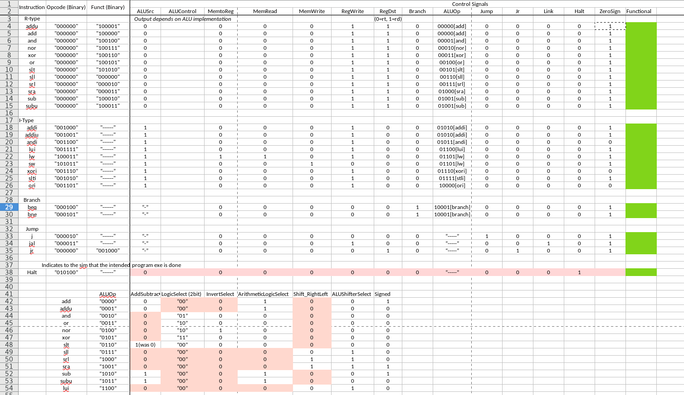

[Part 2 (a.ii)] Implement the control logic module using whatever method and coding style you prefer. Create a testbench to test this module individually, and show that your output matches the expected control signals from problem 1(a).

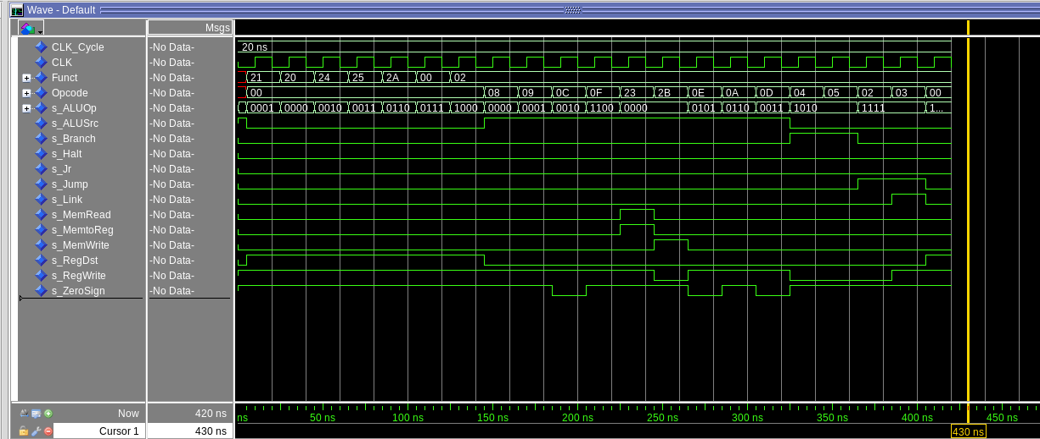

[Part 2 (b.i)] What are the control flow possibilities that your instruction fetch logic must support? Describe these possibilities as a function of the different control flow-related instructions you are required to implement.

Jump and branch instructions j, jal, jr, beq, bne, and also just a normal PC+4(next instr.). The PC will receive one of the following calculated values; PC+4, the jump address, the branch address, or the register address(rs output) from jr.

[Part 2 (b.ii)] Draw a schematic for the instruction fetch logic and any other datapath modifications needed for control flow instructions. What additional control signals are needed?

//ADD PICTURE

The signals we added to the control flow were as follows. Link for jal, Jr for jr, ZeroSign for the sign extender, and Halt for halting execution.

[Part 2 (b.iii)] Implement your new instruction fetch logic using VHDL. Use Modelsim to test your design thoroughly to make sure it is working as expected. Describe how the execution of the control flow possibilities corresponds to the Modelsim waveforms in your writeup.

We just implemented it through individual components. The fetch logic bit into too many other components and didn’t make sense for us to create its own block in our design.

[Part 2 (c.i.1)] Describe the difference between logical (srl) and arithmetic (sra) shifts. Why does MIPS not have a sla instruction?

Sra preserves the sign bit when it shifts(i.e. 1000 sra 2 bits is 1110) while srl just fills it with zeroes when it shifts(i.e. 1000 srl 2 bits is 0010).

[Part 2 (c.i.2)] In your writeup, briefly describe how your VHDL code implements both the arithmetic and logical shifting operations.

Our control unit sends an operation to the ALUControl through the ALUOp code. This 4 bit code differentiates each kind of operation/calculation we have to implement. Sll, srl, and sra, each have different ALUOp codes. The ALUControl unit decodes the operation into signals that the ALU uses to do said operation. One of those signals chooses whether to add 0’s or 1’s to the MSB when shifting. For sra, the signal is 1 and vise versa for srl.

[Part 2 (c.i.3)] In your writeup, explain how the right barrel shifter above can be enhanced to also support left shifting operations.

We just reversed the inputs and outputs of the barrel shifter so that the most signifigant bits were switched with the least signifigant bits. This shifted things using the same cascade of muxes, but in the opposite direction.

[Part 2 (c.i.4)] Describe how the execution of the different shifting operations corresponds to the Modelsim waveforms in your writeup.

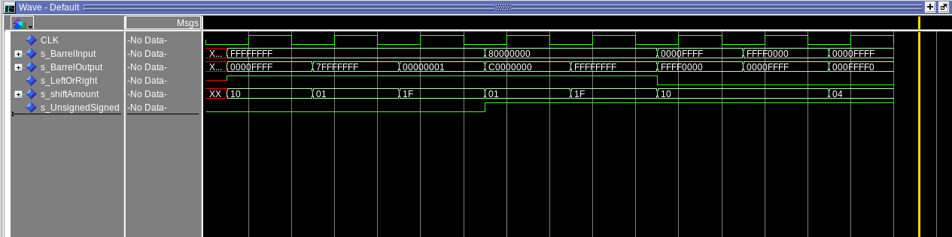
The first 5 tests are right shifts and the last 3 are left shifts because of the LeftOrRight signal. When the UnsignedSigned signal is 1, the shift will be arithmetic and fill with 1’s instead of 0’s. The UnsignedSigned signal doesn’t affect the left shifts because sla isn’t an instruction. Shift amount chooses how much we shift (up to 31). For lui, we force the shift amount to 16 and the direction to left.

[Part 2 (c.ii.1)] In your writeup, briefly describe your design approach, including any resources you used to choose or implement the design. Include at least one design decision you had to make.

We started by implementing all of the components we saw in the basic schematic provided in the Project 1 description. Then we added control signals for jump instructions when designing fetch logic. After that we built our processor and started testing each instruction, adding muxes and fixing mapping as we went.

We also chose to build an ALU control unit instead of implementing it inside our control unit, however, we did this inside the ALU instead of connecting them separately in the Processor. This was because the control and ALU mapped prettier this way. Our most used components were 2t1 muxes. They were essential to our fetch design and also necessary to write the jump address back to the register file for jal.

[Part 2 (c.ii.2)] Describe how the execution of the different operations corresponds to the Modelsim waveforms in your writeup.

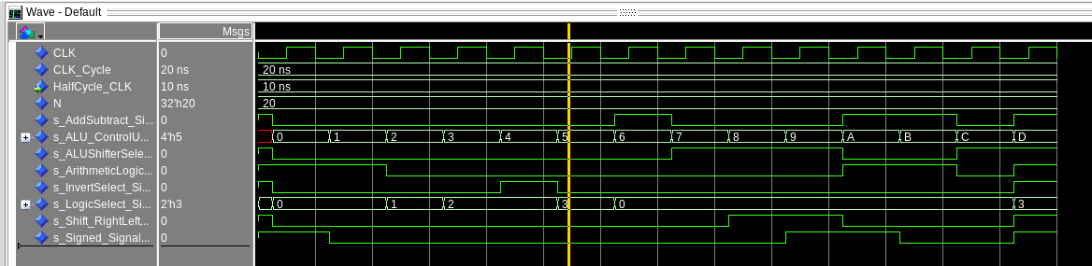
Muxes were already tested in the first 2 labs, but the ALUControl was brand new.

[Part 2 (c.iii)] Draw a simplified, high-level schematic for the 32-bit ALU. Consider the following questions: how is Overflow calculated? How is Zero calculated? How is slt implemented?

//PLUGIN

[Part 2 (c.v)] Describe how the execution of the different operations corresponds to the Modelsim waveforms in your writeup.

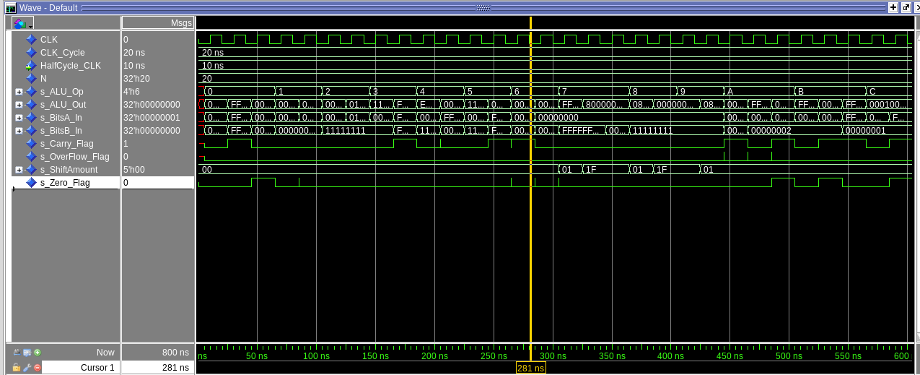

[Part 2 (c.viii)] justify why your test plan is comprehensive. Include waveforms that demonstrate your test programs functioning.
We have a test case for each of our ALU operations here(13 in total). Some instructions, addi and add for example, use the same operation, so that is why we only have 13 ALUOps. They include add, addu, and, or , nor, xor, slt, sll, srl, sra, sub, subu, and lui.

[Part 3] In your writeup, show the Modelsim output for each of the following tests, and provide a discussion of result correctness. It may be helpful to also annotate the waveforms directly.

Bubblesort…
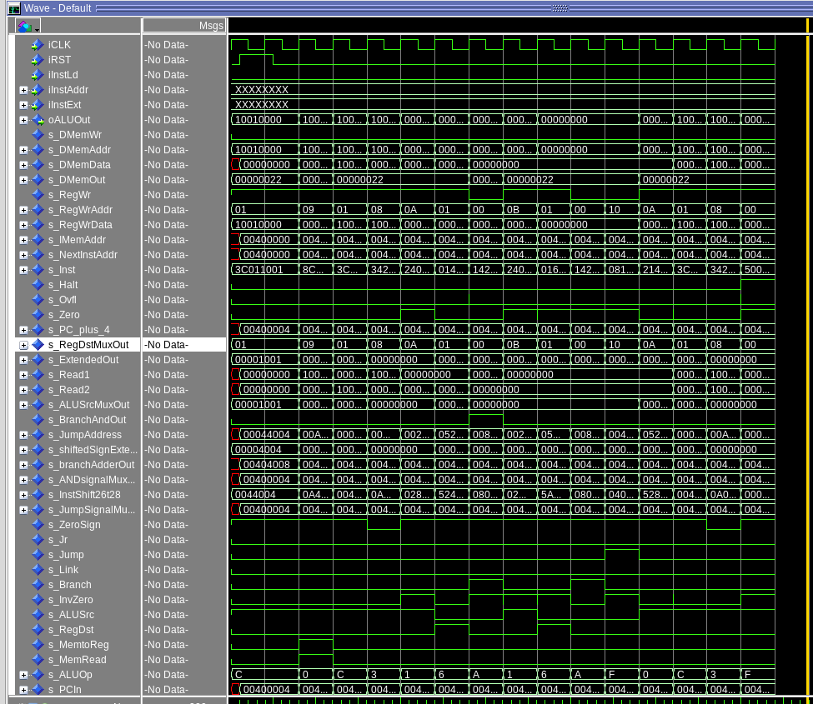

Base…

CF...

[Part 3 (a)] Create a test application that makes use of every required arithmetic/logical instruction at least once. The application need not perform any particularly useful task, but it should demonstrate the full functionality of the processor (e.g., sequences of many instructions executed sequentially, 1 per cycle while data written into registers can be effectively retrieved and used by later instructions). Name this file Proj1_base_test.s.

In our files.

[Part 3 (b)] Create and test an application which uses each of the required control-flow instructions and has a call depth of at least 5 (i.e., the number of activation records on the stack is at least 4). Name this file Proj1_cf_test.s.

In our files.

[Part 3 (c)] Create and test an application that sorts an array with N elements using the BubbleSort algorithm (link). Name this file Proj1_bubblesort.s.

In our files.

[Part 4] report the maximum frequency your processor can run at and determine what your critical path is. Draw this critical path on top of your top-level schematics. What components would you focus on to improve the frequency?

