HIGHBEAM (CTXTOP V4.0) · FOR CLAUDE CODE & GOOGLE ANTIGRAVITY
Pure signal. Zero wasted tokens.
AI coding agents gave software engineers superpowers—and an invisible O(N²) tax. Every raw test log, redundant full-file read, and mistimed model switch replays across every turn that follows, draining 5-hour seat quotas and drowning frontier reasoning in stale noise. Highbeam sits directly inside your local IDE and CLI lifecycle to trim bloat before ingestion, shield your warm 90%–95% KV prompt cache, and keep your model sharp.
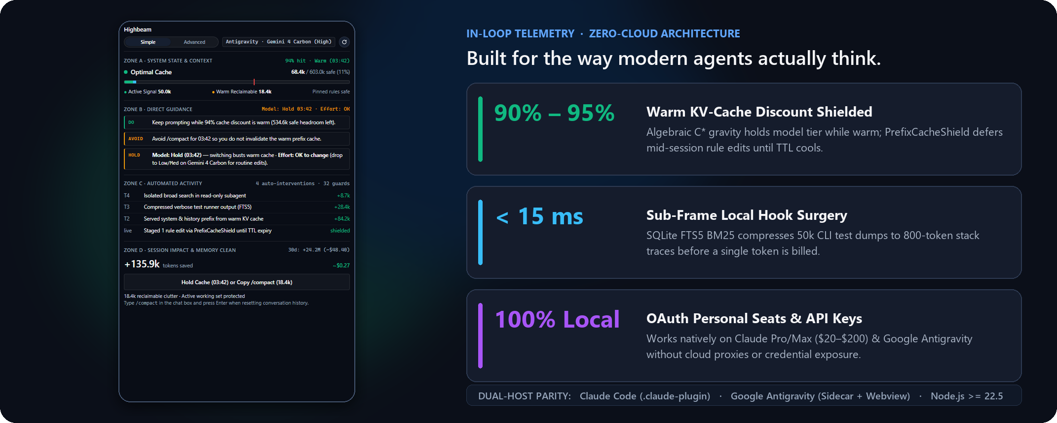
What Highbeam Is — Three Breakthroughs in One Lightweight Extension
ACTIVE CONTEXT SURGEON  Trims Noise Pre-Ingestion  Intercepts 50,000-char test logs via local SQLite FTS5 and folds repeat file reads into compact delta diffs before the model bills or ingests them. | KV-CACHE GRAVITY SHIELD  Protects 90%–95% Discounts  Models your 5-minute / 1-hour prompt cache as a live financial asset—warning before a model switch or rule edit triggers a cold prefill rebuild. | LOCAL ACTUARIAL FINOPS  Works on OAuth & API Keys  Runs 100% locally with zero cloud proxies. Built natively for $20–$200 Claude Pro/Max seats, Google Antigravity seats, and enterprise BYOK keys.

GOOGLE ANTIGRAVITY · 1-LINE INSTALL  npx ctxtop init | CLAUDE CODE · 1-LINE INSTALL  npx ctxtop install --claude
Open Core (MIT + Pro Team FinOps) · Zero Cloud Telemetry · Claude Opus / Sonnet / Haiku & Gemini Pro / Flash · Windows, macOS & Linux

ARCHITECTURE & IN-LOOP PHYSICS
Engineered inside the loop. Under 15 milliseconds.
Cloud LLM proxies sit outside your IDE—observing prompts only after bloat has already entered your conversation history, and failing completely on personal OAuth seats. Highbeam operates pre-ingestion inside your host's native lifecycle hooks (PreToolUse, PostToolUse, PreCompact, and PreInvocation), correlating live transcripts with disk timestamps and Git trees in under 15 ms.
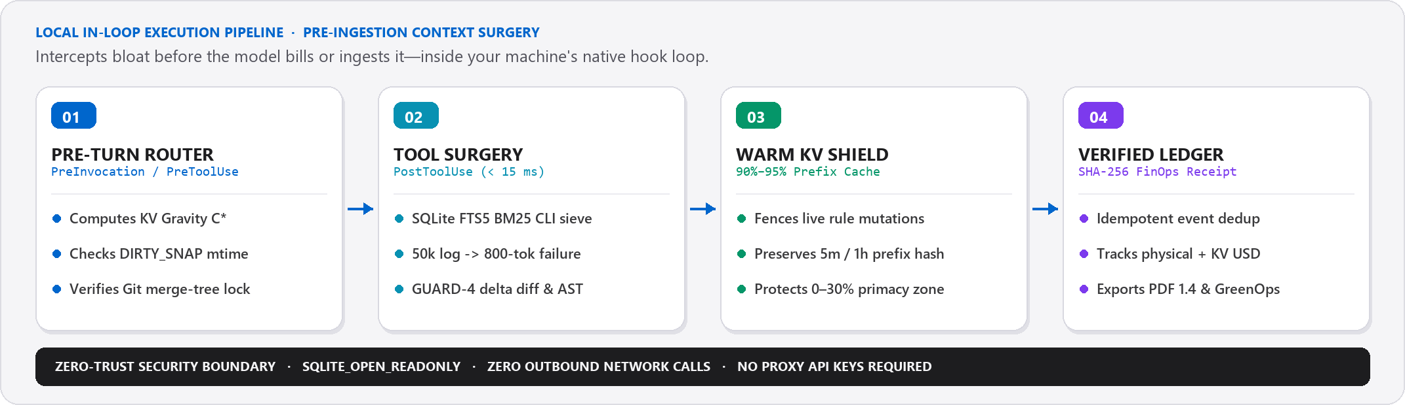
Four Core Engineering Mechanisms Under the Hood
1. Algebraic KV-Cache Gravity (C*) | Downshifting from a frontier model (Opus / Gemini Pro) to a cheaper model mid-session sounds thrifty—until you bust a 120k warm prefix enjoying a 90%–95% read discount and pay 100% cold prefill rates. Highbeam calculates the exact crossover threshold (C*) in real time, advising HOLD when staying on your warm frontier cache is mathematically cheaper.
2. PrefixCacheShield (Warm Prefix Fencing) | Editing AGENTS.md, CLAUDE.md, or MCP tool schemas at the top of your prompt invalidates the cryptographic prefix hash for every token beneath it. When your 5-minute KV cache is warm, PrefixCacheShield automatically stages non-urgent rule mutations and applies them cleanly the moment the cache cools.
3. Local SQLite FTS5 BM25 Sieve (DET-07) | A single verbose test runner or build failure can dump 40,000+ characters of passing suite noise into context—and replay on every subsequent turn. Highbeam indexes raw CLI stdout/stderr into an in-memory Node.js SQLite FTS5 table using Porter stemming and injects only the highest-ranked ~800-token error slice.
4. Stateful Read Dedup & Live Disk Correlation | Agents routinely re-read 800-line files after making a 5-line edit. GUARD-4 replaces unmodified re-reads after edits with compact unified delta diffs and folds 3rd+ unchanged reads into structural AST stubs—while DIRTY_SNAP checks live fs.statSync().mtimeMs so the agent never overwrites edits you just made on disk.
Zero Native Build Friction: Highbeam uses Node.js built-in node:sqlite (Node >= 22.5) and isomorphic ESM handlers—meaning zero C++ node-gyp compilers, zero external daemons to configure, and instant cross-platform parity across Windows, macOS, and Linux.

DUAL-SURFACE EXPERIENCE & 32 AUTONOMOUS GUARDS
Quiet when you are in flow. Deep when you want telemetry.
You shouldn't need a PhD in transformer attention to manage a coding session. Highbeam defaults to Simple View in Coach Mode—compressing routine tool clutter automatically while translating complex cache math into plain DO, AVOID, and HOLD guidance. One click switches to Advanced View for full 40-cell chrono-positional forensics.
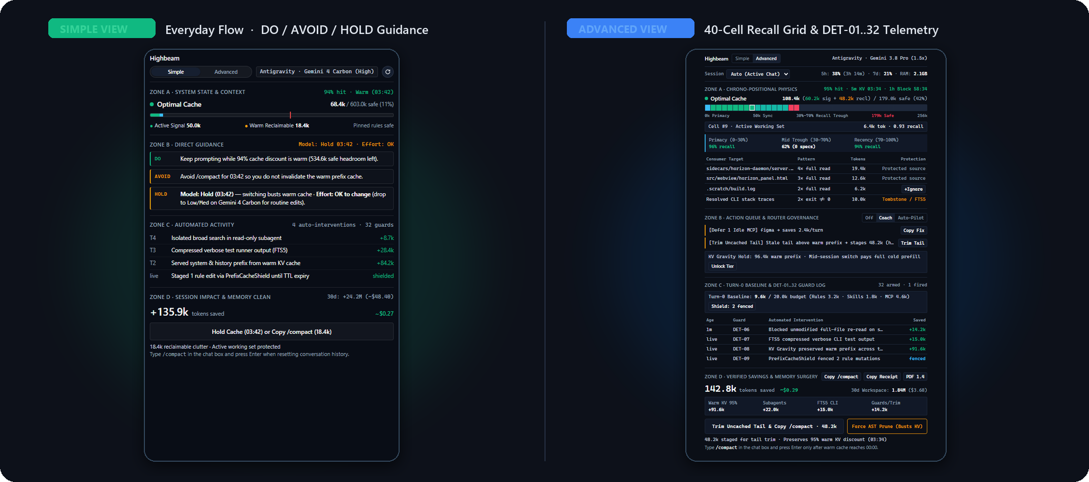
Four Synchronized Flight Zones — Every Signal Has a Purpose
ZONE A · SYSTEM STATE & RECALL PHYSICS  Displays real-time safe context headroom, active signal vs. reclaimable clutter, live KV-cache hit rate & 5m/1h countdown timers, and (in Advanced View) a 40-cell positional grid tracking Primacy (0–30%), Lost-in-the-Middle trough (30–70%), and Recency (70–100%) recall accuracy. | ZONE B · MODEL, EFFORT & ACTION GUIDANCE  Eliminates guesswork before every prompt. Explicitly tells you whether switching Models or Effort tiers is OK (cold cache, zero rewrite penalty) or HOLD 03:42 (warm prefix active), alongside 1-click fixes to defer idle MCP servers or stage uncached tail trims.
ZONE C · 32 AUTONOMOUS DETECTORS & SURGEONS  Live audit feed of every automated protection: DET-06 unmodified re-read blocks, DET-07 FTS5 log compression, DET-08 warm prefix preservation, DET-09 PrefixCacheShield fences, DET-20 multi-agent Git merge-tree collision locks, and DET-30 thinking-drift loop detection. | ZONE D · LOSSLESS /COMPACT & VERIFIED RECEIPTS  Replaces destructive blind compaction with surgical 1-click /compact orchestration. Hydrates a structured State Baton before compaction so architectural rules survive intact, while tallying verified session & 30-day token/USD savings exportable to PDF 1.4.
6 Built-In Slash Skills Across Both Hosts: /horizon (live HUD) · /precheck (prompt & tier check) · /handoff (lossless checkpoint) · /cost-radar (SVG timeline) · /inspect (call-tree spans) · /evolve (rule synthesis)

THE DEVELOPER ADVANTAGE & COMPETITIVE LANDSCAPE
More hours per quota window. Higher IQ per turn.
Developers don't install Highbeam just to watch a cost counter tick—they install it because clean context directly governs how long they can stay in uninterrupted flow and whether their model still writes surgical code on turn 35 of a multi-file refactor.
01 | Stretch $20–$200 Rolling Seat Quotas 1.5x–3x Further  On Claude Pro/Max and Google Antigravity subscriptions, you pay with 5-hour and weekly rolling token ceilings. One un-sieved 30k test dump on turn 4 replays across 15 turns to burn 450,000 quota tokens. Highbeam stops quadratic replay at the source—turning an afternoon rate-limit lockout into an uninterrupted shipping session.
02 | Cure 'Turn-25 Model Lobotomy' & Context Truncation  Even 200k–1M token models suffer documented attention U-curve decay when stale tool clutter floods the 30%–70% mid-window trough or pushes foundational AGENTS.md rules toward eviction. By keeping working memory dense with pure code signal, frontier models follow architectural constraints accurately from turn 1 to turn 50.
03 | Prevent Multi-Agent & Stale-Snapshot Code Regressions  Parallel subagents and background linters create silent race conditions. Highbeam's DET-20 checks in-memory git merge-tree state to block concurrent subagent file collisions, while DIRTY_SNAP halts stale agent edits whenever a file on disk was modified more recently than the agent's last read.
04 | 100% Offline Privacy & Strict OAuth Seat Safety  Highbeam opens local SQLite session databases strictly read-only (SQLITE_OPEN_READONLY), never touches OAuth tokens, never routes prompts through third-party cloud servers, and adds zero telemetry trackers. Safe for regulated enterprise repositories and personal subscriptions alike.
How Highbeam Compares to Existing Developer Tools
Capability | Highbeam v4.0 | CLI Log Counters  (ccusage) | Cloud Gateways  (Helicone / Portkey) | Default IDE  Context Bars
Works on OAuth Personal Seats | Yes (Native) | Yes (Passive) | No (API Key Only) | Yes
Pre-Ingestion FTS5 & AST Surgery | Yes (< 15 ms) | No (Post-hoc) | No (Post-send) | No
Algebraic KV-Cache Shield (C*) | Yes (Live TTL) | No | Passive metrics | No
Live Disk mtime & Git Scope Locks | Yes (Local OS) | No | No (Cloud blind) | No
100% Offline + SHA-256 PDF Receipt | Yes (Built-in) | Offline only | Cloud SaaS | No

VERIFIED ECONOMICS, FINOPS & SUSTAINABLE COMPUTE
Every token accounted for. Down to the cent.
Highbeam never guesses or inflates impact. Every intervention is logged in an idempotent, retry-safe actuarial ledger across all 10 savings event categories—separating physical tokens surgically prevented from model-specific 90%–95% KV-cache read discounts, sealed with a canonical SHA-256 audit hash.
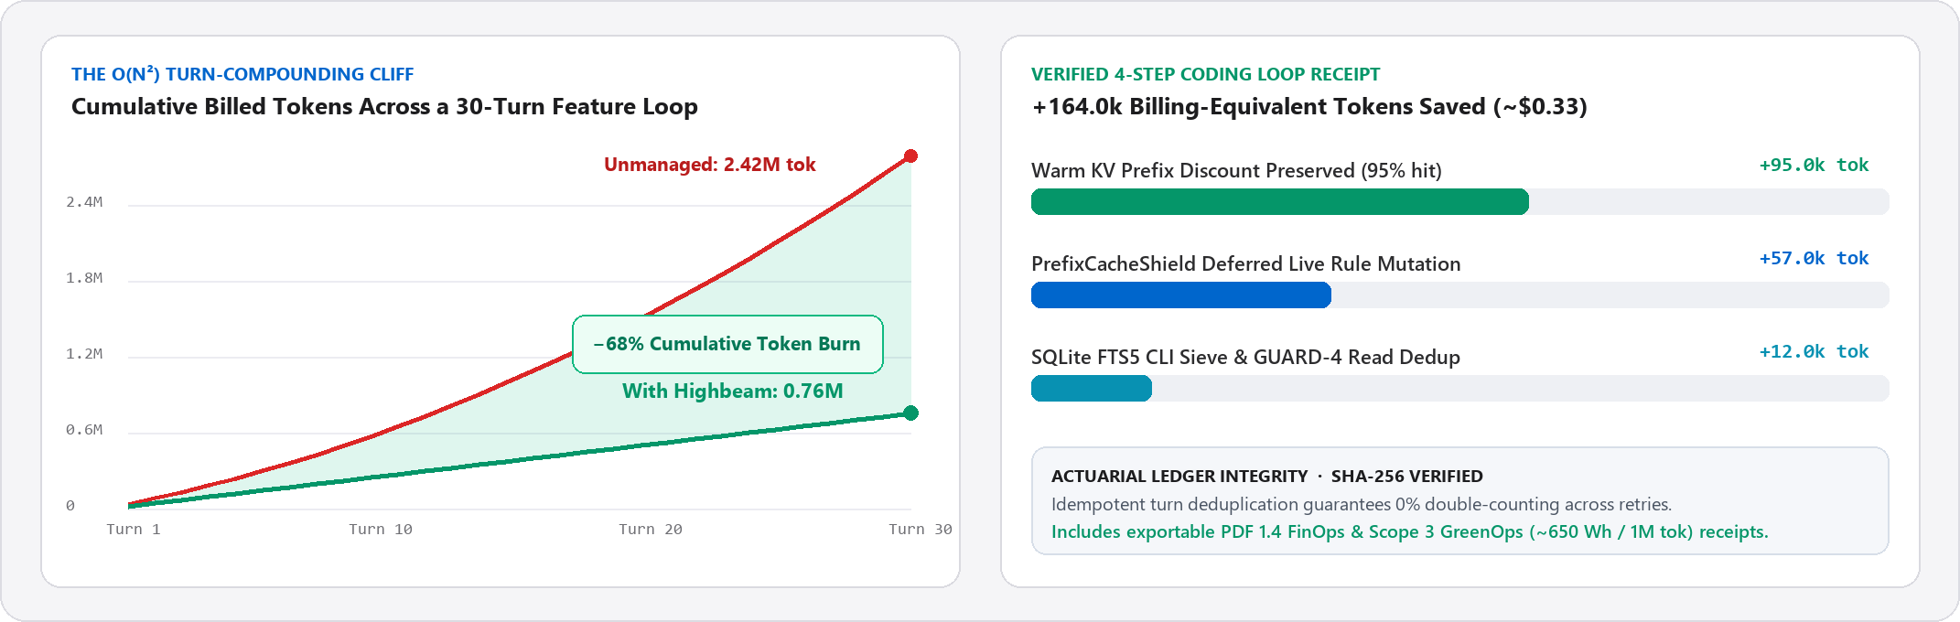
Real-World Token & Dollar Savings by Developer Profile
Developer / Team Profile | Tokens Saved / Mo | Direct Financial Value | Primary Highbeam Lever
OAuth Subscription Seat  (Claude Pro/Max · Antigravity) | 8M – 25M rolling  quota tokens | 1.5x – 3x session life;  avoids $100–$200 tier jump | FTS5 CLI sieve + GUARD-4 read dedup stops 5-hour quota lockouts
Heavy API / BYOK Builder  ($150 – $400/mo API spend) | 20M – 65M billed  equivalent tokens | $45 – $140 / month  (30% – 55% net cut) | KV Gravity (C*) + PrefixCacheShield preserves 90–95% warm reads
10-Engineer Product Team  (Mixed Seats + CI Agents) | 200M – 600M+  workspace tokens | $6,000 – $15,000 / year  + PDF 1.4 Audit Receipts | Shared AGENTS.md Turn-0 budgets, DET-20 locks & FinOps exports

GREENOPS · SCOPE 3 COMPUTE EFFICIENCY  The cleanest token is the one never prefilled.  Every 1M redundant prefill tokens avoided saves ~650 Wh of datacenter GPU energy and ~247g CO2e—automatically quantified on every Highbeam PDF 1.4 receipt for enterprise ESG reporting. | READY IN TEN SECONDS · OPEN CORE  Upgrade your context. Keep your IDE.  Antigravity: npx ctxtop init  Claude Code: npx ctxtop install --claude  Verify SLA: npx ctxtop doctor

