**PROJECT 1: RESEARCHING AND PROGRAMMING LINUX KERNEL MODULE**

**Phạm Nguyễn Huy Hoàng – 1751068**

**Nguyễn Trường Giang – 1751065**

|  |
| --- |
|  |

1. **Linux model kernel**

Linux kernel module is a file with extension name called (.ko). It can be used to plugin or unplug out of kernel when necessary. Linux kernel module has another name called that loadable kernel module.

Driver is the most use loadable kernel module.

Driver using loadable module has 3 advantage:

* Decrease the size of kernel. Because of this it can decrease the waste memory and system boot time.
* Don’t need to retranslate the kernel when a new driver add-on or when change another driver.
* Don’t need to restart system when add a new driver. In windows, when you install a new driver, you need to restart the system, this is not suitable for a sever.

When a module needs to be used but it’s not in the kernel space, the kernel will put it in. This process can be done automatically:

* Step 1: kernel activate the modprobe process with the variable is the name of the module (example: abc.ko).
* Step 2: Modprobe process check file “/lib/modules/<kernel version>/modules.dep to see if abc.ko dependence to any other module. Example the abc.ko dependent to aaa.ko
* Step 3: modprope process will activate the insmode to put all the dependent module in first, then it will add-in the necessary module.

There are 2 way to activate the modprobe process:

* Using kmod. This a part of Linux kernel, it works in kernel space. When any part of the kernel needs to put in a module into the kernel space, it will transmit the name of module into request_module of kmod. Request_module will use call_usermodehelper_setup to create a modprobe process.
* Using udevd. This a process work in the user space. If a device plugin computer system, the PCI bus or USB bus will change, and controller will know this. Bus driver will send a call to udevd. This call has information about the device. Udevd will check file /lib/modules/<kernel-version>/modules.alias to file the drive that compatible with the device. Then udevd create modprobe process.

1. **Character driver**

Like other device driver, the character driver (char driver) has 2 part:

* OS specific has these functions:
  + Create function. This function responsible for:
    - Request kernel to allocate device number.
    - Request kernel to create a device file.
    - Request kernel to allocate memory for the data structure of the driver of initialize them.
    - Request initialize a physical device.
    - Register entry point function to kernel.
    - Register stop function.
  + Stop function: This function does opposite thing that the create function has done.
  + Entry point function. Example: open(), release(), read(), …
* Device specific part has these functions:
  + Group of function create/release device
  + Group of function read/write into the memory of the device.
    - Read/write data memory.
    - Get the information in the memory
    - Setup the command for control memory
  + Group of stop function.

We create vchar_driver.c. This file contains source code to initial driver for a virtual character device. File vchar_driver.c divided into 2 part: OS specific and device specific:

* + OS specific content initialize function, stop function and entry point for driver.
  + Device specific content create/release function for physical device, read/write memory and handle stop signal from physical device

We create 2 file Makefile and Kbuild to make thing easier for the translation:

And here is the result

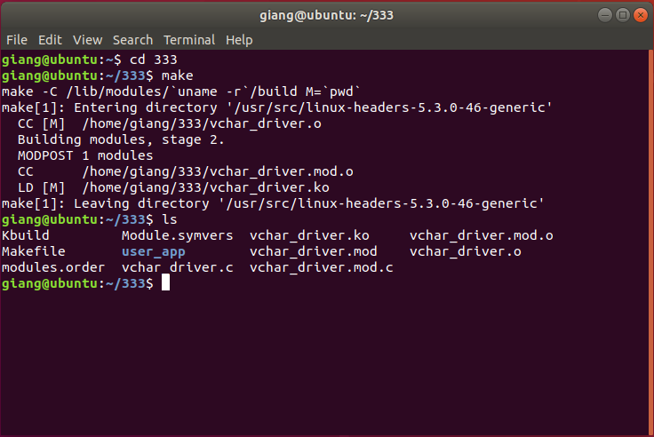

1. **Dynamic allocated device number**

Normally, programmer will create a character driver on a computer and that char driver will use in many other computers. If we use the static allocation device number, that device may use in other computer, this can lead to the char driver can’t be used in that computer. To solve this problem, we use the dynamic allocation device number.

In this method, Linux kernel will provide a function called alloc_chrdev_region. This function will find a value that could be used for device number. We used to call this function in the create function of char driver.



***dev***is an output-only parameter that will, on successful completion, hold the first number in your allocated range.

***firstminor***should be the requested first minor number to use; it is usually 0.

***count***is the total number of contiguous device numbers you are requesting.

***name***is the name of the device that should be associated with this number range; it will appear in */proc/devices* and *sysfs*.

To use the function to init/release device number, we need to add <linux/fs.h> library



To save the value of device number, we create a vchar_drv structure that stores dev_num

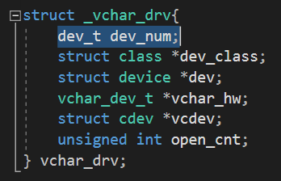

In the vchar_driver_ninit function of this driver, we call alloc_chrdev_region to request kernel to find a suitable device number. If there is no suitable device number, this function returns a negative value. So that, we return a negative number to inform Linux kernel that this char driver can’t put into kernel.

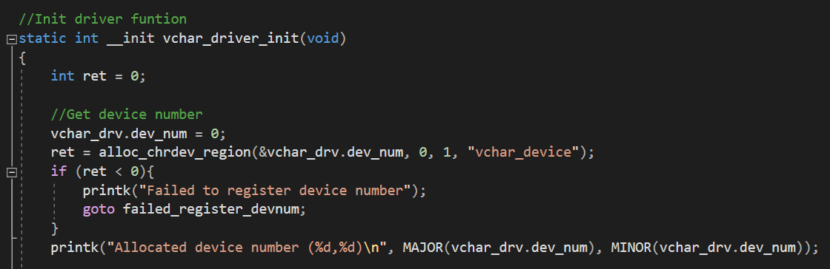



Finally, in the vchar_driver_exit of this driver, we call unregister_chrdev_region function to release device number.

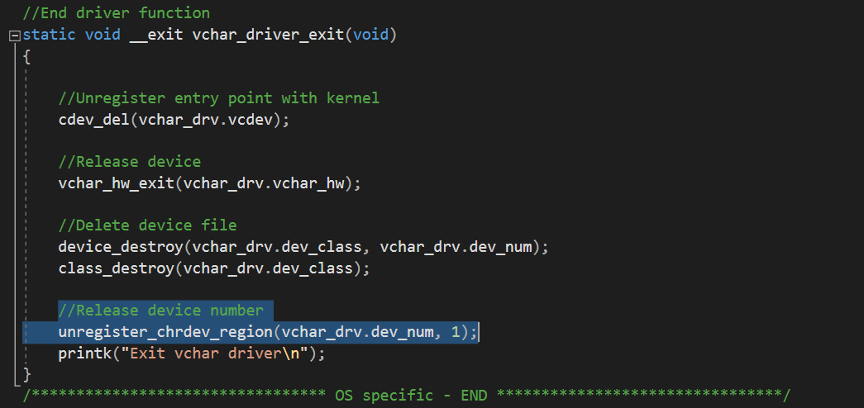

After loading module to kernel, we get the device number by using *dmesg.*

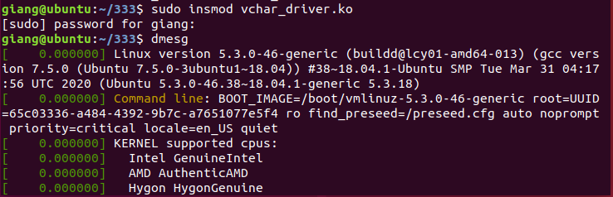



1. **Creating device file**

The automatic creation of device files can be handled with udev. Udev is the device manager for the Linux kernel that creates/removes device nodes in the /dev directory dynamically. Just follow the below steps.

1. Include the library **linux/device.h**, which contains library to create device file.
2. Create the struct Class
3. Create Device with the class which is created by the above step

To create a device file automatically, we need to include the <linux/device.h>



To store the return value of functions class_create and device_create, we need to add *dev_class and *dev to the vchar_drv struct.

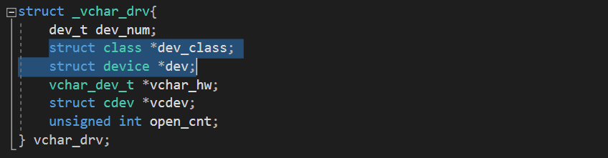

In the vchar_driver_init function, we call class_create to create a device class name class_vchar_dev. If this function can’t be done successfully, we need to call unregister_chrdev_region function to release device number which has been initialized before. If success, we need to continue to call device_create to create a device name vchar_dev in the folder /dev. If device_create is failed, we will call class_destroy to release the device class.

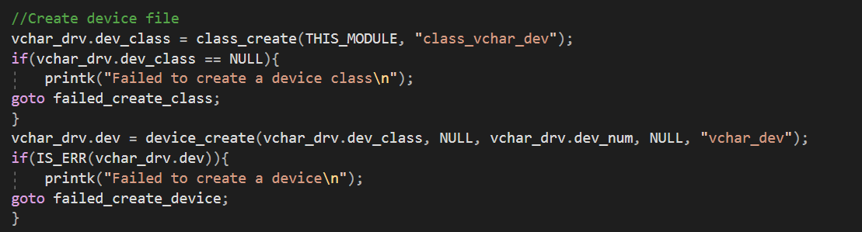

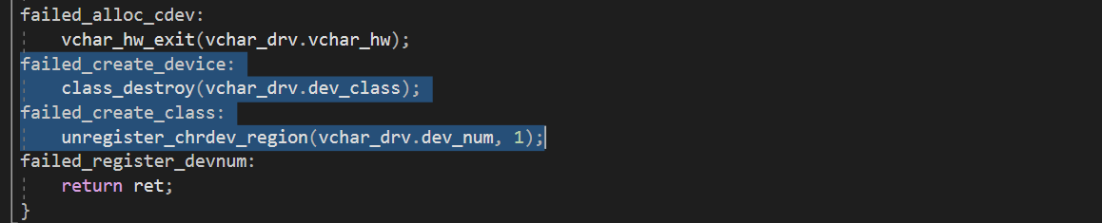

Finally, in function vchar_driver_exit, we call functions device_destroy and class_destroy to release what have been created.

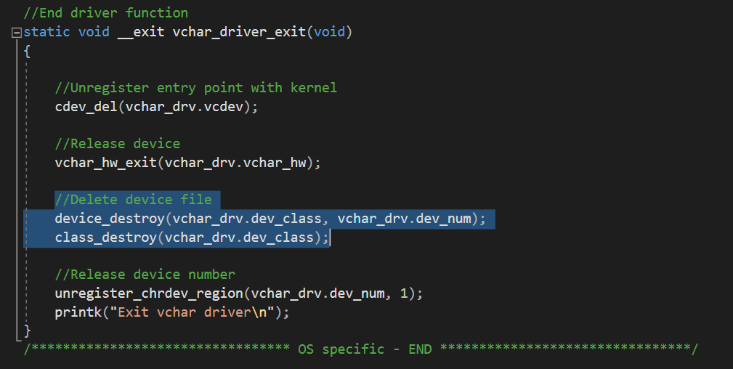

While initializing character driver, function class_create will creates folder class_vchar_dev in folder /sys/class, and function device_create will create folder vchar_dev in folder /class_vchar_dev. Inside folder vchar_dev there is a file name uevent. Uevent store datas that character driver sends to process udevd. Using theses data, udevd will create a device file vchar_dev in folder /dev.

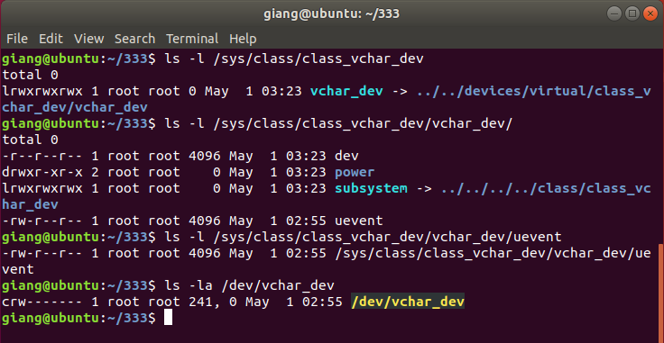

1. **Register entry points open and release.**

* **cdev structure**

In Linux kernel **struct inode** structure is used to represent files. Therefore, it is different from the file structure that represents an open file descriptor. There can be numerous file structures representing multiple open descriptors on a single file, but they all point to a single **inode**structure.

First, we include <linux/cdev.h> library to use the cdev structure and relevant function/



Next, we save the address of cdev structure, we add *vcdev into vchar_drv. To save how many time device file had been open, we add open_cnt into vchar_drv structure.

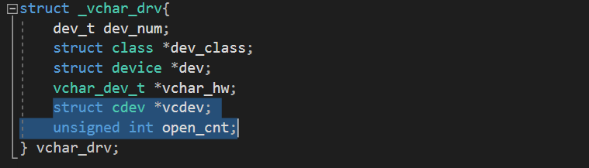

Next, to deploy vchar_driver_open and vchar_driver_release, we assign these functions to pointer open and release of file_operation structure.

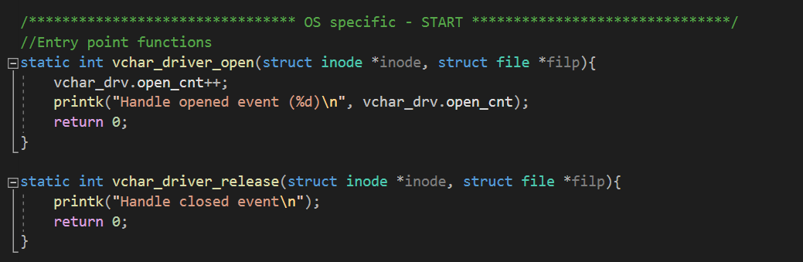

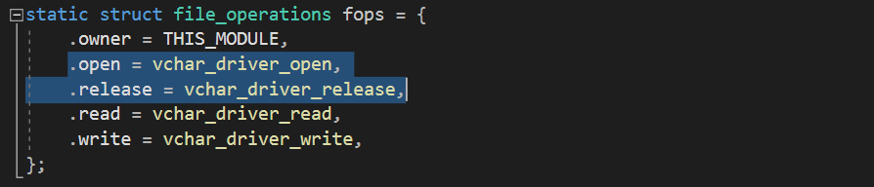

Inside vchar_driver_init function, we register cdev structure to Linux kernel. First, call the cdev_alloc function to request the kernel create a case for new cdev. If this process failed, we destroy all the thing had been done before. If success, we continued to call cdev_init to fill the information of cdev. Then call cdev_add to send these information to kernel.

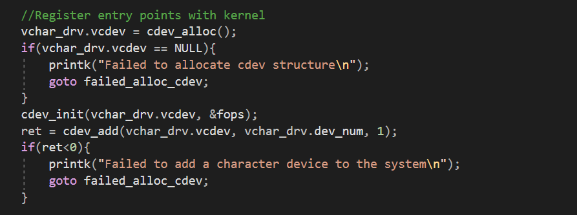

Inside vchar_driver_exit, we call cdev_del to unregister entry point with kernel.

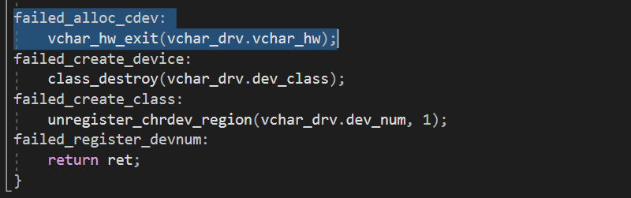

From here, I created a user app in user space that contact with vchar driver by system call open and close to check entry points close and open. First I created a folder name user_app, and inside that folder, I created user_random.c file and a Makefile to run this file.

This is the Makefile.

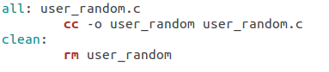

Inside user_random.c, I created functions to check entry points open and release.

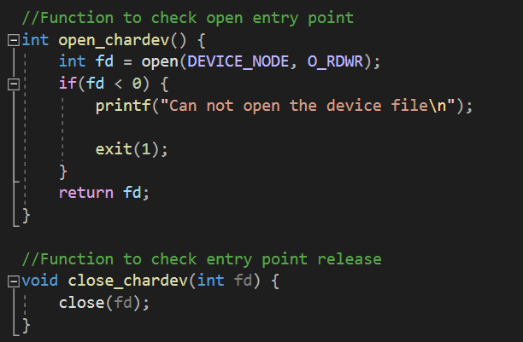

And using switch case to give options

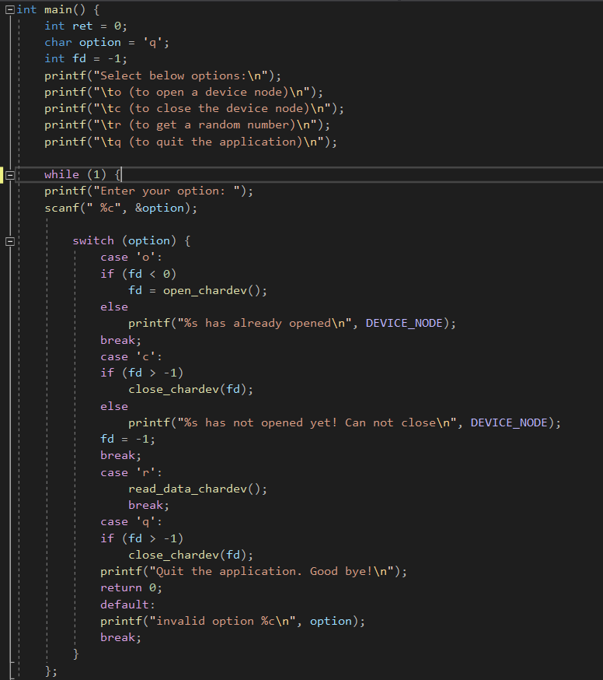

I will run this app and check dmesg to see if open and release entry points is working or not. This app is in user space and is not allowed to access to /dev/vchar_dev so we have to use chmod to grant access.

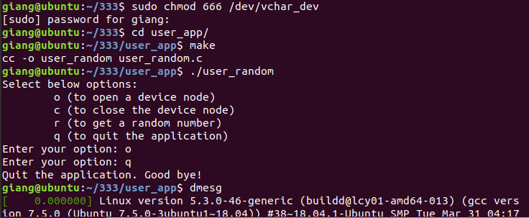



1. **Register entry points read and write**

We add the <linux/uaccess.h> library to use the copy_to_user function and copy_from_user.



I put the function to create a random integer number in entry point read. First, initializing rand as an integer variable, then using get_random_bytes function to get a random integer number and that value is assigned into rand. Size of an integer number is 4 bytes. Call copy_to_user to copy rand to user buffer and return size of (int).

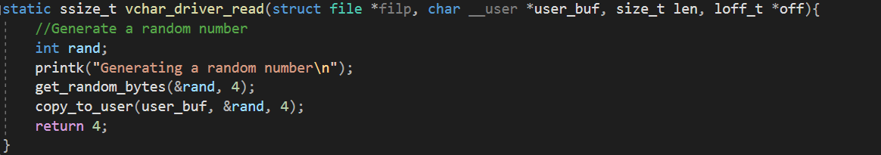

We write vchar_driver_write to deploy entry point write. We don’t use entry point write in this project.



Finally, to register these functions into entry point read and write of char driver, we need to assign address of vchar_driver_read and vhcar_driver_write to read and write of file_operations structure.

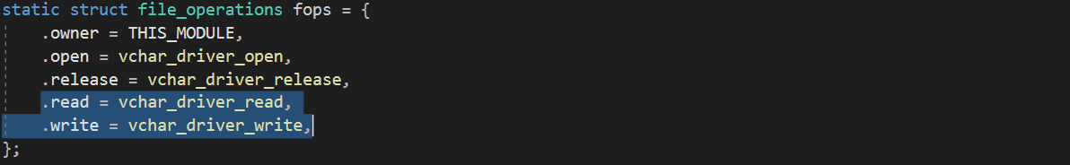

In user_random.c, I created a function to get random integers from character device through entry point read. First opening device file at read-only mode and assigning the return value of the function to variable fd. If the device file can not be opened, quit the process. Read the random integer number to variable num and close the device file. Then print out the value of the random variable with abs() function to get positive number.

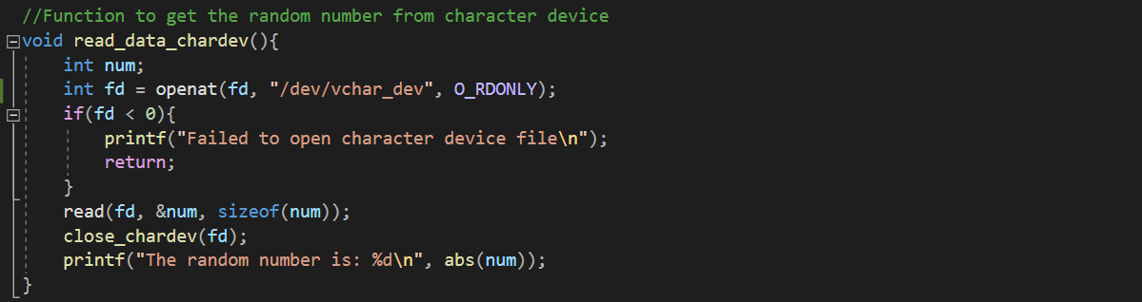

Add option “r” as showing a random integer to the switch case.

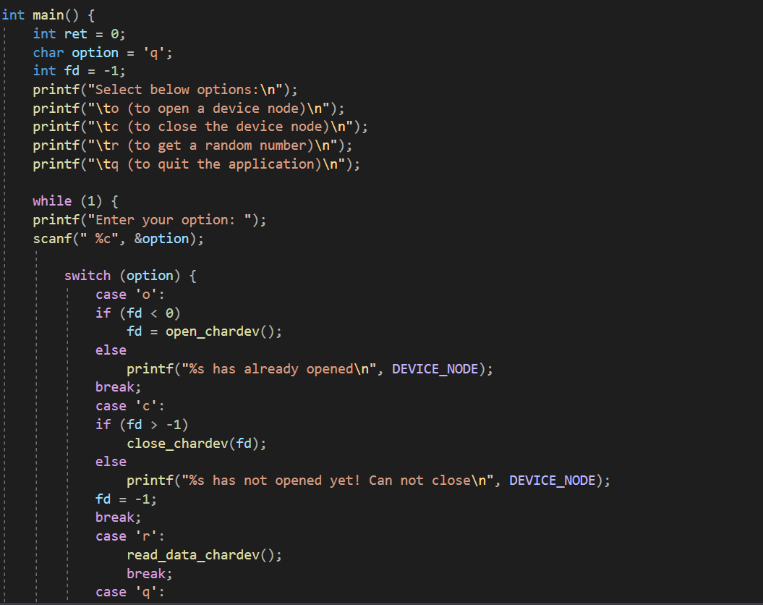

Let’s run this app to see the result.

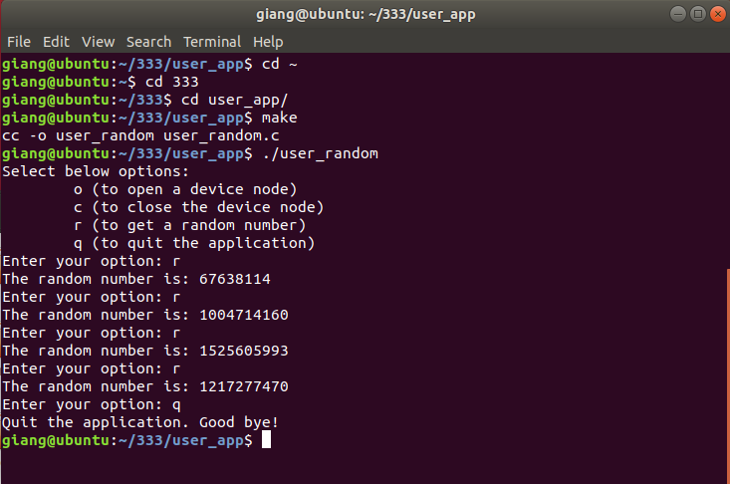

1. **How to run**

First, go to the folder /333 and run make.

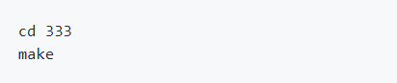

Insert module to kernel.



Get right to read device file.



Go to user_app and run.

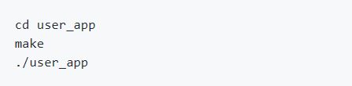

A selection board show up. Press “r” to get a random number.

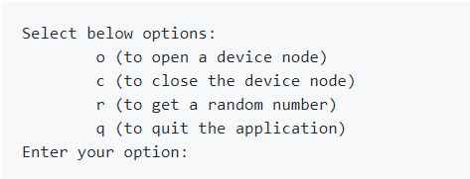

To detach module from kernel.



To clean in /333 and /333/user_app.

