# Inf102-oblig1 – CGJ008

Carl August Gjørsvik

## [1] Quicksort

a)

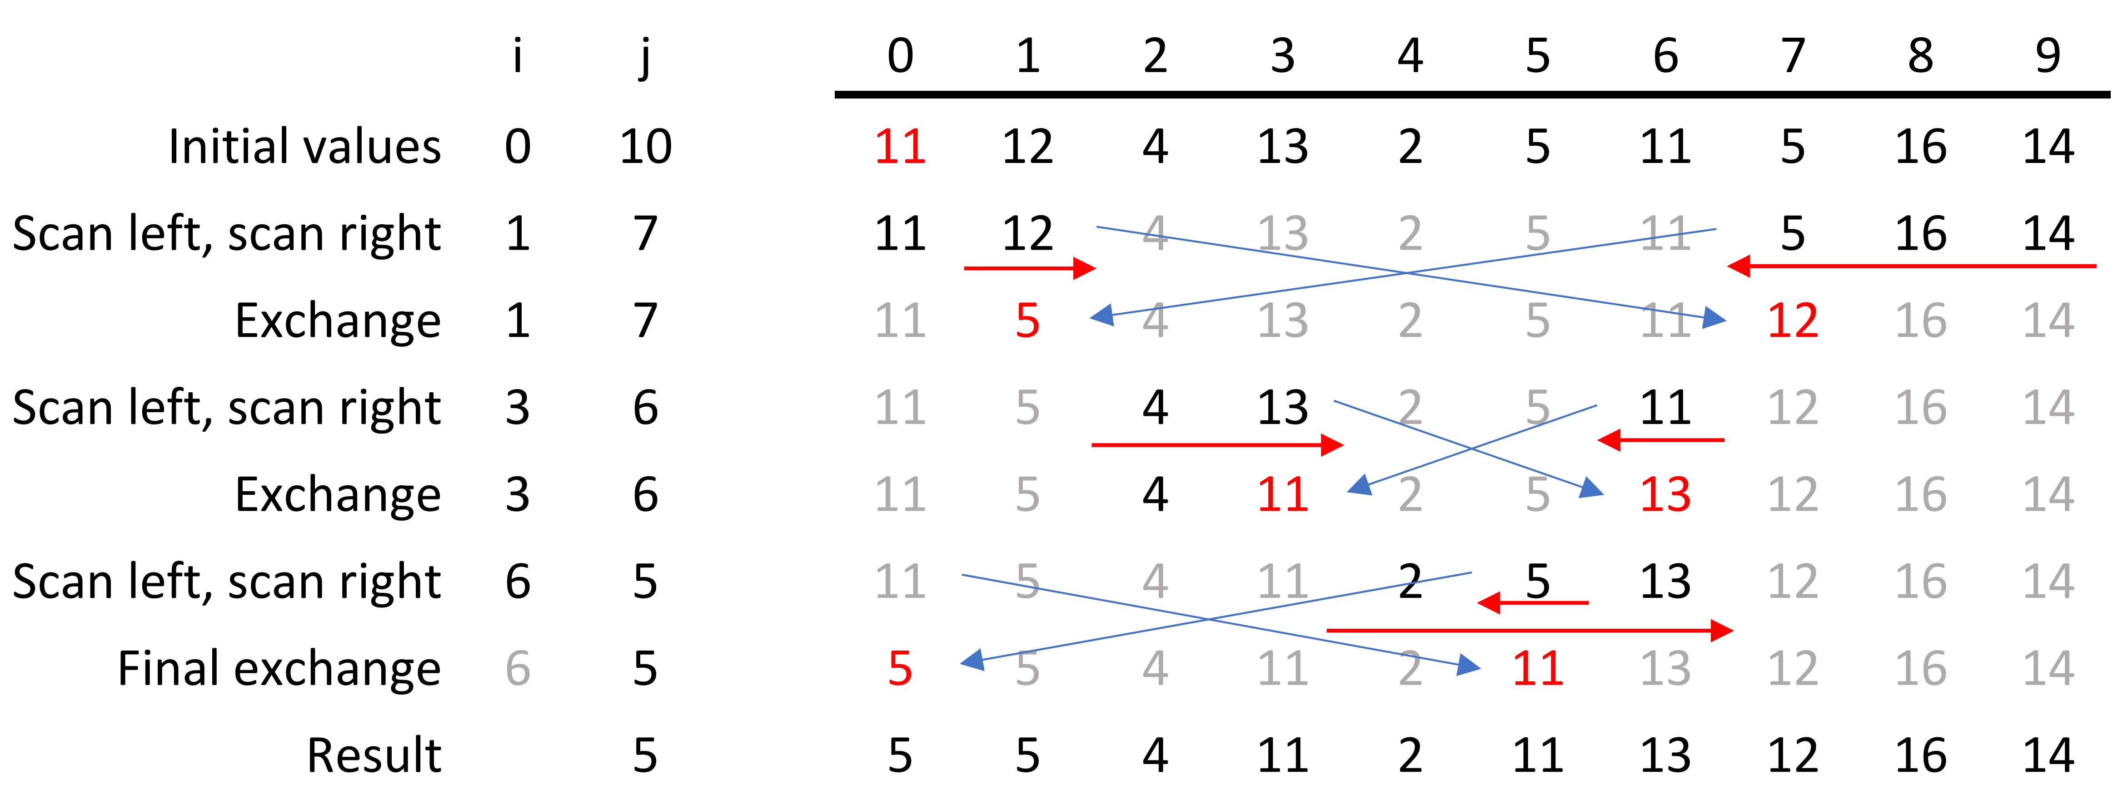

b)

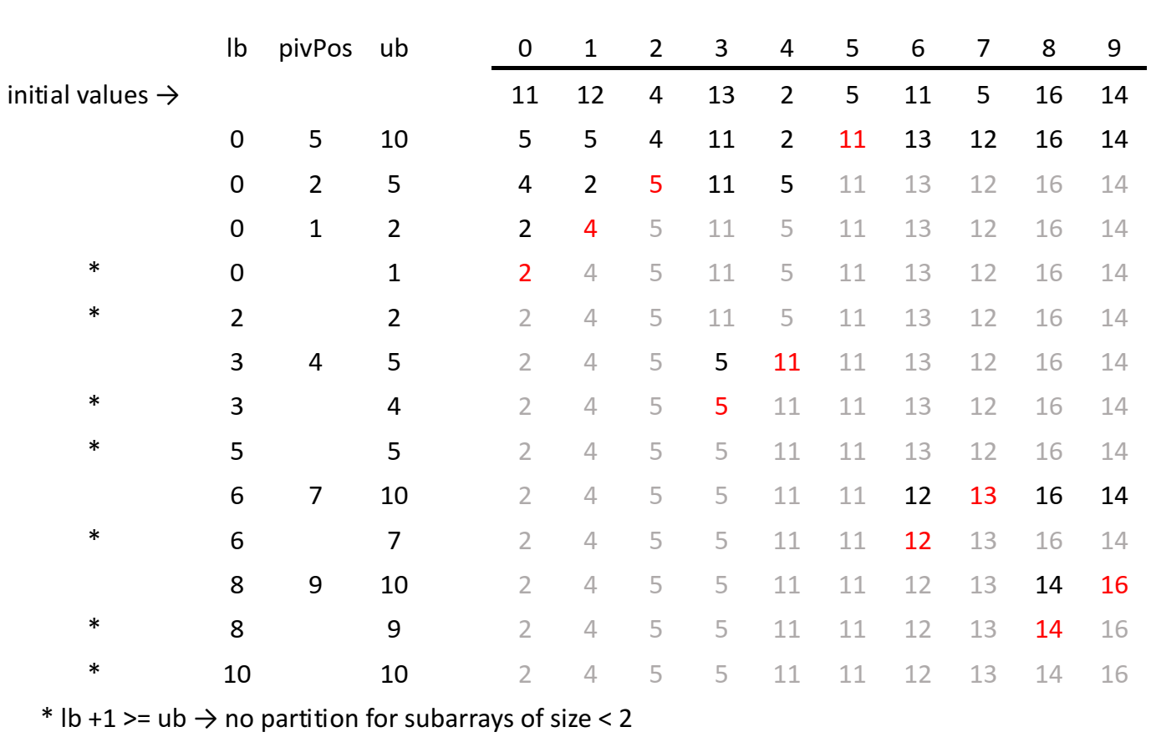

c)

The problem occurs when partition() is called with an array or sub-array comprised of equal values. Using the normal implementation, incrementing and until they point at respectively greater or equal, and lesser or equal values, values will be swapped until and meet in the middle. The result is a lot of swapping, but only O recursive method-calls.

In the case where and “look” for elements strictly greater, will scan to the end of the array and will scan to the first element of the array. Quicksort will then make recursive calls with the sub-arrays created by a pivot at the left-most position, always with one sub-array of length 1 and another with length n-1, n-2, n-3… etc, effectively creating O recursive calls.

## [2] Priority Queues

a) [ null, T, S, R, N, P, O, A, E, I, G, H ]

## [3] Binary Search Tree

a)

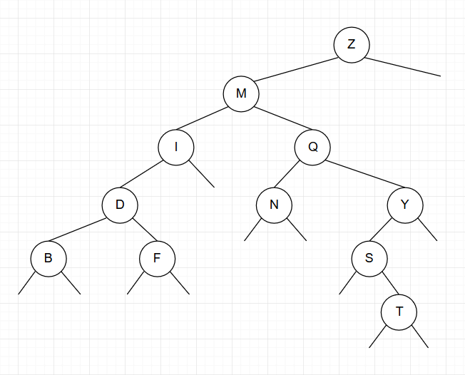

## [4] Balanced Binary Search Trees

a)

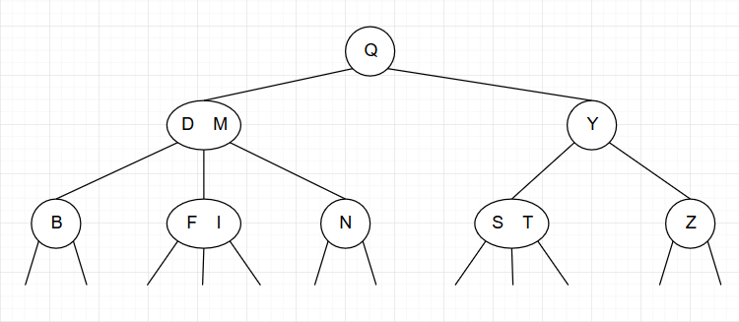

b) Insertion order: B F Y I S D N T

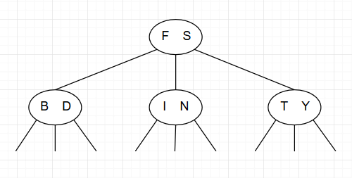

c) () and () are Red-Black BSTs

d)

)  
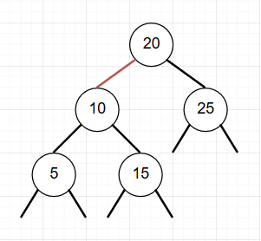

)  
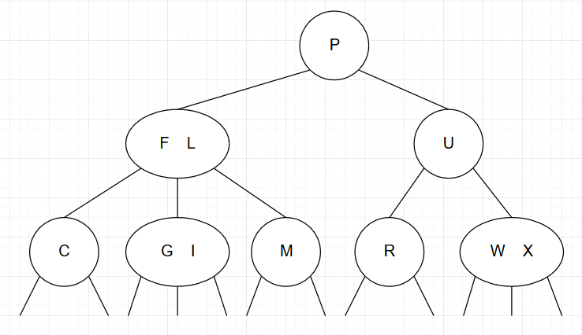

)  
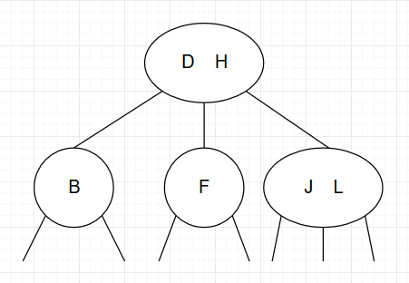

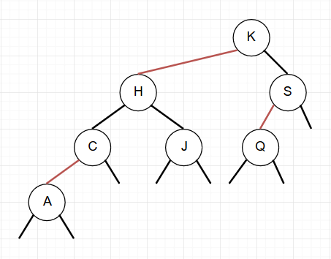

e)

L R F F R F R F R F L

f)