# INF102mandatory2 – CGJ008

Carl August Gjørsvik

# [1] Hash maps

a)

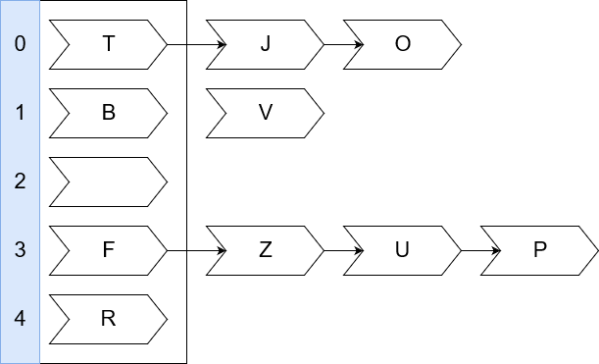

b)

|  |  |  |  |  |  |  |  |  |  |  |  |  |  |  |  |
| --- | --- | --- | --- | --- | --- | --- | --- | --- | --- | --- | --- | --- | --- | --- | --- |
| 0 | 1 | 2 | 3 | 4 | 5 | 6 | 7 | 8 | 9 | 10 | 11 | 12 | 13 | 14 | 15 |
| **P** | **U** | **Z** | **J** | **T** | **O** |  |  |  |  | **B** | **R** |  |  | **F** | **V** |

|  |  |  |
| --- | --- | --- |
| **Function** | **f** | **O** |
| a |  | O |
| b |  | O |
| c |  | O |
| d |  | O |
| e | 1 | O |
| f |  | O |
| g |  |  |
| h |  | O |
| i |  | O |
| j |  | O |
| k |  | O |
| l |  | O |
| m |  | O |
| n |  | O |
| o |  | O |
| p |  | O |