Research Methodology — Project Report
Exploratory Data Analysis of Amazon Sales Data
Using Python

1. Introduction

The rapid expansion of e-commerce has fundamentally transformed global retail, with platforms like Amazon emerging as dominant forces in the way consumers discover, evaluate, and purchase products. As digital transactions generate vast amounts of structured data, the ability to analyse this data systematically has become an indispensable tool for understanding market behaviour, customer preferences, and revenue dynamics.
This project undertakes an Exploratory Data Analysis (EDA) of an Amazon sales dataset comprising 50,000 transaction records spanning two years — from January 2022 to December 2023. The dataset captures a comprehensive range of variables across the sales pipeline, including order details, product categories, pricing, discount structures, quantity sold, customer regions, payment methods, product ratings, and review counts. Specifically, it covers six product categories — Electronics, Fashion, Books, Beauty, Sports, and Home & Kitchen — across four major global regions: North America, Asia, Europe, and the Middle East.
By applying Python-based EDA techniques — including descriptive statistics, data visualisation, and pattern recognition — this study aims to surface meaningful trends and correlations within the dataset. The findings have practical relevance for e-commerce businesses seeking to optimise their sales strategies, improve customer experience, and allocate resources more effectively across product lines and geographies.

2. Objectives of the Study

The primary objectives of this exploratory data analysis project are:
- To examine the distributional characteristics and statistical properties of all numerical and categorical variables in the Amazon sales dataset.
- To identify the key drivers of total revenue by analysing the relationships between price, quantity sold, discount percentage, and revenue outcomes.
- To investigate whether product category, customer region, or payment method significantly influences sales performance, pricing, or customer satisfaction.
- To detect and document any outliers or anomalies in the data that may affect the reliability of downstream analysis.
- To assess temporal patterns in order frequency across months and days of the week.
- To generate actionable insights relevant to pricing strategy, discount policy, and regional market behaviour using Python-based visualisation techniques.

3. About the Dataset

The dataset used in this project is a structured Amazon sales transaction dataset containing 50,000 records over the period January 2022 to December 2023. Each record represents a single order and captures information across 13 variables spanning product details, pricing, customer behaviour, and satisfaction metrics.

Attribute | Details
Dataset Name | Amazon Sales Dataset
Total Records | 50,000 Transactions
Time Period | January 2022 – December 2023
Product Categories | Books, Fashion, Sports, Beauty, Electronics, Home & Kitchen
Customer Regions | North America, Asia, Europe, Middle East
Payment Methods | UPI, Credit Card, Debit Card, Wallet, Cash on Delivery
Price Range | 5.01 – 499.99
Discount Range | 0% – 30% (discrete tiers)
Quantity Sold | 1 – 5 units per order
Rating Range | 1.0 – 5.0 (Mean: 3.0)
Source | Synthetic Amazon Sales Data (Kaggle)

3.1 Variable Descriptions

Numerical Variables:
- order_id — Unique sequential identifier assigned to each transaction.
- product_id — Unique identifier for each product in the catalogue.
- price — Original listed price of the product (5.01 to 499.99).
- discount_percent — Percentage discount offered (0%–30%, in discrete tiers: 0, 5, 10, 15, 20, 30).
- quantity_sold — Number of units purchased in a single order (integer values 1 to 5).
- rating — Customer satisfaction score (1.0 to 5.0).
- review_count — Total number of customer reviews received for the product (0 to 500).
- discounted_price — Effective selling price after discount (derived: price × [1 − discount/100]).
- total_revenue — Total revenue from the transaction (target variable: discounted_price × quantity_sold).

Categorical Variables:
- order_date — Date of the order; used to extract month and day-of-week features.
- product_category — Category of the product: Books, Fashion, Sports, Beauty, Electronics, Home & Kitchen.
- customer_region — Geographic region: North America, Asia, Europe, Middle East.
- payment_method — Payment mode: UPI, Credit Card, Debit Card, Wallet, Cash on Delivery.

4. Univariate Analysis

Univariate analysis examines each variable individually to understand its distribution, central tendency, spread, and shape. The analysis was conducted for both numerical and categorical variables using histograms with KDE curves, box plots, skewness charts, count plots, pie charts, and frequency bar charts.

4.1 Numerical Variables

4.1.1 Histograms + KDE — Distribution and Central Tendency
The distributions of all nine numerical variables were examined using histograms overlaid with Kernel Density Estimation (KDE) curves. order_id and product_id exhibit near-uniform distributions consistent with their role as sequential identifiers. price shows an approximately uniform distribution (mean 252.01, median 252.97). discount_percent is discrete and multi-modal — with spikes at 0%, 5%, 10%, 15%, 20%, and 30% — reflecting standardised discount tiers (mean 13.34%). quantity_sold and rating both take only integer values with means and medians equal to 3.0. discounted_price is mildly right-skewed (mean 218.89 > median 215.81). total_revenue shows the strongest right-skew (mean 657.33 vs median 305.41), driven by high-value outlier transactions.

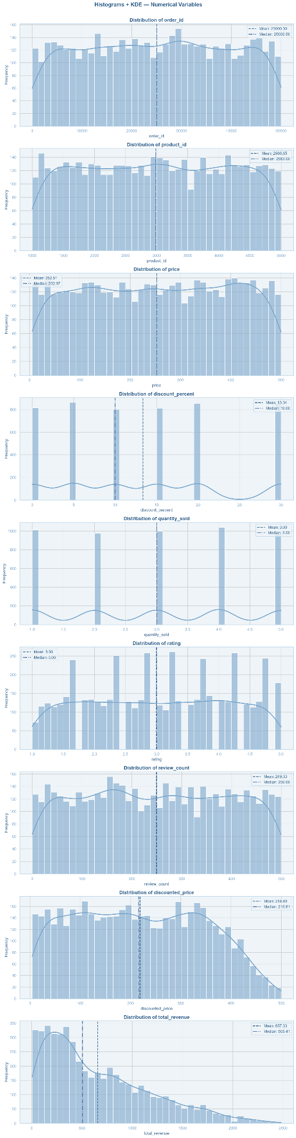
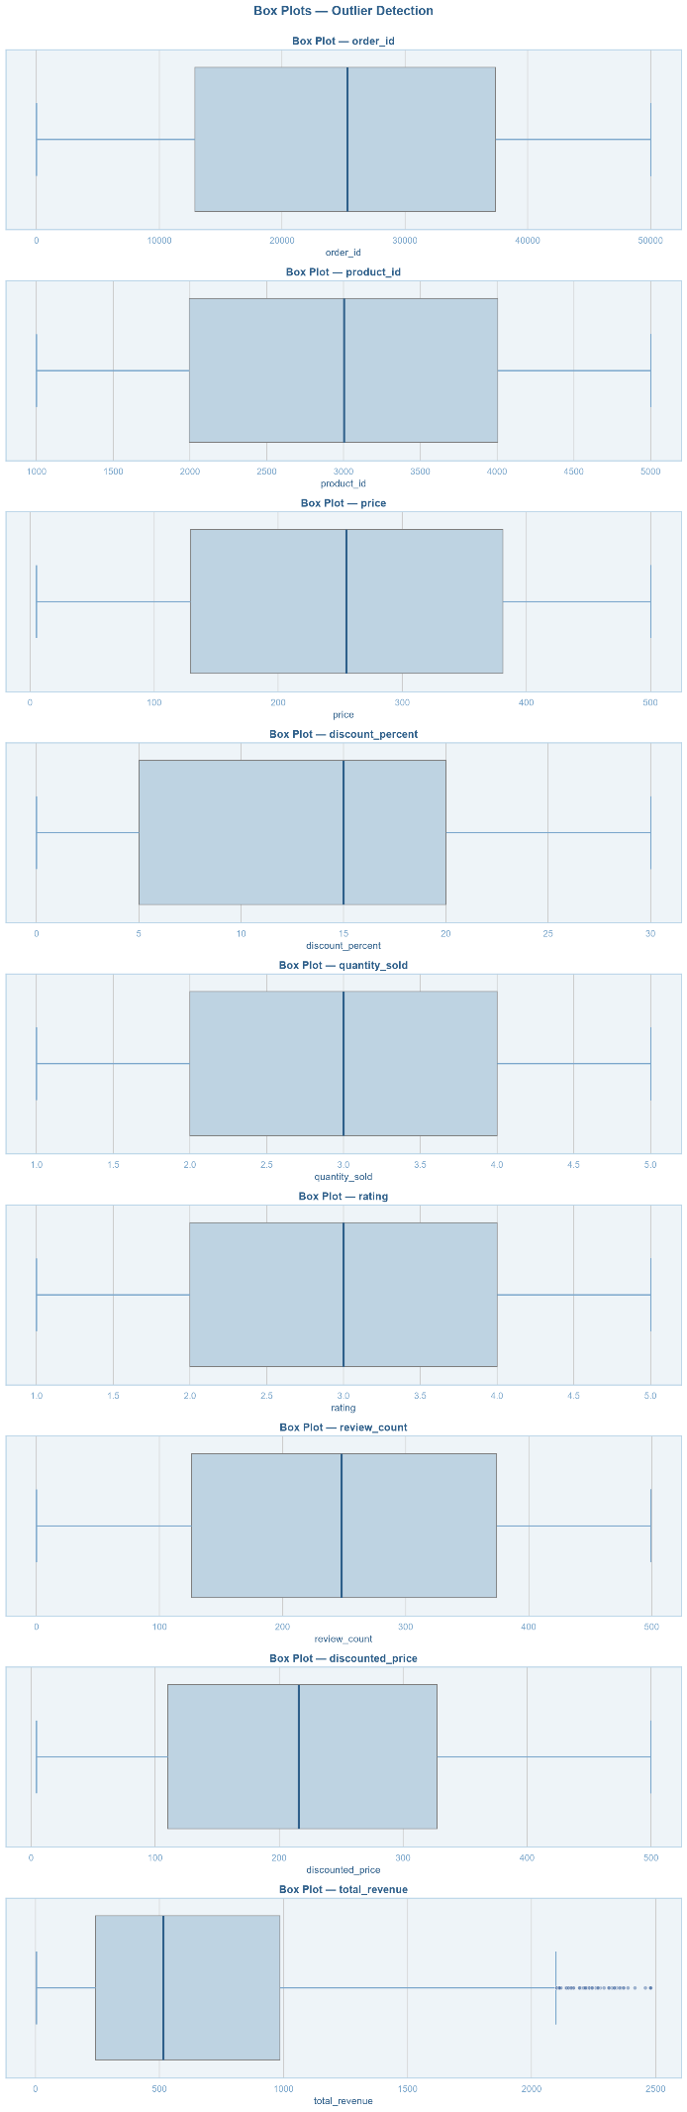
Figure 4.1: Histograms with KDE curves (left) and box plots (right) for all numerical variables.

4.1.2 Skewness of Numerical Variables
The skewness chart summarises the directional asymmetry of each variable. total_revenue records the highest skewness at +0.98, approaching the high-skew threshold. discount_percent shows moderate positive skewness (+0.34). discounted_price is mildly skewed (+0.12). All remaining variables — price, quantity_sold, rating, review_count, order_id, product_id — record skewness at or near 0.00, confirming symmetric distributions.

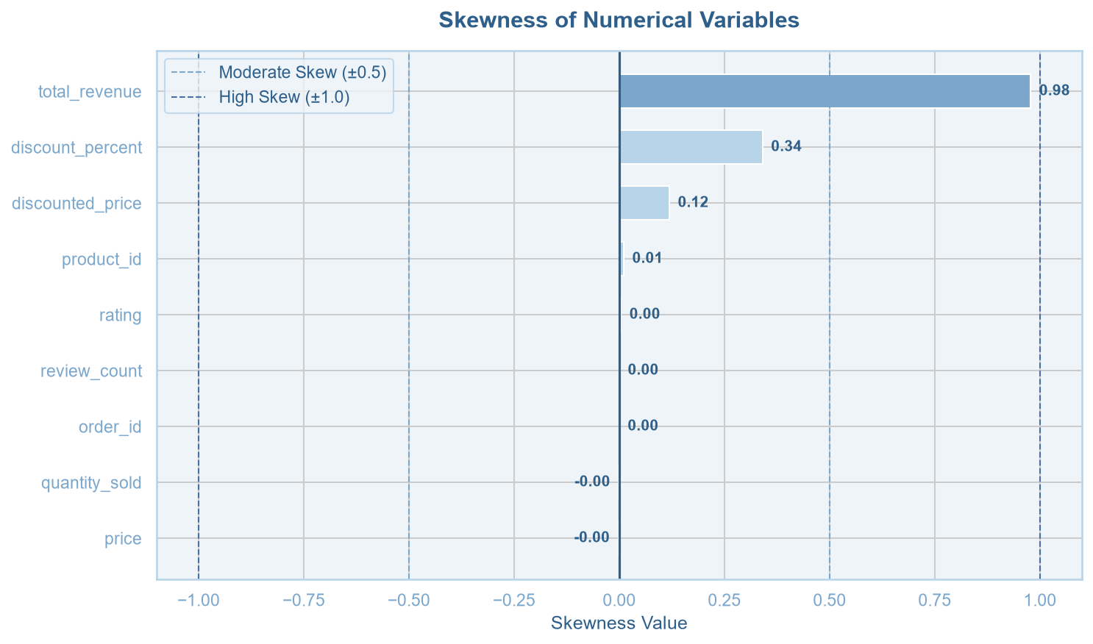
Figure 4.2: Skewness of all numerical variables (dashed lines mark ±0.5 and ±1.0 thresholds).

4.2 Categorical Variables

4.2.1 Product Category
All six product categories are nearly equally represented, ranging from 8,258 (Home & Kitchen) to 8,465 (Beauty) orders — each accounting for approximately 16.5%–16.9% of total orders. This uniform representation ensures no category bias in the analysis.

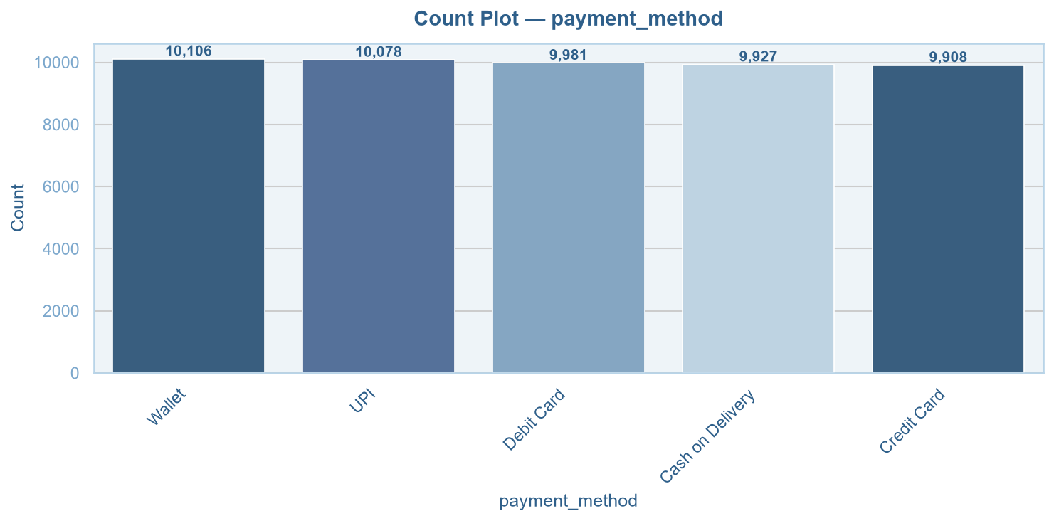
Figure 4.3: Count plot — order frequency by product category.

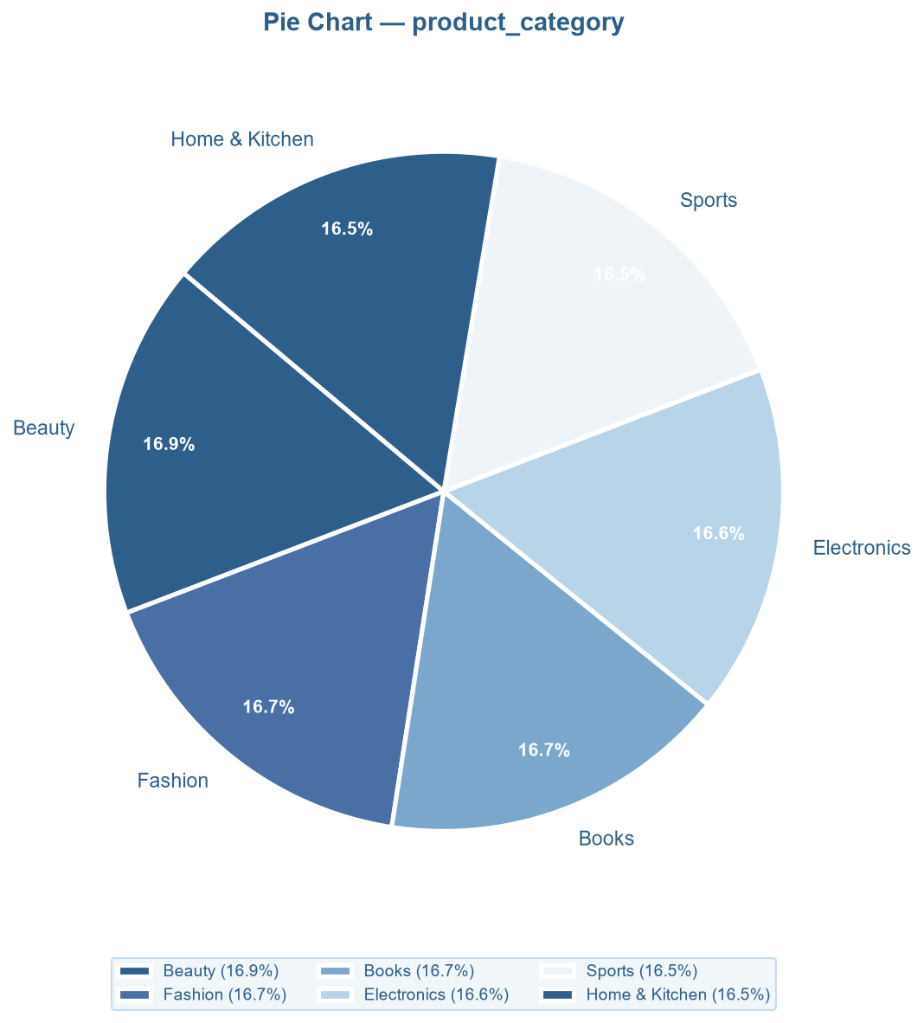
Figure 4.4: Pie chart — percentage share by product category.

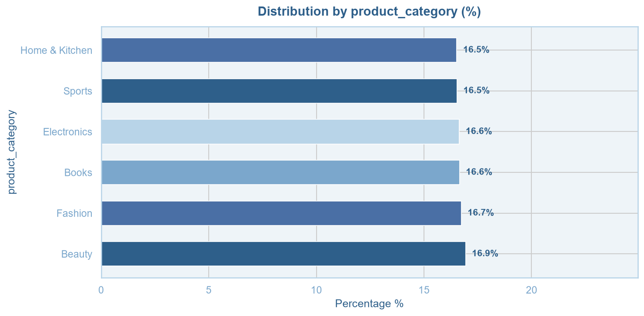
Figure 4.5: Frequency bar chart — percentage distribution by product category.

4.2.2 Customer Region
The four customer regions are distributed with near-perfect uniformity: Asia (25.1%, 12,526 orders), North America (25.0%, 12,517), Middle East (25.0%, 12,505), and Europe (24.9%, 12,452). This balance makes cross-regional comparisons statistically reliable.

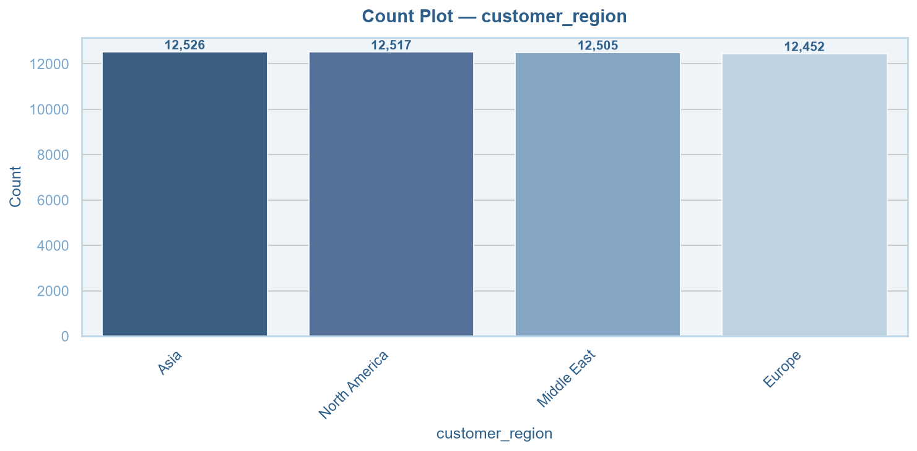
Figure 4.6: Count plot — order frequency by customer region.

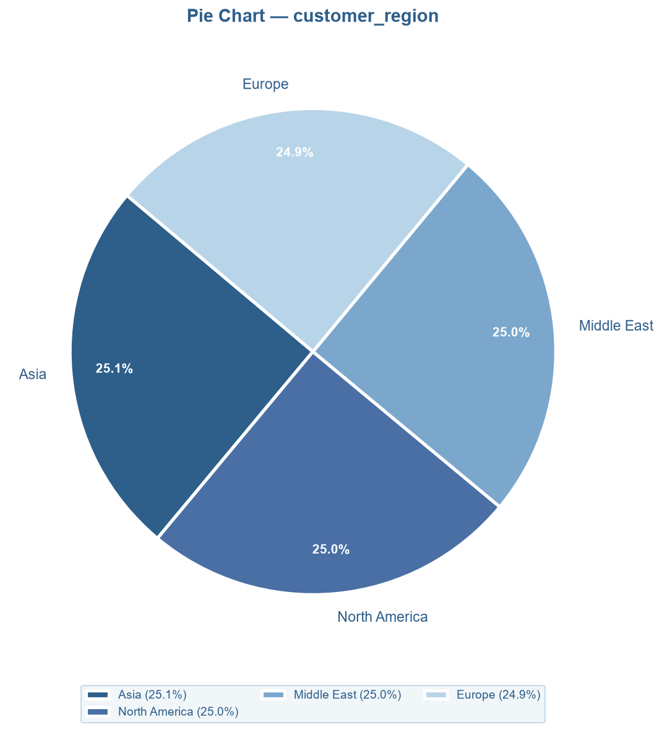
Figure 4.7: Pie chart — percentage share by customer region.

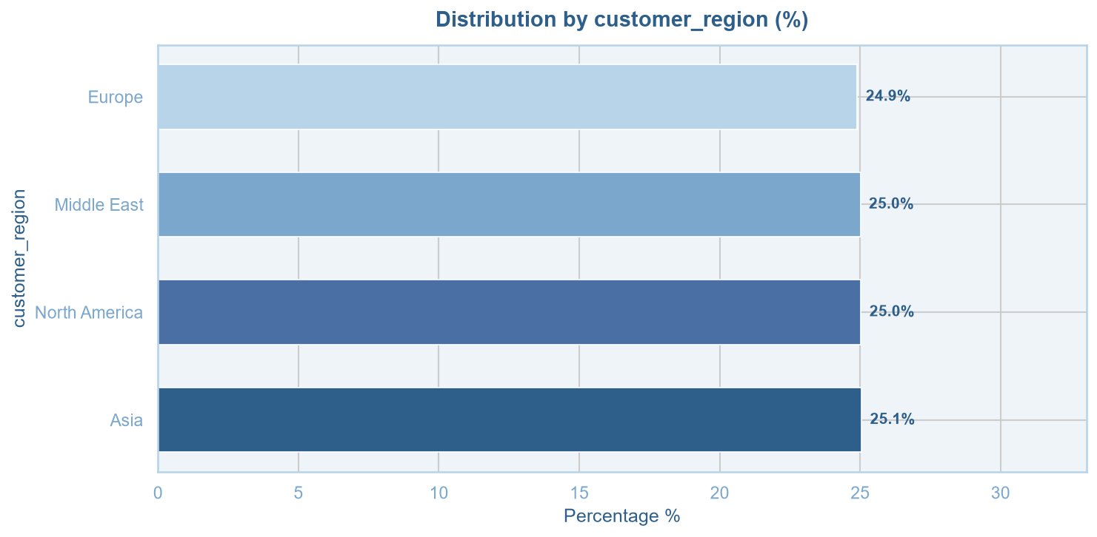
Figure 4.8: Frequency bar chart — percentage distribution by customer region.

4.2.3 Payment Method
All five payment methods — Wallet (20.2%), UPI (20.2%), Debit Card (20.0%), Cash on Delivery (19.9%), and Credit Card (19.8%) — are used with near-identical frequency, reflecting a balanced multi-channel payment landscape with no dominant mode.

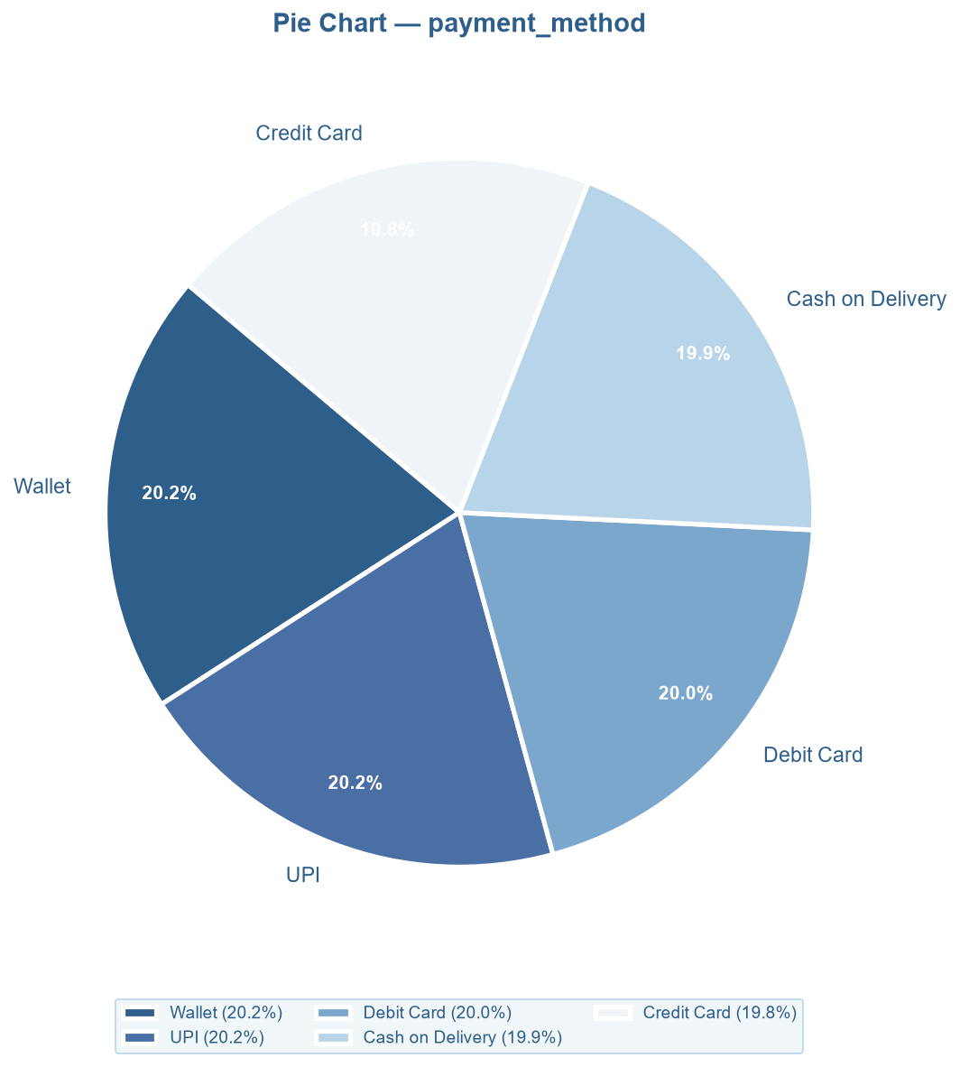
Figure 4.9: Pie chart — percentage share by payment method.

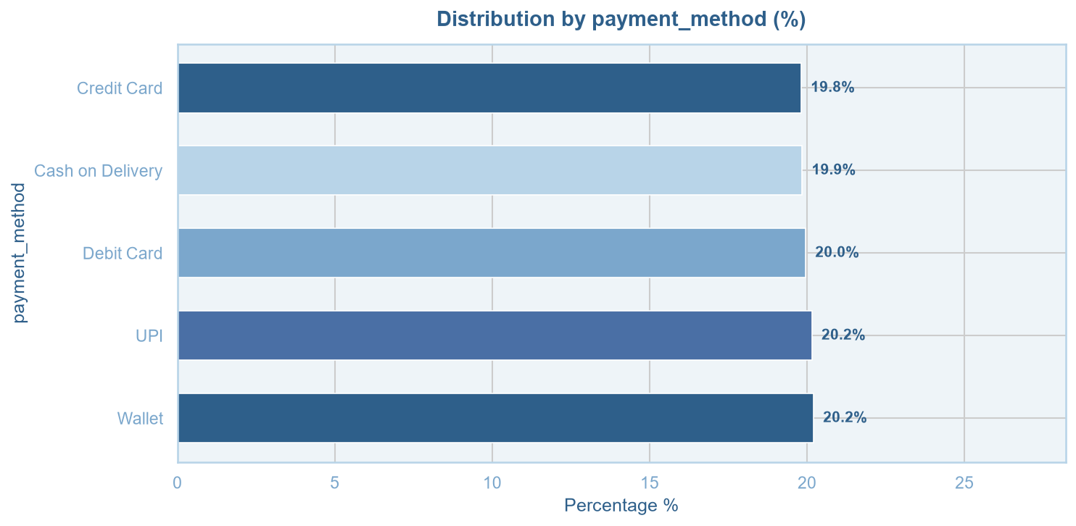
Figure 4.10: Frequency bar chart — percentage distribution by payment method.

4.2.4 Temporal Variables — Day of Week and Month
Orders are distributed across all seven days with minimal variation: Friday (7,317; 14.6%) is highest and Tuesday (7,054; 14.1%) lowest. Monthly volumes are broadly consistent — August and January lead (8.7% each) and February is lowest (7.5%), attributable to the shorter calendar month. The absence of sharp seasonal spikes reflects stable demand throughout the year.

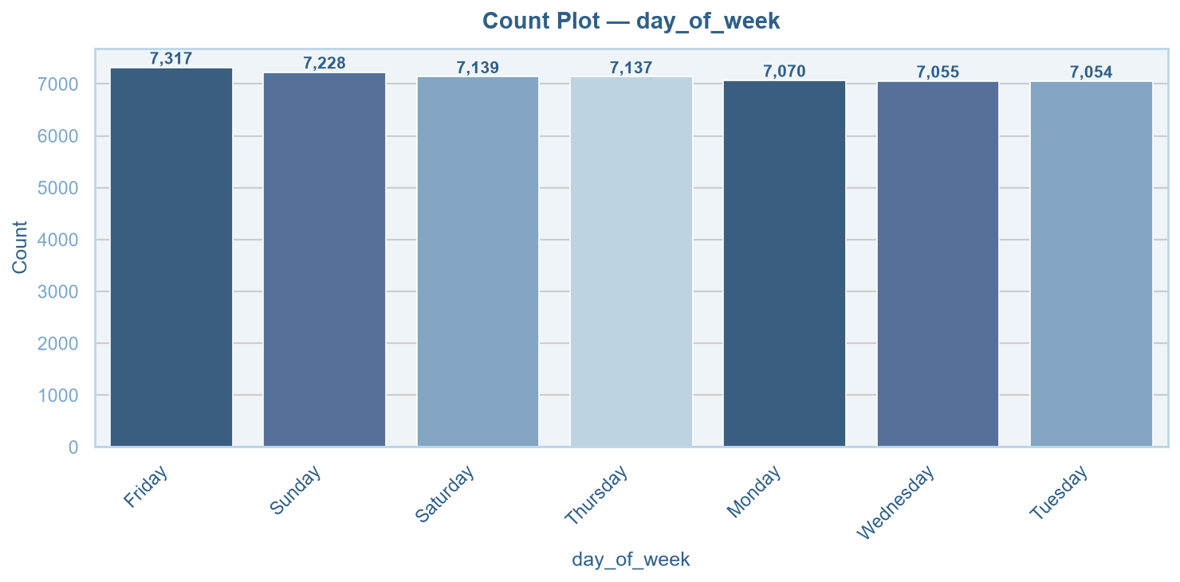
Figure 4.11: Count plot — order frequency by day of week.

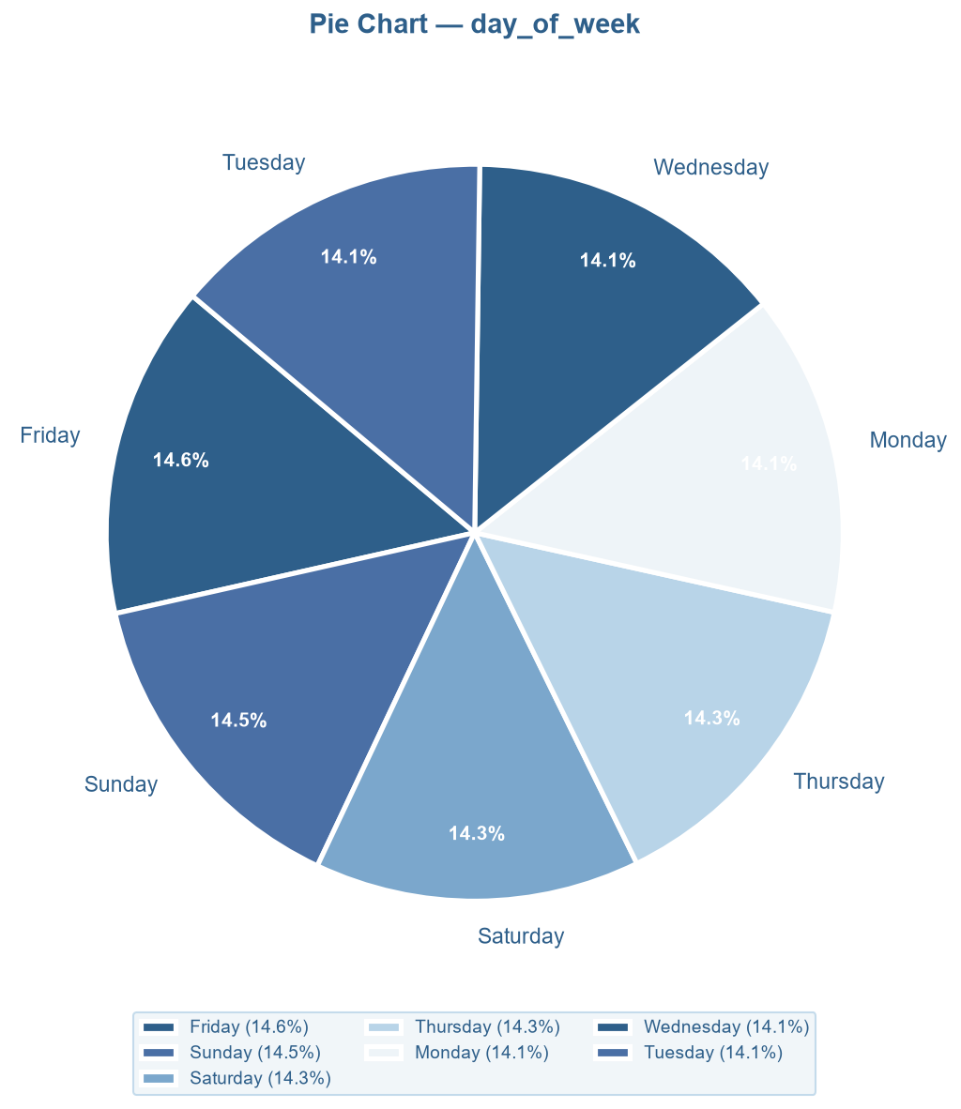
Figure 4.12: Pie chart — percentage share by day of week.

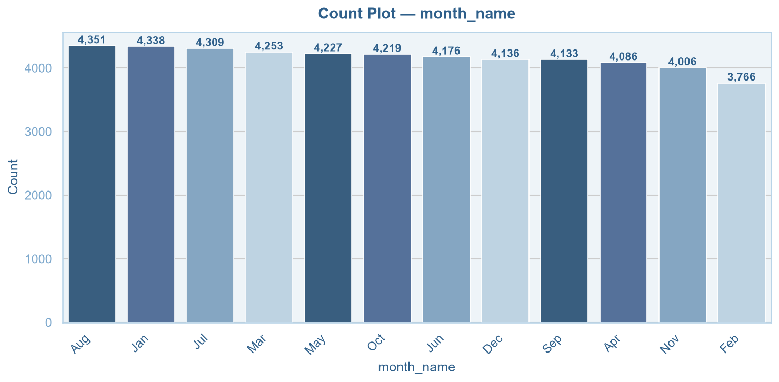
Figure 4.13: Count plot — order frequency by month.

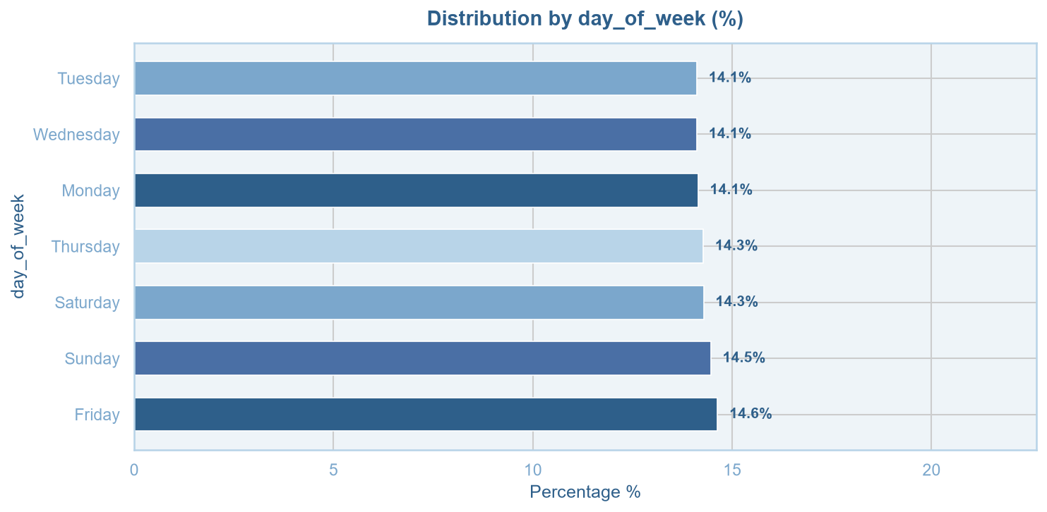
Figure 4.14: Frequency bar chart — percentage distribution by month.

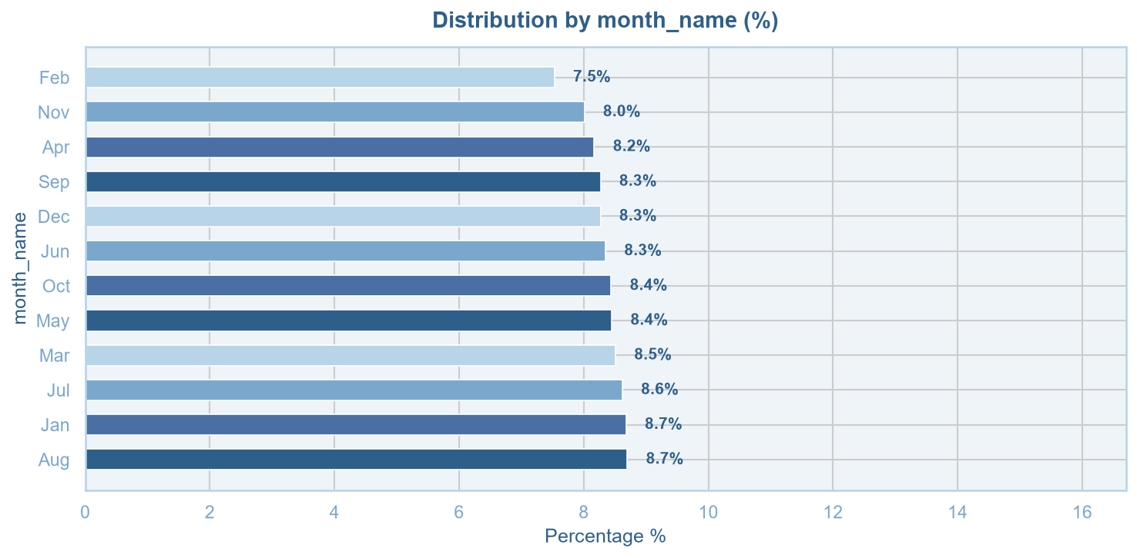
Figure 4.15: Frequency bar chart — percentage distribution by month (alternate view).

5. Bivariate Analysis

Bivariate analysis examines the relationship between pairs of variables to identify associations, patterns, and dependencies. The analysis was conducted using correlation heatmaps, scatter plots, box plots, mean bar plots, violin plots, and a pair plot — covering both numerical–numerical and numerical–categorical relationships.

5.1 Correlation Matrix
The Pearson correlation heatmap provides a comprehensive overview of linear relationships among all numerical variables. Key findings are summarised below:

Variable Pair | r | Interpretation
price ↔ discounted_price | 0.97 | Very strong — mathematically linked (derived variable)
discounted_price ↔ total_revenue | 0.73 | Strong positive — effective price drives revenue
price ↔ total_revenue | 0.71 | Strong positive — higher price = higher revenue
quantity_sold ↔ total_revenue | 0.59 | Moderate positive — volume contributes to revenue
discount_percent ↔ discounted_price | -0.20 | Weak negative — higher discount reduces effective price
discount_percent ↔ total_revenue | -0.14 | Weak negative — deeper discounts slightly erode revenue
rating ↔ any variable | ≈ 0.00 | No linear relationship
review_count ↔ any variable | ≈ 0.00 | No linear relationship

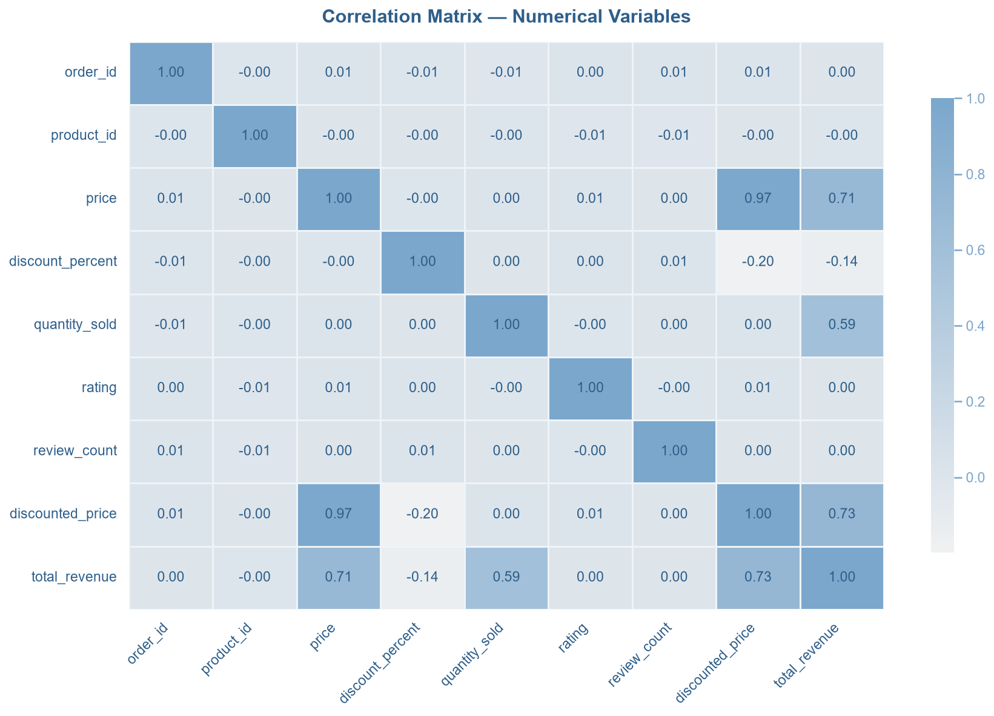
Figure 5.1: Correlation matrix heatmap — Pearson r for all numerical variables.

The near-perfect correlation between price and discounted_price (r = 0.97) is expected since the latter is mathematically derived from the former. Both price (r = 0.71) and discounted_price (r = 0.73) show strong positive correlations with total_revenue, establishing price as the primary revenue driver. quantity_sold contributes moderately (r = 0.59). discount_percent has a mild negative effect on revenue (r = -0.14), while rating and review_count show no meaningful linear relationship with any financial variable.

5.2 Scatter Plots — Numerical vs Numerical
Scatter plots with trend lines were used to examine directional relationships between key variable pairs:
- price vs total_revenue (r = 0.71): A fan-shaped positive relationship with distinct revenue bands for each quantity tier (1–5), revealing the multiplicative structure of revenue generation.
- quantity_sold vs total_revenue (r = 0.59): A step-wise positive pattern where revenue increases discretely with each additional unit sold.
- discount_percent vs total_revenue (r = -0.14): Vertical clusters at each discrete discount tier with a gently downward trend, indicating marginal revenue erosion at higher discounts.
- price vs rating (r = 0.01) and rating vs review_count (r = 0.00): Flat, diffuse scatters confirming statistical independence.

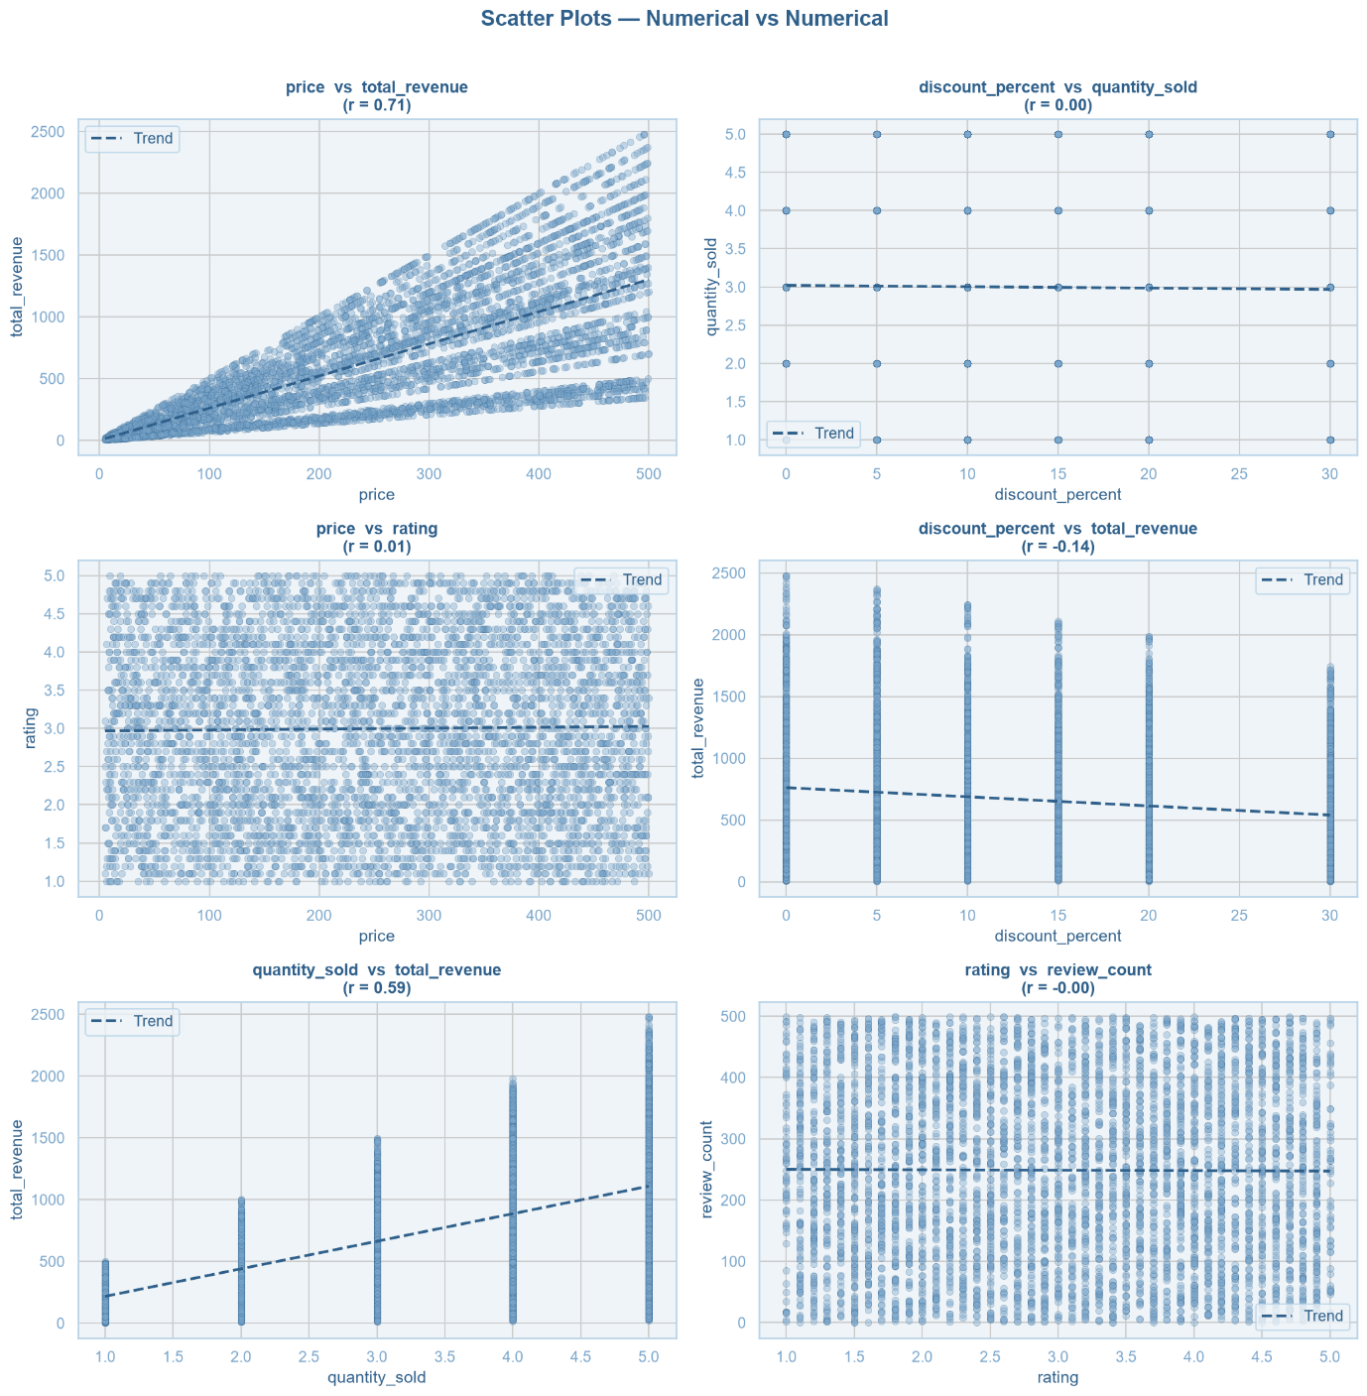
Figure 5.2: Scatter plots with trend lines for six key variable pairs.

5.3 Box Plots — Numerical vs Categorical
Box plots compared numerical variable distributions across categorical groups:
- Total Revenue by Product Category: Median revenues (~500) and IQRs are nearly identical across all six categories, with uniformly distributed high-value outliers.
- Rating by Product Category: Consistent median of 3.0 and identical IQR (~2.0–4.0) across all categories.
- Discount Percent by Category: Books and Fashion show higher median discounts (~15–20%), while Beauty and Electronics show lower medians (~10%).
- Total Revenue and Price by Region: Near-identical distributions across all four regions confirm the absence of geographic pricing differences.
- Rating by Payment Method: All five methods show identical median ratings of 3.0 — payment choice has no bearing on satisfaction.

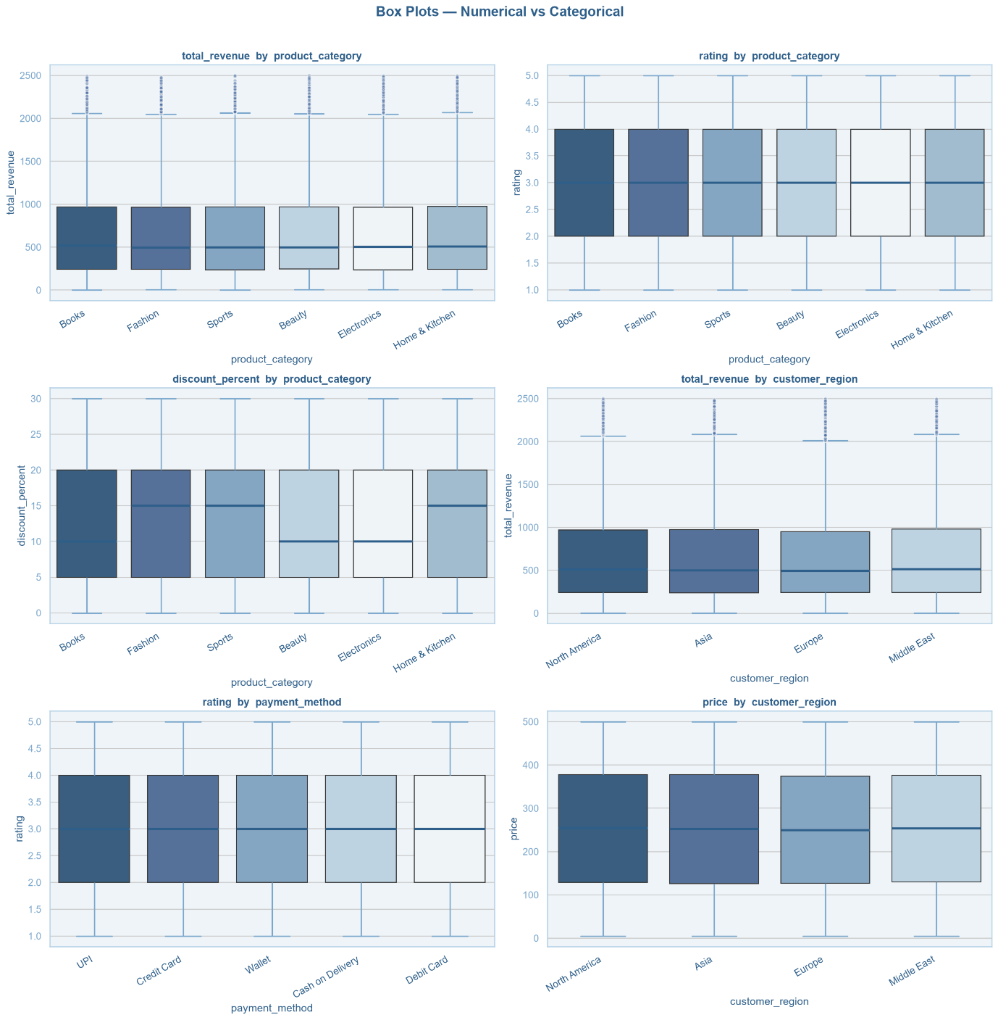
Figure 5.3: Box plots — numerical variables segmented by categorical variables.

5.4 Mean Bar Plots — Numerical by Category
Mean bar plots summarise average values across categorical groups:
- Mean total_revenue by product category: Home & Kitchen leads (662.8) and Sports is lowest (654.2) — a range of less than 9, indicating category-neutral performance.
- Mean rating by product category: All categories record an identical mean of 3.0.
- Mean quantity_sold by region: All four regions record an identical mean of 3.0 units.
- Mean total_revenue by region: Middle East (663.9) to Europe (651.5) — a difference of 12.4, which is negligible.
- Mean discount_percent by payment method: Ranges from 13.2% (UPI) to 13.4% (CoD) — a 0.2 percentage point spread.
- Mean total_revenue by payment method: Wallet (660.9) to UPI (652.9) — an 8-unit gap with no practical significance.

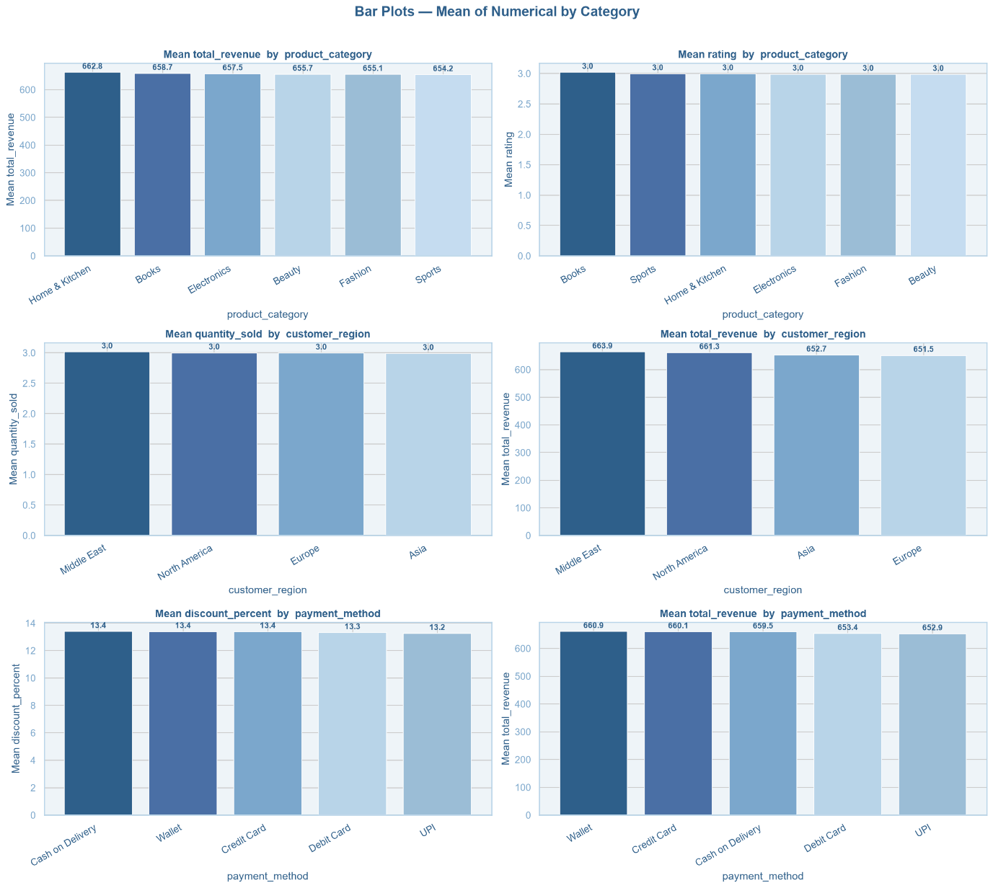
Figure 5.4: Mean bar plots — average values of key numerical variables by categorical groups.

5.5 Violin Plots — Distribution by Category
Violin plots reveal distributional shape and density across categories. Rating across all six product categories produces identical symmetric violin shapes centred at 3.0. Total revenue distributions across all four regions are similarly shaped — dense near 0–500 with long right tails toward 2,500. Price distributions across all five payment methods are uniformly wide, confirming price-independent payment preferences.

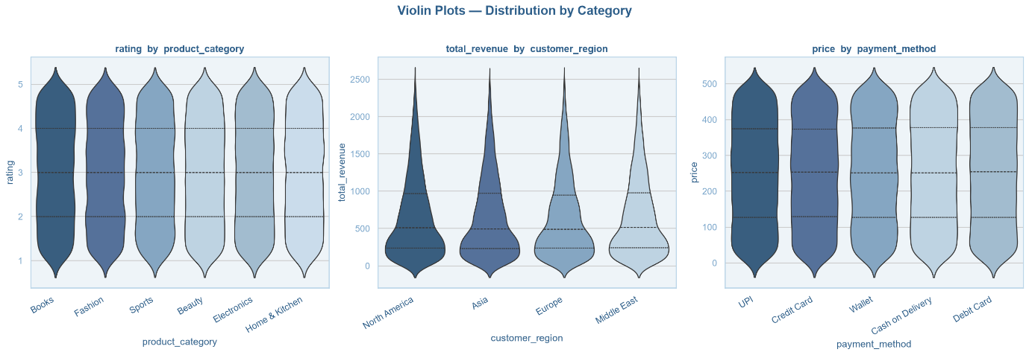
Figure 5.5: Violin plots — rating by product category, total revenue by region, price by payment method.

5.6 Pair Plot — Numerical Variables
The pair plot presents pairwise scatter plots and diagonal KDE distributions for five key numerical variables:
- price vs total_revenue: Strong fan-shaped positive relationship with distinct revenue bands per quantity tier.
- quantity_sold vs total_revenue: Clear horizontal step-bands confirming discrete multiplicative revenue contribution.
- Discount_percent and rating panels: Grid-like or diffuse clouds with flat trends across all pairings.
- Diagonal KDE plots: price — near-uniform; discount_percent — multi-modal; quantity_sold — five equidistant peaks; total_revenue — right-skewed; rating — approximately uniform.

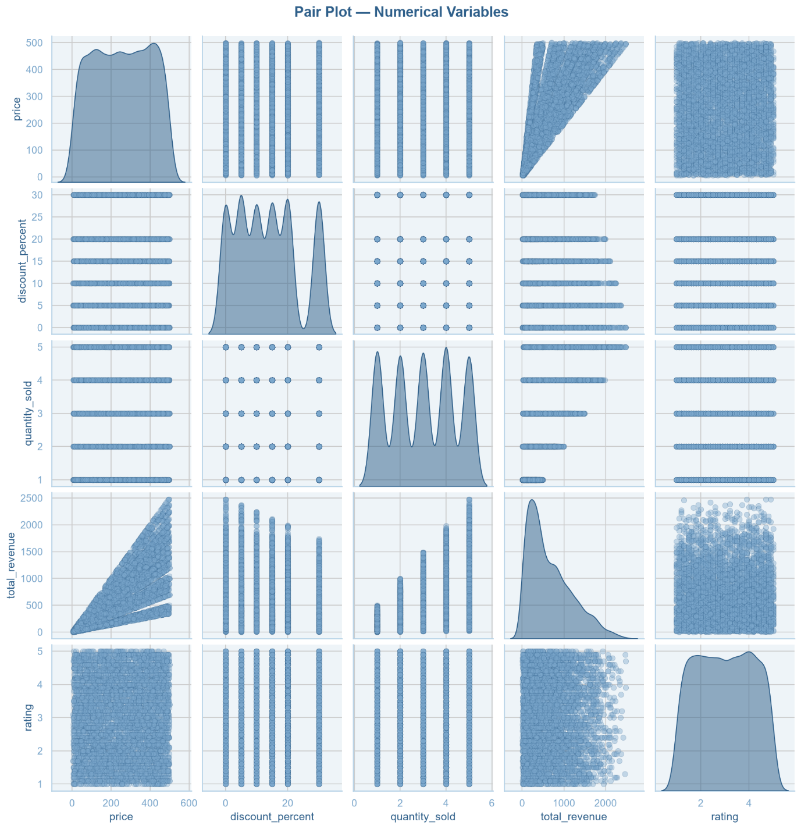
Figure 5.6: Pair plot — pairwise scatter plots and diagonal KDE for key numerical variables.

6. Key Findings and Conclusions

6.1 Summary of Findings

Univariate Analysis:
- Most numerical variables are symmetrically distributed (skewness ≈ 0). The primary exception is total_revenue (skewness = +0.98), which is positively skewed and contains high-value outliers.
- All categorical variables — product category, customer region, payment method, day of week, and month — are near-uniformly distributed, indicating a well-stratified dataset.
- discount_percent displays a discrete multi-modal distribution at standardised tiers (0%, 5%, 10%, 15%, 20%, 30%).

Bivariate Analysis:
- Price is the strongest driver of total revenue (r = 0.71), followed by quantity sold (r = 0.59). Both are statistically significant predictors.
- Discounted price and total revenue are strongly correlated (r = 0.73), confirming the post-discount effective price as a reliable revenue indicator.
- Discount percentage has a weak negative effect on revenue (r = -0.14), suggesting that discounts do not meaningfully compensate for the price reduction in revenue terms.
- Product category, customer region, and payment method show no meaningful differences in mean revenue, rating, or pricing — all group-level averages are statistically equivalent.
- Rating and review count are independent of all financial variables (r ≈ 0.00).

6.2 Conclusions
This exploratory data analysis of the Amazon sales dataset reveals a dataset that is highly balanced across all categorical dimensions and structurally clean across numerical variables. The two primary quantitative insights are: (1) product price is the dominant determinant of per-transaction revenue, and (2) quantity sold plays a meaningful secondary role. All categorical variables — region, product category, and payment method — exhibit negligible variation in their impact on sales outcomes. Future analysis could extend this work through regression modelling to quantify the combined effect of price and quantity on revenue, and through inferential statistical tests to formally assess whether the small observed group-level differences are statistically significant.

6.3 Limitations
- The near-perfect uniformity across all categorical variables suggests the dataset may be synthetically generated or deliberately stratified, which may limit the real-world generalisability of findings.
- The analysis is purely exploratory and does not establish causal relationships between variables.
- Temporal analysis is limited to order frequency; revenue trends over time were not examined in this phase.

