Jwt configuration
user.module.ts before install depandencies
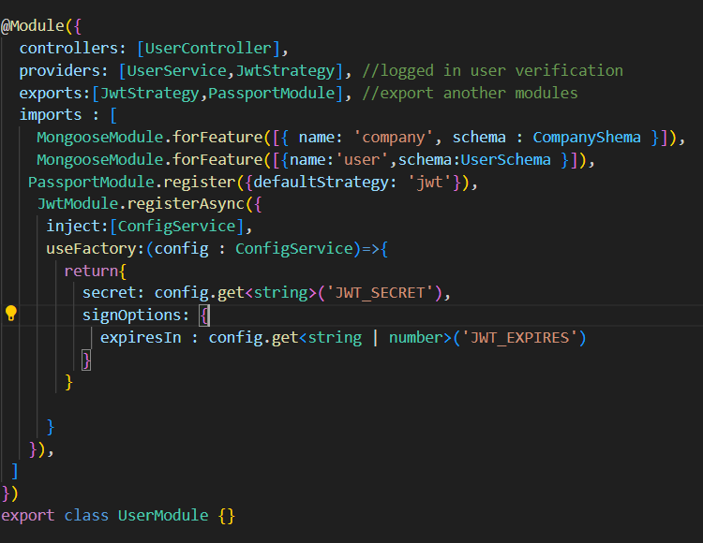

user.services.ts generate jwt token and pass
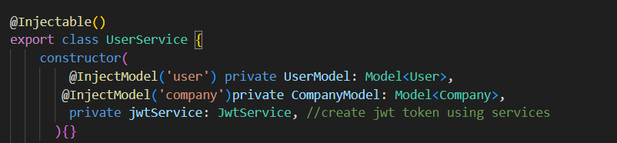
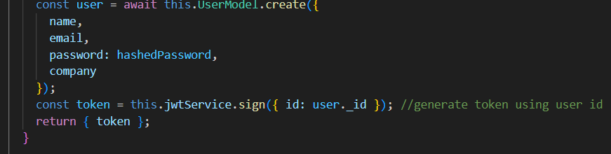
write inside method
login and signup jwt creation is completed and pass to the jwt to responseits completed to create jwt token then we take the token and use for logged in or not like use jwtStatagey use protect by controller see below and get it.
create jwtStrategy.ts using only logged in user access the routes

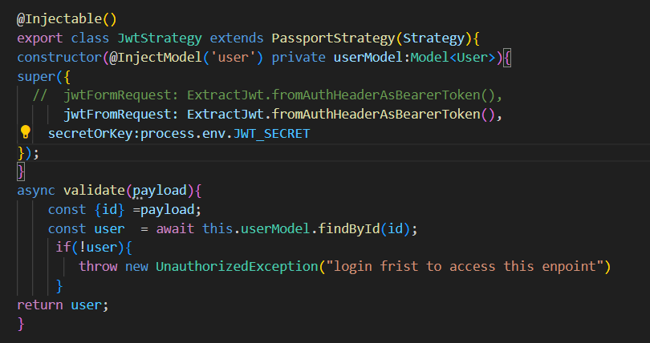

use jwtstrategy to verify user logged in or not using every controller endpoints
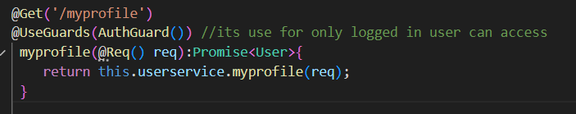

create protected routes using role based access
role.decator.ts and role.guards.ts we need to create

role.decotors.ts
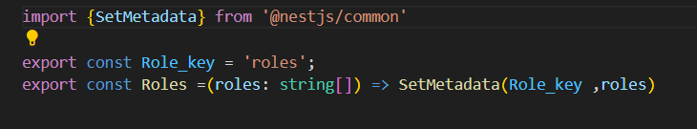

role.gurads.ts
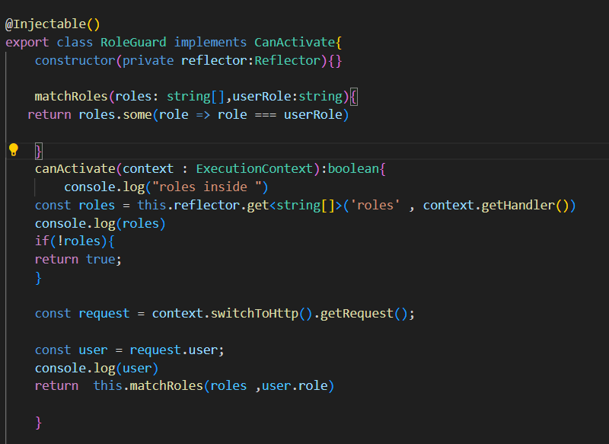

using controllers to use guards to access role based routes

