**SMART WATER MANAGEMENT**

**IoT_Phase5**

Reg no:610821106028

Name: GUNASEKAR.K

**INTRODUCTION**

Smart water management is a crucial and evolving concept in our increasingly water-stressed world. It encompasses a range of innovative technologies and strategies aimed at efficiently and sustainably managing our water resources. From monitoring and conservation to distribution and quality control, smart water management is driving the transformation of water systems to ensure a more resilient and environmentally responsible future. In this context, this introduction will explore the key components and benefits of smart water management, highlighting its significance in addressing global water challenges.

**Objectives:**

* To stop wastage of water due to overflow and leakage.
* To monitor real-time water consumption.
* To create public awareness.
* To enhance the sustainable resource management.

**Water Detection Algorithm:**

The algorithm detects the possible existence of a water leak considering four scenarios, for this it takes the input parameters:

* Device ID
* User ID
* Time T2
* Consumption In T2
* The Location
* Scenario A verifies if the consumption received has a negative value or the total consumption accumulated in the last 24 h has a negative trend; This could be due to failures in the smart meters when capturing consumption.
* Scenario B verifies if there is a continuous flow of water consumption in the last 24 h, since there was no consumption at any zero time, which is highly unlikely for normal consumption.
* Scenario C verifies if there is a high consumption outside its historical behavior.

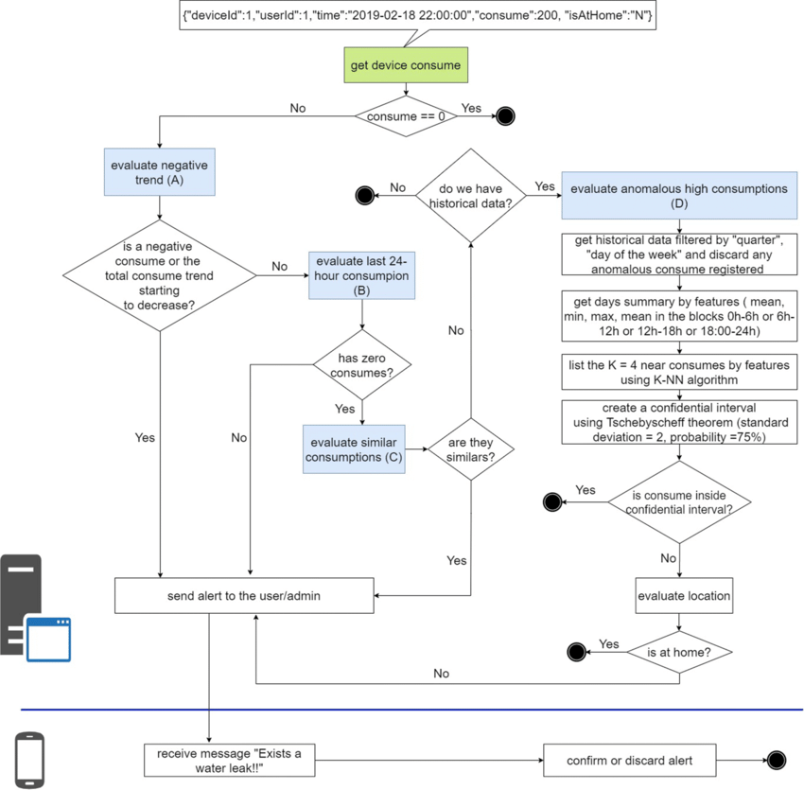

**IoT Device setup:**

The below figure shows the five main components of the system, which allow the collection, storage, analysis and visualization of water consumption.

**Code implementation:**

Python script on IoT sensors to send real-time water consumption data to the data-sharing platform.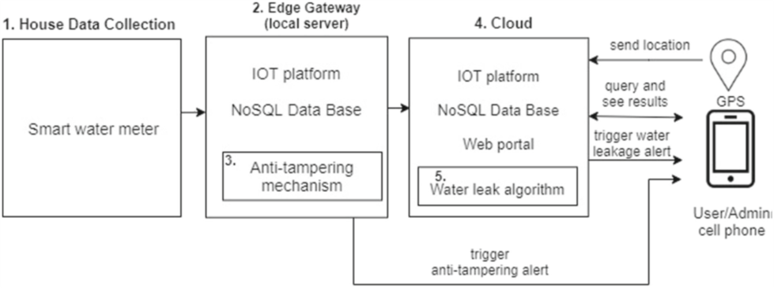

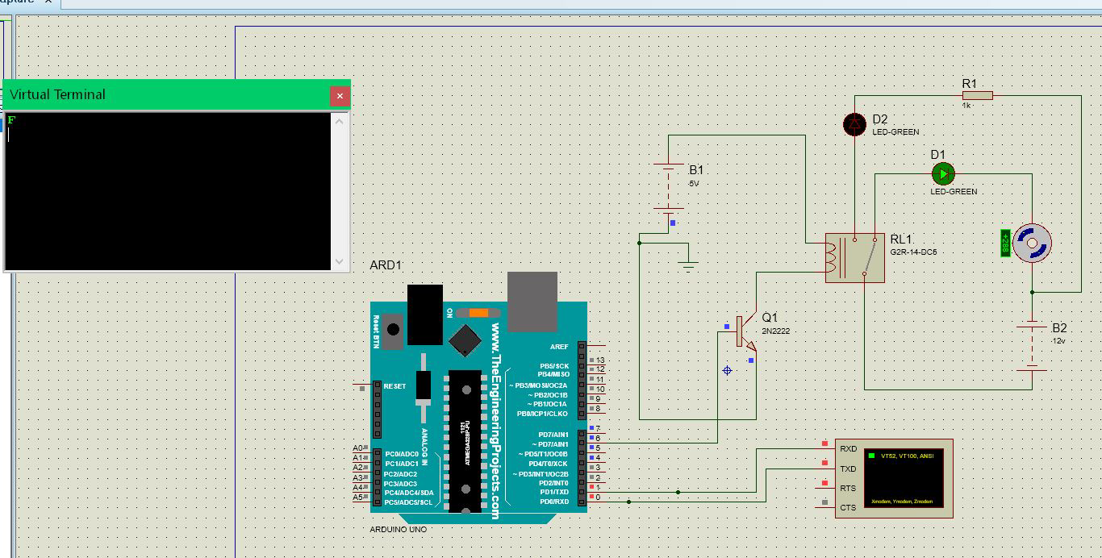

# Define MQTT parameters

broker_address = "your_broker_address"

port = 1883

topic = "water_consumption"

# Function to simulate water consumption data

def generate_water_data():

return {"timestamp": int(time.time()), "flow_rate": round(uniform(0.5, 5.0), 2)}

# Callback when the client connects to the broker

def on_connect(client, userdata, flags, rc):

print("Connected with result code "+str(rc))

client.subscribe(topic)

# Callback when a message is published to the topic

def on_publish(client, userdata, mid):

print("Message Published")

# Main script

client = mqtt.Client()

client.on_connect = on_connect

client.on_publish = on_publish

# Connect to the broker

client.connect(broker_address, port, 60)

try:

while True:

water_data = generate_water_data()

payload = json.dumps(water_data)

# Publish the data to the topic

client.publish(topic, payload)

time.sleep(10) # Adjust the interval based on your requirements

except KeyboardInterrupt:

print("Script terminated by user.")

client.disconnect()

**Data sharing platform:**

Designing the platform to display water consumption data from IoT sensors and promote water conservation efforts (using html, CSS and JS).

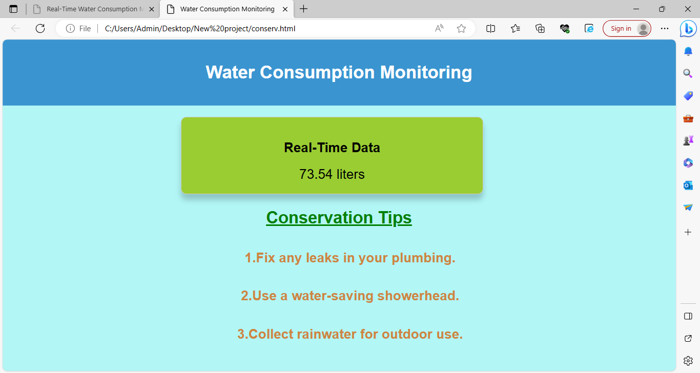

The webpage displays the real time data of water level based on the information given by the sensors.

**HTML:**

<!DOCTYPE html>

<html>

<head>

<title>Water Consumption Monitoring</title>

<link rel="stylesheet" type="text/css" href="style.css">

</head>

<body>

<header>

<h1>Water Consumption Monitoring</h1>

</header>

<main>

<div class="data-container">

<h2>Real-Time Data</h2>

<div class="water-consumption" id="water-consumption">

Loading...

</div>

</div>

<div class="conservation-tips">

<h2>Conservation Tips</h2>

<ul>

<li>Fix any leaks in your plumbing.</li>

<li>Use a water-saving showerhead.</li>

<li>Collect rainwater for outdoor use.</li>

</ul>

</div>

</main>

<script src="script.js"></script>

</body>

</html>

**CSS:**

body {

font-family: Arial, sans-serif;

margin: 0;

padding: 0;

}

header {

background-color: #3498db;

color: #fff;

text-align: center;

padding: 20px;

}

main {

text-align: center;

padding: 20px;

}

.data-container {

border: 1px solid #ccc;

padding: 20px;

border-radius: 5px;

box-shadow: 0 0 10px rgba(0, 0, 0, 0.2);

}

.water-consumption {

font-size: 24px;

}

.conservation-tips {

margin-top: 20px;

}

ul {

list-style-type: disc;

}

ul li {

margin: 10px 0;

}

**JavaScript:**

document.addEventListener("DOMContentLoaded", function () {

const consumptionElement = document.getElementById("water-consumption");

function updateWaterConsumption() {

const randomConsumption = (Math.random() * 100).toFixed(2);

consumptionElement.textContent = randomConsumption + " liters";

}

setInterval(updateWaterConsumption, 5000);

// Initial data load.

updateWaterConsumption();

});

Using the above frontend code I built the basic prototype of the data sharing platform.

**Benefits of the system :**

* Real-time water consumption analysis
* Reduced maintenance costs
* Predicting potential failures
* Remote monitoring
* Interactive reports
* Reduced risks
* Reducing leakage

**CONCLUSION**

In conclusion, smart water management is not just a solution for today's water challenges but a visionary approach that holds the promise of a more sustainable and secure future. By harnessing cutting-edge technologies, data-driven insights, and proactive strategies, we can ensure the efficient use of this precious resource, reduce waste, and mitigate the effects of water scarcity and pollution. As we continue to face pressing environmental and societal challenges, the adoption of smart water management practices becomes increasingly critical. It offers hope for a world where clean, accessible water is available to all while preserving the delicate balance of our ecosystems. Embracing smart water management is not only a choice but a responsibility, a commitment to safeguard our most essential resource for generations to come.