**PRACTICAL NO:6**

Date:-07/02/2025 Submission Date:- 14/02/2025

Write-up: -

· Replication

· Replication Architecture

· Replication benefits and limitations

Implement Replication

You are a database administrator for a company, and you need to set up a MongoDB replica set to ensure high availability and data redundancy. Perform the following tasks:

· Initialize a replica set with three nodes on different ports (27017, 27018, 27019).

· Check the status of the replica set.

· Add a new secondary node to the existing replica set.

· Simulate a failover scenario by stepping down the primary and observing the election of a new primary.

· Check replication status and read from a secondary node using readPreference

**A.First create a folder in c or d drive as name data**

**B.Then create 3 sub folder in it**

**1.primary**

**2.secondary1**

**3.secondary2**

**C.Then open a window powershell or cmd prompt**

**D.Then execute the code:**

**mongod --port=2717 --dbpath="D:\data\secondary1" --replSet="test-set"**

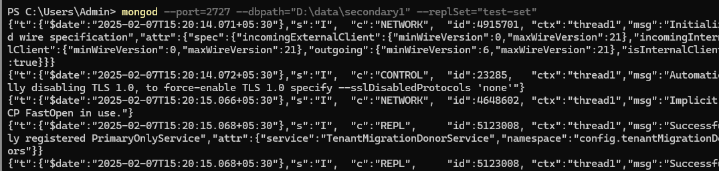

**mongod --port=2727 --dbpath="D:\data\secondary1" --replSet="test-set"**



**mongod --port=2737 --dbpath="D:\data\secondary2" --replSet="test-set"**

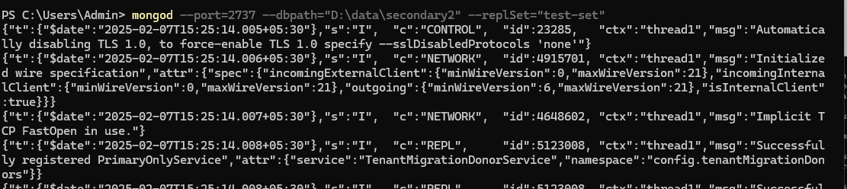

**After doing all this 3 command for open a new window shell for initializing**

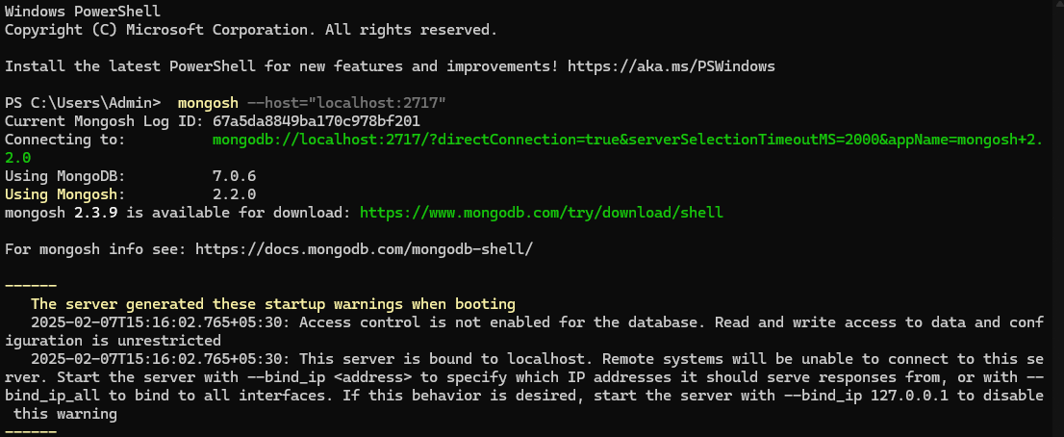

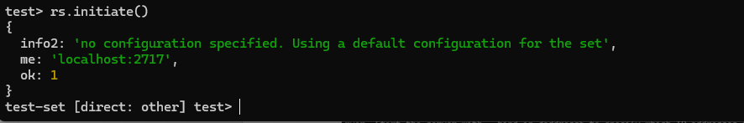

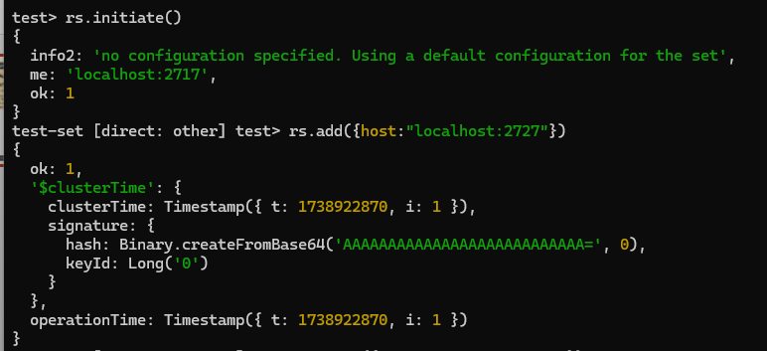

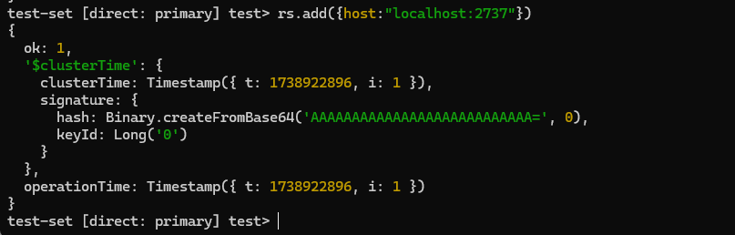

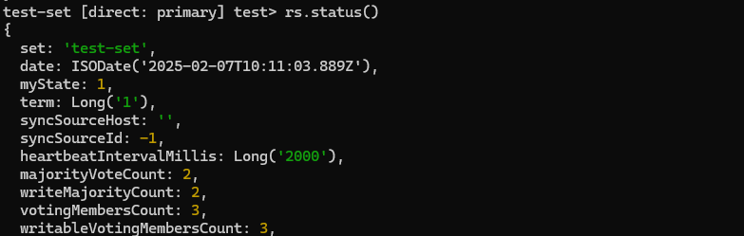

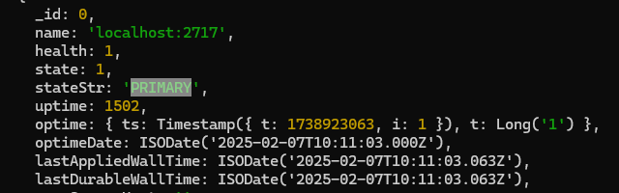

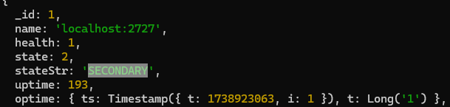

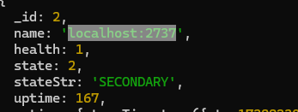

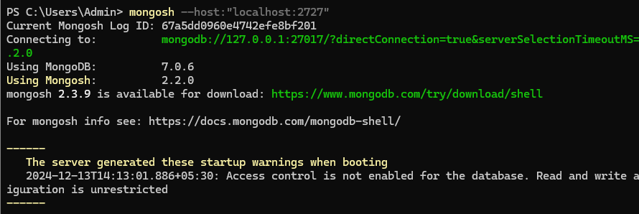

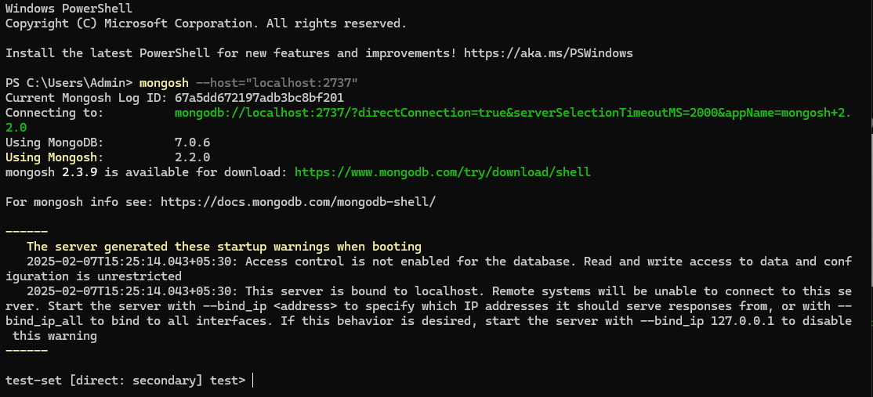

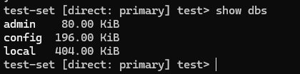

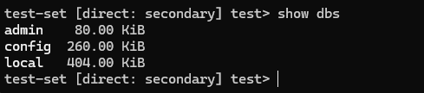

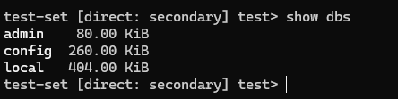



**Insert:**

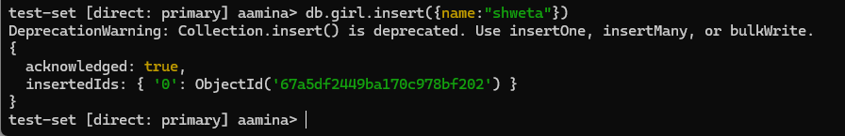

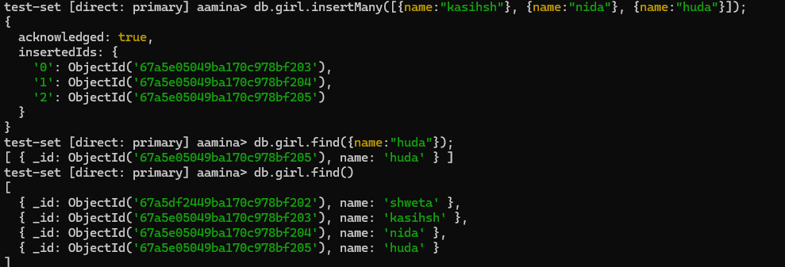

**Find:**



**Secondary folder is replicate the db of primary**

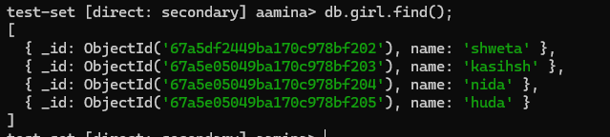

**Same as third folder**

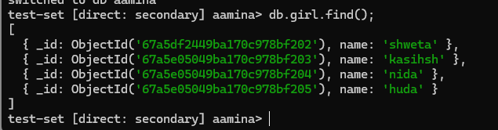

**Update:**

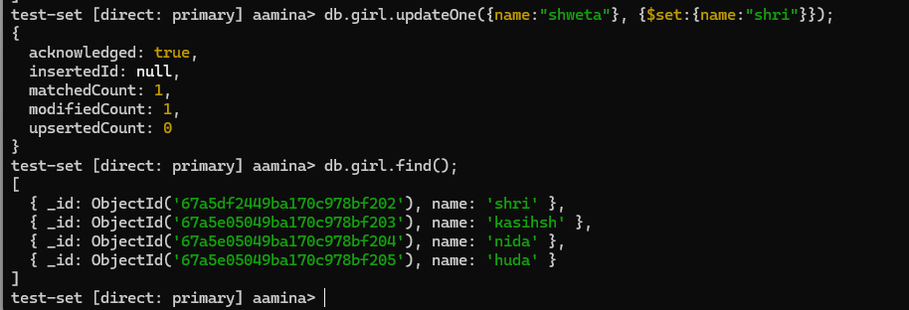

**Delete:**

