PRACTICAL NO:08

AIM: Database Backup and Restore

Date :07/03/2025 Submission date: 11/03/2025

Implement database backup and restore it(for prac 1 & 2)

<https://sqlbak.com/blog/how-to-backup-mysql-database-on-windows/>

step 1 : creating the tables

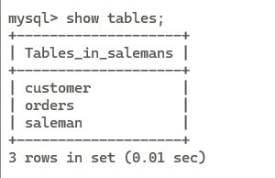

Step2 : entering the path of mysql server to bin to the environment vaaribale

"C:\Program Files (x86)\MySQL\MySQL Server 5.1\bin

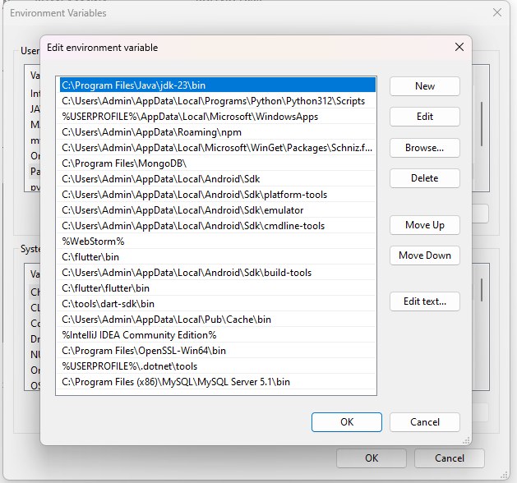

Step 3: open the cmd the paste the path and change the directory

cd "C:\Program Files (x86)\MySQL\MySQL Server 5.1\bin"

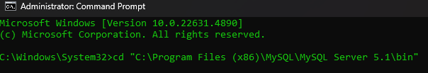

To create a backup of all MySQL server databases, run the following command:

mysqldump --user root --password --all-databases > all-databases.sql

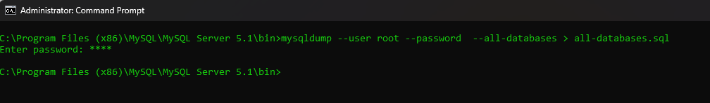

To recover data, use the following command:

mysql --user root --password mysql < all-databases.sql



Often you need to backup not the entire server, but a specific database. To dump a specific database, use the name of the database instead of the –all-database parameter.

mysql --user root --password db < all-databases.sql

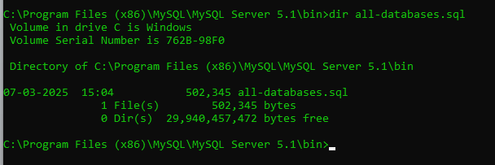

Backup files

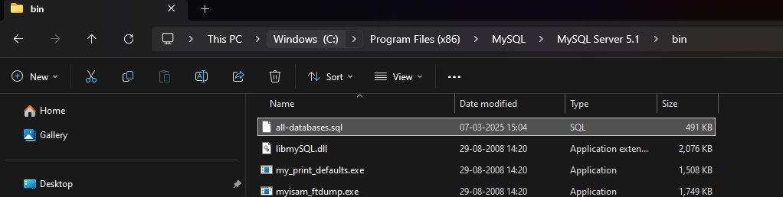

Restore data of the files

