**ORDS INSTALLATION**

**SQL-Developer App Installation:**

* Now, we need to install SQL developer from Oracle Software Delivery site as below,

1. Go to the link below,

Link: <https://www.oracle.com/database/sqldeveloper/technologies/download/>

1. Download “windows 64-bit With JDK 11 included”

1. After that a Zip file will download. Now unzip the file and install SQL developer.

**Install ORDS Software:**

* Connect to the Database server and switch to oracle user.
* Create a directory like “ords”

$ mkdir -p /home/oracle/ords/ords-config

$ cd ords/

* Now download the ORDS zip file using wget command

$ wget <https://download.oracle.com/otnsoftware/java/ords/ords-23.1.0.086.1423.zip>

$ unzip ords-23.1.0.086.1423.zip

* Now install ords using ords.war file

$ java -jar ords.war --config /home/oracle/ords/ords-config/ install

* After that command You will be prompted like below,

|  |
| --- |
| The configuration folder /home/oracle/ords/ords-config does not contain any configuration files.  Oracle REST Data Services - Interactive Install  Enter a number to select the type of installation  [1] Install or upgrade ORDS in the database only  [2] Create or update a database pool and install/upgrade ORDS in the database  [3] Create or update a database pool only  **Choose [2]:**  Enter a number to select the database connection type to use  [1] Basic (host name, port, service name)  [2] TNS (TNS alias, TNS directory)  [3] Custom database URL  **Choose [1]:**  Enter the database host name [localhost]: <Hostname>  Enter the database listen port [1521]: <Port>  Enter the database service name [cdb1]: <SID or Service name>  Provide database username with administrator privileges.  Enter the administrator username: sys  Enter the database password for SYS AS SYSDBA: <sys Password>  Connecting to database user: SYS AS SYSDBA url: jdbc:oracle:thin:@//localhost:1521/cdb1  Retrieving information.  Enter the default tablespace for ORDS_METADATA and ORDS_PUBLIC_USER [SYSAUX]:  <go with default>  Enter the temporary tablespace for ORDS_METADATA and ORDS_PUBLIC_USER [TEMP]:  <go with default>  Enter a number to select additional feature(s) to enable:  [1] Database Actions (Enables all features)  [2] REST Enabled SQL and Database API  [3] REST Enabled SQL  [4] Database API  [5] None  **Choose [1]:**  Enter a number to configure and start ORDS in standalone mode  [1] Configure and start ORDS in standalone mode  [2] Skip  **Choose [1]:**  Enter a number to select the protocol  [1] HTTP  [2] HTTPS  **Choose [1]:**  Enter the HTTP port [8080]: **<go with default>** |

* If ORDS installed successfully, at the end you can see as below,

* Now run the following command

$ **nohup java -jar ords.war --config /home/oracle/ords/ords-config/ serve &**

* Now connect to the database and create a user like “CONVERTRITE”

**Command**: **CREATE USER <Username> IDENTIFIED BY <PASSWORD>;**

* **Proxy Permissions**: Verify that the user has been granted proxy privileges to “testuser”. Run the following command to grant proxy permissions:

**ALTER USER <proxy_user> GRANT CONNECT THROUGH <Username>;**

* Now Give the privileges to User by running the SQL script which is available at /home/oracle/ords/scripts/installer/ords_installer_privileges.sql

Picture for your reference.

**Enable ORDS for a Schema :**

* Now open sql developer application on your windows system and connect 12c Database.

* Right-click on the connection and select the "REST Services > Enable REST Services..." menu option.

* Check the "Enable schema" checkbox and alter the schema alias if you don't want to expose the schema name in the URL. In this case we will ignore authorization. Click the "Next >" button.

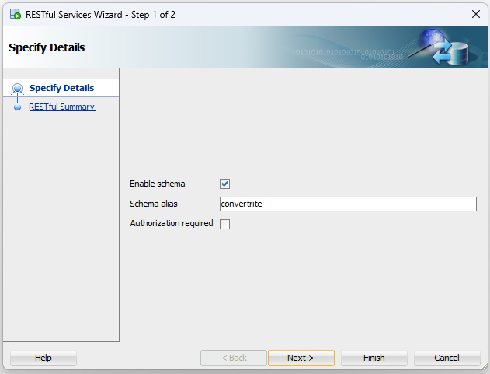

* If you want to see the code that will run to enable ORDS for the schema, click the "SQL" tab.

* Click on “finish” and Click the "OK" button.

* Now try to hit the following URL : http://**<Server ip>**:8080/ords/sql-developer/

It will show as below,

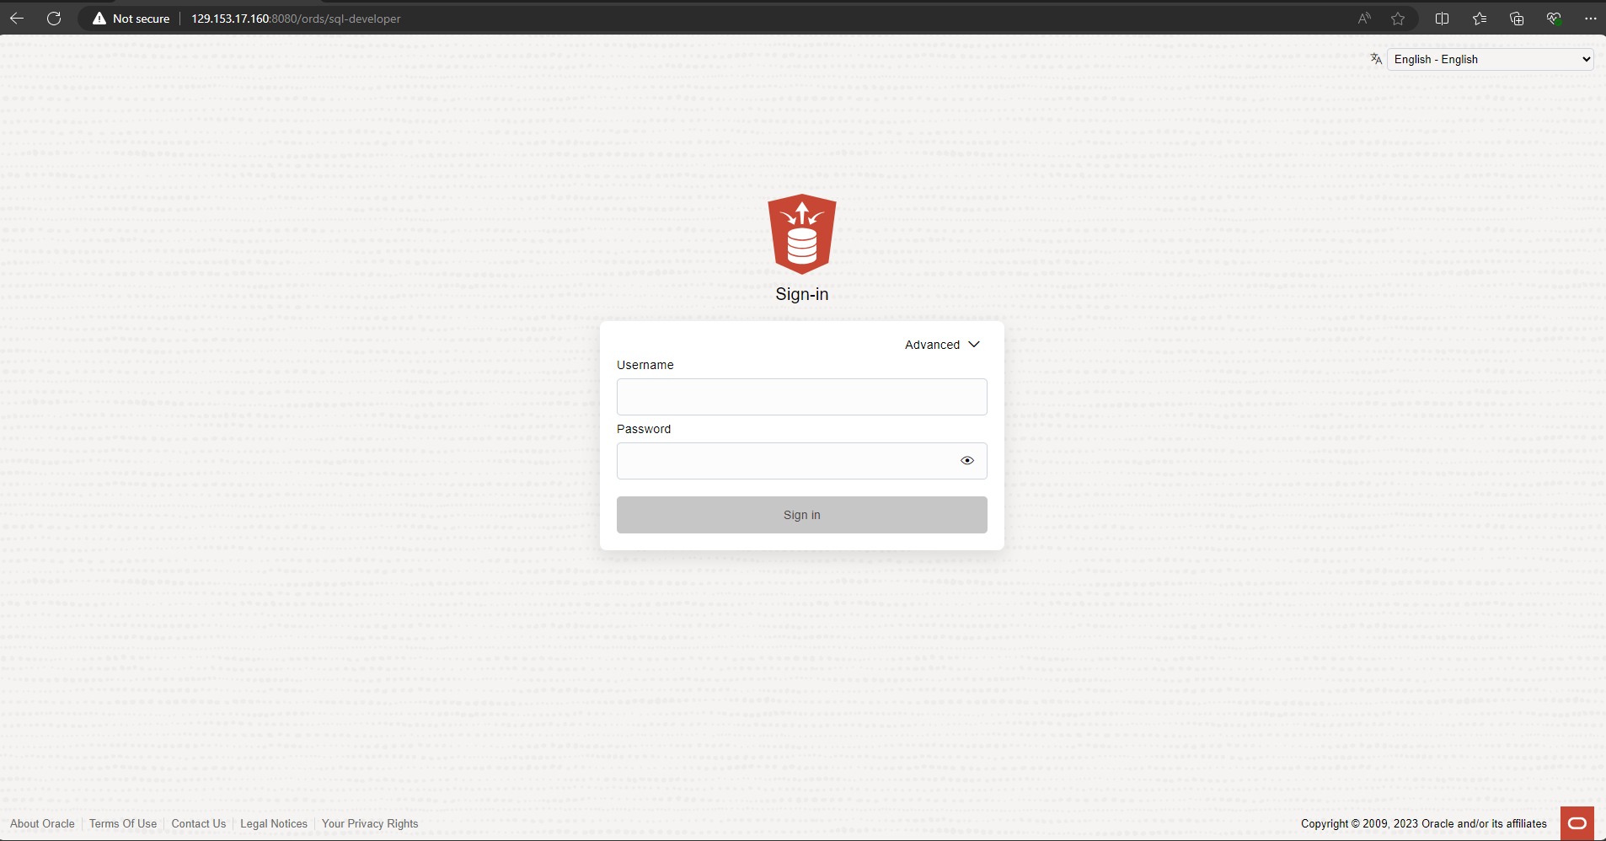

* Once you logged in successfully the Dashboard screen will be like as below,

