This repo consists of terraform code to launch an ec2 server ,vpc, security groups along with RDS Mysql DataBase Instance.

Prerequsites

An AWS Account

1.IAM Access/Root Access

2.Access key

3.Secret Access key

EC2 Server Specifications

1. OS: Ububtu 20.04

2. Instance Type - t2.micro

3. Security Groups

   Inbound rules  22 for ssh and 80 for http

   outbound rules - all

4. VPC Creation

5. two subnets for database availabity

6. Availability Zones  - us-east-1a, us-east-1b

7. Route table for traffic routing

8. Internet gateway for internet access to ec2 server

9. Apache Tomcat Installed

DB server Specification

1.Instance type : db.t3.micro

2. storage : 20gb

3. Security groups : 3306 port allowed from server ip

4. username and password for database

We will use three files for setting up above infrastructure.

1. Main.tf

first we will initialize terrraform using this file

this file consists of all the resources that are being created

2.variables.tf

we will pass sensitive and dynamic data for resources using this file, so that we can use same code multiple times just by changing the variable values.

3.outputs.tf

we can view the id's of resources that are being generated  ex (server ip). instead of going to cloud console, we can get the required details using this file.

Steps to deploy Infrastructure:

1. Terraform init : this will initialize the terraform

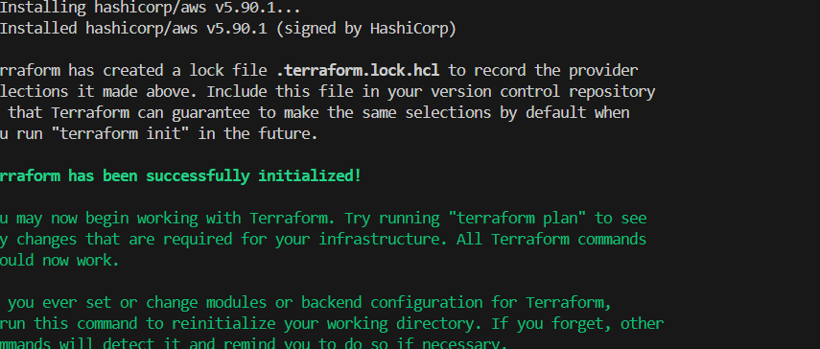

2. Terraform plan : this command will checks the file for any  code errors and shows the resources that will be created.

3.Terraform apply: this command will create resources but we need to type "yes", then only resources will be generated.

we can see the output after deployment of infrastructure is completed.

We Can see in the cloud also that resouces are created

login to the ec2-instance.

NOTE:  Don't forget to cleanup the resources after work is completed, because it costs heavily.

