GIT

1. create a directory gitex1: mkdir gitex1

cd gitex1/

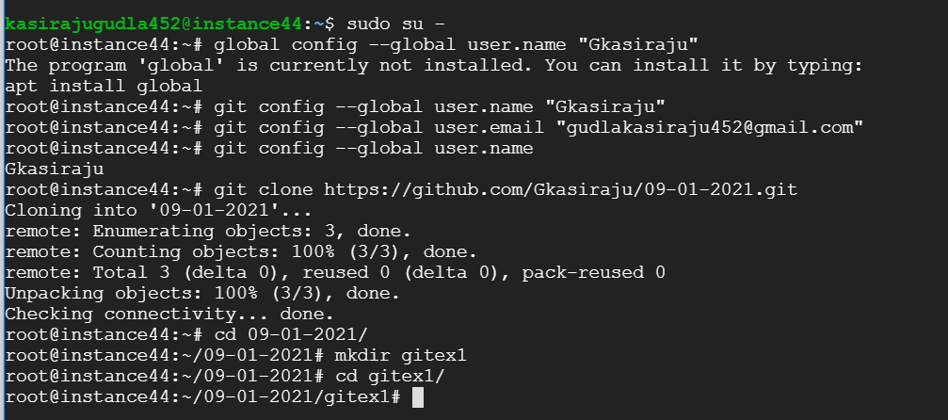

1. create the following files.

file1.txt, file2.txt

Commands: touch file1.txt

Touch file2.txt



1. commit both the files with a commit message "initial Commit"

git commit –m “initial meassage”

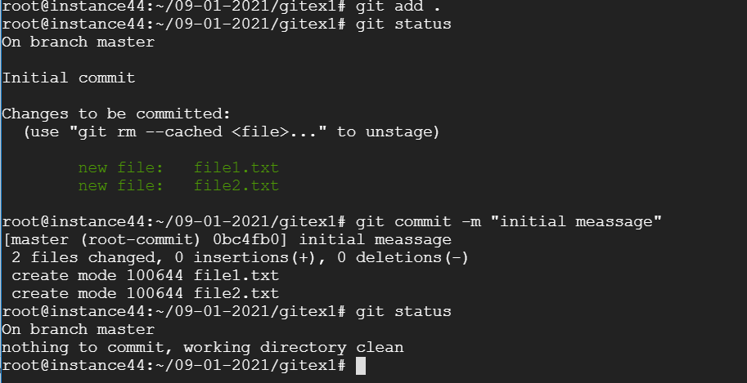

1. The above commit message needs to changed to "Initial Commit for file1.txt file2.txt"

git commit – amenda

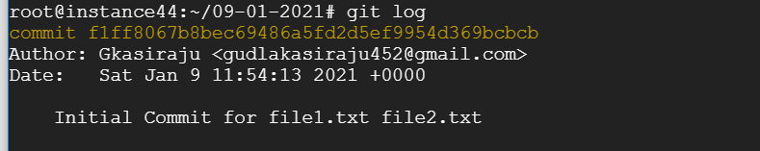

1. check the status of your commits

git status

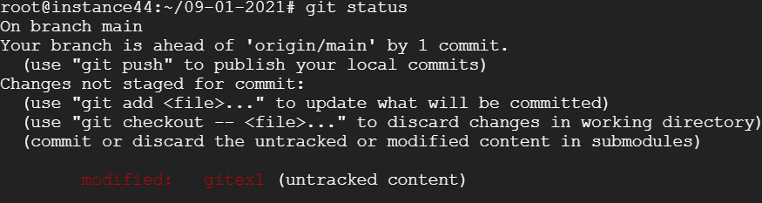

1. I forgot to add a file named file3.txt as part of last commit

Touch file3.txt

Git add file3.txt

Git commit –m “last commit”

Git status

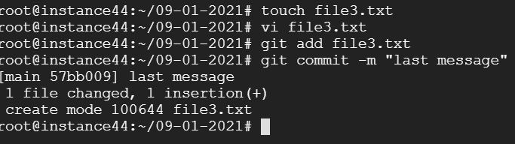

1. Add file4.txt to staging

Touch file4.txt

Git add file4.txt

Git status

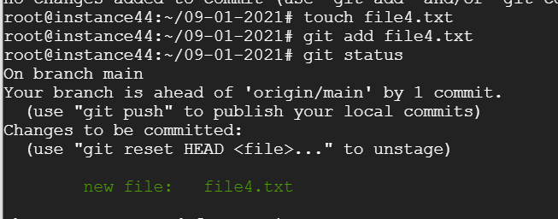

1. revert the above file4.txt from staging

git rm --cached file4.txt

git status

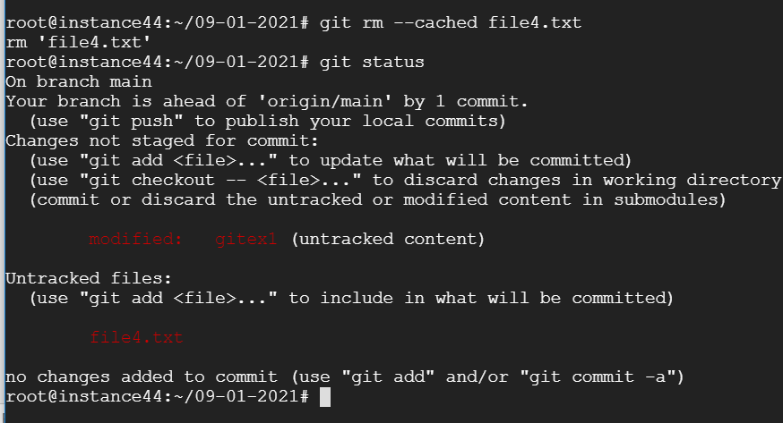

1. Again Add file4.txt to staging and commit

Git add .

Git commit –m “file4 is added”

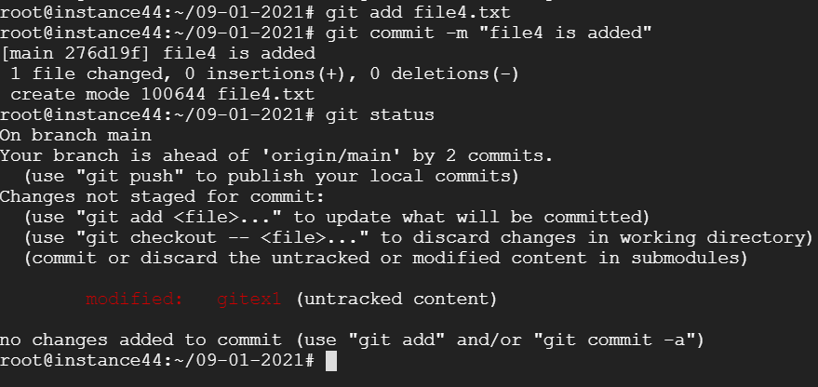

1. Now undo the commit and remove the file4.txt

git reset –soft HEAD ~1

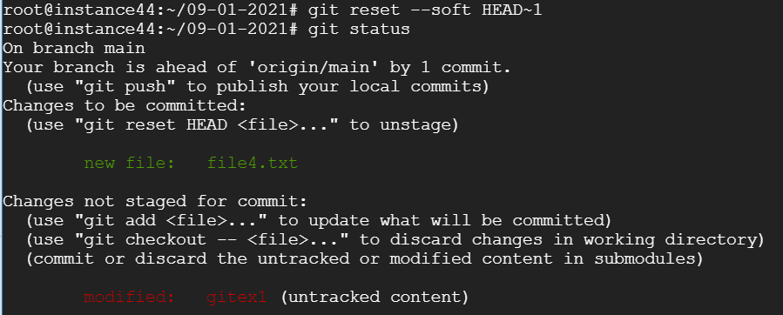

git rm –cached file4.txt

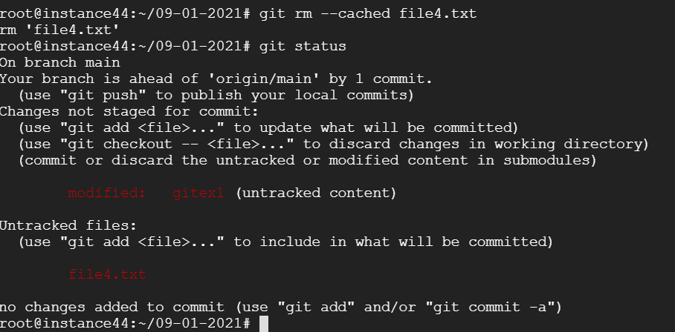

1. create a file5.txt and temporary save the same

touch file5.txt



1. create a branch br1

git checkout –b br1

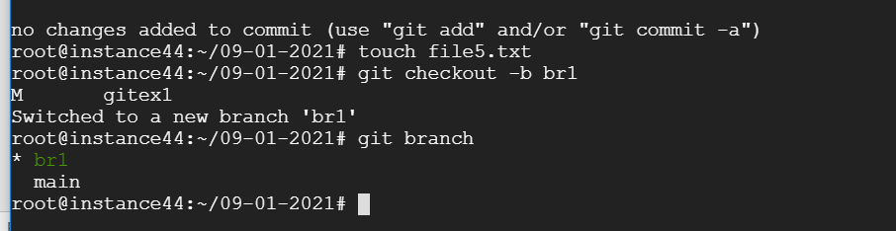

1. rename the branch to future_branch1

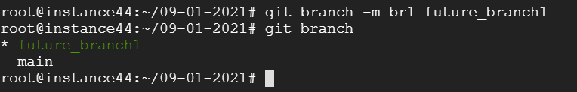

1. make some changes to file1.txt and commit

vi file1.txt

git add .

git commit –m “changes are done in future branch”

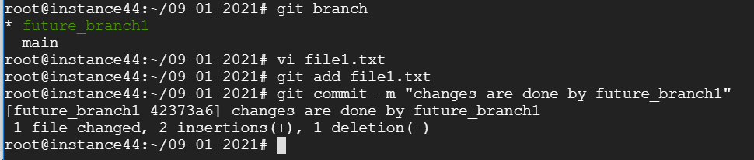

1. create branch hotfix_branch

git checkout –b hotfix_branch

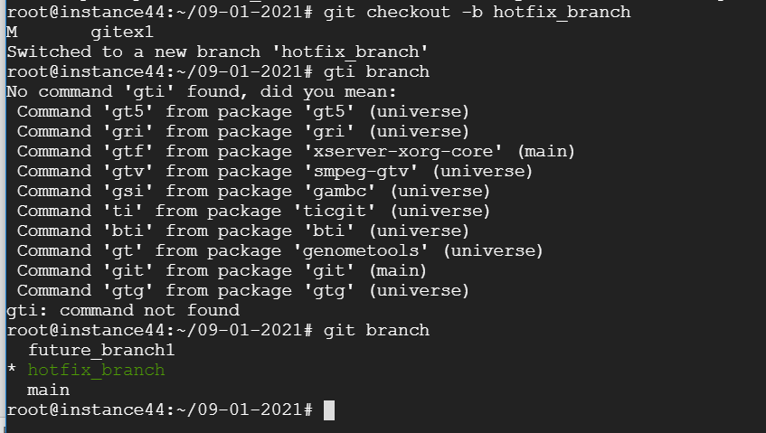

1. modify file1.txt and commit

vi file1.txt

git add .

git commit –m “changes are done in hotfix_branch branch”

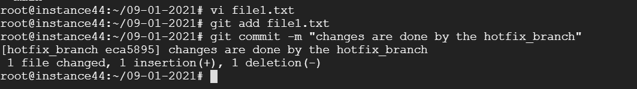

1. merge both future_branch1 and hotfix_branch

git checkout master

git merge future_branch1 hotfix_branch

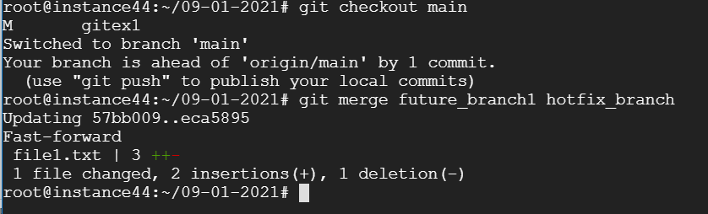

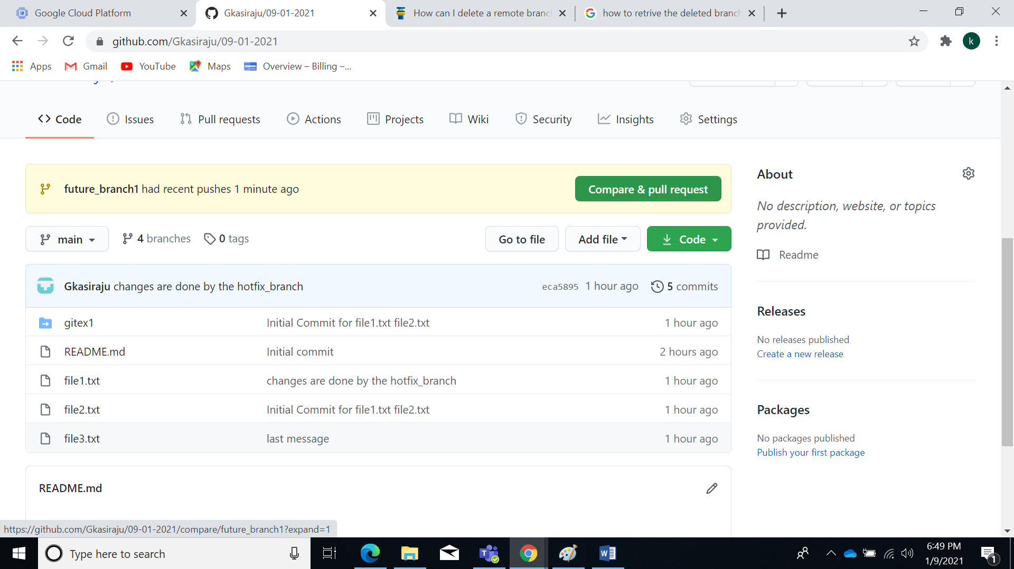

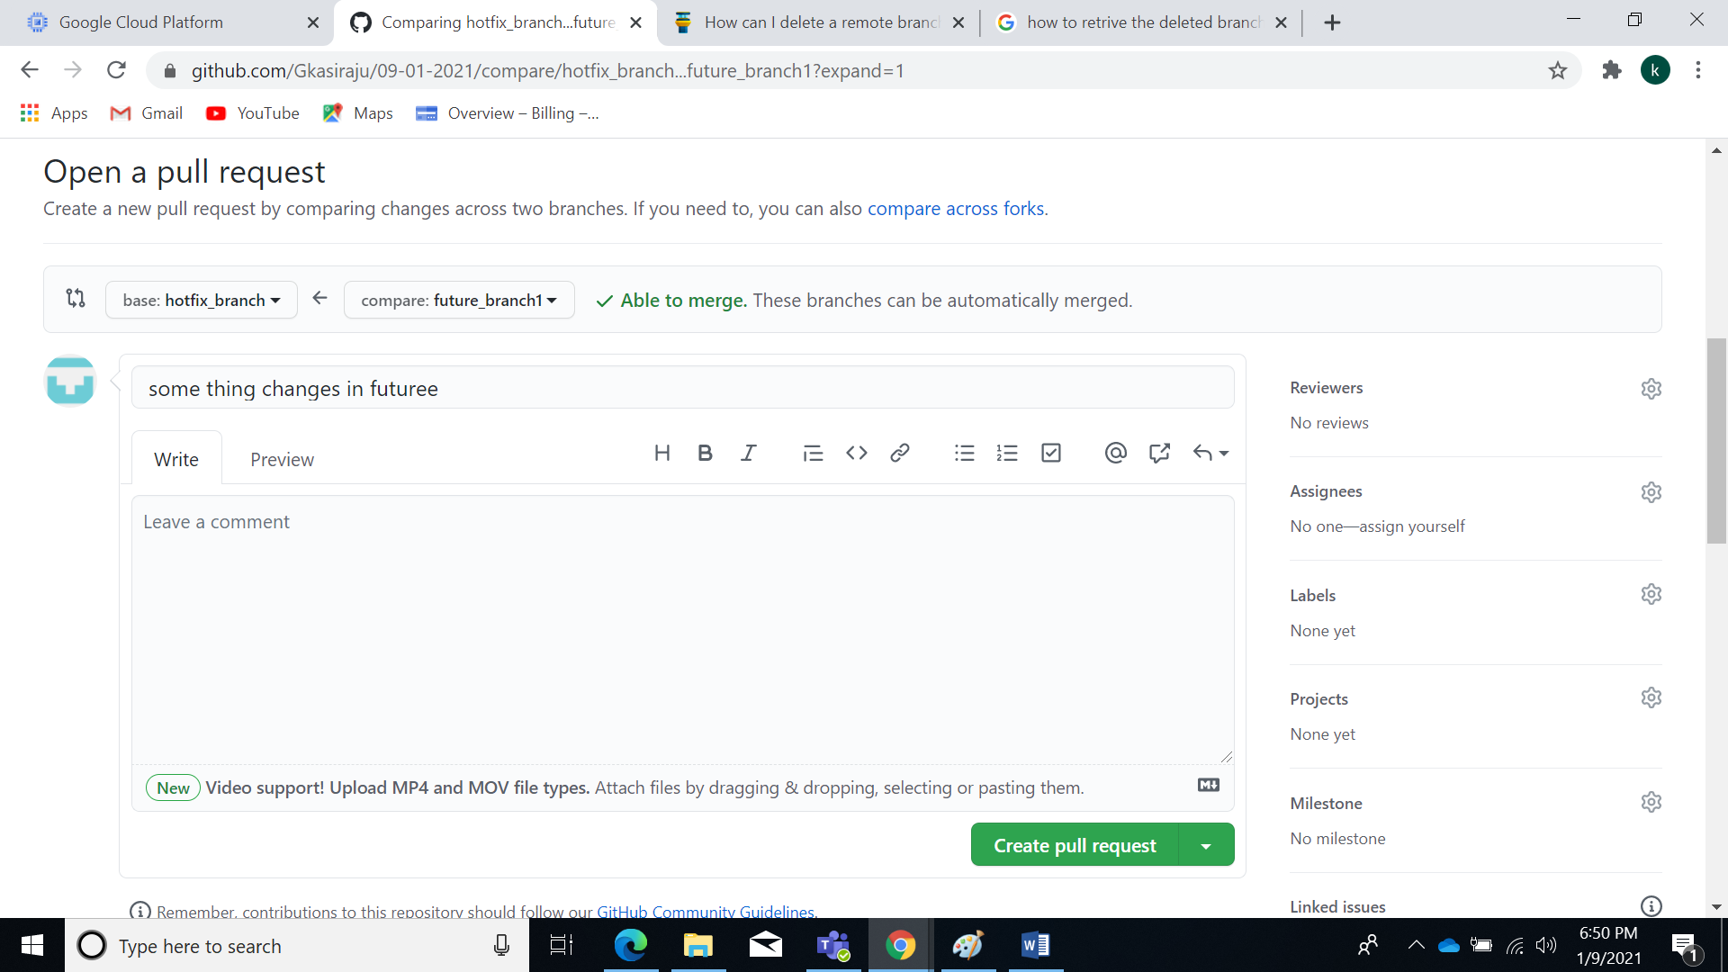

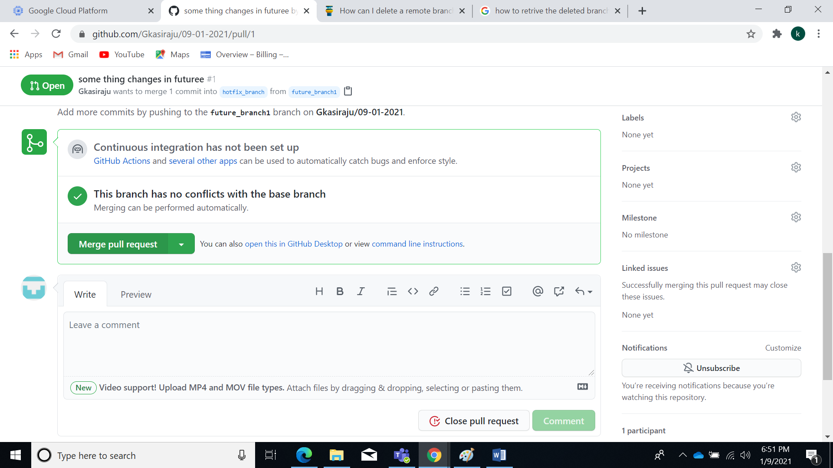

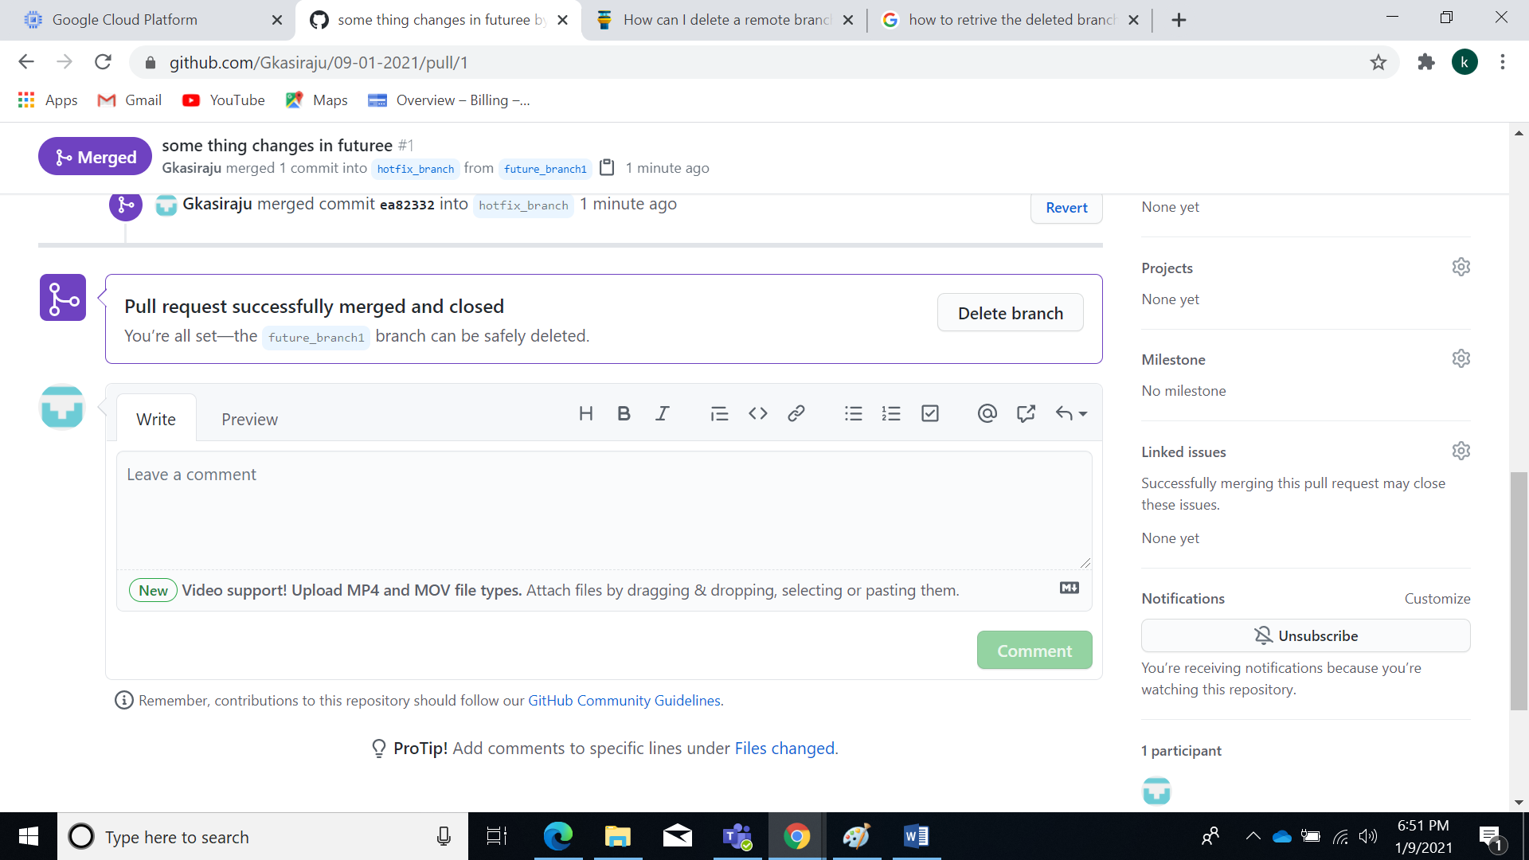

1. Resolve any merge conficts
2. connect to remote repo and push the changes to remote repo

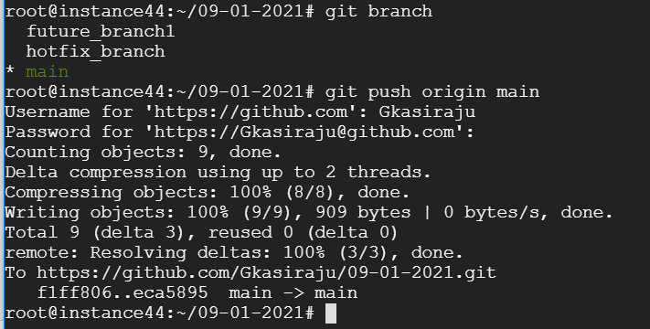

20) delete the remote branch future_branch1



New merge conflicts:

Mkdir gitex1

Cd gitex1/

Git init

Echo “this is first line”>merge.txt

Git add merge.txt

Git commit –m initial commit

Git checkout –b new_branch

Echo “some thing changes happen”>merge.txt

Git add merge.txt

Git commit –m “changes done by new_branch”

Git checkout master

Echo “second time changes”>>merge.txt

Git add merge.txt

Git commit –m second commit

Git merge

Git status

Cat merge.txt

