Note:

**-m** is the module and **-a** should contain the command it should run which goes as an argument to command and shell.

1. Validate the connection between ansible control machine and host using ansible ping module

ansible all -m ping

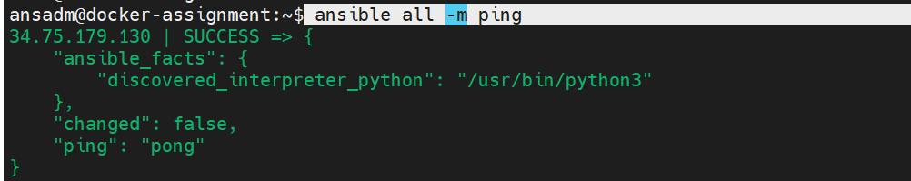

2.Get the uptime of remote hosts using ansible ad hoc command

ansible all -m shell -a "uptime"



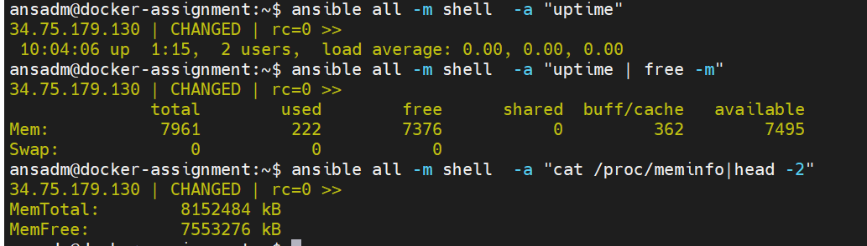

3.How to check the free memory or memory usage of  hosts using ansible ad hoc command

the free -m command on the remote hosts and collecting the information

ansible all -m shell -a "uptime | free -m"

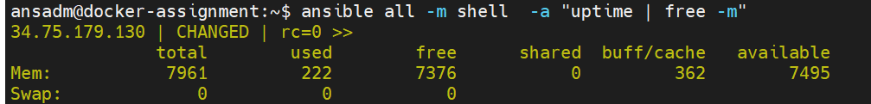

4.ansible ad hoc command to get physical memory allocated to the host

ansible all -m shell -a "cat /proc/meminfo|head -2"



5.ansible ad hoc command Execute a command as root user (sudo) on host

**-b** is the option for become and by default it will become root user

–**K**is to tell ansible to ask for SUDO password

ansible all -m shell -a "cat /etc/passwd|grep -i ansadm" --ask-become-pass

6.ansible ad hoc command to Execute a command as a different user  (sudo su)

ansible all -m file -a "path=/tmp/oracle/binaries state=directory mode=0755" -b --become-user=ansadm

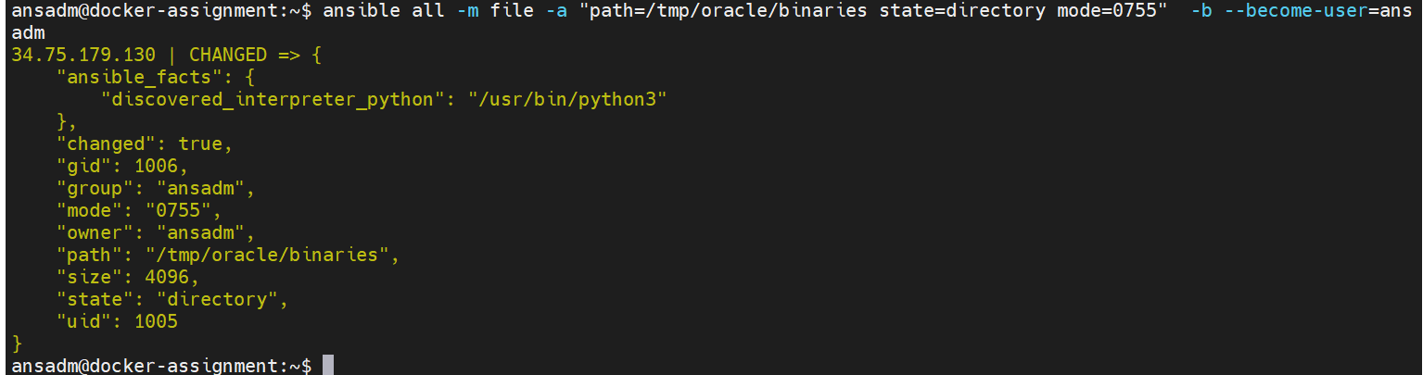

7.Create a unix user group with ansible ad hoc command

ansible all -m group -a "name=ansadm state=present"

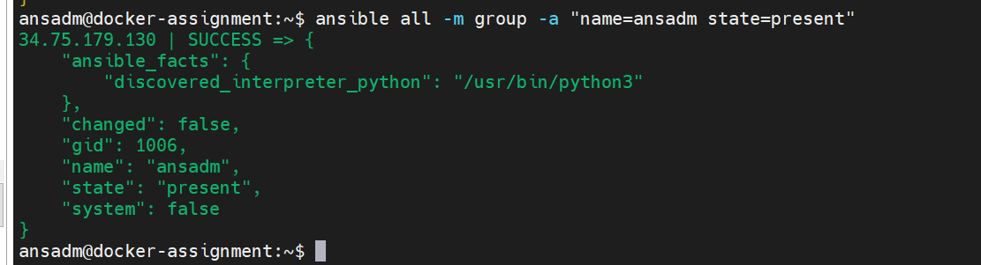

8.Create a unix user with ansible ad hoc command

ansible all -m user -a "name=ansadm group=ansadm createhome=yes" --ask-pass

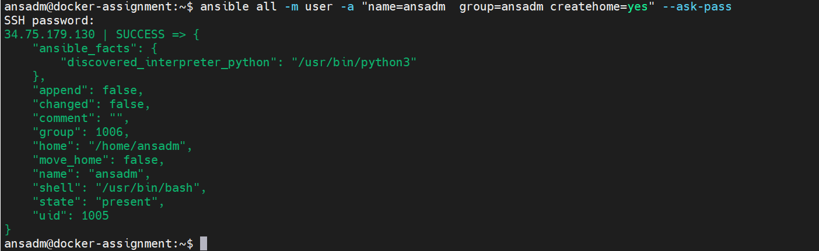

9.Create a Directory with 755 permission using ansible ad hoc command

ansible all -m file -a "path=/tmp/oracle state=directory mode=0755" --ask-pass

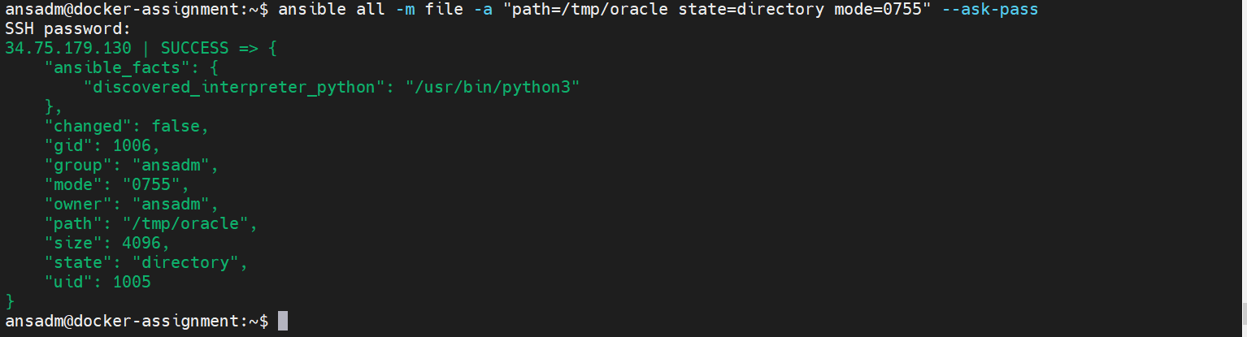

10.Create a file with 755 permission using ansible ad hoc commands

ansible all -m file -a "path=/tmp/testfile state=touch mode=0755"

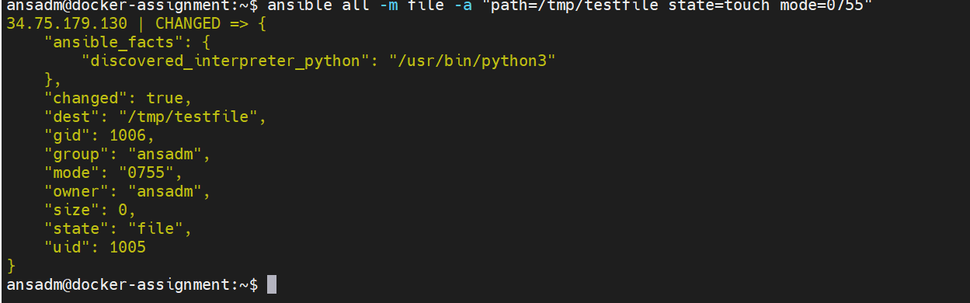

11.Change ownership of a file using ansible ad hoc command

ansible all -m file -a "path=/tmp/oracle group=ansadm owner=ansadm" --ask-pass

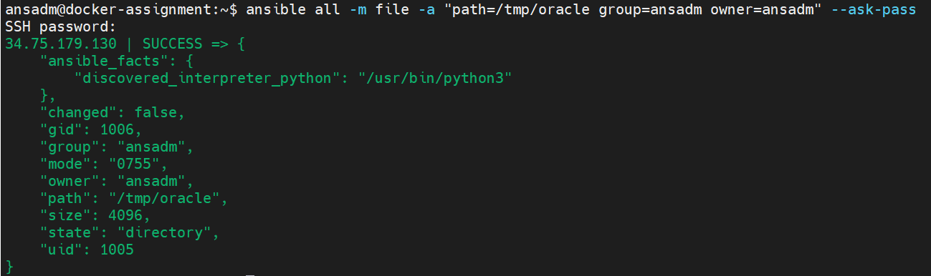

12.how to check free disk space of hosts using ansible ad hoc commands

ansible all -a "df -h"

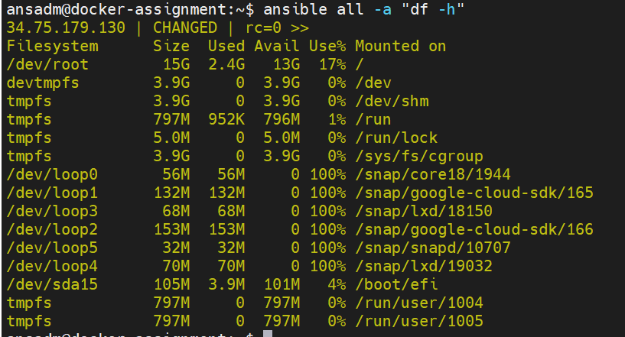

13.ad hoc command to Install a package using yum command

ansible multi -s -m yum -a "name=httpd state=installed"

14.ad hoc command to Start or stop the service

ansible multi -s -m service -a "name=httod state=started enabled=yes"

15.Install and configure python Django application server with ansible ad hoc commands

16.Managing Cron Job and Scheduling with Ansible ad hoc

ansible all -m cron -a "name='daily-cron-all-servers' minute=*/15  
job='/path/to/minute-script.sh'"

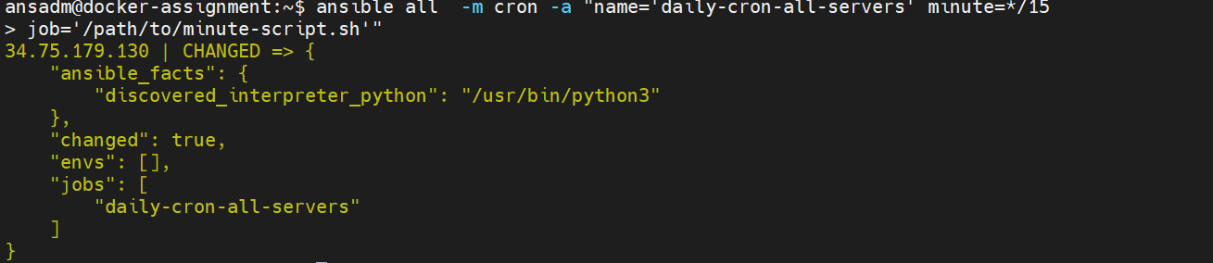

17.Running operations in the background asynchronous with Polling ansible

Ansible playbook exercises:

1. Create a playbook to print “hello world”

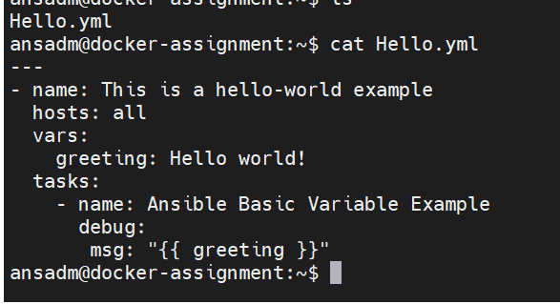

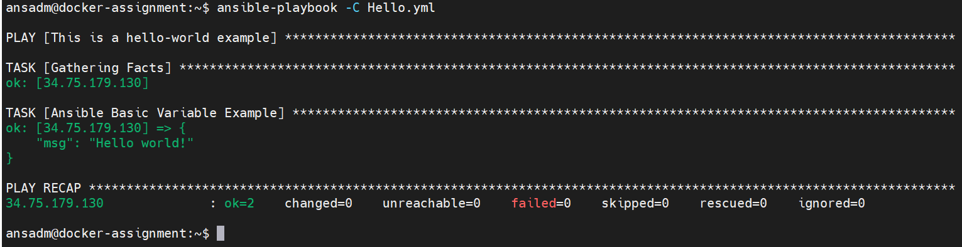

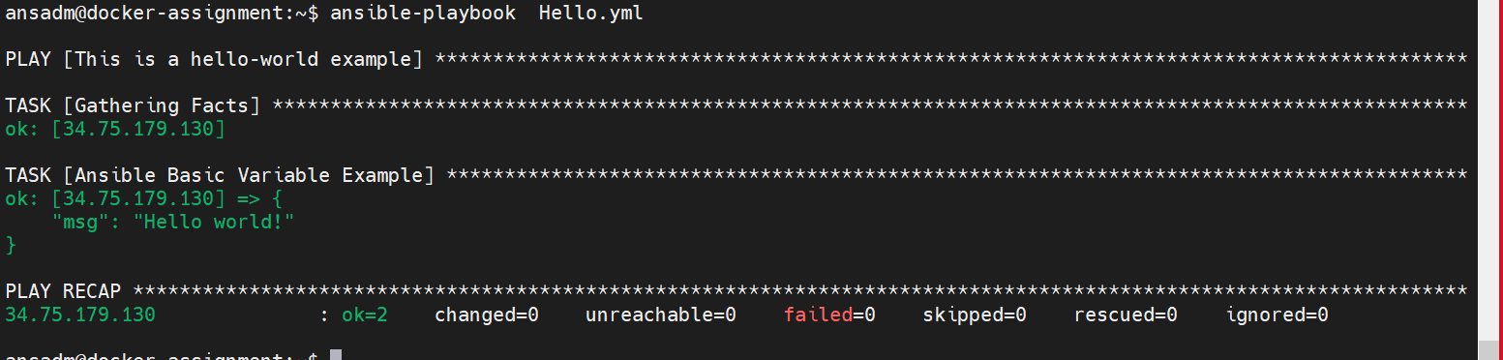

2.Playbook to install nginx and uninstall nginx

---

- hosts: all

tasks:

- name: ensure nginx is at the latest version

apt: name=nginx state=latest

- name: start nginx

service:

name: nginx

state: started

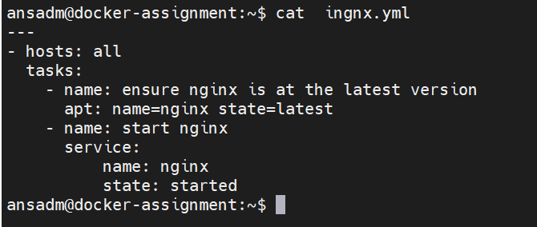

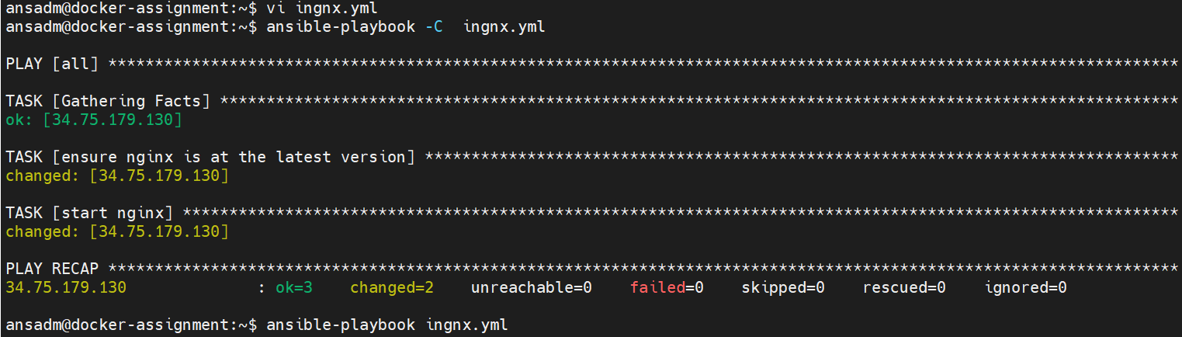

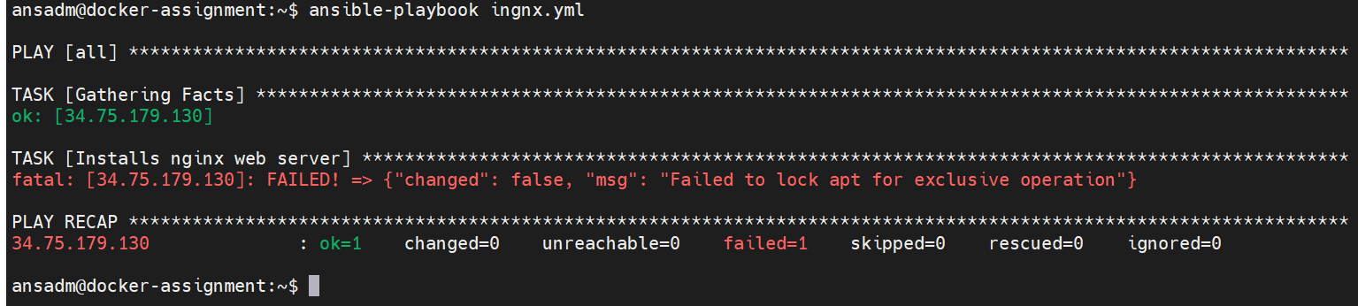

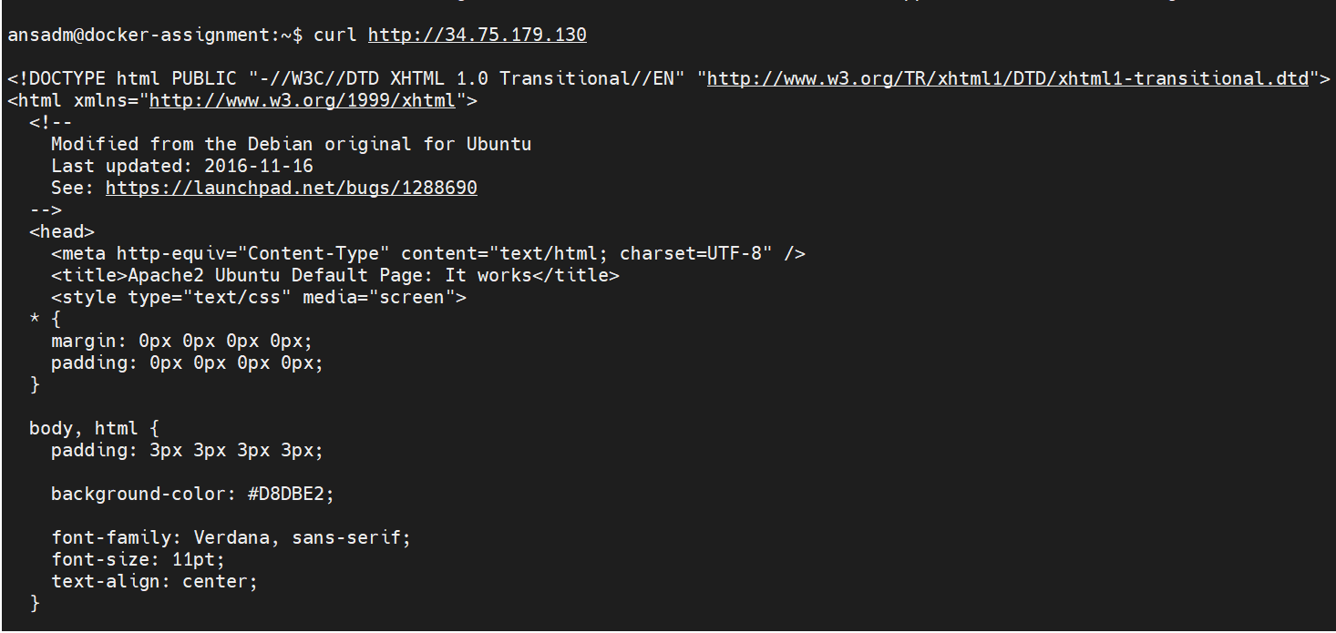

vi uningnx.yml

---

- hosts: all

tasks:

- name: stop nginx

service:

name: nginx

state: stopped

- name: ensure nginx is not installed

apt: name=nginx state=absent

ansible-playbook -C uningnx.yml

ansible-playbook uningnx.yml

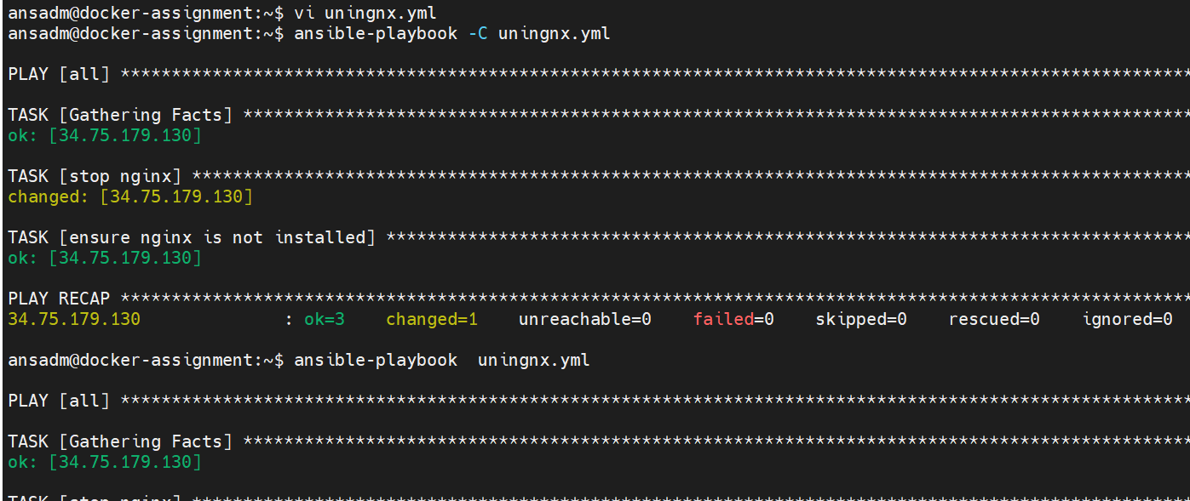

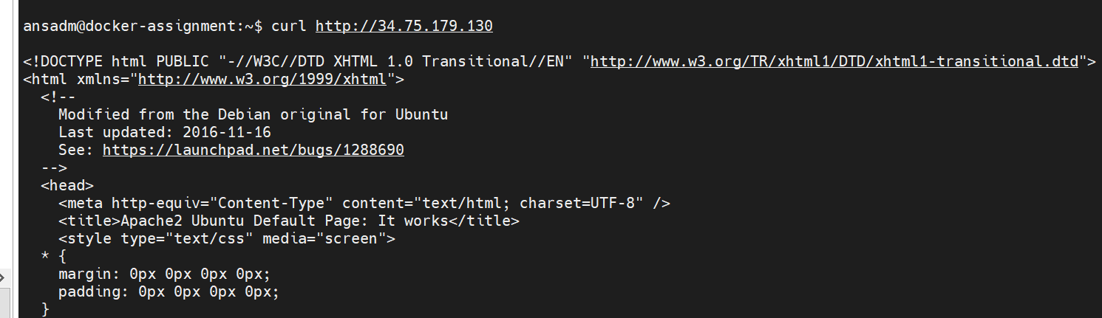

3.Playbook to install apache and uninstall apache (start the service only if the installation is successful)

4. Playbook to use variable and print the var which should print hello-world

---

- hosts: all

vars:

students:

- Mark

- Melisa

- Arthur

- Kevin

- Lisa

tasks:

- name: Ansible List variable Example

debug:

msg: "{{ students[2] }}"

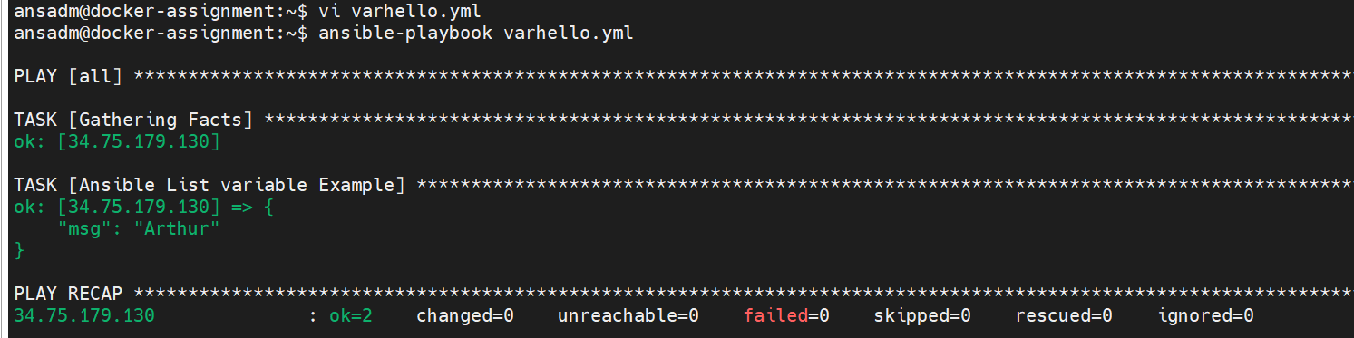

5. Playbook to use register command to print the output of ls -lrt ---

- hosts: all

tasks:

- shell: “ls -lrt”

register: shell_result

- debug:

var: shell_result.stdout_lines

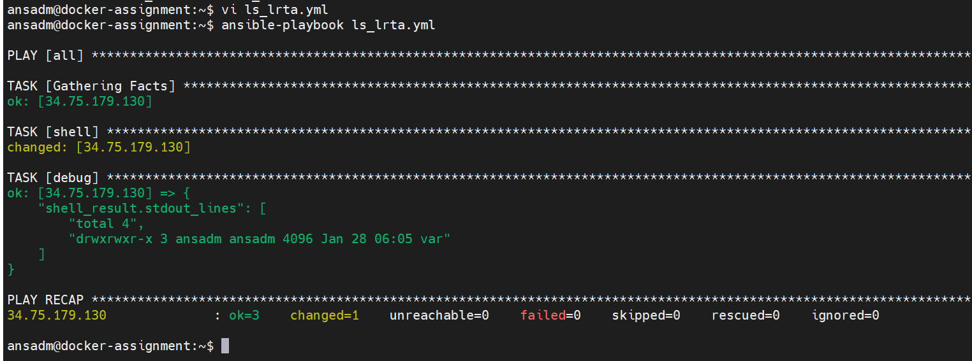

6.Playbook to use debug command to print the output of greeting variable : hello world

---

- name: Demo

hosts: all

gather_facts: False

become: False

tasks:

- debug:

msg: Hello world!

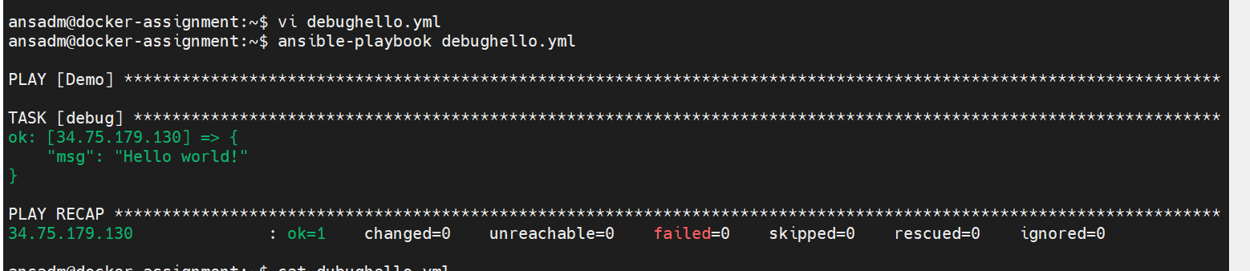

7.Playbook to install jdk 1.8