**ANSIBLE INSTALLATION DOCUMENT**

**Ansible: Ansible** is simple open source IT engine which automates application deployment, intra service orchestration, cloud provisioning and many other IT tools

First of all we need to create two instance and we need to connect those. For that one is act as master and another one is act as slave.

For that start your instance in static IP address.





**Sudo su – go to root directory**

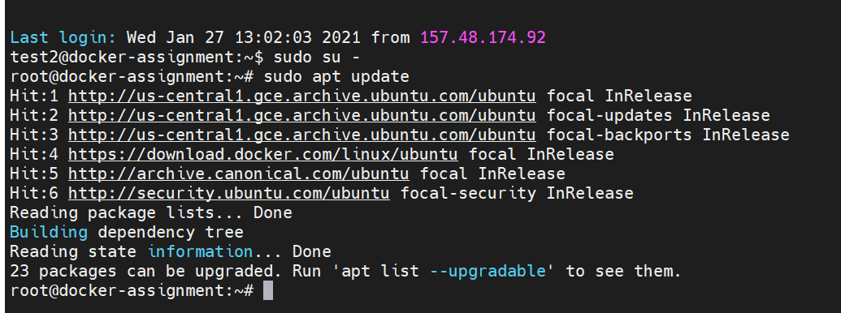

And update it by using sudo apt update

sudo useradd -m -s $(which bash) -G sudo ansadm:

creating new user inside the root as a name of ansadm



Passwd ansadm:

Adding a new password to created user if we want login to that user in first time it need the password and it is shown below. After successfully added the password it show password update successfully.

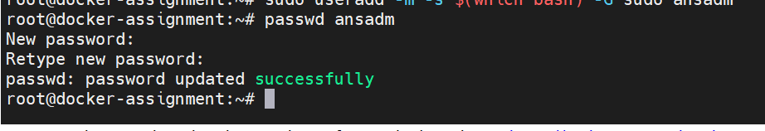

Then we login to that user by setting the password we can the id of user by the command of id ansadm

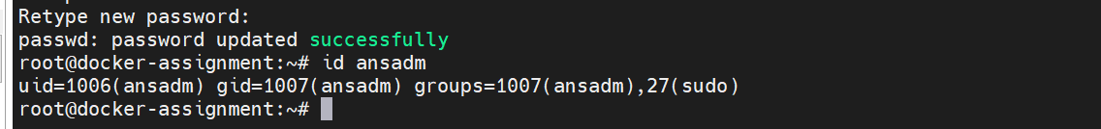

Go inside the ansadm by the command of sudo su - ansadm

If we want to which directory we can use the pwd and also we can use exit for logout from the user or root

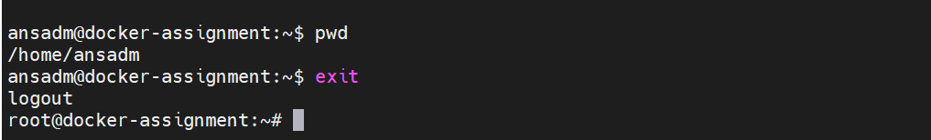

we need to change the sudoers file inside the path /etc/sudoers

echo "ansadm ALL=(ALL) NOPASSWD:ALL" >> /etc/sudoers : This is for enable no password for all echo is used to add the line at end of sudoers file As shown below.

OR

whether it changed using visudo command



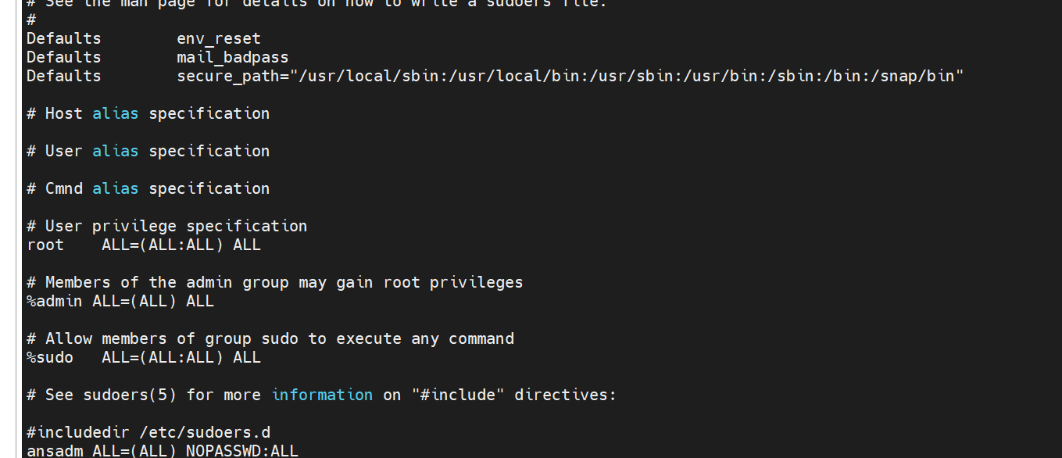

Here we are going to slave in this instance we are repating the process until now as like master

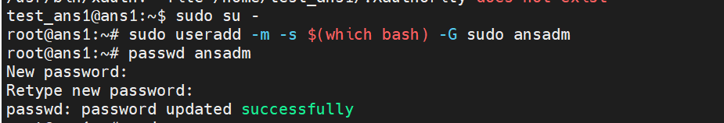



To enable SSH password authentication, you must SSH in as root to edit this file:

/etc/ssh/sshd_config

Then, change the line

PasswordAuthentication no

to

PasswordAuthentication yes





Then we can restart the instance by using systemctl restart sshd



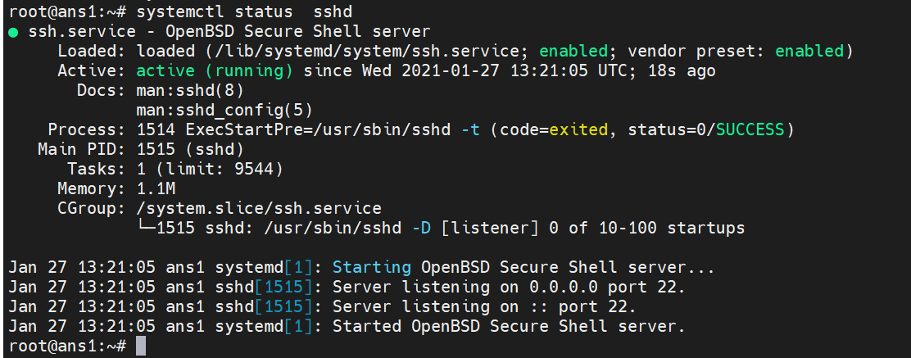

Then back to master instance:

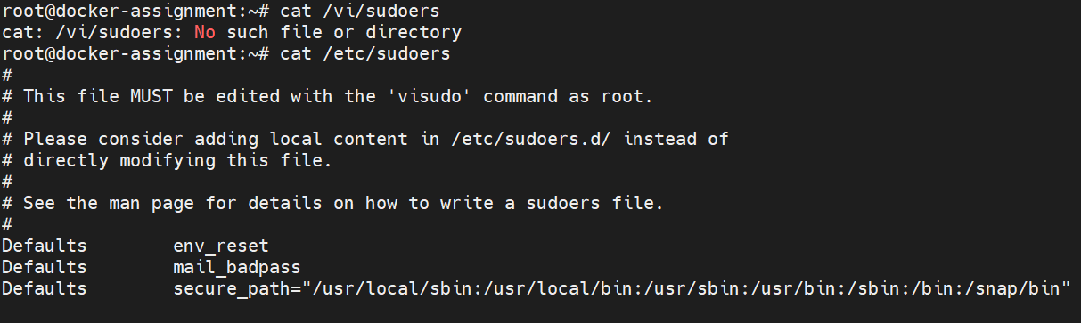

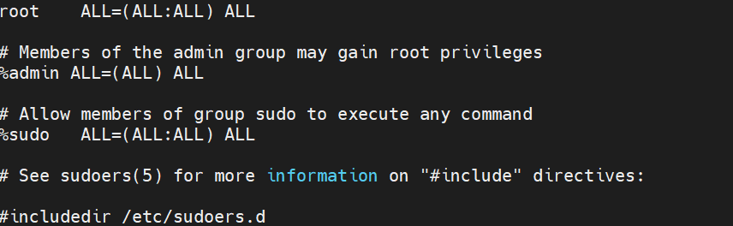

* Now go to ansadm.

sudo su - ansadm

here we need to insatll the ansible as a command of sudo apt install ansible after successfully donwload you can see like this.

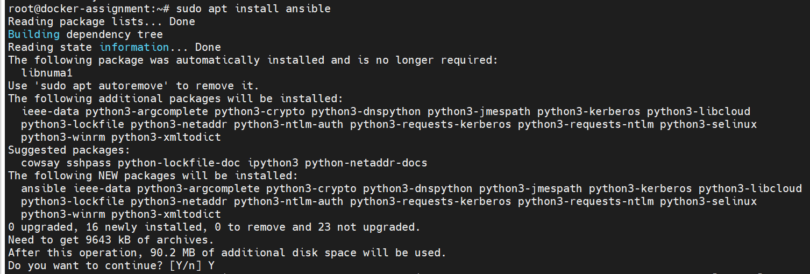

ansible --version

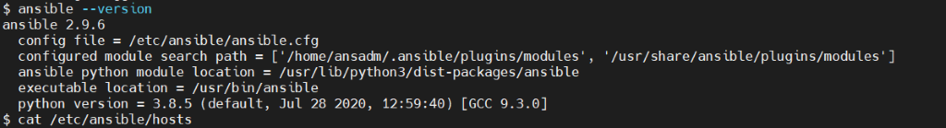

Now we need to add the private ip of the second instance(slave) where we want to run our ansible slave using the below command.

Sudo vi/etc/ansible/hosts



Inside that we need to add slave ip addres as shown below

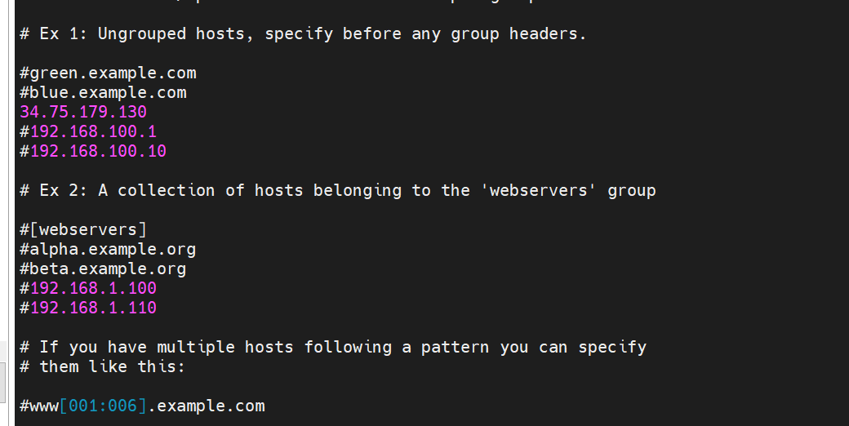

Now we need to generate ssh key and using this ssh key we will connect with the ssh key

Ssh-keygen

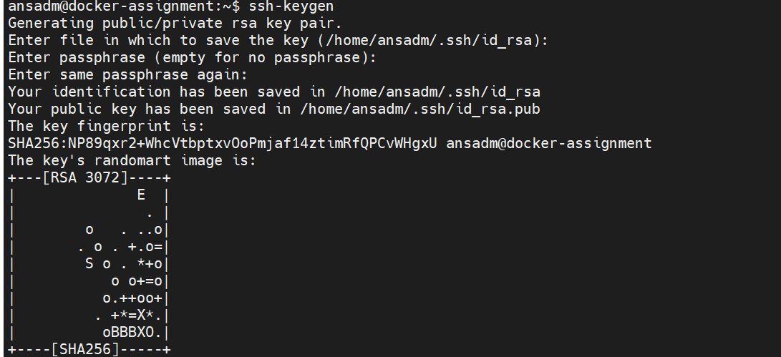

 copy the ‘Ip’ of slave instance to the master instance using the below command.

ssh-copy-id ansadm@’here we need to paste the slave ip address’

ssh-copy-id ansadm@34.75.179.130

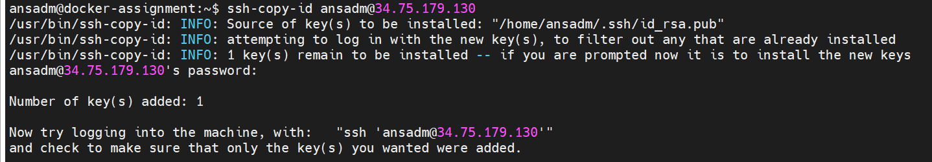

Then finally we nee dto check the connection is established or not by using the command

Ansible all –m ping

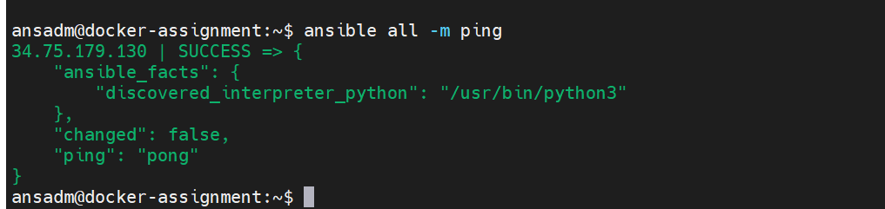

Hi senthil when I am trying to build a custom image through Jenkins pipeline it showing some error like Docker Not Found but when I am trying with commands then it is working

