LINUX

1) How many No. of users are logged on to this system ?

A) W is the command for the to know how many and who are loged on to the system.

Ex: whoami, who

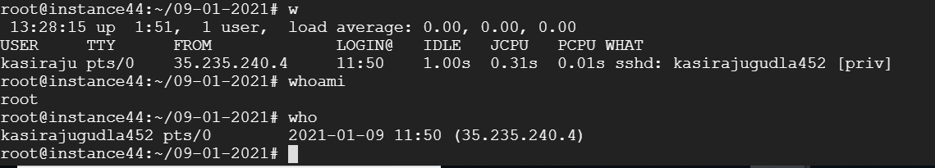

2) Display a sorted list of logged on users (only user name), but every user only once .

A) we can use either who or sort or tail to show users in sorted list

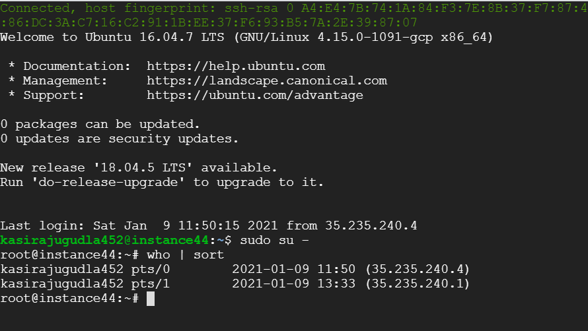

3) search for lines containing 'fred' in /etc/passwd ?

A)The etc/passwd file in ubntu is an text based databse of information about users that may log into the system or other operating system user identities that own running process

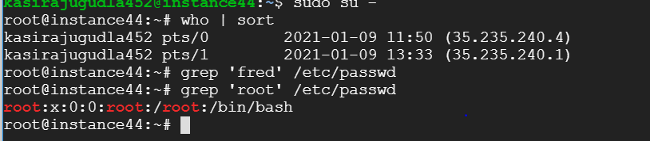

4) find joe, Joe, JOe, JOE, etc. in users.txt file

A) First of all create user.txt by using command vi user.txt

After opening new file then enter Joe,JOE,Joe,Joe

After closing the file then you can use the command grep -I ‘joe’ users.txt

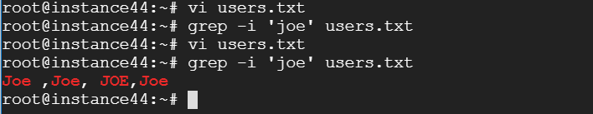

5) find 'fred', but only at the start of a line in /etc/passwd ?

A) Here we are use command grep ‘^fred’ /etc/passwd.

^ means indicate that select users who have fred at the start of the line

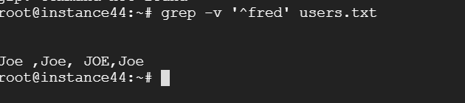

6) find any line *not* containing 'fred' in users.txt file

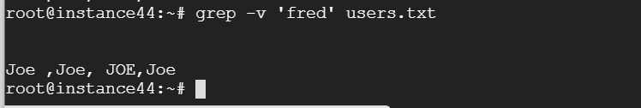

7) find Foo or Goo in all files in the current dir

A) grep –v ‘[FG]oo’

8) Find the passwd file under all sub-directories starting from root directory.

Find /- name passwd

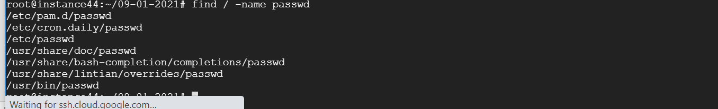

9) display the top 5 largest file in the current directory and its subdirectory.

A) find .-printf’%s%p\n’|sort –nr|head -5

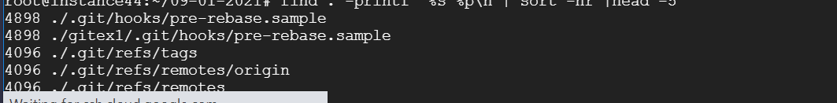

10) Find all directories

AL ls -l –d*

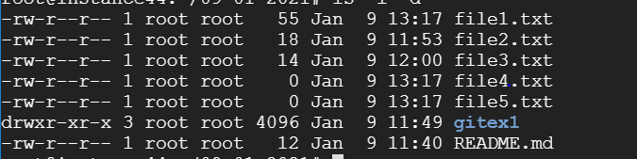

11) Remove *.zip files that are over 2GB.

A) find –type f –name *log -size+2048M -delete



12) The ___SLEEP______ command is sometimes used in scripts to wait a number of seconds.

13) Count the number of *.conf files in /etc and all its subdirs.

A) the command is find /etc –name ‘*conf’ | wc -1



14)  Issue the date command. Now display the date in YYYY/MM/DD format.

A) date +%F

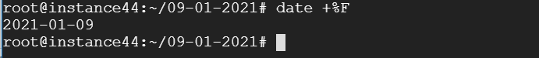

15)  Use find and -exec to rename all .htm files to .html.

A)

16) explain the below permissions (3 sets of rwx)

A) rwx are the below permission on a file they indicate (user group executes)

R-Read

W-Write

X-Execute

These 3 permission indicate the status of a file

17) Change the ownership of all files in ~/permissions to yourself.

A) chmod –R 777 ./



18) With chmod, is 770 the same as rwxrwx--- ?

A)

19)  As root, create a file in the users ~/permissions directory

A) touch/home/username/permissions rootfile

20) Group membership is defined by the __/etc/group__ file.

21) A user can type the ____groups______ command to see a list of groups where the user belongs to.



22)  Create the groups tennis, football and sports.



23) In one command, make venus a member of tennis and sports.



24) Rename the football group to foot.

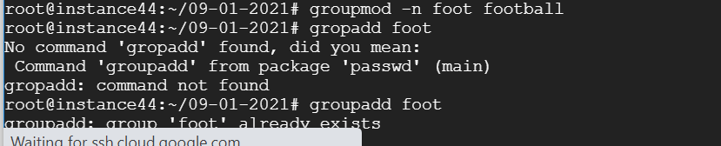

25) User passwords are encrypted and kept in ______WORLD-READBLE TABLE__

cp -R /home/hope/files/* /home/hope/backup

chown xxx:xxx file1.txt

uname -a

ls –lrt

(ps -ef OR ps -aux)

find ./ | grep "abcd"

find / -type d -name "dir1"